

Race timming system Introduction

# Introduction

In this lesson we will use the micro:bit to record the speed of a car

# Necessary:

* Micro:bit controller
* Kitronik :MOVE motor kit or other robot or toy car which can be driven
* USB cable
* Micro:bit program or internet link in which to do programming

# Process!

1. At the beginning, you need to create a part of the track from which the driving speed will be measured when driving to which place. It should choose a specific distance.
2. A **table, floor or cardboard** **sheet** can be used for this purpose. And for this you will need **foil or foil tape**.
3. You need to **stick four strips of folio** that will get the data you need. **Every two strips** should be glued as **close** to the two **together as possible**, this will depend on how efficiently the data will be obtained.

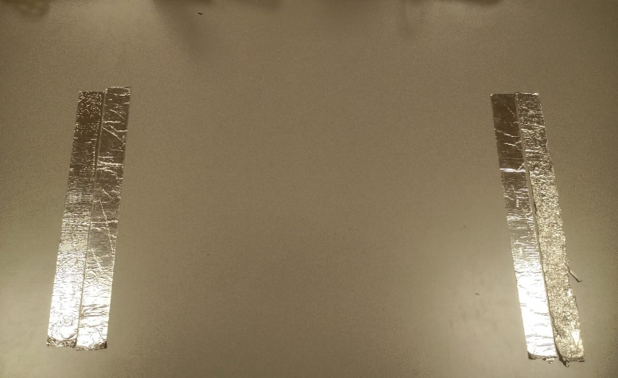

1. You also need to **equip** the **robot or toy car** with a **foil strip**. For this to work, the **strip needs to touch the ground**, as it needs to touch the foil sheets that are glued to the surface your vehicle will be driving on. The foil that is attached to the robot **must be wide enough** so that **both sheets of foil** that are glued next to each other **can be touched** **at the same time** when driving. Folly, which is attached to the robot, should not simply slide on the driving surface, but should press against it a little to have better data reading. If the contact with the foils is insufficient, the project may not work.

! We taped the wheels on the heavier robot and it worked, but the lighter robot didn't, so we had to improvise and find a solution to make it work. In this project, you should count on improvisation and imagination.

!!! Warning!!! **Connect the foil to the robot carefully and do it when the robot is turned off, if the connected foil touches electronic parts, then when it is turned on, a short circuit may occur, and the robot's chip may burn**.

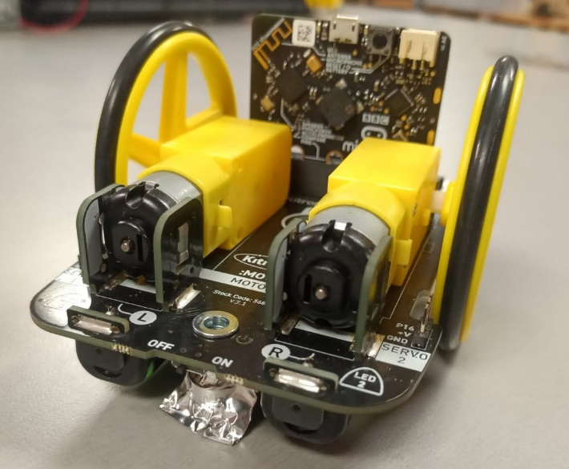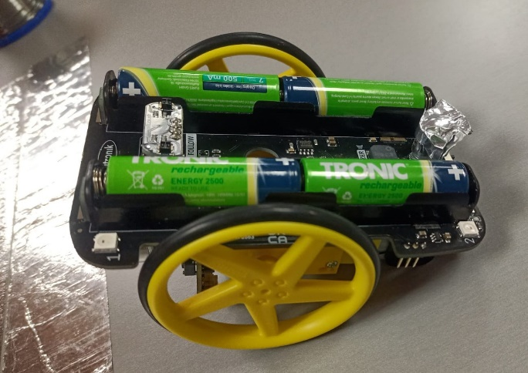

1. Next, you need to create a data collection system. This can be done by **connecting** the **adhesive foil tapes** to the **micro:bit controller**. They are connected using **crocodile wires**. **One side** is connected to micro:bit **pin 0** and **GND** (this one put in this side, where will be **start**), the **other side** is connected to **pin 1** and **GND** (this one put in this side where will be **finish**).

1. Now it needs to be programmed. From **basic** take block **on start** and input block **show leds** also from **basic**. The **Show LEDs** mark the **middle LED**.
2. Then choose block on pin P0 pressed from input.
3. Create **variables time 0, time 1, diffTime(ms).**
4. Put block **set time 0 to** from **variables** in block **on pin P0 pressed**.
5. From **control** take block **event timestamp** and put it into block **set time 0 to**.
6. From **Basic** block **show leds** put in **on pin P0 pressed**.
7. Then choose block **on pin P1 pressed** from **input**
8. Put block **set time 1 to** from **variables** in block **on pin P0 pressed**.
9. From **control** take block **event timestamp** and put it into block **set time 1 to**.
10. From **Basic** block **show leds** put in **on pin P1 pressed**.
11. Take block **set diffTime(ms) to 0** from **Variables** and put it into block **on pin P1 pressed**
12. From **math** take block **0 – 0** and put in block **set diffTime(ms) to**.
13. In block **0 – 0** put **time 1** variable minus **time 0** variable.
14. Then put block **show number 0** from **basic** into block **on pin P1 pressed**
15. And in **show number** block put in variable **diffTime(ms).**

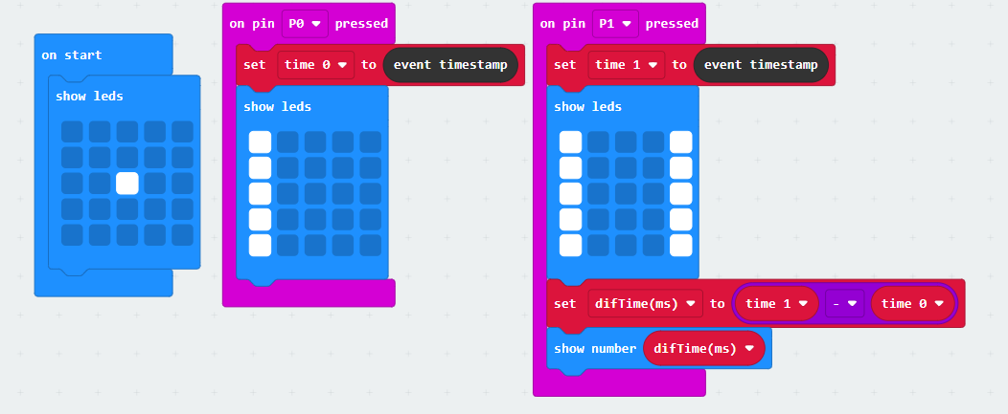

1. **Download** in micro:bit controller

Python:

# Challange:

Improve the code so that pressing the B button restarts the code. Then you won't have to recompile the code every time after making a trip