

Lab 1

[Click here to Register Attendance](https://goo.gl/forms/J9WP2kj83JC1mKYU2)

| Name |  |
| --- | --- |
| Date |  |
| Student No |  |
| Student Email |  |

### **GitHub**

1. Make a copy of this document on Google Docs
2. Go to <http://github.com>
3. Sign up for a GitHub Account (make sure to use your ATU Sligo student email address when you signup as this will entitle you to a free Student that includes 5 free private repositories.)
4. Enter your GitHub username here and also enter it into this [form](https://forms.gle/2WXr81guCMnnAb989):

|  |
| --- |

1. Once your account has been setup, try creating a new Repository called **firstrepo** using the Add Repository button below your profile picture.
2. Use the Add File button to add a new file to your repository, give your new file a name, type some text and save the file.

### **Arduino IDE & Coding Basics**

1. Find the Blink tutorial on the Arduino Website

<https://www.arduino.cc/en/Tutorial/BuiltInExamples/Blink>

1. Open the Arduino Create Integrated Development Environment (IDE)
2. Click Examples -> Built-in -> Basics… and choose the Blink sketch:  
   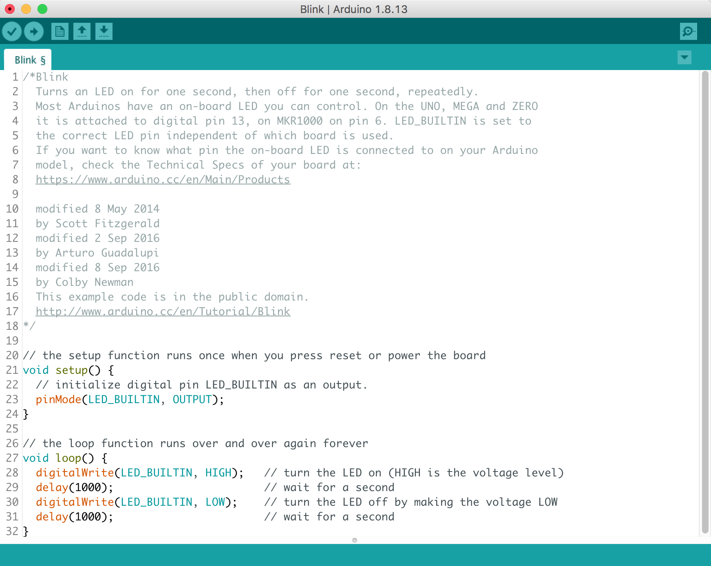
3. Compile the Blink sketch and confirm it compiles correctly
4. Change the blink delay values to 500 - what will be the effect of this change?

|  |
| --- |

1. Add a ‘modified by’ line to the sketch comment at the top, with your name and date and paste a screen shot replacing this one:  
   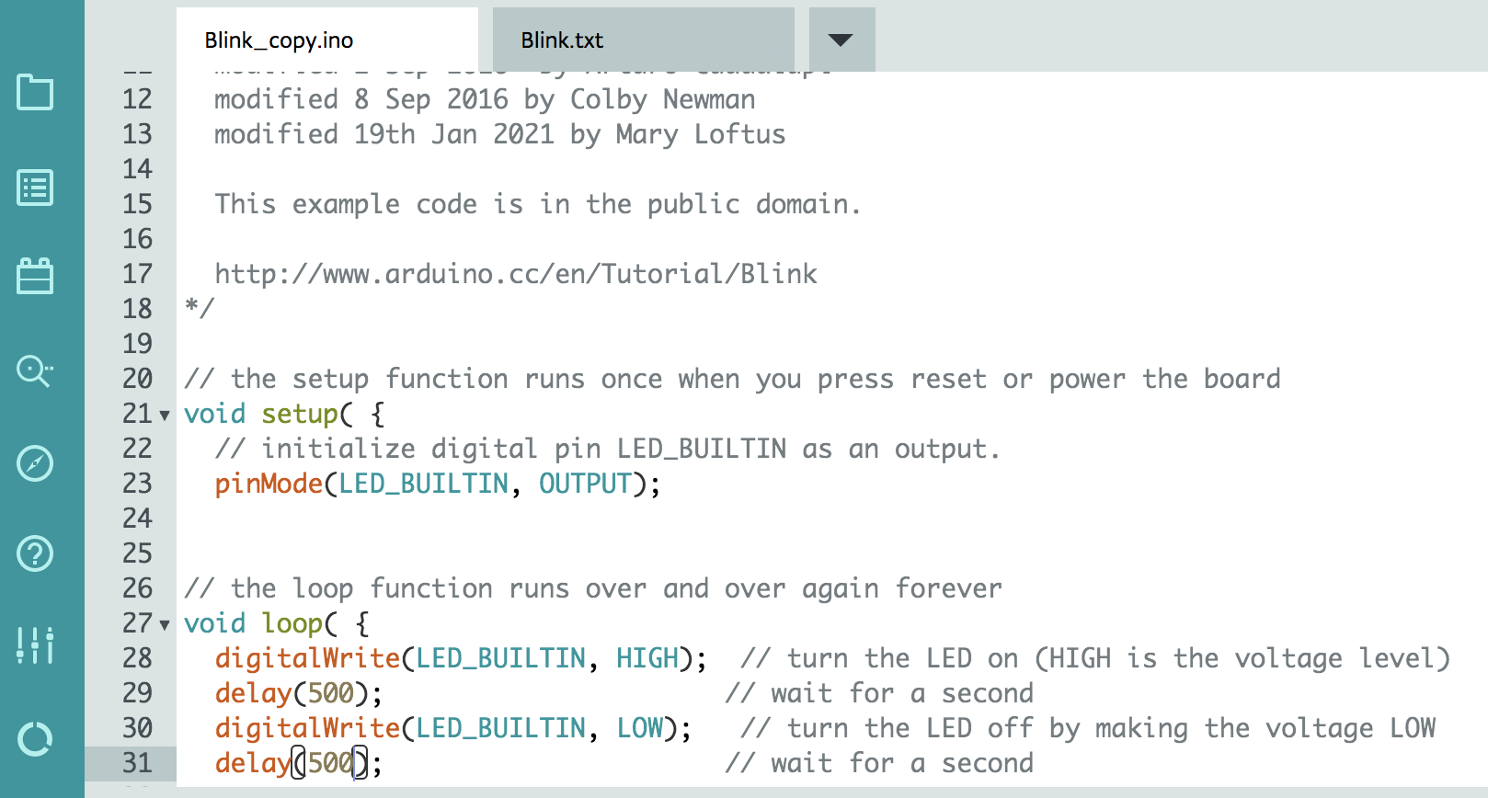
2. Watch this video to see the Arduino & Grove kit run the Blink code: <https://www.youtube.com/watch?v=vFB0fH_F5Kg>
3. What is the effect of twisting the LED adjuster with a screwdriver in the video?

|  |
| --- |

1. What pin number was the LED put into?

|  |
| --- |

1. How would you change the code above to have it run the sketch as seen in the video?   
   Hint: the Blink sketch lights up the built-in LED (using the variable LED_BUILTIN) and you want to light up the LED plugged into the Grove kit port...

|  |
| --- |

1. **Correcting Code:**  
   Paste the code you find [here](https://github.com/marloft/ITSligoIoT/blob/main/BlinkErrors) (on GitHub) into a new Arduino Create Web Editor window and then use the compiler to find the errors in the code and correct them.
2. Upload your corrected version of BlinkErrors to your GitHub account and provide the link here:

|  |
| --- |

1. Paste a screenshot here of your corrected code uploaded to GitHub
2. ***Upload your Lab to Moodle!***