KARR – User Guide

Kristian's Aquatic Roving Robot

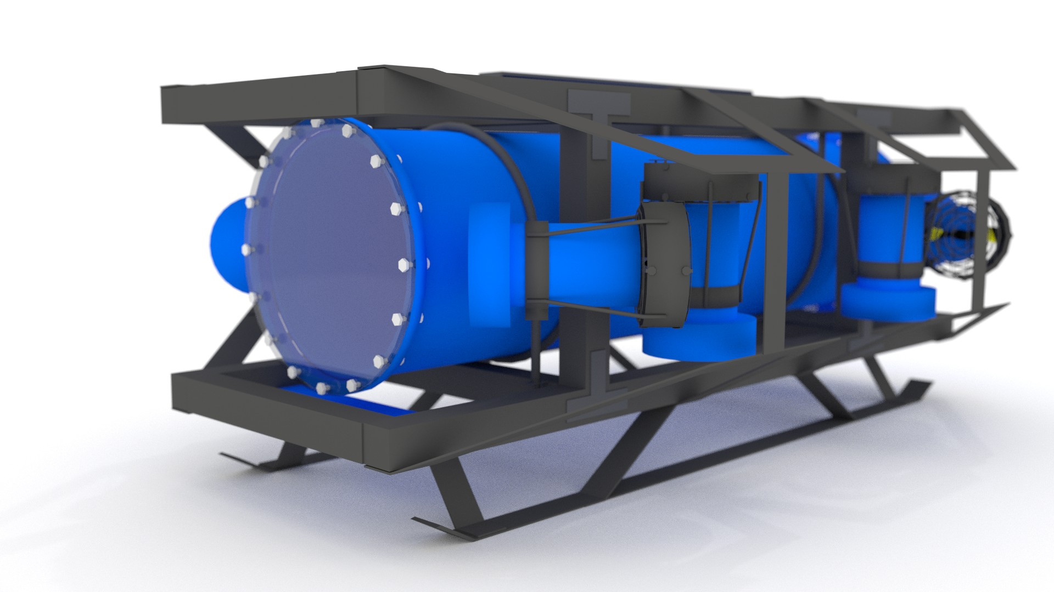

Kristian Charboneau
User Guide
12/2015

About
KARR is an observation class underwater Remotely Operated Vehicle (ROV). It is designed to explore lakes, ponds, and your backyard swimming pool. To facilitate this goal the rov is equipped with a camera and lighting system. This guide will walk you through setting up and using the KARR rov.
System Overview
The main components that comprise the system are the rov, tether, video display, Logitech F310 gamepad, and laptop (not included). The tether consists of a CAT 5 cable and the camera's video/power cable. The video display is used to view the camera feed, and the laptop runs the rov's control software, which uses the gamepad as input.
Recommended Supplies
- LiPo battery charger with balancer
- Silicon grease
- Laptop running Linux or OS X
- Logitech F310 usb gamepad
Setup
Before use KARR's LiPo battery needs to be charged. KARR is designed to be used with a 3S (11.1v) battery. This type of battery is commonly used with RC vehicles.
NOTE: Special precautions are needed when using LiPo Batteries. Refer to the instructions that came with your battery and/or charger for precautions and proper use. Only use a charger designed for LiPo batteries. It is recommended to use a charger with a built-in balancer.
The internal battery is equipped with a low voltage alarm. If the voltage drops below the threshold an alarm will sound. It is recommended to stop operation and charge the battery at this point. To charge the battery first remove the battery compartment hull. Simply pull the acrylic tube away from the rear end cap assembly. The front end cap assembly should remain attached to the acrylic tube. Slide the tube forward until the battery is accessible. Disconnect the battery from the main power connector (see figure) and remove the low voltage alarm. Connect the batteries power and balance cables to your charger (consult your charger's documentation for specific charging procedures).
Once the battery is charged slide the acrylic tube back into place. It is recommended to apply a light amount of silicon grease to any exposed O-rings before reseating the tube. This will help ensure a proper seal. Make sure there is no hair, dust, or other foreign material on the O-rings or inside of the tube.
Tether
Once the rov is sealed up the tether can be connected to the operator-side equipment ( the tether is permanently secured to the rov and shouldn't need to be removed from the rov under normal circumstances). Connect the CAT 5 cable to the USB over ethernet adapter, and plug the usb portion of the adapter into your laptop's usb port. Next, connect the composite video cable (the yellow RCA style connector) into your video display or adapter). The camera requires 12V to operate. This can be supplied from any 12V DC power source capable of supplying 500ma. For example a vehicle's 12v output, a generator with 12v out, or a 12v battery are all possible sources. Connect the tether barrel jack (center positive) to the 12V DC power source. The camera's built-in led should light up, indicating it is getting power.
Turning the ROV On and Off
The rov is equipped with a magnetic power switch system. This allows the rov to be turned on and off without having to open up the water tight containers. To turn the rov on hold the included magnet (or any magnet should that one get lost) against the outside of the power tube directly in-front of the magnetic switch. When the rov has been turned on there will be an audible click and several status lights and the running lights in the electronics enclosure will turn on. At this point the magnet can be pulled away. To turn the rov off simply hold the magnet near the magnetic switch. The status and running lights will turn off, indicating that the rov has powered down.
<Images>

Lights
The rov has several lights, including status lights and illumination lights. The battery tube and main electronics tube both have high power illumination lights. The main electronics lights are always on when the rov is on. The battery compartment lights are dim-able through the Operator Console software.
<Images>
Several of the components in the rov have status lights. The magnetic switch control circuitry has a red led that illuminates when the rov is on. Each motor controller has a green led that lights when the controllers receive power. The micro-controller has red and purple leds that flash when the tether is connected to a laptop.
<Images>
Installing the Software
To use KARR you will need to install the Operator Console software on your laptop. The software currently works with Mac OS X and Linux based operating systems.
Installation on Linux:
The software has been tested on Fedora Linux, but should work with the other major Linux distributions. First, make sure the necessary dependencies are met. The software requires Python 2.7 or newer, pygame and pyserial. Use your distro's package manager to install these dependencies. For example:
sudo yum install python pygame python-serial
or
sudo apt-get install python pygame python-serial
Next, download the Operator Console software from GitHub. The software can be found at https://github.com/Kristian-Charboneau/KARR.

Installation on Mac OS X:
The software has been tested on OS X Yosemite. First, make sure the necessary dependencies are met. The software requires Python 2.7 or newer, pygame and pyserial. While OS X has python preinstalled it is recommended to install Python from python.org. Pygame can be found at http://pygame.org/. Pyserial can be installed thru PIP:
sudo pip install pyserial
Next, download the Operator Console software from GitHub. The software can be found at https://github.com/Kristian-Charboneau/KARR.
Download Through Git:
open a terminal and run:
git clone https://github.com/Kristian-Charboneau/KARR.git
Note: this will clone the entire repository, including source, design, and documentation files.
To run the Operator Console enter this into the same terminal used to clone the repo:
./OperatorConsole/ROV.py
To upgrade the software to the latest version simply open a terminal at the project folder and run:
git pull
Download Without Git:
Go to https://github.com/Kristian-Charboneau/KARR.git. Click the “Download Zip” button.
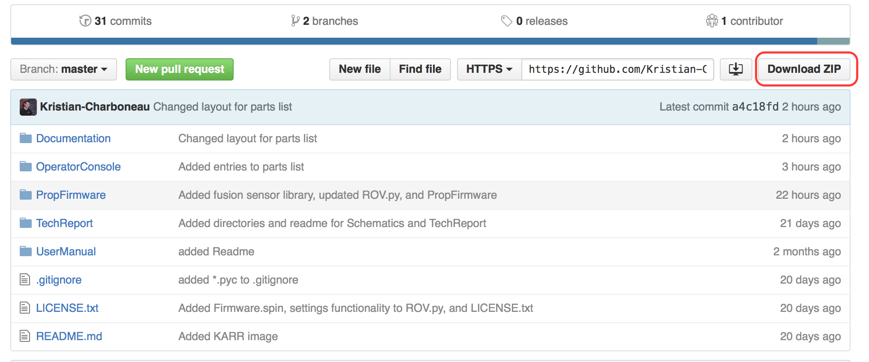
Note: this will download the entire repository, including source, design, and documentation files.
Extract the zip archive to a location in your home folder. The subfolder called Operator Console contains the files necessary to run the Operator Console.
Open a terminal and enter
/path/to/OperatorConsole/ROV.py
For example, if you extracted the archive to your home directory the path may look something like this:
/home/yourname/KARR/OperatorConsole/ROV.py
The Software

For convenience a symlink to ROV.py can be placed in /usr/bin. In a terminal enter:
sudo ln -s /path/to/OperatorConsole/ROV.py /usr/bin
This will allow you to run the software by opening a terminal and typing:
rov

The Operator Console program is a command line application that allows you to control the rov and see relevant information about the rov. It uses a usb gamepad (designed for the Logitech F310, though it should work with other gamepads) to control the rov. The below sections explain how to use the various portions of the program.
GUI
The program has a basic text based gui for displaying information. The gui is split up into “screens” to organize information. To switch screens press the Start button on the gamepad. There are several screens available: Telemetry Info, Errors, Execution Time, and Motor Status.
- The telemetry screen displays heading, velocity, acceleration, and internal temperature.
- The Error screen displays any errors reported.
- The Execution Time screen displays the execution time for several critical parts of the software. This is useful for troubleshooting.
- The Motor Status screen displays the speed values for each motor (note this is not the real value, rather what value the motor should be at).
ROV Control
The rov can move forwards/backwards and left/right, rotate left/right, and tilt forwards and backwards. Refer to the graphic below for the button mapping.
<Insert Image>
The lights in the battery compartment can also be dimmed using the gamepad. Press the A button to increase brightness and the B button to lower the brightness.
To exit the program press the Back button.

