1. Sequence Diagram for Play Media Flow

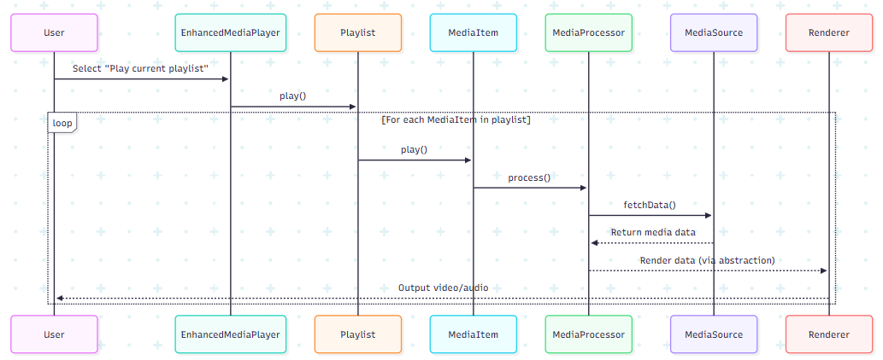

2. Sequence Diagram for Applying Decorators (Subtitles, Equalizer, Watermark)

