Awesome GIS project

Kristian Lunow Nielsen

This is an [R Markdown](http://rmarkdown.rstudio.com) Notebook. When you execute code within the notebook, the results appear beneath the code.

Try executing this chunk by clicking the *Run* button within the chunk or by placing your cursor inside it and pressing *Ctrl+Shift+Enter*.

To read more, see (Deng, Giesecke, and Lai 2010)

## Parsed with column specification:  
## cols(  
## .default = col_double(),  
## `Ward name` = col_character(),  
## `Old code` = col_character(),  
## `New code` = col_character()  
## )

## See spec(...) for full column specifications.

## Data contains duplicated keys: E09000001

## Over coverage: 626 out of 659 data records were not appended. Run over_coverage() to get the corresponding data row numbers and key values.

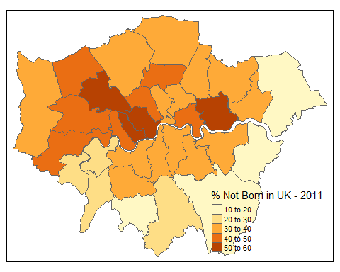

Add a new chunk by clicking the *Insert Chunk* button on the toolbar or by pressing *Ctrl+Alt+I*.

When you save the notebook, an HTML file containing the code and output will be saved alongside it (click the *Preview* button or press *Ctrl+Shift+K* to preview the HTML file).

The preview shows you a rendered HTML copy of the contents of the editor. Consequently, unlike *Knit*, *Preview* does not run any R code chunks. Instead, the output of the chunk when it was last run in the editor is displayed.

(Creal 2009; Deng, Giesecke, and Lai 2010)

library(citr)

## Warning: package 'citr' was built under R version 3.4.4

Creal, Drew. 2009. “A survey of Sequential Monte Carlo Methods for Economics and Finance.” *Econometric Reveiws*.

Deng, Shaojie, Kay Giesecke, and Tze Leung Lai. 2010. “Sequential Importance Sampling and Resampling for Dynamic Portfolio Credit Risk.” *INFORMS 2010*.