**Google Earth Engine for R**

2018-May-26



Image

# R Markdown

This is an R Markdown document. Markdown is a simple formatting syntax for authoring HTML, PDF, and MS Word documents. For more details on using R Markdown see <http://rmarkdown.rstudio.com>.

When you click the **Knit** button a document will be generated that includes both content as well as the output of any embedded R code chunks within the document. You can embed an R code chunk like this:

summary(cars)

## speed dist   
## Min. : 4.0 Min. : 2.00   
## 1st Qu.:12.0 1st Qu.: 26.00   
## Median :15.0 Median : 36.00   
## Mean :15.4 Mean : 42.98   
## 3rd Qu.:19.0 3rd Qu.: 56.00   
## Max. :25.0 Max. :120.00

## Including Plots

You can also embed plots, for example:

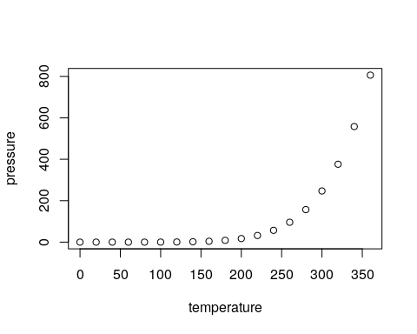

Note that the echo = FALSE parameter was added to the code chunk to prevent printing of the R code that generated the plot. A grande vantagem de usar o rgee e que, além da vasta opção de imagens, as funções já são pré estabelecidas do tipo: image$nomalizedDifference(c(banda, banda)) para o cálculo de índices normalizados e não precisamos nos preocupar com diferente resoluções entre bandas como B5(20m) e B3(10m) no NDWI, pois elas são ajustadas automaticamente pelo GEE.

# Instalación   
library(rgee)  
ee_Initialize()

## ── rgee 0.6.2 ──────────────────────────────────────────────────── earthengine-api 0.1.223 ──   
## ✓ email: not_defined  
## ✓ Initializing Google Earth Engine: ✓ Initializing Google Earth Engine: DONE!  
## ✓ Earth Engine user: users/antonybarja8   
## ─────────────────────────────────────────────────────────────────────────────────────────────