Workshop No. 1

Packet Tracer Basics

Kristian Ferley Mayorga Sarmiento

20202020046



**Computer Engineering**

**Eng. Carlos Andrés Sierra, M.Sc.**

**Grupo:** *020-82*

*September 7, 2024*

**Solution**

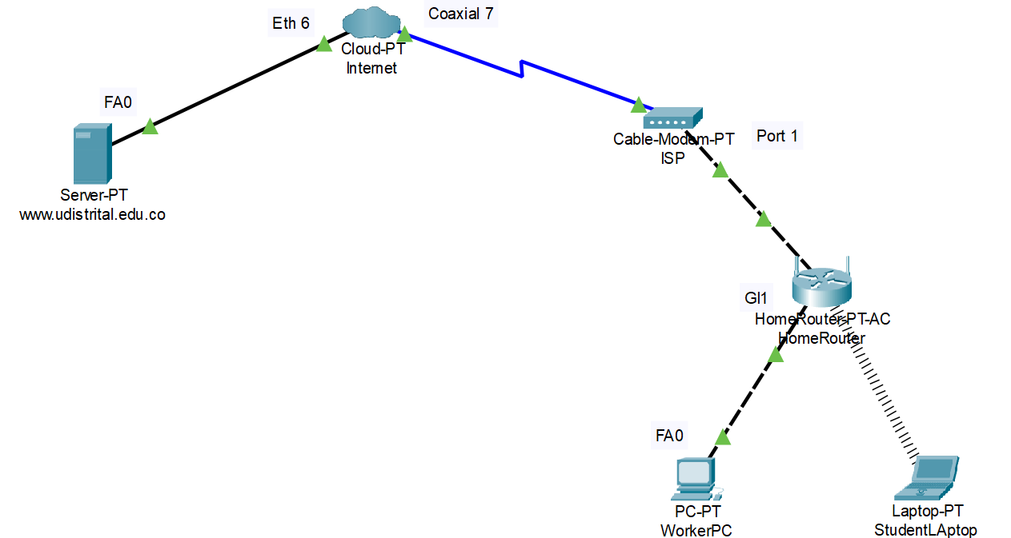

As we can see, the connection from the server to Cloud-PT is done using a straight-through copper cable, since it gives us much more speed, although it can be a bit weak, but it is not suitable for such long distances.

From Cloud-PT to the ISP, we see that we use coaxial cable, since it is much cheaper and ideal for long distances due to its rigidity.

From the ISP to the Homerouter and from the Homerouter to the PC (WorkerPC), we could have used any cable, but that would depend on which ports we have active on our PC and on our router. In addition, we chose the crossover cable, which allows us to maintain the same speed when transporting information.

We proceed to configure the different devices and services that we have, as we see below:

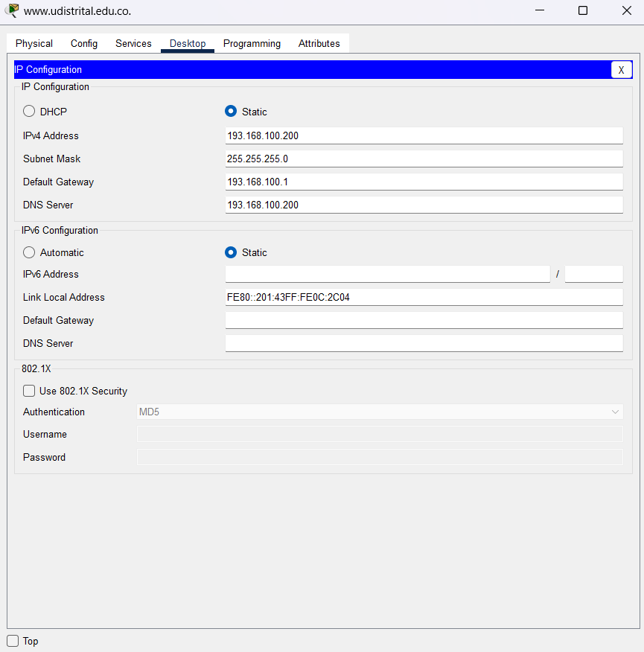

Image 1. Server configuration

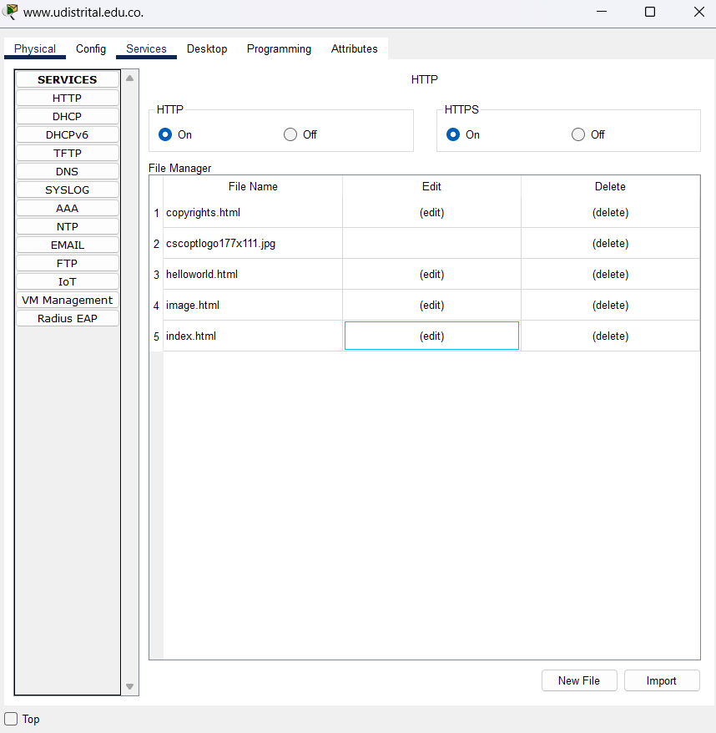

Image 2. Services HTPP

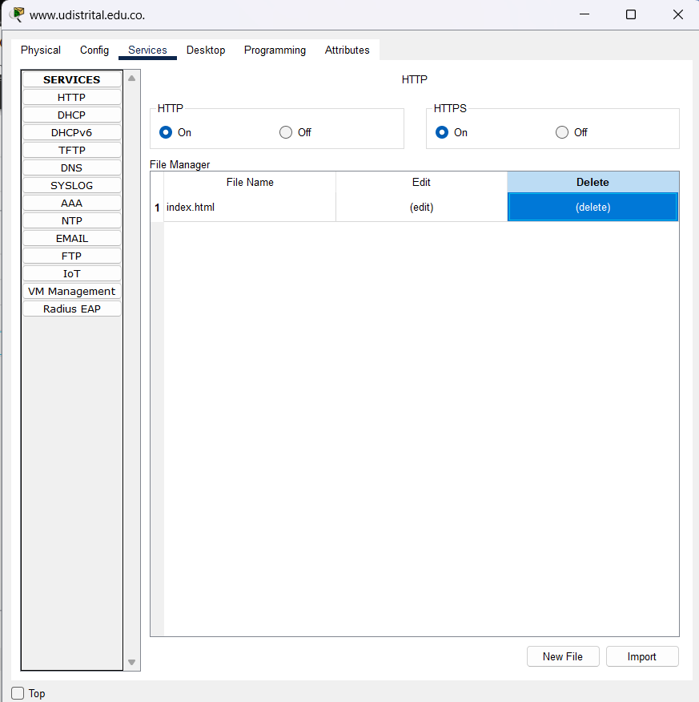

Image 3. Removing HTPP services

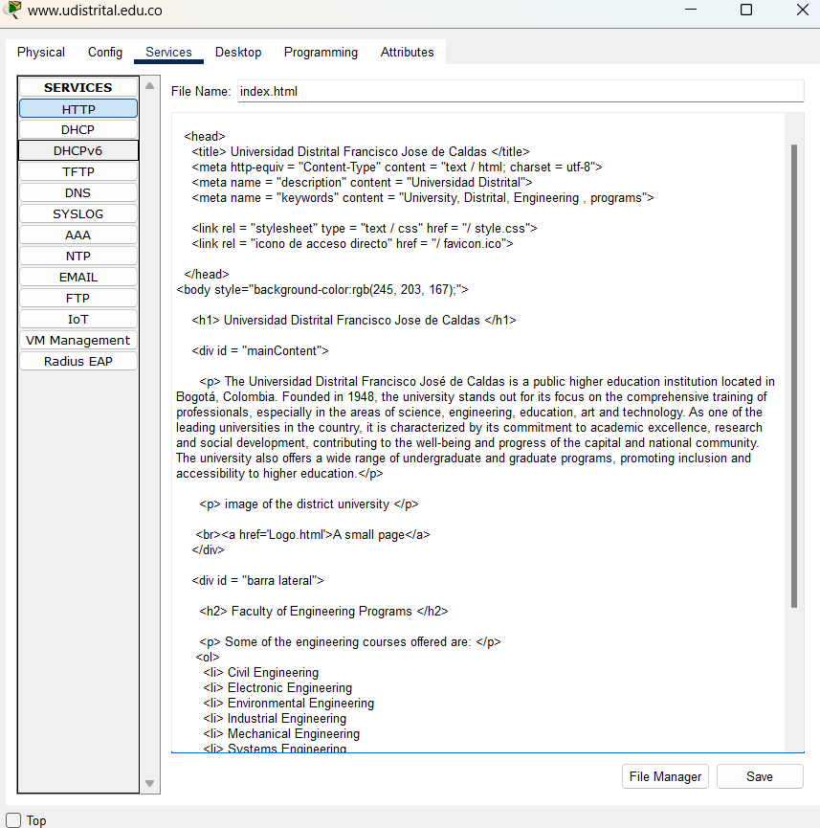

Image 4. Placing the web page code

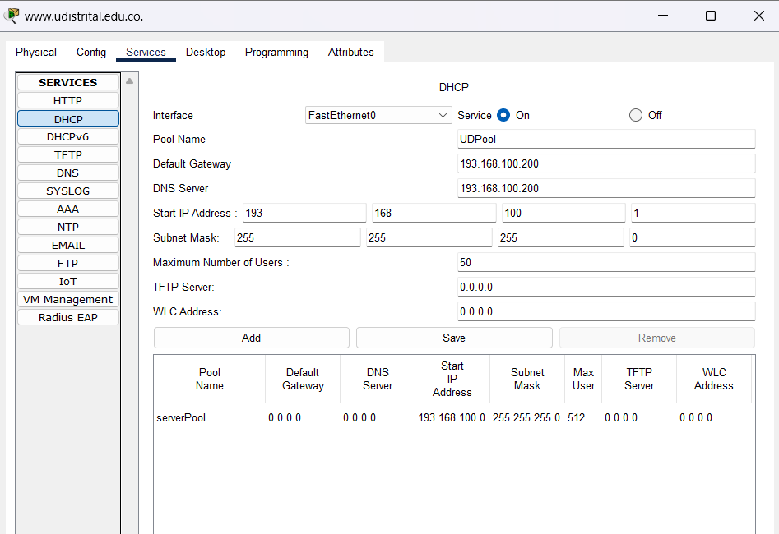

Image 5. Adding the DHCP service

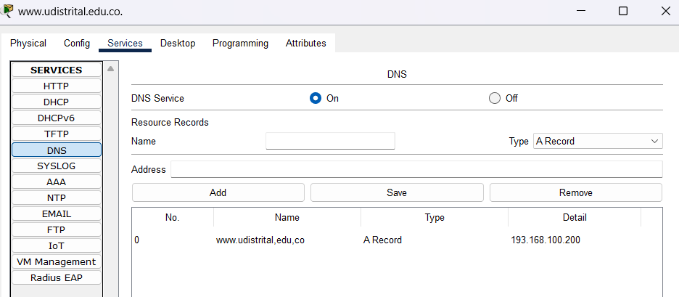

Image 6. Adding the DNS service

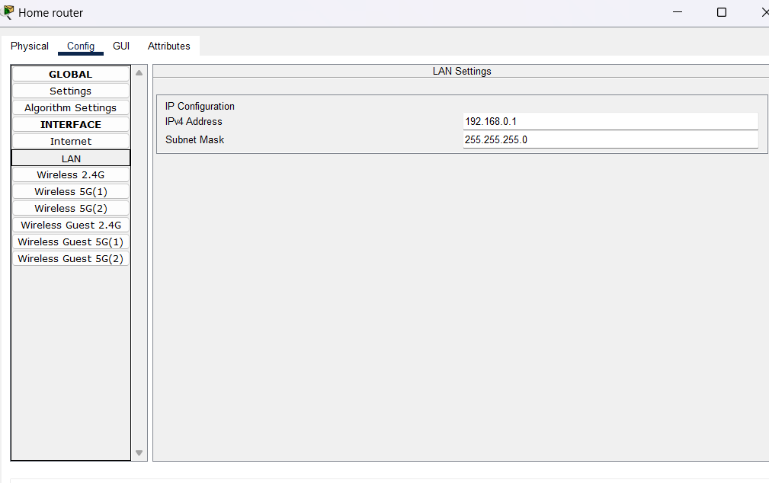

Image 7. Setting up the IP and mask of a wireless router

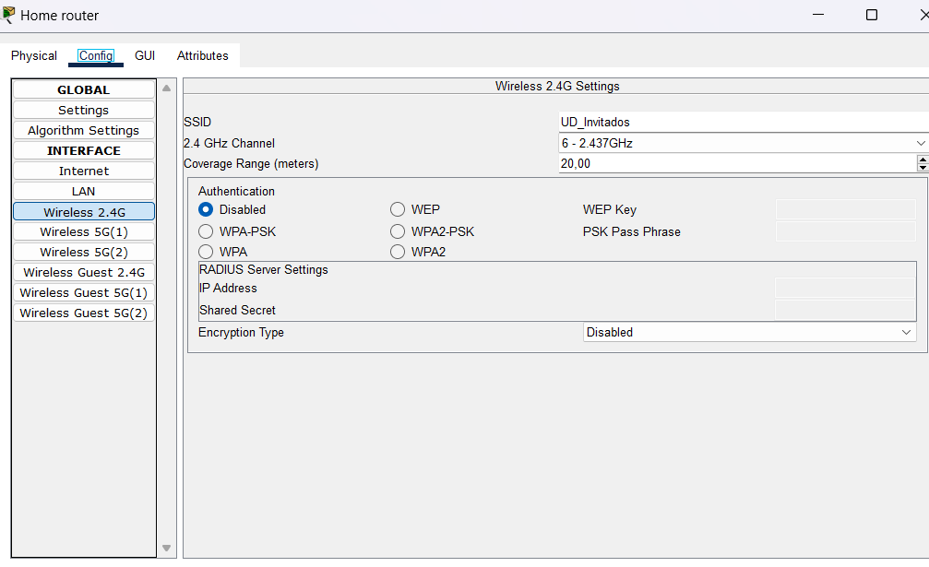Image 8. setting the Wireless

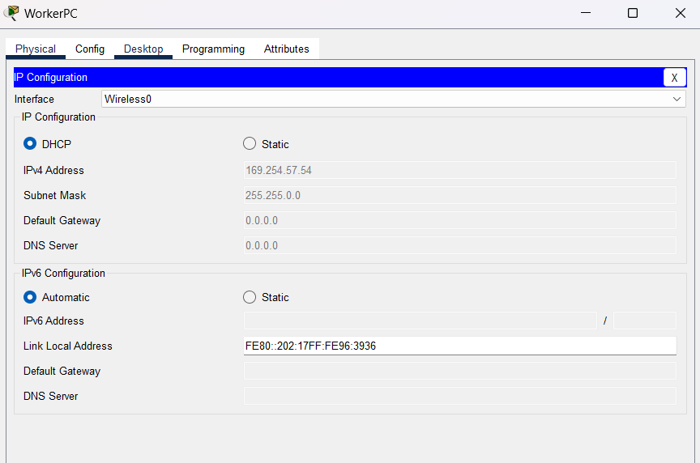Image 9. Setting up the IP and mask of a wireless PC

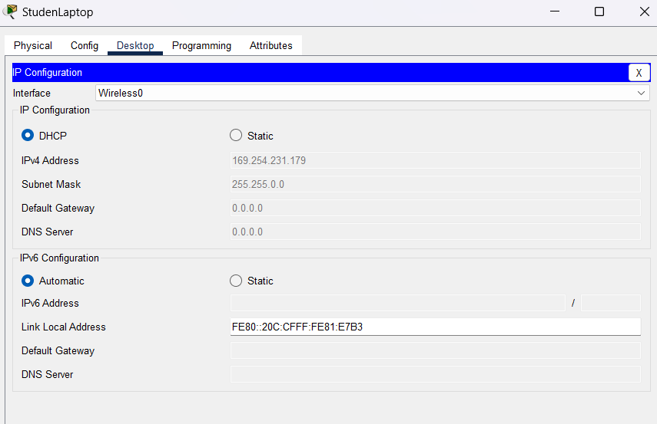

Image 10. setting IP laptop

Checking the network, we access the university page created from the PC.

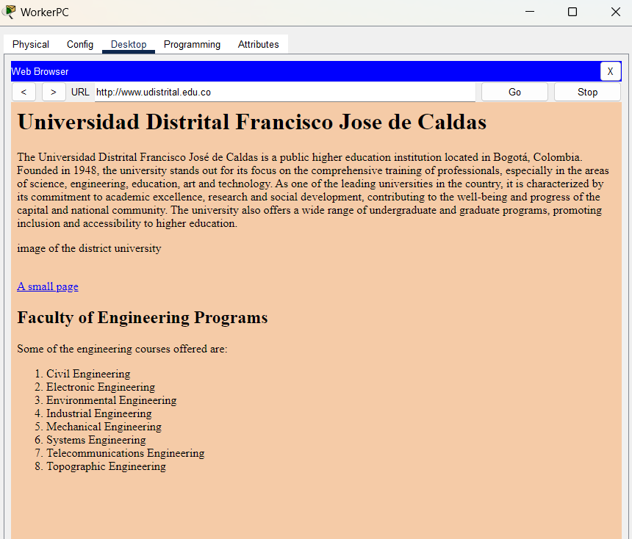

Image 11. network connection check

Checking the network, we access the university page created from the Laptop.

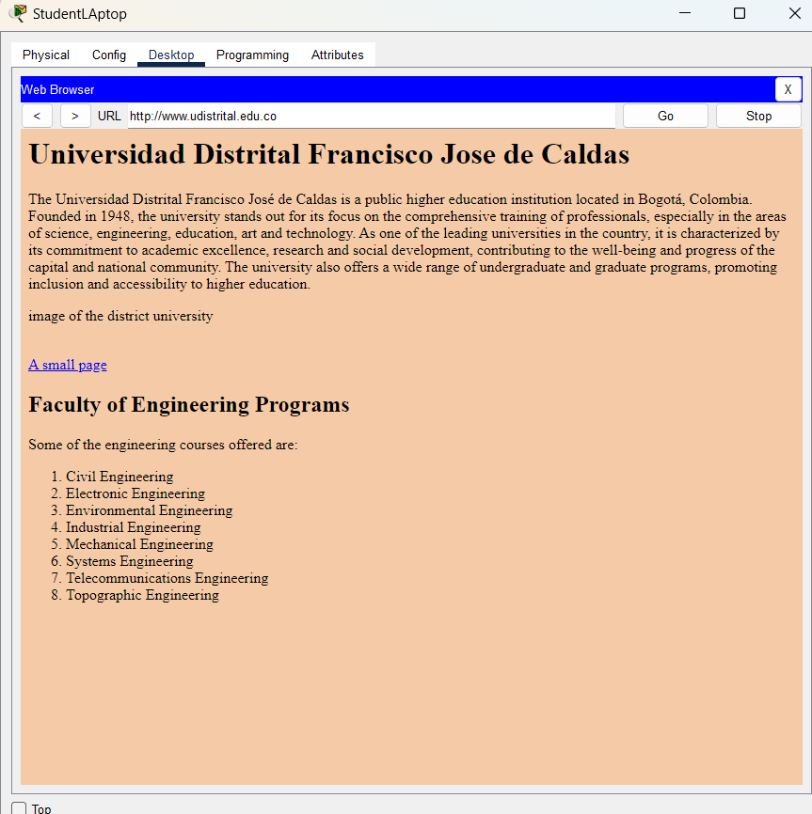

image 12. network connection check

As we can see, the university page appears, therefore we have a connection between the server and the client, fulfilling the objective of the workshop.