DB e API REST

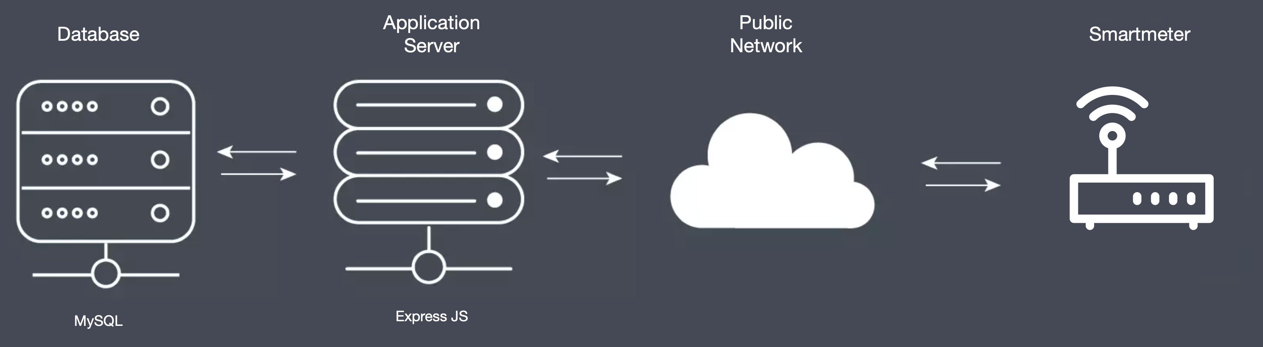
PLATFORM STRUCTURE
The database, which stores the smart-meter data and the related measures, is a DB MySQL installed on Amazon AWS cloud.
The application server, also on Amazon AWS cloud, is based on Express JS, and it is programmed in Node JS. The host of server is: ebalance.c0tt4fjleyti.eu-west-3.rds.amazonaws.com
The smartmeters send the measure every 5 seconds to the application server which provides to save the record on the DB MySQL. In reading phase the smartmeters (SMs) interact with the server to download the configuration, any reset or reboot commands and to download any firmware updates. Every smartmeter is uniquely identified by a serial code (e.g.: SM018).

For each monitored structure/building more than one Smart Meter is installed. So the data of the smart meters are collected and averaged every 15 minutes in the table related to the specific structure/building. The classification of each structure is reported in table 1.
Moreover, as explained before, for each building there can be more than one smart meter, their data are stored in the DB every 5 seconds under the name SM018_5s to SM034_5s. The installation of SM in the specific building is resumed in the following table.
Building/structure | Smart Meter 5 seconds | Smart meter 15 minutes
Experimental building Chiodo 2 | SM028_5s | SMEBPLUSCHIODO2_15m
Office Buildings Cubo 18 B | SM018_5s;  SM019_5s | SMEBPLUSCUBO18B_15m
Office Buildings Cubo 31B | SM034_5s;  SM020_5s;  SM020_5s | SMEBPLUSCUBO31B_15m
Office Buildings Cubo 41B | SM022_5s;  SM023_5s; | SMEBPLUSCUBO41B_15m
Office Buildings Cubo 44B | SM024_5s; SM025_5s | SMEBPLUSCUBO44B_15m
Residential buildings Monaci121 | SM029_5s | SMEBPLUSMON121_15m
Residential buildings Monaci122 | SM032_5s | SMEBPLUSMON122_15m
Residential buildings Monaci123 | SM030_5s | SMEBPLUSMON123_15m
Residential buildings Monaci124 | SM031_5s | SMEBPLUSMON124_15m
Residential buildings Monaci223 | SM033_5s | SMEBPLUSMON223_15m

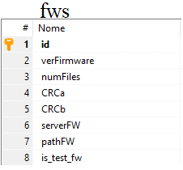
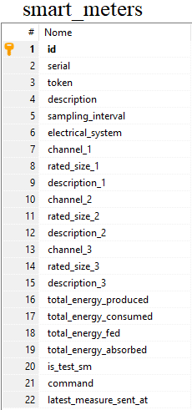
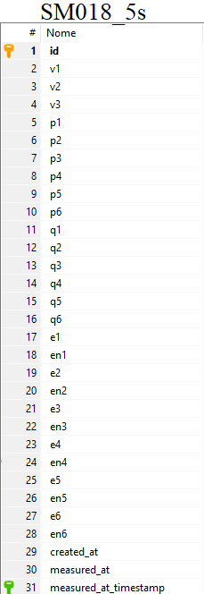
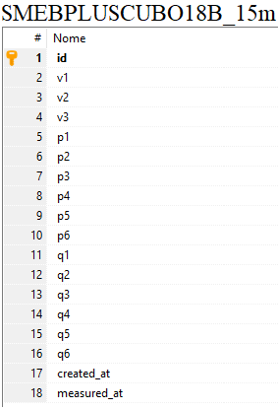
DATABASE

The database has a very simple structure. It contains a table for each smartmeter that will contain the relative measure data with a resolution time of 5 seconds, named with the name of the smart meter (SM018_5s). The choice is to add a table for each smartmeter to avoid creating excessively large tables considering the amount of data that each smartmeter sends. There is also another table for each building that will contain the relative measure data, with a resolution time of 15 minutes. This last table is named using also the name of the structure (e.g. SMEBPLUSCUBO18B_15m) and it groups the data of more than one SM.

fws
This table contains the references of any new firmware versions for the smart meters
smart_meters
This table contains the master data, the customer registry of all the smart meters
SM018_5s
Table that contains all the measures sent by the smartmeter with serial code “SM018_5s” with a resolution time about 5 seconds.
SMEBPLUSCUBO18B_15m
Table that contains all the measures averaged and grouped, sent by the smartmeters installed in the building 18B_15m with a resolution time about 15 minutes.

The connection to the DB can be done using the following parameters:
host: 'ebalance.c0tt4fjleyti.eu-west-3.rds.amazonaws.com',
user: 'root',
password: 'e.balance.2020',
database: 'ebalance'
Account for deployment:
host: 'ebalance.c0tt4fjleyti.eu-west-3.rds.amazonaws.com',
user: 'ebalance_new',
password: 'e.balance.2022',
database: 'ebalance'

DESCRIPTION OF TABLES FIELDS
smart_meters
- serial: unique alphanumeric identifier of the smartmeter;
- token: alphanumeric that can be used in the API (to be sent in the request as a header);
- Description: a brief description of the system that the smartmeter is monitoring;
- sampling_interval: time resolution (in seconds) used to send the measures of the smartmeter (the fault value is 5);
- electrical_system: it indicates the type of system where the smartmeter is installed (single-phase or three-phase). The value 0 indicates a single-phase system while the value 1 indicates a three-phase system;
- channel_1 (2, 3): the used smartmeter has several measurement channels and this field indicates if the channel is used and its type. In particular, if the value of this field is 9, it means that the channel is not used, if instead it is equal to 0 it is a bi-directional channel (for example the exchange with the network), if it is equal to 1 it is a load otherwise if it is 2 it indicates an energy source such as a photovoltaic system.
- rated_size_1 (2, 3): the rate power of the monitored plants expressed in kW (for example the rated PV power or the power of the electricity supply contract);
- description_1 (2, 3): brief description indicating what the channel is monitoring (grid, photovoltaic, etc.);
- total_energy_produced: field that can contain the total amount of energy (in Wh) produced by the system since it is monitored with the smart meter;
- total_energy_consumed: field that can contain the total amount of energy (in Wh)consumed since it is monitored with the smart meter;
- total_energy_fed: field that can contain the total amount of energy (in Wh) supplyed to the grid since the smart meter is installed;
- total_energy_absorbed: field that can contain the total amount of energy (in Wh) taken from the grid since the smart meter is installed;
- is_test_sm: the default value is 0 and it indicates an operating smartmeter, it is 1 to indicate that the smartmeter is in the test phase (it is used for example to test the firmware before being released);
- command: a string indicating a remote command that can be sent to the smartmeter (for example the "reboot" command restarts the device, "resetEnergy" resets the energy measured up to that moment and eliminates any measures queue recorded and not yet sent)
- latest_measure_sent_at: date and time of last measurement sending

SM0XX_5s
- v1 (2, 3): the voltage value measured by the corresponding phase of the plant where the smart meter is installed (if it is a single-phase plant only the v1 field will be used, if it is a three-phase plant both v2 and v3 will be used);
- p1: for a single-phase system it represents the active power (in W) measured by channel 1, for a three-phase system it represents the power measured for phase 1 of channel 1. The chosen convention (valid for all the power and energy quantities present in the table and which will therefore be avoided for the following fields) if the relative channel is for example the grid, the positive power values represent a power absorbed by the grid while the negative values represent the power fed into the grid. Similarly, for a photovoltaic production plant the generated power will have a negative value.
- p2: for a single-phase system it represents the active power (in W) measured by channel 2, for a three-phase system it represents the power measured for phase 2 of channel 1.
- p3: for a single-phase system it represents the active power (in W) measured by channel 3, for a three-phase system it represents the power measured for phase 3 of channel 1.
- p4: for a single-phase system it represents the active power (in W) measured by channel 4, for a three-phase system it represents the power measured for phase 1 of channel 2.
- p5: for a single-phase system it represents the active power (in W) measured by channel 5, for a three-phase system it represents the power measured for phase 2 of channel 2.
- p6: for a single-phase system it represents the active power (in W) measured by channel 6, for a three-phase system it represents the power measured for phase 3 of channel 2.
- q1: for a single-phase system it represents the reactive power (in VAr) measured by channel 1, for a three-phase system it represents the reactive power measured for phase 1 of channel 1.
- q2: for a single-phase system it represents the reactive power (in VAr) measured by channel 2, for a three-phase system it represents the reactive power measured for phase 2 of channel 1.
- q3: for a single-phase system it represents the reactive power (in VAr) measured by channel 3, for a three-phase system it represents the reactive power measured for phase 3 of channel 1.
- q4: for a single-phase system it represents the reactive power (in VAr) measured by channel 4, for a three-phase system it represents the reactive power measured for phase 1 of channel 2.
- q5: for a single-phase system it represents the reactive power (in VAr) measured by channel 5, for a three-phase system it represents the reactive power measured for phase 2 of channel 2.
- q6: for a single-phase system it represents the reactive power (in VAr) measured by channel 6, for a three-phase system it represents the reactive power measured for phase 3 of channel 2.

- e1 (2, 3, 4, 5, 6): positive component of energy (absorbed)
- en1 (2, 3, 4, 5, 6): positive component of energy (fed into the grid or produced)
- created_at: date and time in which the record relating the measures in the DB is created.
- measured_at: date and time in which the measures have been carried out.
- measured_at_timestamp: timestamp relating to the measure

SMEBPLUSXXX_15m
The fields are v1(2, 3), p1(2, 3, 4, 5, 6), q1(2, 3, 4, 5, 6), the description is the same of the table with a time resolution of 5 seconds, the difference is that the data are averaged over 15 minutes and in some case, the data of more smart meters are aggregated.
data | description
v1 | Voltage value measured by the first phase
v2 | Voltage value measured by the second phase
v3 | Voltage value measured by the third phase
p1 | Active power adsorbed by loads connected on the first phase
p2 | Active power adsorbed by loads connected on the second phase
p3 | Active power adsorbed by loads connected on the third phase
p4 | Active power produced by PV plant connected on the first phase
p5 | Active power produced by PV plant connected on the second phase
p6 | Active power produced by PV plant connected on the third phase
q1 | Reactive power adsorbed by loads connected on the first phase
q2 | Reactive power adsorbed by loads connected on the second phase
q3 | Reactive power adsorbed by loads connected on the third phase
q4 | Reactive power adsorbed by loads connected on the fourth phase
q5 | Reactive power adsorbed by loads connected on the fifth phase
q6 | Reactive power adsorbed by loads connected on the sixth phase

