Relief manuscript v2

Introduction
Skeletal muscle mass and strength decline with age, best prevented or treated with regular resistance training (RT). The decline in muscle mass and -strength advances upon reaching approximately 50 years of age and accelerates further after reaching 70, and, if left unchecked, has a high probability of leading to sarcopenia^{1,2}. Muscular weakness and low muscle mass per se is further linked to diabetes, disability, cognitive decline, osteoporosis and early all-cause mortality, prevented/treated by either attaining or maintaining a healthy skeletal muscle mass^{1,3,4}. Older adults are expected to gain similar benefits from RT as the young, i.e., increased muscle mass, -strength and overall physical performance^{5,6}. To ensure maximal gains from a period of RT, the anabolic stimulus provided from exercising must be sufficient^{5–7}, of which training volume is a principal determinant⁸.
Whether the anabolic stimulus is sufficient may in part depend on how responsive aging skeletal muscle is to it. Earlier findings suggest that older adults have a less responsive skeletal muscle mass compared to young, with a lower muscle protein synthesis (MPS) response to a session of resistance exercise training (RT) or protein ingestion^{2,9,10}. However, baseline levels of MPS do not differ by age, and the activity in MPS-influencing proteins (e.g. mTOR) is elevated in fasted muscle from older adults compared to the young^{2,11,12}. The increased baseline mTOR activity could represent a compensation to increased relative muscle loading due to age-related loss of muscle mass, or dysregulation of the mTOR complex². Further, likely as a consequence of altered mTOR regulation, ribosomal gene transcription and ribosome biogenesis is reduced in older adults^{2,11,13}. The increase in ribosomal content following onset of RT is believed to provide support for skeletal muscle fibre hypertrophy, through increased translational capacity yielding a higher baseline MPS^{14,15}. Indeed, regardless of age, individuals who respond to RT exhibit an accumulation in markers of ribosome biogenesis (e.g., total RNA and/or rRNA), compared to those who do not experience benefits of RT^{16–18}.
Given the dose-response relationship between training volume and gains in muscle mass and strength observed in younger adults⁸, and recent findings that older “non-responders” can achieve improved hypertrophy with higher training volume¹⁹, increasing training volume may represent a strategy to enhance the anabolic stimulus and thereby support the ribosome biogenesis response necessary for adaptation. Therefore, by comparing low and moderate training-volume protocols in healthy young and older adults, we aim to; determine if there is a difference in response to RT between young and older adults; does RT volume mitigate this difference; is it reflected in markers of ribosome biogenesis. The primary outcomes for these aims will be skeletal muscle mass accretion and -strength, while we will also examine the effects of training volume on glucose tolerance, due to it connection to age-related decline^{20–23}.

Methods
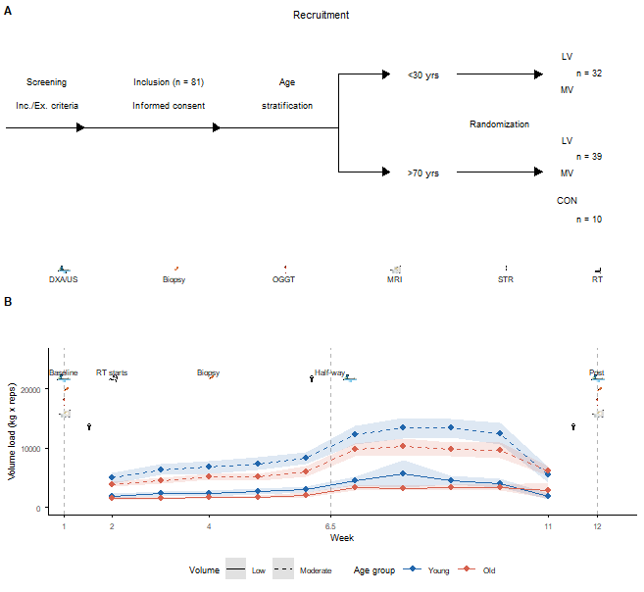
Figure 1: Study overview and weekly training volume. (A) Participant recruitment and randomization flow, and testing modalities used throughout the study: dual-energy x-ray absorptiometry / ultrasound (DXA/US), muscle biopsy, oral glucose tolerance test (OGGT), magnetic resonance imaging (MRI), strength testing (STR), and resistance training (RT). LV = low volume, MV = moderate volume, CON = non-training control. (B) Weekly training volume load (kg × repetitions) for the leg press exercise across the intervention, shown separately by age group (young, old) and training volume condition (low, moderate; solid vs. dashed lines respectively). Shaded ribbons represent the 95% confidence interval around the weekly mean. Vertical dashed lines and accompanying icons mark key study timepoints: baseline testing (week 1) and the start of training (week 2), a muscle biopsy at week 4, mid-intervention testing (week 6.5), and post-intervention testing (week 12); icons above each timepoint indicate which assessments were performed.

Study Overview
This study was conducted as an age-stratified within-participant trial employing a unilateral design. All participants performed a whole-body unilateral training program, with training protocols (low and moderate) randomly assigned to either leg/arm. The intervention lasted for 12 weeks, with 10 weeks of exercising and two weeks of testing (Figure 1). The participants exercised for a total of 24 training sessions, two sessions per week for the first five weeks, increased to three sessions per week for the five last weeks, including a taper down to two sessions for the 10th and final week. The effects of the intervention on skeletal muscle mass was measured as thigh muscle volume (MRI: baseline, post), thigh muscle thickness (ultrasound: baseline, half-way, post) and lean body mass (DXA: baseline, half-way, post). Skeletal muscle strength was assessed as peak torque with the humac dynamometer, 1RM leg-press with the Keiser Airpress and maximal voluntary bicep curl contraction with the MuscleLab system (all baseline, half-way, post). Glucose tolerance was measured by the oral glucose tolerance test at baseline and post-intervention. Molecular data was gathered via micro biopsy at baseline, after three weeks of RT (six training session) and post-intervention. All tests were performed at the same time of day (± 2hrs), and measurement of lean body mass, muscle thickness, glucose tolerance, and sampling of muscle tissue was conducted in an overnight fasted state. Participants were asked to maintain their habitual physical activity level throughout the intervention, and to not perform any additional type of heavy exercise.
All participants gave their written informed consent before study enrollment. The study was approved by the Regional Committee for Medical and Health Research Ethics - South-East Norway (ID nr. 255224), pre-registered at clinicaltrials.gov (Identifier: NCT05063279), and conducted according to the Helsinki Declaration.

Participants
Thirty-two young (24 ± 3.1 years) and 49 old (75.5 ± 5.6 years) adults were recruited locally; 10 of the old participants were randomly allocated to a control group. Inclusion criteria were age 20–30 or above 70 years (Figure 1). Exclusion criteria were: insufficient Norwegian proficiency; RT more than once weekly and/or endurance training three or more times weekly within the last six months; unstable cardiovascular disease; illness or injury contraindicating RT; serious mental illness; or allergy to local anaesthesia.

Resistance training protocol
Resistance training was performed as a whole-body training program. Each RT-session contained three lower-body exercises (unilateral leg press, unilateral knee extension and -flexion) and three upper-body exercises (unilateral chest-press, unilateral bent-over rows, and unilateral bicep curls), using individualized settings in all exercise apparatuses. The low training volume condition was performed as a single set of 10RM per exercise, and the moderate training volume condition was performed as three sets of 10RM per exercise. As a general warm-up, the participants cycled on an indoor exercicse bicycle for 5-10 minutes. Before lower-body exercises the participants performed 1 set of 10 repetitions in bilateral leg press, and before upper-body exercises they performed a warm-up set of 10 push-ups, modified to their individual fitness level (e.g., standard, from the knees, or against a wall). To ensure progressive loading and an adequate stimulation of the skeletal muscle, the exercise load was increased in the following set if the participants lifted more than 12 repetitions. Resting time between each set was two minutes. For safety and standardization purposes, all sessions were monitored by trained personnel. To ensure sufficient recovery, at least one day separated training days throughout the intervention.

Measurement of body mass composition
MRI was measured in a non-fasted state, in accordance with the manufacturer’s protocol (S-Scan, Esaote Europe B.V., Maastricht, the Netherlands). The images were analysed using the 3D Slicer software (SOURCE). The layering details within 3D Slicer software were the same for all the images (fat = 300-max, muscle = 1-300, bone = 0-750, and intra-muscular fat = 300-max), as was the calculation of the area to be analyzed (approx. 20% from the trochanter major proximally and 30% from the knee-joint distally). Muscle thickness of m. vastus lateralis and m. rectus femoris were measured using B-mode ultrasonography (SmartUs EXT-1 M, Telemed, Vilnius, Lithuania) with a 39 mm 12 MHz, linear array probe. Transverse images were obtained ~60% distally from the trochanter major towards the femoral lateral epicondyle. Three images were captured for each muscle at each time point, where the probe was relocated to the same position between each image. The position of the probe was marked on the skin and subsequently marked on a soft transparent plastic sheet superimposed on the thigh. Landmarks were marked on the plastic sheet for relocation of the scanned areas during post-training measurements. During analysis, pre and post images from the same participant were analysed consecutively using the Fiji software²⁴. The average muscle thickness of the three images captured per muscle per time point was used for further analyses. Dual-energy x-ray absorptiometry (Lunar Prodigy, GE Healthcare, Madison, WI, 320 USA) scans were analyzed with the manufacturer’s software, where the region of interest (RoI) were matched on baseline, half-way and post images.

Assessment of muscular strength
After a standardized warm-up, strength assessments were performed using a standardized sequence; unilateral knee extension torque (legs), unilateral 1RM leg press, and unilateral maximal voluntary contraction in the bicep curl, using individualized settings. At each time point (baseline, halfway, post), muscle strength was assessed twice, on two separate days. During baseline testing, the first of the two testing days represented familiarisation. The participants had at least one whole day of rest between the previous training session and assessment of muscular strength.
Knee extension torque Maximal isometric and isokinetic knee extension torque were measured with a Humac Norm Dynamometer (CSMi, Stoughton, Massachusetts, USA). Isokinetic peak torque was measured concentrically from 90 to 0 degrees knee angle (extended knee was set to 0 degrees) at angular velocities of 60-, 120- and 240 degrees per second, 2x3 repetitions each, with the first set of each exercise as a sub-maximal warm-up. Isometric knee extensor peak torque was measured at a knee angle of 60 degrees, for a maximum of 10 seconds and two repetitions per test. The isometric tests were concluded when the participants reached a plateau or peak torque development decreased, which on average occurred between 2-4 seconds into the test. Between sets of the same angular velocity the resting time was 30 seconds, and between angular velocities (i.e. from 60- to 120 degrees per second) the resting time was 1 minute.
One repetition maximum The 1RM test was measured with a Keiser AIR300 Leg press (Keiser Corporation, Fresno, USA). As a specific warm-up, the participants performed 4 repetitions at ~50% of 1RM. Maximal one repetition leg press strength was defined as the maximal load lifted in a controlled fashion, starting from a knee angle of 90 degrees, within 5kg. From the ~50% of 1RM warm-up, the load was increased at most by increments between 10-40kg for the initial attempts, and at least between 5-10kg when the participants signified being near their maximal effort. Resting time between 1RM attempts was 30 seconds.
Maximal isometric bicep curl Maximal isometric force of the bicep muscle was measured with a MuscleLab force sensor (Ergotest Innovation AS, Stathelle, Norway), at a fixed elbow angle of 90 degrees. The participants were given one warm-up attempt per arm, and two attempts to perform their maximal force development in the bicep exercise. The isometric tests were concluded when the participants reached a plateau, peak torque development decreased (which on average occurred between 2-4 seconds into the test), or after 10 seconds.

Oral Glucose Tolerance Test
The oral glucose tolerance test was completed in an overnight-fasted state, where participants ingested a bolus of 75g of glucose (Glucosum monohydricum, Merck KGaA, Darmstadt, Germany) mixed with 250ml water. Capillary blood was gathered from the participants’ fingers and analyzed with in-house equipment (BIOSEN, C-Line, EKF diagnostic GmbH, Barleben). The glucose bolus was ingested after the baseline blood draw, and subsequent blood draws were taken at 15, 30, 45, 60, 90, and 120 minutes after glucose ingestion.

Skeletal muscle sampling and analyses
Muscle biopsies were collected from m. vastus lateralis. The biopsies were sampled under antiseptic and anaesthetised conditions (Lidokain 10 mg ml-1, Mylan Hospital AS, Oslo Norway), using the micro-biopsy technique with a 12-14 gauge needle (Universal Plus, Mermaid medical A/S, Stenløse, Denmark) operated with a spring loaded biopsy gun (Bard Magnum, Bard Norway A/S, Oslo, Norway). Samples were divided into four aliquots for RNA, protein, immunohistochemistry and DNA analyses. At week 3 and 12 measurements, there were 48 hours between the previous training session and biopsy sampling.

Protein extraction and western blotting
The wet muscle tissue was freeze-dried for 24h and dissected, then homogenised with a plastic rod in an ice cold lysis buffer. Briefly, 150ul of RIPA buffer was added per mg muscle tissue dry weight, with 1ul protease/phosphatase inhibitors per 100ul lysis buffer. The samples were kept on ice at all times except for when manually disrupting to homogenise the tissue, and then incubated for 30 min on a rotator while on ice. Following the incubation, the samples were spun in the centrifuge for 40 min, at 15 000g at 4°C. Total protein was then diluted to 2ug/ul stock and aliquoted to run the samples in triplicates for protein concentration determination and for western blotting. Protein concentration was determined in a 1:10 dilution (Pierce Detergent Compatible Bradford Assay Reagent, Thermo Fisher Scientific, Oslo, Norway).
Western blots were done using the Jess Automated Western Blot System (Bio-Techne, Minneapolis, USA), according to the manufacturer’s protocol, optimized for our lab. The stock solution (2ug/ul) was prepared with fluorescent master mix from the EZ standard pack (Bio-Techne) and 0.1X sample buffer (Bio-Techne) and thus diluted to 0.75 ug/ul for the assay. The assay samples were then briefly vortexed, denatured at 95°C, vortexed and spun down prior to loading the assay plate. To control for within-plate variation, we used a total protein normalization reagent (Bio-Techne) for all assays. A specific between-plate normalization was not used, however, all samples from one participant were analyzed on the same plate. Primary antibodies were purchased from Santa Cruz Biotechnology (Texas, USA): UBF 1:50, UBF F-9, sc-13125; and Cell Signaling Technology (Massachusetts, USA): c-Myc 1:15, c-Myc D84C12. Ready-to-use secondary antibodies (anti-mouse and anti-rabbit) were purchased from Bio-Techne. After loading, the assay plate was centrifuged at 2500 rpm for 5 min at room temperature. The assay was then run on the Jess system, with the chemiluminescence detection module.

Total RNA extraction and RNA sequencing
Total RNA was extracted using TRIzol from muscle tissue homogenised using 0.5mm RNase-free Zirconium beads (~50 ul; Next Advanced, Averill Park, NY, USA) and mechanical agitation (Bullet Blender, Next Advanced, Averill Park, NY, USA). Chloroform (Sigma-Aldrich, Oslo, Norway) was used for phase separation, and the RNA pellet was precipitated with isopropanol (VWR International, Oslo, Norway). For assessment of RNA content and purity, RNA was eluted in TE buffer (1:2) and assessed via spectrophotometry. Samples with a 260/280 ratio below 1.8 were excluded. The RNA stock was stored at -80°C until further analyses.
Two hundred and six total RNA samples were selected for RNA-sequencing analysis of which 192 samples passed initial quality assessment (RIN > 8) and were used in downstream analyses. The samples were selected from the pool of intervention participants that had both baseline and post samples collected. Purified mRNA (poly-T oligo-attached magnetic beads) was used for library preparation and subsequent 150-bp paired-end sequencing (Illumina NovaSeq, Novogene Europe, Cambridge, United Kingdom). Raw reads were filtered (SOFTWARE, settings) and aligned to the Human genome (Release) followed by gene and transcript level quantification using RSEM (version).
Gene counts (filtered for low-abundance targets) were modeled using a regularized negative binomial generalized linear mixed model^{glmmmtb?} including model parameters for sex, time (baseline and post-intervention), age-group (young and old) and condition (low- and moderate-volume) and the interaction between time age and condition. A varying intercept (random effect) was used for participant, and the dispersion parameter was estimated using the nbinom2 parameterization available in glmmTMB^{glmmmtb?}. The effective library size^{robinson2010?,edger?} was included as an offset to account for sequencing depth. Regularization through an empirical Bayes shrinkage approach^{efron2010?} was achieved using a two-step approach. First, naive models were fitted for all target counts (gene/transcript) using our in-house pipeline^{seqwrap?} and estimates for all model parameters (except the intercept) were used to create priors for subsequent informed models. Fixed effect priors were constructed using a normal distribution with mean and standard deviations from each parameter value from the first model pass, the prior for the varying intercepts were constructed using a gamma distribution with the shape parameter informed by the mean from the naive model estimates and the scale parameter fixed to 2. Finally, the dispersion parameter priors were constructed by fitting a trend model (Local Polynomial Regression Fit) to the association between raw mean log counts and log dispersion across all targets. The predicted dispersion at target-specific raw mean log count was used as the mean and the model residual standard error was used as the standard deviation to define a normally distributed target-specific prior.

Statistical analyses
All statistical analyses were performed in R (version 4.5.1; R Core Team, 2025), and except for RNA sequencing, all outcomes were analysed with Bayesian multilevel models in brms [version 2.23.0;^{brms?}], and contrasts were derived from posterior draws with marginaleffects [version 0.32.0;^{marginaleffects?}]. Muscle volume, muscle thickness, upper-body lean mass, 1RM leg press, bicep curl MVC, UBF and c-Myc were log-transformed and standardized. For these outcomes, each combination of allocation, age group, volume condition and sex was given its own baseline and change over time. Varying effects accounted for participants (intercept and change over time) and for limbs within participants, with additional terms for repeated tests where these were performed. Peak torque was modelled as a quadratic function of angular velocity. Total RNA was modelled at the level of technical replicates, with tissue weight as a covariate. OGTT glucose was modelled as a B-spline function of sampling time. Weakly informative priors were used throughout and checked by prior predictive simulation. Convergence was assessed by R-hat (< 1.01) and effective sample size (> 400). Group changes were averaged across sexes with equal weight. They were back-transformed and reported as percent change, with between-group contrasts reported as ratios expressed in percent. Estimates are given as posterior means with 95% equal-tailed credible intervals (CI) and the posterior probability of an effect in the direction of the estimate (P(>0) or P(<0)). Effects were termed credible when the 95% CI excluded zero. Otherwise they were described as likely (P ≥ 90%), weak evidence (P ≥ 75%) or no evidence (P < 75%). RNA-seq counts were modelled with negative binomial mixed models (glmmTMB^{glmmmtb?}) regularized by empirical Bayes priors^{seqwrap?,efron2010?}. P-values were adjusted with the Benjamini–Hochberg procedure within each contrast (FDR < 5%), followed by rank-based gene-set enrichment analysis^{xu2024a?}. Full model specifications are given in the Supplementary Material.

Results

Exercise Volume Load
Moderate volume exercise was estimated to ~2.8× higher than low in both age groups (young mod: 137438.7 ± 54491.7 kg, young low: 50693.5 ± 25707.7 kg, old mod: 118124.8 ± 38224.6 kg, old low: 42134.1 ± 14352.5 kg).

Skeletal Muscle Hypertrophy
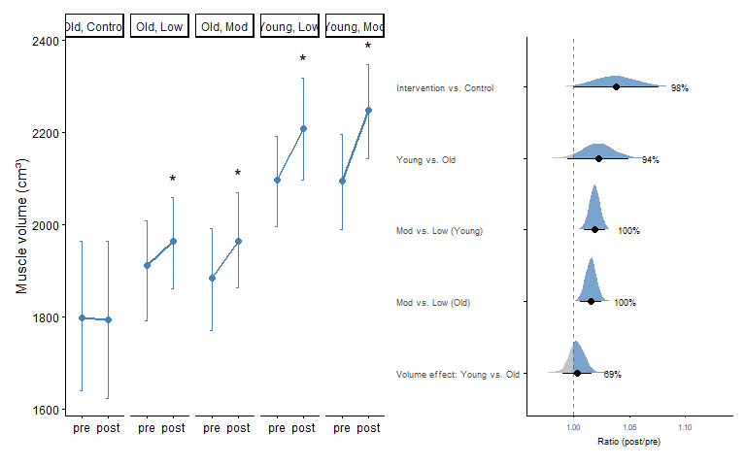
Figure 2: Posterior distribution of five between-group contrasts for the ratio (post/pre) of thigh muscle volume. Each row shows the full posterior density, with the point marking the mean ratio and the black bars the 50% and 95% CI. The dashed line marks no change (ratio = 1); the density is shaded blue where the ratio exceeds 1. The percentage label gives the posterior probability that the ratio exceeds 1 (pos), as a measure of directional confidence.
Thigh Muscle Volume: Older adults in the intervention group (averaged across volume conditions) increased muscle volume by 3.7% (95% CI [1.8%, 5.8%], P(>0) > 99.9%), while there was no evidence of a change in the control group (0.0%, 95% CI [−3.0%, 3.1%], P(<0) = 50.0%). The difference between them was 3.8% (95% CI [0.0%, 7.6%], P(>0) = 97.6%). Young adults (averaged across volume conditions) increased by 6.0% (95% CI [3.9%, 8.1%], P(>0) > 99.9%), likely more than older adults, although the 95% CI included zero (2.2%, 95% CI [−0.5%, 5.0%], P(>0) = 94.0%). Within young adults, low-volume training increased muscle volume by 5.0% (95% CI [2.9%, 7.2%], P(>0) > 99.9%) and moderate-volume training by 7.0% (95% CI [4.9%, 9.2%], P(>0) > 99.9%), with a larger increase under moderate volume (1.9%, 95% CI [0.9%, 2.8%], P(>0) > 99.9%). In older adults, low-volume training increased muscle volume by 2.9% (95% CI [1.0%, 5.0%], P(>0) = 99.9%) and moderate-volume training by 4.6% (95% CI [2.6%, 6.6%], P(>0) > 99.9%), again with a larger increase under moderate volume (1.6%, 95% CI [0.6%, 2.5%], P(>0) = 99.9%). There was no evidence that the volume effect differed between age groups (0.3%, 95% CI [−1.0%, 1.6%], P(>0) = 68.5%).
M. Vastus Lateralis Thickness Older adults in the intervention group (averaged across volume conditions) increased muscle thickness by 7.6% from baseline to post (95% CI [3.5%, 11.9%], P(>0) > 99.9%), while there was only weak evidence of an increase in the control group (3.4%, 95% CI [−3.3%, 10.5%], P(>0) = 83.4%). There was also only weak evidence of a difference between them (4.2%, 95% CI [−3.7%, 12.4%], P(>0) = 84.8%). By the half-way point, the intervention group had increased by 5.3% (95% CI [1.2%, 9.4%], P(>0) = 99.7%), with weak evidence of an increase in the control group (3.6%, 95% CI [−3.7%, 11.0%], P(>0) = 82.7%) and no evidence of a difference between them (1.8%, 95% CI [−5.9%, 10.4%], P(>0) = 66.0%). Young adults (averaged across volume conditions) increased by 10.5% (95% CI [6.5%, 14.9%], P(>0) > 99.9%), with weak evidence of a larger increase than in older adults (2.8%, 95% CI [−2.7%, 8.6%], P(>0) = 83.8%). The same was true at the half-way point (young: 8.9%, 95% CI [4.7%, 13.2%], P(>0) > 99.9%; difference: 3.5%, 95% CI [−2.1%, 9.4%], P(>0) = 88.7%). Within young adults, low-volume training increased muscle thickness by 9.0% (95% CI [3.8%, 14.2%], P(>0) > 99.9%) and moderate-volume training by 12.1% (95% CI [7.0%, 17.5%], P(>0) > 99.9%), with weak evidence of a larger increase under moderate volume (2.9%, 95% CI [−2.6%, 8.7%], P(>0) = 83.9%). In older adults, moderate-volume training increased muscle thickness by 12.2% (95% CI [6.7%, 17.7%], P(>0) > 99.9%), whereas there was only weak evidence of an increase with low-volume training (3.2%, 95% CI [−1.8%, 8.2%], P(>0) = 89.8%). The increase was larger under moderate volume (8.8%, 95% CI [2.9%, 14.9%], P(>0) = 99.8%). The same pattern was present at the half-way point, with weak evidence of a larger increase under moderate volume in young adults (3.3%, 95% CI [−2.1%, 8.9%], P(>0) = 88.4%) and a larger increase under moderate volume in older adults (7.3%, 95% CI [1.6%, 13.0%], P(>0) = 99.7%). The volume effect was likely larger in older than in young adults at post, although the 95% CI included zero (−5.4%, 95% CI [−12.7%, 2.4%], P(<0) = 91.9%), with weak evidence at the half-way point (−3.6%, 95% CI [−10.7%, 3.8%], P(<0) = 84.0%).
Upper body lean mass Older adults in the intervention group (averaged across volume conditions) tended to increase upper-body lean mass by 1.2% from baseline to post (95% CI [−0.3%, 2.7%], P(>0) = 93.4%). There was no evidence of a change in the control group (0.8%, 95% CI [−1.9%, 3.6%], P(>0) = 72.8%) and no evidence of a difference between the groups (0.3%, 95% CI [−2.8%, 3.5%], P(>0) = 57.8%). At the half-way point, there was weak evidence of an increase in the intervention group (0.7%, 95% CI [−0.5%, 2.0%], P(>0) = 86.8%) and weak evidence of a decrease in the control group (−0.8%, 95% CI [−3.1%, 1.6%], P(<0) = 75.6%), with weak evidence of a difference between them (1.6%, 95% CI [−1.1%, 4.3%], P(>0) = 87.8%). Young adults (averaged across volume conditions) increased upper-body lean mass by 3.1% (95% CI [1.5%, 4.8%], P(>0) > 99.9%), likely more than older adults, although the 95% CI included zero (1.9%, 95% CI [−0.2%, 4.2%], P(>0) = 95.5%). At the half-way point, young adults tended to have increased (1.3%, 95% CI [−0.1%, 2.7%], P(>0) = 96.6%), with no evidence of a difference from older adults (0.6%, 95% CI [−1.3%, 2.5%], P(>0) = 74.1%). Within young adults, low-volume training increased upper-body lean mass by 3.3% (95% CI [1.3%, 5.3%], P(>0) > 99.9%) and moderate-volume training by 2.9% (95% CI [0.9%, 4.9%], P(>0) = 99.8%), with no evidence of a difference between them (−0.4%, 95% CI [−2.7%, 1.9%], P(<0) = 63.1%). In older adults, there was weak evidence of an increase with low-volume training (1.1%, 95% CI [−0.7%, 3.0%], P(>0) = 89.4%), and moderate-volume training likely increased it (1.2%, 95% CI [−0.6%, 3.1%], P(>0) = 90.0%), with no evidence of a difference between them (0.1%, 95% CI [−1.9%, 2.2%], P(>0) = 52.0%). There was no evidence of a volume difference at the half-way point in either young (−0.2%, 95% CI [−2.5%, 2.0%], P(<0) = 57.5%) or older adults (−0.6%, 95% CI [−2.7%, 1.4%], P(<0) = 71.8%). There was also no evidence that the volume effect differed between age groups (half-way point: 0.4%, 95% CI [−2.6%, 3.6%], P(>0) = 59.5%; post: −0.4%, 95% CI [−3.4%, 2.6%], P(<0) = 61.6%).

Skeletal Muscle Strength
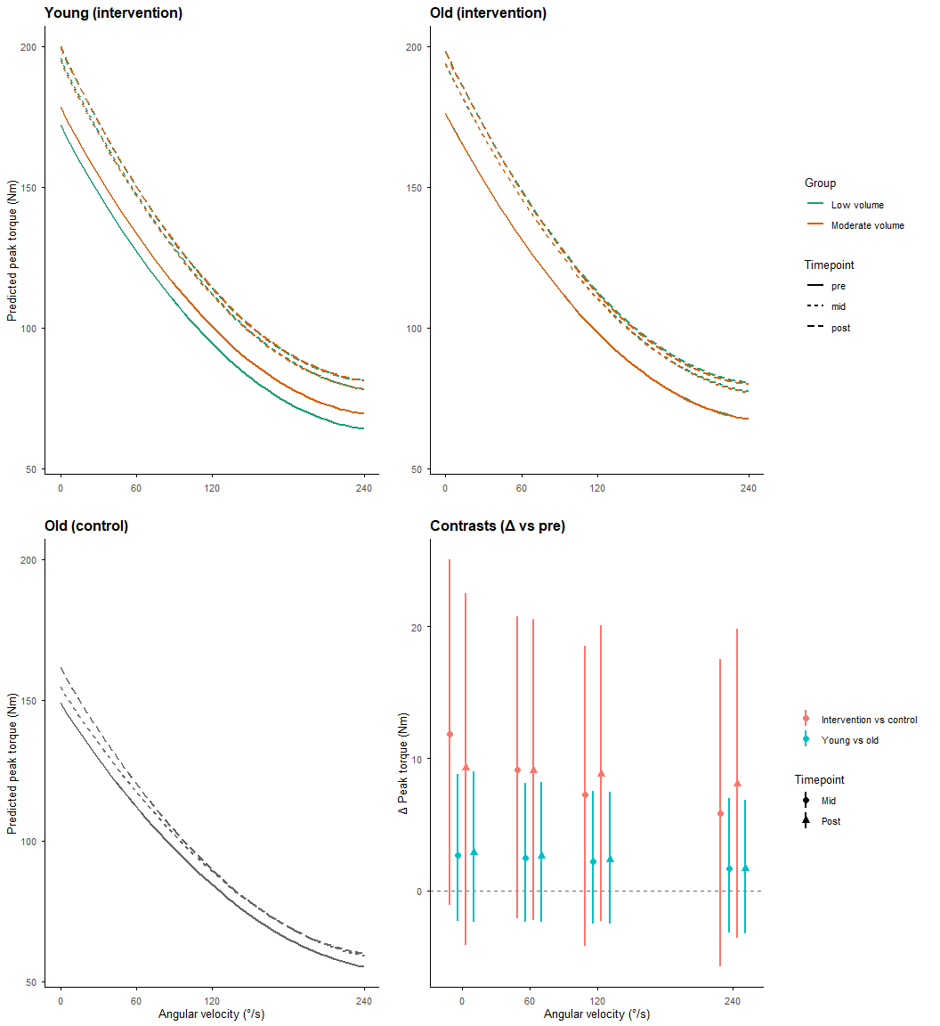

Figure 3: Model-predicted peak isokinetic and isometric torque as a function of angular velocity (force–velocity relationship) in young and older adults across the resistance-training intervention. Lines show posterior median predictions from the Bayesian multilevel model, colored by training volume (low/moderate) and styled by timepoint (pre/mid/post). Top left: young intervention participants. Top right: older intervention participants. Bottom left: older passive control. Bottom right: pooled contrasts (intervention vs. control, and young vs. old, both pooled across volume condition) at the four tested angular velocities, shown as posterior mean change from pre-intervention (Δ, Nm) with 95% credible intervals, at the mid- and post-intervention timepoints.
Isometric Force and Isometrick Peak Torque In older adults, peak torque in the intervention group (averaged across volume conditions) increased by 12.4%–19.0% from baseline to post, with larger increases at faster angular velocities (isometric: 12.4%, 95% CI [9.1%, 16.1%], P(>0) > 99.9%; 60°/s: 13.2%, 95% CI [9.3%, 17.5%], P(>0) > 99.9%; 120°/s: 14.6%, 95% CI [9.4%, 20.3%], P(>0) > 99.9%; 240°/s: 19.0%, 95% CI [11.0%, 27.6%], P(>0) > 99.9%). The control group also tended to increase (6.8%–9.2%), although the 95% CI excluded zero only for isometric torque (isometric: 8.6%, 95% CI [0.3%, 17.7%], P(>0) = 97.8%; 60°/s: 7.5%, 95% CI [−1.8%, 17.8%], P(>0) = 94.1%; 120°/s: 6.8%, 95% CI [−5.3%, 20.7%], P(>0) = 85.4%; 240°/s: 9.2%, 95% CI [−10.1%, 32.4%], P(>0) = 80.9%). There was only weak evidence that the intervention group increased more than the control group (3.7%–10.1%; isometric: 3.7%, 95% CI [−5.1%, 12.7%], P(>0) = 79.2%; 60°/s: 5.5%, 95% CI [−4.6%, 16.1%], P(>0) = 85.3%; 120°/s: 7.7%, 95% CI [−5.7%, 21.9%], P(>0) = 86.3%; 240°/s: 10.1%, 95% CI [−11.2%, 33.9%], P(>0) = 81.0%). By the half-way point, the intervention group had already increased by 9.9%–14.4% (isometric: 9.9%, 95% CI [6.6%, 13.4%], P(>0) > 99.9%; 60°/s: 11.0%, 95% CI [7.1%, 15.2%], P(>0) > 99.9%; 120°/s: 12.4%, 95% CI [7.2%, 17.9%], P(>0) > 99.9%; 240°/s: 14.4%, 95% CI [6.7%, 22.4%], P(>0) > 99.9%), whereas there was only weak evidence of a change in the control group (3.9%–7.6%; isometric: 3.9%, 95% CI [−4.1%, 12.4%], P(>0) = 82.4%; 60°/s: 4.9%, 95% CI [−4.4%, 14.9%], P(>0) = 85.1%; 120°/s: 6.1%, 95% CI [−5.9%, 19.9%], P(>0) = 83.4%; 240°/s: 7.6%, 95% CI [−11.2%, 30.3%], P(>0) = 76.5%). The intervention–control difference at this point (6.0%–7.3%) tended to favour the intervention for isometric torque, with weak or no evidence at faster velocities (isometric: 6.0%, 95% CI [−2.7%, 15.4%], P(>0) = 90.8%; 60°/s: 6.1%, 95% CI [−4.1%, 17.0%], P(>0) = 88.2%; 120°/s: 6.3%, 95% CI [−7.0%, 20.4%], P(>0) = 82.8%; 240°/s: 7.3%, 95% CI [−13.2%, 30.5%], P(>0) = 74.8%).
Young adults (averaged across volume conditions) increased peak torque by 14.2%–21.8% (isometric: 14.2%, 95% CI [10.7%, 18.0%], P(>0) > 99.9%; 60°/s: 15.4%, 95% CI [11.1%, 19.9%], P(>0) > 99.9%; 120°/s: 17.2%, 95% CI [11.6%, 23.2%], P(>0) > 99.9%; 240°/s: 21.8%, 95% CI [13.2%, 30.9%], P(>0) > 99.9%). There was only weak evidence that this increase was larger than in older adults (1.6%–2.5%; isometric: 1.6%, 95% CI [−1.2%, 5.0%], P(>0) = 84.7%; 60°/s: 1.9%, 95% CI [−1.7%, 6.0%], P(>0) = 83.9%; 120°/s: 2.3%, 95% CI [−2.4%, 7.5%], P(>0) = 82.4%; 240°/s: 2.5%, 95% CI [−4.4%, 10.1%], P(>0) = 75.2%). The pattern was similar at the half-way point, where young adults had increased by 11.6%–17.2% (isometric: 11.6%, 95% CI [8.2%, 15.2%], P(>0) > 99.9%; 60°/s: 13.1%, 95% CI [9.0%, 17.5%], P(>0) > 99.9%; 120°/s: 14.9%, 95% CI [9.5%, 20.6%], P(>0) > 99.9%; 240°/s: 17.2%, 95% CI [9.1%, 25.9%], P(>0) > 99.9%), with weak evidence of a larger increase than in older adults (1.5%–2.5%; isometric: 1.5%, 95% CI [−1.3%, 4.9%], P(>0) = 83.9%; 60°/s: 1.8%, 95% CI [−1.7%, 6.1%], P(>0) = 83.0%; 120°/s: 2.2%, 95% CI [−2.4%, 7.5%], P(>0) = 81.9%; 240°/s: 2.5%, 95% CI [−4.3%, 10.3%], P(>0) = 76.1%). The age difference was confined to the low-volume condition. At the half-way point, young adults’ low-volume increase was larger than older adults’ at isometric, 60°/s and 120°/s (3.6%–5.6%; isometric: 3.6%, 95% CI [0.3%, 7.9%], P(>0) = 98.3%; 60°/s: 4.6%, 95% CI [0.2%, 9.7%], P(>0) = 98.0%; 120°/s: 5.6%, 95% CI [0.1%, 12.1%], P(>0) = 97.7%), and likely larger at 240°/s (6.4%, 95% CI [−2.5%, 16.5%], P(>0) = 92.0%). By post, these differences remained likely, although all 95% CIs included zero (3.3%–6.1%; isometric: 3.3%, 95% CI [−0.1%, 7.4%], P(>0) = 97.1%; 60°/s: 4.2%, 95% CI [−0.2%, 9.1%], P(>0) = 97.0%; 120°/s: 5.2%, 95% CI [−0.4%, 11.4%], P(>0) = 96.6%; 240°/s: 6.1%, 95% CI [−2.5%, 15.8%], P(>0) = 91.5%). Under moderate volume, there was no evidence of an age difference at either time point (−1.2% to −0.1%, P(<0) ≤ 66.8%).
Within young adults, peak torque increased under both low volume (16.2%–26.7%; isometric: 16.2%, 95% CI [12.2%, 20.5%], P(>0) > 99.9%; 60°/s: 18.1%, 95% CI [13.3%, 23.2%], P(>0) > 99.9%; 120°/s: 20.8%, 95% CI [14.4%, 27.6%], P(>0) > 99.9%; 240°/s: 26.7%, 95% CI [16.7%, 37.7%], P(>0) > 99.9%) and moderate volume (12.2%–17.2%; isometric: 12.2%, 95% CI [8.6%, 16.0%], P(>0) > 99.9%; 60°/s: 12.8%, 95% CI [8.4%, 17.3%], P(>0) > 99.9%; 120°/s: 13.8%, 95% CI [8.1%, 19.8%], P(>0) > 99.9%; 240°/s: 17.2%, 95% CI [8.3%, 26.4%], P(>0) > 99.9%). The increase was smaller under moderate volume at every angular velocity (moderate vs. low: isometric: −3.4%, 95% CI [−6.0%, −1.1%], P(<0) = 99.8%; 60°/s: −4.5%, 95% CI [−7.3%, −1.6%], P(<0) = 99.9%; 120°/s: −5.7%, 95% CI [−9.4%, −2.2%], P(<0) > 99.9%; 240°/s: −7.4%, 95% CI [−13.7%, −1.2%], P(<0) = 98.8%), and this difference was already present at the half-way point (isometric: −4.0%, 95% CI [−6.6%, −1.6%], P(<0) > 99.9%; 60°/s: −5.1%, 95% CI [−8.1%, −2.2%], P(<0) > 99.9%; 120°/s: −6.3%, 95% CI [−10.0%, −2.8%], P(<0) > 99.9%; 240°/s: −7.5%, 95% CI [−13.9%, −0.8%], P(<0) = 98.5%). In older adults, low- and moderate-volume training produced similar increases (low: 12.5%–19.5%; isometric: 12.5%, 95% CI [9.0%, 16.3%], P(>0) > 99.9%; 60°/s: 13.4%, 95% CI [9.1%, 17.9%], P(>0) > 99.9%; 120°/s: 14.9%, 95% CI [9.3%, 20.8%], P(>0) > 99.9%; 240°/s: 19.5%, 95% CI [10.8%, 28.9%], P(>0) > 99.9%; moderate: 12.3%–18.5%; isometric: 12.3%, 95% CI [8.8%, 16.1%], P(>0) > 99.9%; 60°/s: 13.1%, 95% CI [8.9%, 17.5%], P(>0) > 99.9%; 120°/s: 14.4%, 95% CI [8.9%, 20.3%], P(>0) > 99.9%; 240°/s: 18.5%, 95% CI [10.1%, 27.9%], P(>0) > 99.9%). There was no evidence of a difference between them at any angular velocity, either at post (isometric: −0.2%, 95% CI [−2.3%, 2.0%], P(<0) = 56.7%; 60°/s: −0.3%, 95% CI [−2.9%, 2.3%], P(<0) = 58.6%; 120°/s: −0.4%, 95% CI [−3.7%, 2.9%], P(<0) = 60.3%; 240°/s: −0.7%, 95% CI [−6.4%, 5.1%], P(<0) = 60.3%) or at the half-way point (isometric: 0.1%, 95% CI [−1.9%, 2.3%], P(>0) = 54.5%; 60°/s: 0.1%, 95% CI [−2.4%, 2.7%], P(>0) = 52.3%; 120°/s: 0.0%, 95% CI [−3.2%, 3.3%], P(<0) = 50.8%; 240°/s: −0.5%, 95% CI [−6.4%, 5.5%], P(<0) = 56.4%).
The volume effect (moderate vs. low) differed between age groups at isometric, 60°/s and 120°/s. Relative to low volume, moderate volume was less favourable in young than in older adults, both at post (isometric: −3.3%, 95% CI [−6.5%, −0.2%], P(<0) = 98.2%; 60°/s: −4.2%, 95% CI [−8.1%, −0.4%], P(<0) = 98.5%; 120°/s: −5.3%, 95% CI [−10.1%, −0.5%], P(<0) = 98.4%) and at the half-way point (isometric: −4.1%, 95% CI [−7.5%, −1.1%], P(<0) = 99.6%; 60°/s: −5.1%, 95% CI [−9.0%, −1.4%], P(<0) = 99.6%; 120°/s: −6.3%, 95% CI [−11.0%, −1.5%], P(<0) = 99.6%). At 240°/s the difference was likely, although the 95% CI included zero (post: −6.7%, 95% CI [−14.8%, 2.0%], P(<0) = 94.1%; half-way: −7.0%, 95% CI [−15.2%, 2.1%], P(<0) = 94.3%).
1-Repetition Maximum Leg Press Older adults in the intervention group (averaged across volume conditions) increased 1RM leg press by 13.1% from baseline to post (95% CI [8.6%, 17.5%], P(>0) > 99.9%). The control group increased by a similar amount (11.9%, 95% CI [4.1%, 20.2%], P(>0) = 99.8%), and there was no evidence of a difference between them (1.2%, 95% CI [−6.8%, 9.7%], P(>0) = 60.6%). Both groups had already increased by the half-way point (intervention: 9.7%, 95% CI [6.1%, 13.4%], P(>0) > 99.9%; control: 7.2%, 95% CI [0.7%, 14.2%], P(>0) = 98.3%), again with no evidence of a difference (2.4%, 95% CI [−5.0%, 10.1%], P(>0) = 73.7%). Young adults (averaged across volume conditions) increased by 12.9% (95% CI [8.3%, 17.5%], P(>0) > 99.9%), with no evidence of a difference from older adults (−0.1%, 95% CI [−5.7%, 5.8%], P(<0) = 52.6%). The same held at the half-way point (young: 9.6%, 95% CI [5.7%, 13.6%], P(>0) > 99.9%; difference: −0.1%, 95% CI [−4.9%, 5.0%], P(<0) = 52.4%). Within young adults, low- and moderate-volume training increased 1RM by 12.2% (95% CI [7.1%, 17.5%], P(>0) > 99.9%) and 13.7% (95% CI [8.4%, 19.0%], P(>0) > 99.9%), respectively, with no evidence of a difference between them (1.3%, 95% CI [−3.2%, 6.0%], P(>0) = 70.4%). In older adults, low- and moderate-volume training increased 1RM by 13.0% (95% CI [8.0%, 18.1%], P(>0) > 99.9%) and 13.2% (95% CI [8.3%, 18.3%], P(>0) > 99.9%), respectively, again with no evidence of a difference (0.2%, 95% CI [−4.1%, 4.5%], P(>0) = 53.0%). At the half-way point, there was no evidence of a volume difference in young adults (0.4%, 95% CI [−4.1%, 4.9%], P(>0) = 56.5%) and only weak evidence in older adults (1.6%, 95% CI [−2.6%, 6.1%], P(>0) = 76.3%). There was no evidence that the volume effect differed between age groups, either at the half-way point (−1.1%, 95% CI [−7.1%, 4.9%], P(<0) = 65.4%) or at post (1.2%, 95% CI [−4.9%, 7.5%], P(>0) = 64.3%).
Bicep Curl Force Developement Older adults in the intervention group (averaged across volume conditions) increased bicep curl MVC by 5.3% from baseline to post (95% CI [1.6%, 9.1%], P(>0) = 99.8%), while the control group decreased (−8.0%, 95% CI [−14.2%, −1.9%], P(<0) = 99.3%). The resulting difference between groups (14.6%, 95% CI [6.2%, 23.6%], P(>0) > 99.9%) was already present at the half-way point (14.1%, 95% CI [6.0%, 22.9%], P(>0) = 99.9%), likely driven mainly by the control group’s decline (−11.0%, 95% CI [−16.7%, −5.1%], P(<0) > 99.9%) rather than by a change in the intervention group, for which there was only weak evidence of an increase at that point (1.5%, 95% CI [−2.1%, 5.1%], P(>0) = 78.6%). Young adults (averaged across volume conditions) tended to increase by 3.8% (95% CI [−0.2%, 7.8%], P(>0) = 96.9%), with no evidence of a difference from older adults (−1.4%, 95% CI [−6.5%, 3.9%], P(<0) = 71.1%). At the half-way point, young adults tended to have increased by a similar amount (3.8%, 95% CI [−0.1%, 7.7%], P(>0) = 97.2%), with weak evidence of a larger increase than in older adults (2.3%, 95% CI [−2.9%, 7.8%], P(>0) = 80.3%). Within young adults, low-volume training increased MVC by 6.4% (95% CI [1.2%, 11.8%], P(>0) = 99.0%), whereas there was no evidence of an increase with moderate-volume training (1.3%, 95% CI [−4.0%, 6.5%], P(>0) = 68.5%); the increase was likely smaller under moderate volume, although the 95% CI included zero (moderate vs. low: −4.8%, 95% CI [−11.2%, 1.7%], P(<0) = 92.4%). In older adults, moderate-volume training increased MVC by 6.5% (95% CI [1.3%, 11.7%], P(>0) = 99.3%), and low-volume training tended to increase it by 4.2% (95% CI [−0.7%, 9.3%], P(>0) = 94.8%), with no evidence of a difference between them (2.3%, 95% CI [−4.2%, 9.1%], P(>0) = 74.7%). At the half-way point, there was weak evidence of a smaller increase under moderate volume in young adults (−3.3%, 95% CI [−9.6%, 3.4%], P(<0) = 84.2%) and no evidence of a volume difference in older adults (1.5%, 95% CI [−4.8%, 8.4%], P(>0) = 67.2%). The volume effect was likely less favourable to moderate volume in young than in older adults at post, although the 95% CI included zero (−6.8%, 95% CI [−15.1%, 2.2%], P(<0) = 93.2%), with weak evidence at the half-way point (−4.7%, 95% CI [−13.2%, 4.6%], P(<0) = 85.0%).

Oral Glucose Tolerance Test
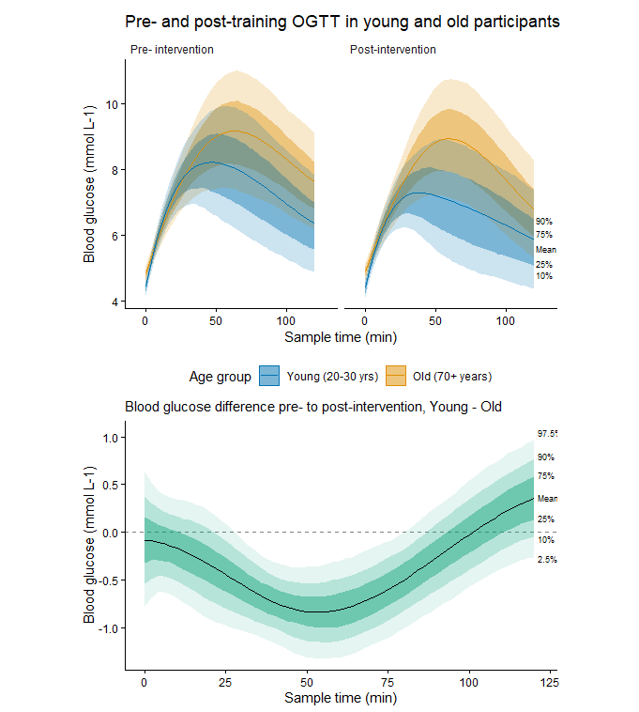
Figure 4: Oral glucose tolerance test (OGTT) responses before and after the training intervention, by age group. Top panels: blood glucose concentrations (mmol L⁻¹) across the 2-hour sampling period, shown for pre-intervention (left) and post-intervention (right) timepoints, in young (20–30 years) and old (70+ years) participants. Shaded ribbons represent the 10th, 25th, 75th, and 90th percentiles of the posterior distribution around the mean (solid line). Bottom panel: the estimated difference in training-induced change in blood glucose (post minus pre) between young and old participants, across the sampling period. Shaded ribbons represent the 2.5th, 10th, 25th, 75th, 90th, and 97.5th percentiles of the posterior distribution around the mean difference (solid line); the dashed horizontal line indicates no difference between age groups.
The intervention group showed a credible reduction in glucose response in older adults relative to control, beginning at 38 minutes post-ingestion and persisting through the end of the sampling window (mean difference at 120 min = −0.73 mmol/L, 95% CI [−1.48, −0.02], pos = 97.7%; pos = 97.5% at 38 min), with old intervention participants showing a lower post-training glucose response than old controls throughout this period. Young adults showed a greater training-induced reduction in glucose than old adults across part of the sampling window: the young vs. old difference was credible between 30 and 78 minutes post-ingestion (pos = 98.6% and 98.2% at the window boundaries), with the largest divergence at 54 minutes (−0.85 mmol/L, 95% CI [−1.34, −0.36], pos = 100%). Outside this window the difference was not credible: before 30 min the point estimate trended in the same direction but pos remained well below the credible threshold, and after 78 min the point estimate briefly crossed to the opposite sign, consistent with the age-related difference no longer being detectable by the end of the 2 h window.

Molecular
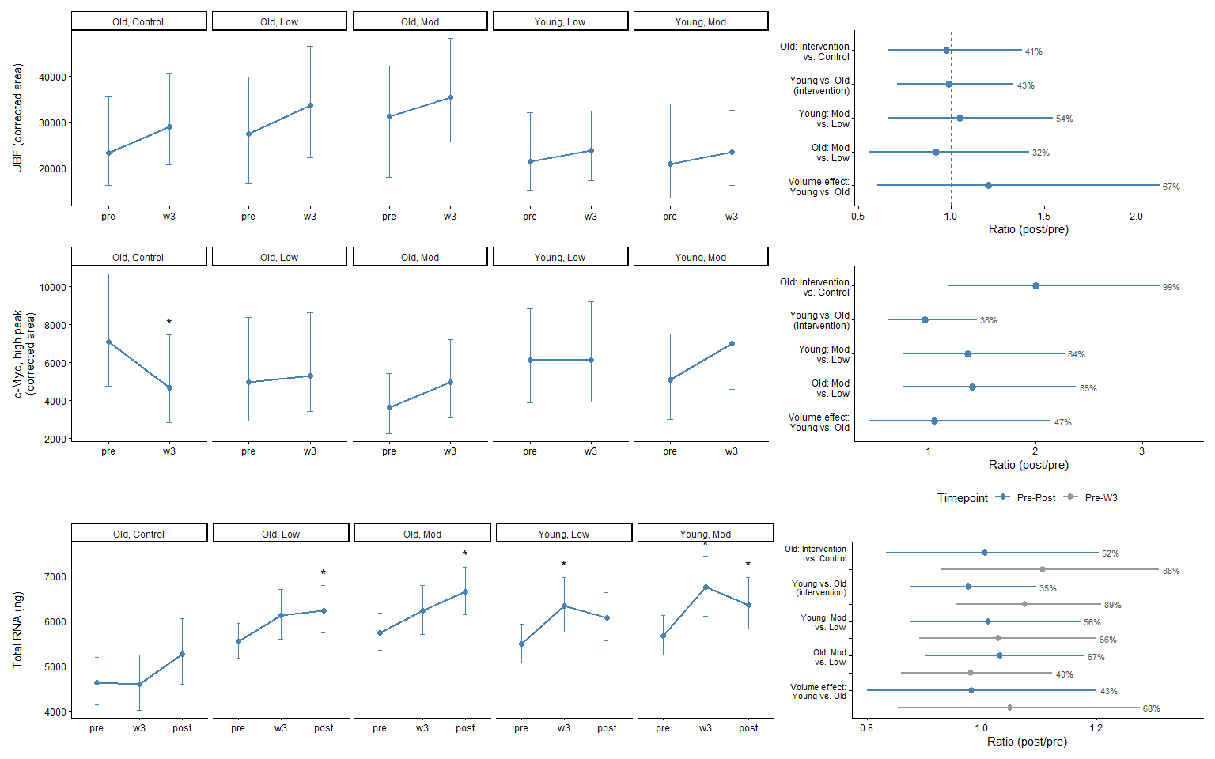
Figure 5: UBF and c-Myc (high peak, ~60 kDa) protein content, and total RNA yield, before and 3 weeks into (and after, where applicable) the training intervention. Panels A, C, and E: predicted values at each measured timepoint, corrected area (arbitrary units) for UBF and c-Myc, and total RNA (ng, adjusted for tissue weight). Error bars represent the 95% credible interval around the posterior mean (point and line). Panels B, D, and F: posterior distributions for five key between-group and between-condition contrasts — Old: Intervention vs. Control, Young vs. Old (intervention), Young: Mod vs. Low, Old: Mod vs. Low, and Volume effect: Young vs. Old, expressed as the ratio of change between the two groups or conditions being compared. For UBF and c-Myc, only the pre-to-week 3 change is shown, reflecting the timepoints measured. For total RNA, both the pre-to-week 3 change (grey) and the pre-to-post change (blue) are shown, per the legend. Points show the posterior mean ratio with 95% credible intervals; the dashed vertical line indicates no difference between groups (ratio = 1). Percentages indicate the posterior probability that the ratio exceeds 1 — i.e., the probability that the first-named group or condition in each comparison showed the larger increase.
UBF Protein Older adults in the intervention group (averaged across volume conditions) tended to increase UBF protein content by week 3 (19.1%, 95% CI [−7.0%, 49.0%], P(>0) = 90.1%), as did the control group (24.9%, 95% CI [−15.7%, 64.3%], P(>0) = 90.8%), with no evidence of a difference between them (−2.6%, 95% CI [−33.7%, 38.1%], P(<0) = 58.6%). There was weak evidence of an increase in young adults (averaged across volume conditions; 15.7%, 95% CI [−8.0%, 44.2%], P(>0) = 88.5%), with no evidence of a difference from older adults (−1.5%, 95% CI [−29.0%, 33.8%], P(<0) = 56.8%). Within young adults, there was weak evidence of an increase with both low-volume (15.2%, 95% CI [−18.7%, 52.5%], P(>0) = 80.8%) and moderate-volume training (17.6%, 95% CI [−15.2%, 60.7%], P(>0) = 83.2%), with no evidence of a difference between them (4.4%, 95% CI [−34.0%, 54.8%], P(>0) = 53.9%). In older adults, there was weak evidence of an increase with low-volume training (27.1%, 95% CI [−13.3%, 74.7%], P(>0) = 88.9%) and no evidence with moderate-volume training (13.1%, 95% CI [−18.8%, 55.0%], P(>0) = 74.9%), again with no evidence of a difference between them (−8.2%, 95% CI [−44.1%, 41.9%], P(<0) = 67.8%). There was no evidence that the volume effect differed between age groups (20.1%, 95% CI [−39.8%, 112.3%], P(>0) = 67.2%).
c-Myc Protein The difference in c-Myc (high peak) protein content between the old intervention group (averaged across volume conditions) and the control group was large by week 3 (99.8%, 95% CI [17.5%, 216.3%], P(>0) = 99.3%). This difference was driven mainly by a decrease in the control group (−34.5%, 95% CI [−56.0%, −5.5%], P(<0) = 98.6%), while the intervention group tended to increase (25.9%, 95% CI [−8.9%, 68.1%], P(>0) = 92.0%). There was weak evidence of an increase in young adults (averaged across volume conditions; 18.6%, 95% CI [−12.5%, 57.5%], P(>0) = 85.9%), with no evidence of a difference from older adults (−3.5%, 95% CI [−37.8%, 45.0%], P(<0) = 61.5%). Within young adults, there was no evidence of a change with low-volume training (4.4%, 95% CI [−30.1%, 49.1%], P(>0) = 55.2%), while moderate-volume training tended to increase c-Myc (37.3%, 95% CI [−12.2%, 106.2%], P(>0) = 91.5%). There was weak evidence of a larger increase under moderate volume (36.2%, 95% CI [−23.8%, 127.4%], P(>0) = 83.5%). The same pattern held in older adults: there was no evidence of a change with low-volume training (9.6%, 95% CI [−29.9%, 64.4%], P(>0) = 62.0%), moderate-volume training tended to increase c-Myc (47.9%, 95% CI [−4.7%, 118.4%], P(>0) = 95.5%), and there was weak evidence of a larger increase under moderate volume (41.0%, 95% CI [−24.3%, 138.0%], P(>0) = 84.5%). There was no evidence that the volume effect differed between age groups (5.2%, 95% CI [−55.8%, 114.3%], P(>0) = 46.7%).
Total RNA Older adults in the intervention group (averaged across volume conditions) increased RNA yield by 14.1% from baseline to post (95% CI [5.3%, 23.5%], P(>0) = 99.9%). The control group tended to increase by a similar amount (13.5%, 95% CI [−4.1%, 34.2%], P(>0) = 93.2%), and there was no evidence of a difference between them (0.5%, 95% CI [−16.7%, 20.3%], P(>0) = 52.4%). The two groups differed in timing: the intervention group had already increased by week 3 (9.2%, 95% CI [1.2%, 18.2%], P(>0) = 98.6%), whereas the control group had not changed at that point (−0.9%, 95% CI [−15.1%, 15.2%], P(<0) = 55.0%). The difference between them at week 3 was still uncertain (10.6%, 95% CI [−7.0%, 30.8%], P(>0) = 87.6%). Young adults (averaged across volume conditions) increased by 11.6% by post (95% CI [2.6%, 21.4%], P(>0) = 99.6%), with no evidence of a difference from older adults (−2.4%, 95% CI [−12.6%, 9.5%], P(<0) = 65.3%). At week 3, however, young adults had increased by 17.4% (95% CI [7.8%, 28.0%], P(>0) > 99.9%), with weak evidence of a larger increase than older adults (7.4%, 95% CI [−4.5%, 20.8%], P(>0) = 88.9%). Between week 3 and post, young adults’ RNA yield likely fell back relative to older adults’ (−9.0%, 95% CI [−20.4%, 4.5%], P(<0) = 91.9%). Within young adults, both low-volume (15.7%, 95% CI [3.5%, 29.5%], P(>0) = 99.5%) and moderate-volume training (19.2%, 95% CI [6.4%, 33.5%], P(>0) = 99.9%) increased RNA yield by week 3. At post, the increase was 12.2% under moderate volume (95% CI [0.4%, 25.9%], P(>0) = 97.8%), while low volume tended to increase it by 10.8% (95% CI [−0.7%, 24.1%], P(>0) = 96.6%). There was no evidence of a difference between volume conditions at either time point (week 3: 2.9%, 95% CI [−10.8%, 19.9%], P(>0) = 65.7%; post: 1.1%, 95% CI [−12.6%, 17.1%], P(>0) = 56.0%). In older adults, low-volume (12.3%, 95% CI [1.0%, 24.6%], P(>0) = 98.3%) and moderate-volume training (15.8%, 95% CI [4.4%, 28.3%], P(>0) = 99.8%) both increased RNA yield by post, having tended to increase already by week 3 (low: 10.3%, 95% CI [−0.3%, 22.0%], P(>0) = 97.1%; moderate: 8.3%, 95% CI [−2.3%, 19.9%], P(>0) = 93.3%). There was no evidence of a difference between volume conditions at either time point (week 3: −1.9%, 95% CI [−14.0%, 12.3%], P(<0) = 60.4%; post: 3.1%, 95% CI [−9.9%, 17.8%], P(>0) = 67.2%). There was no evidence that the volume effect differed between age groups, either at week 3 (5.0%, 95% CI [−14.6%, 27.5%], P(>0) = 68.4%) or at post (−1.7%, 95% CI [−20.0%, 20.0%], P(<0) = 57.2%).

RNA-sequencing
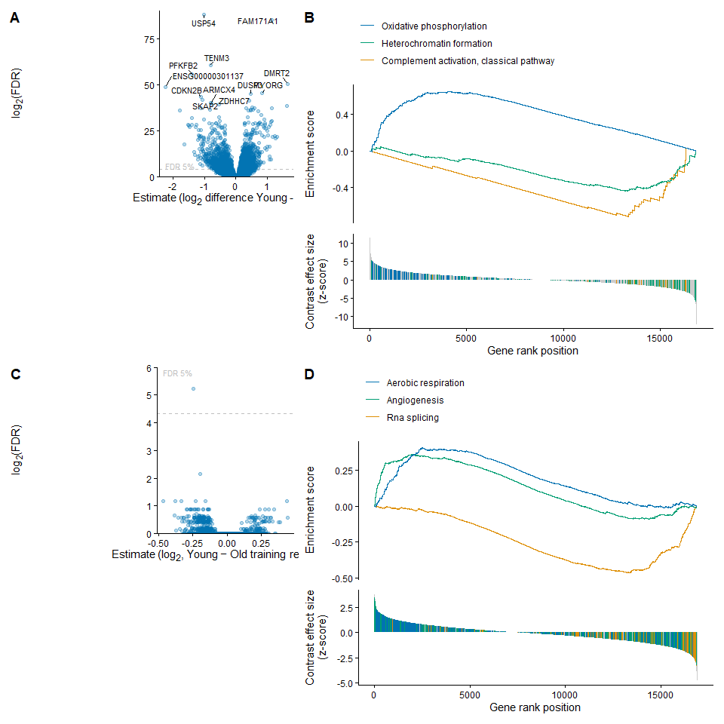
Figure 6: Baseline and training-related transcriptional differences between age groups. (A) Baseline age differences (Young − Old): volcano plot of gene-level estimates (log₂ fold-change) against FDR (log₂ scale), with the dashed line marking FDR = 5%. Genes with the strongest evidence of differential expression are labeled. (B) Rank-based gene-set enrichment analysis (GSEA) of the baseline age contrast, showing the running enrichment score (top) and per-gene contrast effect size (z-score, bottom) across gene rank position, for three representative gene sets (oxidative phosphorylation, heterochromatin formation, complement activation, classical pathway). (C) Age × training-response difference (Young − Old): volcano plot of gene-level estimates for the interaction contrast, in the same format as (A). (D) GSEA of the age × training-response interaction contrast, in the same format as (B), for three representative gene sets (RNA splicing, angiogenesis, aerobic respiration).
Comparing gene-expression profiles between age groups at baseline (Young − Old) revealed marked differences, with 2082 genes showing robust differences between the groups (FDR < 5%, Fig 6A/B). Rank-based gene-set enrichment analysis^{xu2024a?} indicated that young participants had relatively higher expression of genes related to aerobic energy metabolism (oxidative phosphorylation) and relatively lower expression of genes related to immune system activation (complement activation, classical pathway) and epigenetic regulation of gene expression (heterochromatin formation). Training induced a large, broad transcriptional response in both age groups: 3503 genes changed from baseline to post in young participants, and 4241 in old participants (FDR < 5%, Fig 6C/D). Individual genes with the strongest training-induced changes were predominantly collagen and basement-membrane genes in both groups (e.g., COL4A1, COL4A2, LAMB1, PXDN in young; COL4A1, LAMA4, COL3A1, COL1A2, SPARC in old).
Rank-based gene-set enrichment analysis^{xu2024a?} showed that the dominant biology of the training response was similar between age groups: 6 of the top 10 enriched categories were shared, with matching direction and comparable magnitude in both young and old (RNA splicing, ribonucleoprotein complex biogenesis, integrin-mediated signaling pathway, cell adhesion mediated by integrin, collagen metabolic process, and mRNA transport). Training up-regulated genes related to ECM/connective tissue remodeling (e.g., integrin-mediated signaling and adhesion, collagen metabolic process) and down-regulated genes related to RNA-processing and ribosome biogenesis (e.g., RNA splicing, ribonucleoprotein complex biogenesis, mRNA transport) in both groups. While essentially no genes (1 gene at 5% and 0 at 1%) showed a statistically significant age-dependent training response after FDR correction, gene-set enrichment analysis of the age × time interaction contrast revealed that the magnitude of the shared training response differed somewhat between age groups in specific processes: the down-regulation of RNA splicing and related mRNA-processing categories was more pronounced in young than old, while the up-regulation of angiogenesis and aerobic respiration/cellular respiration categories was more pronounced in young than old.
A smaller set of categories differed by age: young participants showed additional enrichment for cytoplasmic translation, mesenchymal cell migration, and angiogenesis, while old participants showed additional enrichment for coagulation- and vascular-related categories. In contrast to the broadly age-independent training effect, the effect of training volume (moderate vs. low) was age-dependent: a substantial number of genes differed by volume in old participants (1216 genes, FDR < 5%), while essentially no genes showed a volume effect in young participants. Among old participants, higher training volume was associated with relatively higher expression of genes related to mitochondrial biogenesis and oxidative metabolism (e.g., inner mitochondrial membrane organization, respiratory electron transport chain, purine-containing compound biosynthesis) and relatively lower expression of genes related to muscle contractile function and translation (e.g., skeletal muscle contraction, cytoplasmic translation, muscle organ development, striated muscle cell differentiation, ribosomal small subunit biogenesis). This volume effect was considerably more modest than the main training effect, both in the number of genes involved and in statistical strength.

Discussion
Overall, both young and old participants in the intervention responded in terms of muscle growth and -strength, also improving their tolerance to glucose ingestion. Young participants had a larger gain in muscle mass than old (weak to moderate evidence), though this was less consistent for muscle thickness and upper-body lean mass. Muscle strength showed a weaker age effect than hypertrophy, and this varied by training volume: young showed strong evidence of an age difference under low volume but none under moderate volume, and no clear age difference was observed in 1RM leg press. In terms of training volume, both age groups benefited from moderate volume for muscle hypertrophy, whereas young responded better to low than moderate volume for strength (particularly peak torque), with the old showing no clear dose effect on strength. Young also improved glucose tolerance more than old. Molecular markers of ribosome biogenesis (total RNA, UBF, c-Myc) increased in both groups, though on a delayed timescale in old, and RNA-sequencing data showed a marked difference between age groups at baseline that became more similar after training.
While it has been suggested that older adults can gain similar improvements in both muscle mass and -strength as young¹, this was not clearly evident in the present study. The young participants had larger gains from pre to post in thigh muscle volume and upper-body lean mass, with some weaker evidence of the same for muscle thickness and upper-body lean mass, compared to the old. While both volume conditions led to increased muscle volume in both age groups, the evidence for increased muscle thickness in old was weaker under low volume than moderate, and the evidence for increased upper-body lean mass in old was weaker than in young under both doses — representing two discrepancies: between muscle volume and thickness gains, and between upper- and lower-body gains. Hypertrophy attenuation in older individuals (~60+ years) is a broadly used statementbetz_aerobic_2025?,endo_optimizing_2020?,stec_randomized_2017?, likely stemming from the classic MRI CSA study by Welle and co-workers^{welle_effect_1996?}, where they found that older individuals (62-72yrs) experienced lesser training-induced increases in skeletal muscle CSA in the elbow and knee flexors compared to young. However, Welle et al. also found no difference in skeletal muscle CSA between young and old in the knee extensors. In terms of strength, older individuals increased similarly to young in elbow flexors and knee extensors, and in fact surpassed young in knee flexor strength, when strength was analysed as relative change in specific tension (strength per cm2 of CSA)^{welle_effect_1996?}. Based on this, while hypertrophy attenuation was present in certain skeletal muscle, it was not universal, and despite less hypertrophy, older individuals had similar and even larger gains in specific tension strength^{welle_effect_1996?}. An important point here, was that hypertrophy was not universal to all skeletal muscle groups, and later work by Greig et al.^{greig_blunting_2011?} noted that the literature was quite equivocal on this topic, either finding skeletal muscle mass in old to be less responsivewelle_effect_1996?,kosek_efficacy_2006? or similar to young^{ivey_effects_2000?}. Furthermore, recent work find no decline in the potential for muscle hypertrophy^{karlsen_preserved_2020?} or no substantial influence of age on muscle hypertrophy response to resistance training^{de_santana_lower_2024?}. Among the studies that have compared young and old head-to-head to this date, the results are inconclusive at best, with some finding less myofiber hypertrophy in old compared to youngpetrella_efficacy_2006?,kosek_efficacy_2006?, less myofiber hypertrophy but similar strength gainsbickel_exercise_2011?,raue_improvements_2009?, or less myofiber hypertrophy and strength after 10.5 weeks, where muscle strength caught up after 21 weeks^{mero_resistance_2013?}. Taken together, most studies measuring hypertrophy in knee extensors via whole-muscle volume MRI find no age effectwelle_effect_1996?,ivey_effects_2000?,karlsen_preserved_2020?,de_santana_lower_2024?, with the exceptions being the findings of Raue et al.^{raue_improvements_2009?} and Welle and co-workers data on knee and elbow flexors^{welle_effect_1996?}. When hypertrophy is measured on the fiber level though, this flips, and most studies find an attenuation in old compared to youngkosek_efficacy_2006?,petrella_efficacy_2006?,bickel_exercise_2011?,mero_resistance_2013?, the exception here being^{karlsen_preserved_2020?}. In this regard, our data does not show a definitive age effect on training-induced hypertrophy, though the moderate-to-strong evidence that thigh muscle volume and upper-body lean mass increased more in young compared to old does indicate that an age effect was more likely than not.
Though weaker than in muscle hypertrophy, there was some evidence to suggest a possible difference in muscle strength gains between the age groups as well. Peak torque showed weak evidence of a difference between young and old, favoring young, while bicep curl MVC showed weak evidence favoring old. Further complicating this, was the weak evidence for a difference between the old intervention group and control in peak torque, as well as no difference between old intervention group and control in 1RM leg press. The difference between the old intervention and control observed in bicep curl MVC is likely due in part to the decrease in the control group, though both volume conditions showed evidence of an increase in the old, with moderate volume showing the stronger effect. Previous studies have shown differing results here, where old individuals may lag behind in hypertrophy but not in strengthwelle_effect_1996?,bickel_exercise_2011?,mero_resistance_2013? or where both change similarly^{raue_improvements_2009?}. Notably, since the evidence of a difference between young and old in strength gains in the present study was quite weak, one should take care not to over-interpret it, and we cannot exclude the possibility of there not being a difference. A no-difference scenario would entail a discrepancy between muscle hypertrophy and strength gains, where the most common explanation is that neural adaptation drives the early stage strength gain, while hypertrophy is lagging behind [SOURCES]. This does not fully apply here, since both young and old had gains in muscle mass and -strength, the discrepancy stems from the young gaining more than old. Given the weak evidence of an age difference between young and old, on could argue that the old participants in the present study effectively gained similar increases in strength, with less changes in muscle mass, indeed corroborating that hypertrophy and strength does not have a 1:1 relationship. This was addressed previously by Reggiani and Schiaffino^{reggiani_muscle_2020?}, arguing that there are three possible relationships between size change and strength change; strength can increase in proportion to, less or more than size. At the core of this concept, lies the idea that not all muscle growth is forceful, where the proportion between sarcoplasmic proteins and myofibrillar proteins can be altered during hypertrophy, producing a higher or lower density of actual force-generating molecular motors per unit of muscle size^{reggiani_muscle_2020?}. Therefore, theres no given % of CSA, muscle volume, lean mass that grant a proportional increase in the contractile machinery, some of the gain could be sarcoplasmic rather than myofibrillar^{reggiani_muscle_2020?}. Alternatively or additionally, it could stem from myosin isoform shifts and post-translational changes to the contractile machinery, affecting force generation independent of size^{reggiani_muscle_2020?}. Notably, myofibrillar vs. sarcoplasmic hypertrophy, myosin isoform shifts and post-translational changes are less, if at all, explored in young vs. old participants, but the notion that the skeletal muscle mass can get stronger without the same growth in size at least seems like a plausible explanation for why the old in the present study increased similarly in strength, but not size, compared to the young. Furthermore, the learning-effect should be considered, given the tendencies to increase in peak torque, and similar increase in 1RM in the control group compared to the old intervention group. The participants in the present study only had one familiarization test, perhaps not enough to rule out the learning-effect, which could explain the control groups results for lower-body strength. If that was the only explanation though, it does not make sense that the control group decreased their bicep curl MVC from baseline to post.
In broad strokes, moderate-volume training was most beneficial in the hypertrophy outcomes, specifically in muscle volume, where the evidence was strong in both age groups. This remained true in muscle thickness for the old intervention group, however, the evidence was weak for the young intervention group here. No evidence of a volume-condition difference within age groups was observed in upper-body lean mass. As for the strength outcomes, there was more evidence of low-volume training being more beneficial (strong for peak torque, moderate-to-strong for bicep curl MVC) for the young, while the old intervention group showed no difference between volume-conditions. Most studies investigating the effects of training volume on muscle mass and/or -strength, tend to find that a moderate-training volume benefits both size and strength5,16,19,25,krieger_single_2010?,rocha_different_2024?, where Hammarström et al.¹⁶ demonstrated that young benefited more from a moderate volume in both muscle mass and strength, a contrast to our findings that low-volume training was more beneficial for peak torque, perhaps also bicep curl MVC. A similar pattern to the present study was observed by Da Silva et al.^{da_silva_repetitions_2018?}, where more training volume improved hypertrophy compared to low, but no additional gain in strength/neuromuscular outcomes.^{da_silva_repetitions_2018?} notably only had old participants, and the volume manipulation was done through one group performing repetitions to failure, two groups performing submaximal repetitions, one of which doubled the amount of sets the repetitions to failure group had. Further, a recent mate-regression by Pelland et al.^{pelland_resistance_2026?} found a clear positive effect of volume on both hypertrophy and strength (posterior probability of 100%), but also diminishing returns in both, where the diminishing returns for strength was considerably more pronounced than for hypertrophy. As such, it seems hypertrophy could be more volume-sensitive than strength, with some evidence of strength not always following hypertrophy after increasing training volume^{pelland_resistance_2026?}. This could be corroborated by that strength saturates at a lower training dose, as seen when comparing;⁸, where volume reached a significant effect on hypertrophy at 10+ sets/week, against²⁵, where strength gains only required 2-3 sets per session. Also of interest, Schoenfeld²⁶ found the opposite pattern when manipulating training load rather than volume, where strength was clearly load dependent and hypertophy insensitive. Furthermore, in 2019, Schoenfeld recruited 34 resistance-trained men randomized to low-volume, moderate-volum, or high-volume training, and found that while all groups experienced similar gains in muscle strength and endurance, muscle hypertrophy significantly increased with higher training volumes^{schoenfeld_resistance_2019?}. Thus, one could argue that the this field is quite equivocal, but that may very well stem from the wide spread in study designs.
Many of the aforementioned studies differ in population or duration, manipulate volume or intensity differently, or investigate old and young separately. The two studies including both young and old differ substantially in design, where one first implemented a volume/dose model in the maintenance phase^{bickel_exercise_2011?}, while the other manipulated training intensity rather than training volume^{letocart_muscles_2021?}.^{bickel_exercise_2011?} recruited 39 young (20-35yrs) and 31 old (60-75yrs) untrained individuals to a 16 week progressive RT program, with a 32 week detraining/maintenance training period. In the maintenance period, one group was assigned to detraining, one group to a third of the initial volume via reduced training frequency (1 session, down from 3x/w), and one group to a ninth of the initial volume via reduced sets (1 set, down from 3) and training frequency (1 session, down from 3x/w). Following this,^{bickel_exercise_2011?} found similar relative strength gains but greater hypertrophy gains in young compared to old, during the 16-week training program, and also an equally sustained enhancement of muscle performance during the detraining/maintenance phase, while maintenance of muscle mass gains required more frequent dosing in the old.^{letocart_muscles_2021?} recruited 11 recreationally active young men and 35 sedentary old men to a 12-week resistance program where the young exercised with a moderate-load training intervention corresponding to 55% of 1RM, while the old were randomly assigned to either moderate (55%) or high-load (80% of 1RM). They exercised three times a week, with three exercises for the lower extremities.^{letocart_muscles_2021?} found that the old exercising with a moderate training intensity gained more m. quadriceps and m. triceps surae volume compared to the young, with no difference between old exercising with moderate- or high-intensity. Overall, our findings align with^{bickel_exercise_2011?} where greater hypertrophy gains were observed in young compared to old, and moderate-volume training being more beneficial in this regard, and none of these, or the aforementioned volume-manipulating studies have found low-volume to outperform moderate-volume in terms of skeletal muscle strength. This may be a novel finding, and could harken back to the pattern seen when contrasting⁸ and²⁵, suggesting strength increases saturate at a lower training volume than hypertrophy.
Glucose tolerance improved more in the young compared to the old, specifically between 30 and 78 minutes after ingesting glucose. The only previous study including both young and old in a chronic RT intervention, found only nominal improvements in glucose tolerance in both groups, where elderly remained well below the young group^{craig_influence_1989?}. Notably,^{craig_influence_1989?} had fewer participants, and compared pre-post points rather than the full time frame of the OGTT like the present study. Chronic RT studies with old adults alone have found lowered 2h glucose and OGTT AUC compared to control after 8 weeks of RT (3x/week)^{andersson_improving_2017?}; decreased fasting glucose and OGTT AUC (0-30min) after high-, low- and volume-matched load for 10 weeks^{tsai_effects_2021?}; decreased blood glucose, basal insulin, and HOMA-IR in postmenopausal women after 12 weeks of whole-body progressive RT^{moreno_lima_resistance_2015?}; and a decrease in HOMA-IR in non-diabetic elderly men compared to type 2 diabetic elderly men and control, after 12 weeks of RT (3x/week)^{shabkhiz_resistance_2021?}. Acute studies comparing single session volume effect have found reduced glucose AUC with RT, reduced fasting glucose only after higher-volume in young women^{reed_effects_2012?}, and improved oral glucose insulin sensitivity and glucose/insulin/c-peptide AUC in insulin resistant individuals after a high-volume session only^{silva_improvements_2026?}. A meta-analysis by Li et al.^{li_effects_2021?} investigated 12 RCTs with non-athletic and aged participants (60+), and found that population, training intensity, and duration all had significant effects on HOMA-IR, with largest effect sizes for high-intensity and long-term (>12 weeks) exercise in older adults without type 2 diabetes. In the same meta-analysis, they also found that moderate-intensity and short-term (<12 weeks) had a greater effect on HbA1c, particularly in people with type 2 diabetes^{li_effects_2021?}. On the contrary, Zhang et al.^{zhang_effects_2025?} found more inconsistent evidence for high-intensity RT, with some long-term high-intensity trials failing to improve glycemia, HbA1c, or HOMA-IR.
Taken together, the data suggest that chronic RT should improve glycemic markers in older adults, but the effect is modest and not universal. Chronic RT improved glucose/insulin/HOMA-IR in older adults in three separate studiesandersson_improving_2017?,tsai_effects_2021?,moreno_lima_resistance_2015?, with evidence from the meta-analysis by^{li_effects_2021?} supporting an effect, however small on average. This is corroborated by early findings from^{craig_influence_1989?} and more so the present study with a high resolution OGTT curve, that elderly do indeed respond in terms of improved glucose tolerance, however less than young adults undertaking the same chronic RT. Baseline metabolic health could be a moderator of the response, but in what direction is not clear. Chronic RT did not improve HOMA-IR in diabetic elderly men compared to non-diabetic elderly men, while both groups improved strength^{shabkhiz_resistance_2021?}. Acute RT, meanwhile, improved oral glucose sensitivity and glucose/insulin/C-peptide AUC only in the insulin resistant^{silva_improvements_2026?}. Notably, this may very well reflect chronic vs. acute mechanisms, but with the current findings its not a clear-cut “healthier responds more” picture. In the methodological perspective of the studies reviewed here, studies using fasting glucose/HOMA-IRmoreno_lima_resistance_2015?,shabkhiz_resistance_2021?,li_effects_2021? show less consistent findings and contradictory RT-intensity conclusionsli_effects_2021?,zhang_effects_2025?, compared to studies using outcomes derived from the OGTTandersson_improving_2017?,tsai_effects_2021?. Most of the methods used in these articles are collapsed to single-time point (fasting glucose/insulin, 2h glucose, HOMA-IR) or single summary statistics (OGTT AUC), which fails to capture the full window of post-prandial glucose clearance as the OGTT curve in the present study. This is important, since the difference between young and old in the present study would not have been detected by comparing for instance 2h glucose alone. Before 30 minutes, there was only a trend towards young having a larger improvement in glucose tolerance compared to the old, and after 78 min the we were no longer able to statistically distinguish any difference between the two intervention groups. The full OGTT curve also shows that not only has the old intervention group improved their glucose tolerance more than the old control group, but the difference remains credible to the last measured time point, whether the difference ends there or at a later time point however, we cannot tell.
There might be an argument that the larger improvement observed in the young participants between 30 and 78 min is not meaningful, since the groups are statistically indistinguishable before 30 min and after 78; there’s not a clear difference at the start or end of the test. However, there is evidence from cross-sectional/observational research that elevated 1-hour OGTT (>8.6 mmol/L) glucose identifies a higher-risk phenotype for future T2D and is independently associated with subclinical vascular damage and reduced insulin sensitivity/clearance, even in individuals who are indistinguishable from lower-risk individuals by standard fasting and 2h criteriamarini_decreased_2013?,sciacqua_association_2012?. While this evidence concerns absolute 1h glucose level in cross-sectional cohorts rather than training-induced change, it indicates this region of the curve is not physiologically inert simply because it’s invisible to standard fasting/2h criteria — though no comparable study has yet tested whether a training-induced improvement here confers the same protective association. It should also be noted here that while the appropriate RT volume could be an important leverli_effects_2021?,zhang_effects_2025?, this was not testable in the present study since the volume conditions were done within-participant.
Briefly, both UBF and c-Myc protein increased from baseline to week 3, however UBF content increased similarly in the old control, suggesting this was a general temporal effect rather than a training-specific response. On the contrary, c-Myc content was markedly lower in the old control group than in old intervention. Total RNA also increased in most groups including control, and differed by timing and not magnitude. The young increased primarily from baseline to week 3, and the old caught up by post, with no clear difference between age groups or intervention and control, and no volume condition effect. Lastly, the RNA-seq data revealed a largly age-independent training response dominated by up-regulation of ECM/collagen genes and down-regulation of RNA-processing/ribosome-biogenesis genes from baseline to post. The Age×time interaction is essentially null at the single-gene level, but GSEA shows old adults have a smaller-magnitude version of the same shared response (less RNA-splicing down-regulation, less angiogenesis/aerobic-respiration up-regulation). Training volume was impactful in the old (mitochondrial biogenesis up, contractile/translation genes down with more volume) but not at all in young.
Findings from the present study suggests that ribosome biogenesis may be delayed rather than blunted in the elderly, as elderly reach close to the same levels of change as young, only at a later time point. The young group had the expected early rise following both moderate and low-volume exercise (19 and 16% respectively), which eased only modestly by post (12 and 11%), remaining clearly elevated above baseline rather than returning toward it — a pattern consistent with previous findings from our lab^{27,28}. While the elderly intervention group did not match this change after 3 weeks (mod = 8%, low = 10%), they achieved near similar increases at post (mod = 16%, low = 13%). These changes were clear across both volume conditions in the young at week 3, and for moderate-volume at post; low-volume in the young showed only a weaker, less certain trend toward an increase at post. In the elderly, a clear increase emerged only at post. Control also showed a similar baseline-to-post increase as old (13%), though this was a weaker, less certain trend than the changes seen in the trained groups. From baseline to week 3, the change in control was considered flat, at -1%. A possible explanation here could be timing of the strength tests, as post-strength testing was conducted three-four days prior to the biopsy - whereas at baseline biopsies were sampled before strength testing, and there were no strength testing at all around the week 3 biopsy sampling. Given that total RNA is quite sensitive to such stimuli [SOURCE ACUTE STUDIES], the strength testing alone may have caused the observed spike in total RNA in the control group, and does indeed present a methodological weakness of a poorly timed test.
Changes in UBF and c-Myc protein matches the total RNA pattern quite well from baseline to week 3, with UBF tending to increase across all four intervention subgroups, albeit weakly, while c-Myc did not increase following low-volume exercise in the old intervention group. In the control group, c-Myc content decreased while content of UBF increased in a similar fashion to the old intervention group. Observed changes in protein content in the intervention group matches previous short-term/acute study findings^{27,29}, and the fact that low-volume training did not yield meaningful change in the old may further corroborate the narrative that increasing RT volume is more important for the elderly¹⁹. What does not quite add up in this story, is the increase of UBF content in the control group, paired with a decrease in c-Myc, since UBF is expected to be a downstream and training-specific target, triggered by c-Myc’s transcriptional control²⁹.
The RNA-seq pattern observed in the present study quite closely matches previous findings. An earlier metformin trial in older adults found progressive resistance training to significantly increase expression of genes involved in ECM remodelling and down-regulate genes in RNA-processing pathways^{kulkarni_metformin_2020?}, the same two dominant, opposite-direction gene sets observed in the present study. Recently, an aged-muscle reanalysis across modalities found that combined training and resistance training were mainly linked to ECM, collagen, adhesion, basement membrane, also similar to our results^{yang_transcriptomic_2026?}. Impaired transcriptional responses in mitochondrial, ECM and immune system genes have also been described as defining features of age-related anabolic resistance to resistance training^{deane_proteomic_2022?}, among these, baseline expression of genes related to oxidative phosphorylation was relatively lower in old compared to young, while genes related to activation of the immune system were relatively higher in the old, in the present study. The down-regulation of RNA-processing/ribosome-biogenesis gene categories at post compared to baseline may at first glance seem inconsitent with the increased total RNA from baseline to post. On the contrary, this fits well within the interpretation that once translational capacity has been built up, during the early-phase, further biogenesis-gene transcription is dialed back via feedback^{28,30}.

References
1 Fragala MS, Cadore EL, Dorgo S et al. Resistance Training for Older Adults: Position Statement From the National Strength and Conditioning Association. Journal of Strength and Conditioning Research. 2019;33(8):2019–2052.
2 Timmons JA, Gallagher IJ. Molecular studies of exercise, skeletal muscle, and ageing. F1000Research. 2016;5:1087.
3 Li R, Xia J, Zhang X et al. Associations of Muscle Mass and Strength with All-Cause Mortality among US Older Adults. Medicine & Science in Sports & Exercise. 2018;50(3):458–467.
4 Scheerman K, Meskers CGM, Verlaan S, Maier AB. Sarcopenia, Low Handgrip Strength, and Low Absolute Muscle Mass Predict Long-Term Mortality in Older Hospitalized Patients: An Observational Inception Cohort Study. Journal of the American Medical Directors Association. 2021;22(4):816–820.e2.
5 Chen YC, Chen W-C, Liu C-W et al. Is moderate resistance training adequate for older adults with sarcopenia? A systematic review and network meta-analysis of RCTs. European Review of Aging and Physical Activity. 2023;20(1):22.
6 Marzuca-Nassr GN, Alegría-Molina A, SanMartín-Calísto Y et al. Muscle Mass and Strength Gains Following Resistance Exercise Training in Older Adults 65–75 Years and Older Adults Above 85 Years. International Journal of Sport Nutrition and Exercise Metabolism. 2024;34(1):11–19.
7 Paulussen KJM, McKenna CF, Beals JW, Wilund KR, Salvador AF, Burd NA. Anabolic Resistance of Muscle Protein Turnover Comes in Various Shapes and Sizes. Frontiers in Nutrition. 2021;8:615849.
8 Schoenfeld BJ, Ogborn D, Krieger JW. Dose-response relationship between weekly resistance training volume and increases in muscle mass: A systematic review and meta-analysis. Journal of Sports Sciences. 2017;35(11):1073–1082.
9 Atherton PJ, Smith K. Muscle protein synthesis in response to nutrition and exercise. The Journal of Physiology. 2012;590(5):1049–1057.
10 Wall BT, Gorissen SH, Pennings B et al. Aging Is Accompanied by a Blunted Muscle Protein Synthetic Response to Protein Ingestion. PloS One. 2015;10(11):e0140903.
11 Hodson N, West DWD, Philp A, Burd NA, Moore DR. Molecular regulation of human skeletal muscle protein synthesis in response to exercise and nutrients: A compass for overcoming age-related anabolic resistance. American Journal of Physiology-Cell Physiology. 2019;317(6):C1061–C1078.
12 Markofski MM, Dickinson JM, Drummond MJ et al. Effect of age on basal muscle protein synthesis and mTORC1 signaling in a large cohort of young and older men and women. Experimental Gerontology. 2015;65:1–7.
13 Chaillou T, Montiel-Rojas D. Does the blunted stimulation of skeletal muscle protein synthesis by aging in response to mechanical load result from impaired ribosome biogenesis? Frontiers in Aging. 2023;4:1171850.
14 Figueiredo VC, McCarthy JJ. Regulation of Ribosome Biogenesis in Skeletal Muscle Hypertrophy. Physiology. 2019;34(1):30–42.
15 Figueiredo VC. Revisiting the roles of protein synthesis during skeletal muscle hypertrophy induced by exercise. American Journal of Physiology-Regulatory, Integrative and Comparative Physiology. 2019;317(5):R709–R718.
16 Hammarström D, Øfsteng S, Koll L et al. Benefits of higher resistance‐training volume are related to ribosome biogenesis. The Journal of Physiology. 2020;598(3):543–565.
17 Stec MJ, Kelly NA, Many GM, Windham ST, Tuggle SC, Bamman MM. Ribosome biogenesis may augment resistance training-induced myofiber hypertrophy and is required for myotube growth in vitro. American Journal of Physiology-Endocrinology and Metabolism. 2016;310(8):E652–E661.
18 Stec MJ, Mayhew DL, Bamman MM. The effects of age and resistance loading on skeletal muscle ribosome biogenesis. Journal of Applied Physiology. 2015;119(8):851–857.
19 Lixandrão ME, Bamman M, Vechin FC et al. Higher resistance training volume offsets muscle hypertrophy non-responsiveness in older individuals. Journal of Applied Physiology. 2024;japplphysiol.00670.2023.
20 Bonomini F, Rodella LF, Rezzani R. Metabolic Syndrome, Aging and Involvement of Oxidative Stress. Aging and disease. 2015;6(2):109.
21 North BJ, Sinclair DA. The Intersection Between Aging and Cardiovascular Disease. Circulation Research. 2012;110(8):1097–1108.
22 Westcott WL. Resistance Training is Medicine: Effects of Strength Training on Health. Current Sports Medicine Reports. 2012;11(4):209–216.
23 Strasser B, Siebert U, Schobersberger W. Resistance Training in the Treatment of the Metabolic Syndrome: A Systematic Review and Meta-Analysis of the Effect of Resistance Training on Metabolic Clustering in Patients with Abnormal Glucose Metabolism. Sports Medicine. 2010;40(5):397–415.
24 Schindelin J, Arganda-Carreras I, Frise E et al. Fiji: An open-source platform for biological-image analysis. Nature methods. 2012;9(7):676–682.
25 Krieger JW. Single Versus Multiple Sets of Resistance Exercise: A Meta-Regression. Journal of Strength and Conditioning Research. 2009;23(6):1890–1901.
26 Schoenfeld BJ, Grgic J, Ogborn D, Krieger JW. Strength and Hypertrophy Adaptations Between Low- vs. High-Load Resistance Training: A Systematic Review and Meta-analysis. Journal of Strength and Conditioning Research. 2017;31(12):3508–3523.
27 Lian K, Hammarström D, Hamarsland H, Mølmen KS, Moen SC, Ellefsen S. Glucose ingestion before and after resistance training sessions does not augment ribosome biogenesis in healthy moderately trained young adults. European Journal of Applied Physiology. 2024. doi:10.1007/s00421-024-05446-x.
28 Hammarström D, Øfsteng SJ, Jacobsen NB, Flobergseter KB, Rønnestad BR, Ellefsen S. Ribosome accumulation during early phase resistance training in humans. Acta Physiologica. 2022;235(1). doi:10.1111/apha.13806.
29 Figueiredo VC, Roberts LA, Markworth JF et al. Impact of resistance exercise on ribosome biogenesis is acutely regulated by post-exercise recovery strategies. Physiological Reports. 2016;4(2):e12670.
30 Figueiredo VC, Caldow MK, Massie V, Markworth JF, Cameron-Smith D, Blazevich AJ. Ribosome biogenesis adaptation in resistance training-induced human skeletal muscle hypertrophy. American Journal of Physiology-Endocrinology and Metabolism. 2015;309(1):E72–E83.

