00-manuscript

Introduction
Skeletal muscle mass and strength decline with age, best prevented or treated with regular resistance training (RT). The decline in muscle mass and -strength advances upon reaching approximately 50 years of age and accelerates further after reaching 70, and, if left unchecked, has a high probability of leading to sarcopenia^{1,2}. Muscular weakness and low muscle mass per se is further linked to diabetes, disability, cognitive decline, osteoporosis and early all-cause mortality, prevented/treated by either attaining or maintaining a healthy skeletal muscle mass^{1,3,4}. Elderly are expected to gain similar benefits from RT as young, i.e., increased muscle mass, -strength and overall physical performance^{5,6}. To ensure maximal gains from a period of RT, the anabolic stimulus provided from exercising must be sufficient and ideally combined with nutritional optimisation (especially daily protein addition)^{5–8}. Notably, there are considerable inter-individual variations in adaptations to RT, especially in the elderly, making prescription of an optimal RT program for different phenotypes difficult¹⁴. While the underlying mechanisms of inter-individual variations to RT are not fully elucidated, differential manifestations of aging make the older population quite more heterogeneous than the young^{2,15}.
This heterogeneity in physical function among the elderly is reflected by, perhaps most notably, the different presence of pathophysiological conditions such as insulin resistance, sarcopenia, and anabolic resistance^{1,2,15}. Whether anabolic resistance is a contributor to or a consequence of sarcopenia is uncertain, but the lower muscle protein synthesis (MPS) in the elderly following a session of RT or protein ingestion suggests that skeletal muscle in the elderly is less responsive to anabolic stimuli than in the young^{2,16,17}. Baseline levels of MPS do not differ with age, however, the activity in proteins that influence MPS (e.g., mTOR) is elevated in fasted muscle from the elderly compared to young^{2,15,18}. This discrepancy in mTOR activity is proposed to represent either a compensation to increased relative muscle loading due to decreased muscle mass with age, or dysregulation of the mTOR complex². Further, likely as a consequence of altered mTOR regulation, ribosomal gene transcription and subsequently ribosome biogenesis is reduced in elderly^{2,15,19}, postulated to explain the anabolic resistance in the elderly in a recent study by Chaillou & Montiel-Rojas¹⁹.
Ribosomes are the protein factories of the cell, and the increase in ribosomal content (translational capacity) following onset of RT is believed to provide support for skeletal muscle fibre hypertrophy^{20,21}. Regardless of age, individuals who respond to RT exhibit an accumulation in markers of ribosome biogenesis (e.g., total RNA and/or rRNA), compared to those who do not experience benefits of RT^{12,22,23}. The findings from Hammarstrom et al.²² and Stec et al.²³ along with research from Figueiredo et al.^{20,21} suggests that ribosome biogenesis is indeed a prerequisite for RT-induced adaptations, increasing the translational capacity of the exercised skeletal muscle cells, yielding higher baseline MPS and thus hypertrophy over time. Though occuring across the age-span, the variation in ribosome biogenesis is proposed to be larger or more impactful among the elderly, substantiated by recent findings of impaired ribosome biogenesis in aging skeletal muscle^{15,19}. If the ribosome biogenesis response following RT varies due to differential responsiveness between elderly, it may be sufficient to simply increase the RT volume to enhance the anabolic stimulus and thus ensure ribosome biogenesis and ultimately skeletal muscle growth. Benefits of increasing training volume was observed recently, where elderly defined as “nonresponders” experienced improved whole muscle tissue hypertrophy by exercising with a higher training volume²⁴.
Therefore, this study aims to compare muscle mass accretion and ribosome biogenesis in healthy young and old individuals exercising with a low and a higher training volume for 10 weeks, to provide further knowledge on the effects of RT on age-related declines in muscle mass and -strength, and a possible strategy to counteract anabolic resistance. In addition, a secondary aim is to provide insight into the effects of resistance training on glucose tolerance, which is associated with age-related issues^{25,26}, and for which we have scarce or conflicting knowledge^{27,28}. Together, the results of this study will provide novel insight on how to optimise RT for different phenotypes, and whether or not RT is also an effective tool to improve less explored health variables in healthy young and elderly.

Methods
All participants gave their written informed consent before study enrollment. The study was approved by the Regional Committee for Medical and Health Research Ethics - South-East Norway (ID nr. 255224), pre-registered at clinicaltrials.gov (Identifier: NCT05063279), and conducted according to the Helsinki Declaration.
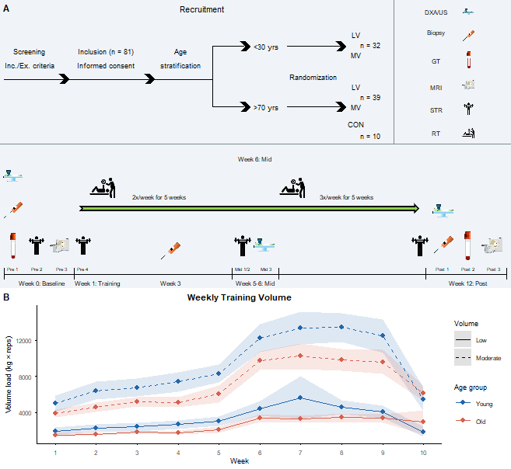

Figure 1: Study design and weekly training volume. (A) Overview of the study timeline, including screening, age stratification, randomization, and testing/training schedule across the 12-week intervention period. Icons indicate DXA/ultrasound scanning, muscle biopsy, blood/glucose tolerance testing (GT), MRI, strength testing (STR), and resistance training (RT) sessions. LV: low volume; MV: moderate volume; CON: non-training control. (B) Weekly training volume load (kg × repetitions) for leg press, by age group and volume condition, averaged across participants. Shaded ribbons represent the 95% confidence interval around the weekly mean. Training frequency was 2 sessions/week for weeks 1–5 and 3 sessions/week for weeks 6–10; leaving 2 remaining sessions for week 10 for a total of 24.

Participants
Thirty-two young (24 ± 3.05 years) and 49 elderly (75.5 ± 5.58 years), a total of 81 individuals, were recruited to this age-stratified randomized simultaneous crossover trial. The participants were recruited through local and social media, and word of mouth. Ten of the 49 elderly were recruited to the control group. The participants were screened through the criteria of inclusion and exclusion. The inclusion criteria for study enrollment were an age between 20-30 or above 70 years of age (Figure 1). If the participants were not able to understand Norwegian, had a dietary fibre intake above 30g/day, exercised RT once a week or more and/or three endurance training sessions or more for the last six months, had unstable cardiovascular disease, illness or injury contradicting RT, serious mental illness or allergy to local anaesthesia, they were excluded prior to the intervention.

Experimental design
This study was conducted as a 12-week RT intervention, with 10 weeks of exercising and two weeks of testing (Figure 1). All the participants performed a whole-body unilateral training program, where one leg and one arm performed a low training volume and the other leg and arm performed a moderate training volume. Over 10 weeks, the participants exercised 24 training sessions in total, 2-3 sessions per week. The effects of the intervention on health variables, skeletal muscle mass and -strength were investigated at three time points: pre-intervention (week 0), halfway through the intervention (week 6) and post-intervention (week 12) (Figure 1). The effects of the intervention on biological characteristics in skeletal muscle were investigated at three time points: pre-intervention (week 1), after six training sessions (week 3) and post-intervention (week 12) (Figure 1). All tests were performed at the same time of day (+/- 2hrs), and measurement of body composition and muscle thickness (ultrasound and DXA), as well as sampling of muscle tissue and blood, was conducted in an overnight fasted state. The participants were asked to keep their habitual activity similar during the intervention on an individual basis, and to not perform any type of heavy exercise apart from the intervention.

Resistance training protocol
Resistance training was performed as a whole-body training program, consisting of 2-3 weekly training sessions. Each RT session contained three lower-body exercises (leg press, knee extension and -flexion) and three upper-body exercises (chest-press, rows and bicep curls). The low training volume condition was performed as 1 set of 10RM per exercise, and the moderate training volume condition was performed as 3 sets of 10RM per exercise. As a general warm-up, the participants cycled on an indoor exercicse bicycle for 5-10 minutes. Before lower-body exercises the participants performed 1 set of 10 repetitions in bilateral leg press, and before upper-body exercises they performed 10 push-ups (ordinary, from the knees, against a wall etc.) as a specific warm-up. To ensure a progressive overload and subsequently adequate stimulation of the skeletal muscle, the exercise load was increased in the following set if the participants lifted more than 12 repetitions, and sessions per week were increased from 2 to 3 half-way through the intervention. Resting time between each set was two minutes. All settings for the different exercise equipment (leg press, knee extension, knee flexion) were recorded at the very first session, and repeated for each session thereafter. For safety and standardisation purposes, all sessions were monitored by trained personnel, also logging training volume (loads and repetitions). To ensure sufficient recovery, there was at minimum 1 day between training sessions throughout the whole intervention.

Measurement of body mass composition
Muscle volume, muscle thickness and body mass composition was determined using magnetic resonance imaging (MRI), ultrasound, and dual-energy x-ray absorptiometry (DXA), respectively. MRI was measured at Revmatismesykehuset (at Inland Hospital) in a non-fasted state at the same time of day (+/- 2hrs), in accordance with the manufacturer’s protocol (S-Scan, Esaote Europe B.V., Maastricht, the Netherlands). The images were analysed using the 3D Slicer software (SOURCE). The layering details within 3D Slicer software were the same for all the images (fat = 300-max, muscle = 1-300, bone = 0-750, and intra-muscular fat = 300-max), as was the calculation of the area to be analyzed (approx. 20% from the trochanter major proximally and 30% from the knee-joint distally). Muscle thickness of m. vastus lateralis and m. rectus femoris were measured using B-mode ultrasonography (SmartUs EXT-1 M, Telemed, Vilnius, Lithuania) with a 39 mm 12 MHz, linear array probe. Transverse images were obtained ~60% distally from the trochanter major towards the femoral lateral epicondyle. Three images were captured for each muscle at each time point, where the probe was relocated to the same position between each image. The position of the probe was marked on the skin and subsequently marked on a soft transparent plastic sheet superimposed on the thigh. Landmarks such as moles and scars were also marked on the plastic sheet for relocation of the scanned areas during post-training measurements. During analysis, pre and post images from the same participant were analysed consecutively using the Fiji software²⁹. The average muscle thickness of the three images captured per muscle per time point was used for further analyses. DXA scans were conducted according to the manufacturer’s standard protocol, and care was taken to match the region of interest on pre and post images.

Assessment of muscular strength
Skeletal muscle strength was assessed with unilateral knee extension torque (legs), unilateral 1RM leg press, unilateral 10-repetition power test and unilateral isometric bicep curl force. All of these tests were performed on the same day, in a fixed order (knee extension torque/force, 1RM leg press, 10-rep power test, isometric bicep curl). Before knee extension torque measurement, the participants used an indoor bicycle as a general warm-up. At each time point (pre, halfway, post), muscle strength was assessed twice, on two separate days. During pre-testing, the first of these two testing days represented familiarisation. The settings for the different testing equipment were recorded during familiarisation, and repeated for each consecutive test. The participants had at least 1 whole day of rest between the previous training session and assessment of muscular strength.
Knee extension torque Maximal isometric and isokinetic knee extension torque were measured with a Humac Norm Dynamometer (CSMi, Stoughton, Massachusetts, USA). Isokinetic peak torque was measured concentrically from 90 to 0 degrees knee angle (extended knee was set to 0 degrees) at angular velocities of 60-, 120- and 240 degrees per second, 2x3 repetitions each, with the first set of each exercise as a sub-maximal warm-up. Isometric knee extensor peak torque was measured at a knee angle of 60 degrees, for a maximum of 10 seconds and two repetitions per test. The isometric tests were concluded when the participants reached a plateau or peak torque development decreased, which on average occurred between 2-4 seconds into the test. Between sets of the same angular velocity the resting time was 30 seconds, and between angular velocities (i.e. from 60- to 120 degrees per second) the resting time was 1 minute.
One repetition maximum The 1RM test was measured with a Keiser AIR300 Leg press (Keiser Corporation, Fresno, USA). As a specific warm-up, the participants performed 4 repetitions at ~50% of 1RM. Maximal one repetition leg press strength was defined as the maximal load lifted in a controlled fashion, starting from a knee angle of 90 degrees, within 5kg. From the ~50% of 1RM warm-up, the load was increased at most by increments between 10-40kg for the initial attempts, and at least between 5-10kg when the participants signified being near their maximal effort. Resting time between 1RM attempts was 30 seconds.
Maximal isometric bicep curl Maximal isometric force of the bicep muscle was measured with a MuscleLab force sensor (Ergotest Innovation AS, Stathelle, Norway), at a fixed elbow angle of 90 degrees. The participants were given one warm-up attempt per arm, and two attempts to perform their maximal force development in the bicep exercise. The isometric tests were concluded when the participants reached a plateau, peak torque development decreased (which on average occurred between 2-4 seconds into the test), or after 10 seconds.

Sampling of muscle tissue and blood
Muscle biopsies were collected from m. vastus lateralis. The biopsies were sampled under antiseptic and anaesthetised conditions (Lidokain 10 mg ml-1, Mylan Hospital AS, Oslo Norway), using the well-established, minimally invasive micro-biopsy technique²², using a 12-14 gauge needle (Universal Plus, Mermaid medical A/S, Stenløse, Denmark) operated with a spring loaded biopsy gun (Bard Magnum, Bard Norway A/S, Oslo, Norway). Subsequent to muscle sampling, biopsies were divided into aliquots for determination of total RNA/targeted mRNA abundances (RNA-seq) and protein abundances (Western Blotting). At week 3 and 12 measurements, there were 48 hours between the previous training session and biopsy sampling.

RNA

Total RNA extraction
Total RNA was extracted using TRIzol from muscle tissue homogenised using 0.5mm RNase-free Zirconium beads (~50 ul; Next Advanced, Averill Park, NY, USA) and mechanical agitation (Bullet Blender, Next Advanced, Averill Park, NY, USA). Chloroform (Sigma-Aldrich, Oslo, Norway) was used for phase separation, and the RNA pellet was precipitated with isopropanol (VWR International, Oslo, Norway). To enable analysis of target gene expression per unit tissue weight^{30,31}, an exogenous RNA control (Lambda, λ polyA External Standard Kit, Takara Bio Inc., Shiga, Japan) was added at a fixed amount to each sample (0.04 ng ml⁻¹ of TRIzol reagent). For assessment of RNA content and purity, RNA was eluted in TE buffer (1:2) and assessed via spectrophotometry. Samples with a 260/280 ratio below 1.8 were excluded. The RNA stock was stored at -80°C until further analyses. Total RNA was normalised to wet muscle weight and log transformed before statistical analyses.

RNA sequencing
Two hundred and six total RNA samples were selected for RNA-sequencing analysis of which 192 samples passed initial quality assessment (RIN > 8) and were used in downstream analyses. Purified mRNA (poly-T oligo-attached magnetic beads) was used for library preparation and subsequent 150-bp paired-end sequencing (Illumina NovaSeq, Novogene Europe, Cambridge, United Kingdom). Raw reads were filtered (SOFTWARE, settings) and aligned to the Human genome (Release) followed by gene and transcript level quantification using RSEM (version).
Gene counts (filtered for low-abundance targets) were modeled using a regularized negative binomial generalized linear mixed model^{glmmmtb?} including model parameters for sex, time (baseline and post-intervention), age-group (young and old) and condition (low- and moderate-volume) and the interaction between time age and condition. A varying intercept (random effect) was used for participant, and the dispersion parameter was estimated using the nbinom2 parameterization available in glmmTMB^{glmmmtb?}. The effective library size^{robinson2010?,edger?} was included as an offset to account for sequencing depth. Regularization through an empirical Bayes shrinkage approach^{efron2010?} was achieved using a two-step approach. First, naive models were fitted for all target counts (gene/transcript) using our in-house pipeline^{seqwrap?} and estimates for all model parameters (except the intercept) were used to create priors for subsequent informed models. Fixed effect priors were constructed using a normal distribution with mean and standard deviations from each parameter value from the first model pass, the prior for the varying intercepts were constructed using a gamma distribution with the shape parameter informed by the mean from the naive model estimates and the scale parameter fixed to 2. Finally, the dispersion parameter priors were constructed by fitting a trend model (Local Polynomial Regression Fit) to the association between raw mean log counts and log dispersion across all targets. The predicted dispersion at target-specific raw mean log count was used as the mean and the model residual standard error was used as the standard deviation to define a normally distributed target-specific prior.

Protein extraction and immunoblotting
The wet muscle tissue was freeze-dried for 24h and dissected, then homogenised with a plastic rod in an ice cold lysis buffer. Briefly, 150ul of RIPA buffer was added per mg muscle tissue dry weight, with 1ul protease/phosphatase inhibitors per 100ul lysis buffer. The samples were kept on ice at all times except for when manually disrupting to homogenise the tissue, and then incubated for 30 min on a rotator while on ice. Following the incubation, the samples were spun in the centrifuge for 40 min, at 15 000g at 4°C. Total protein was then diluted to 2ug/ul stock and aliquoted to run the samples in triplicates for protein concentration determination and for western blotting. Protein concentration was determined in a 1:10 dilution (Pierce Detergent Compatible Bradford Assay Reagent, Thermo Fisher Scientific, Oslo, Norway).
Western blots were done using the Jess Automated Western Blot System (Bio-Techne, Minneapolis, USA), according to the manufacturer’s protocol, optimized for our lab. The stock solution (2ug/ul) was prepared with fluorescent master mix from the EZ standard pack (Bio-Techne) and 0.1X sample buffer (Bio-Techne), and thus diluted to 0.75 ug/ul for the assay. The assay samples were then briefly vortexed, denatured at 95°C, vortexed and spun down prior to loading the assay plate. To control for within-plate variation, we used a total protein normalization reagent (Bio-Techne) for all assays. A specific between-plate normalization was not used, however, all samples from one participant were analyzed on the same plate. Primary antibodies were purchased from Santa Cruz Biotechnology (Texas, USA): UBF 1:50, UBF F-9, sc-13125; and Cell Signaling Technology (Massachusetts, USA): c-Myc 1:15, c-Myc D84C12. Ready-to-use secondary antibodies (anti-mouse and anti-rabbit) were purchased from Bio-Techne. After loading, the assay plate was centrifuged at 2500 rpm for 5 min at room temperature. The assay was then run on the Jess system, with the chemiluminescence detection module.

Oral Glucose Tolerance Test
The oral glucose tolerance test was completed in an overnight-fasted state, where participants ingested a bolus of 75g of glucose (Glucosum monohydricum, Merck KGaA, Darmstadt, Germany) mixed with 250ml water. Capillary blood was gathered from the participants’ fingers and analyzed with in-house equipment (BIOSEN, C-Line, EKF diagnostic GmbH, Barleben). The glucose bolus was ingested after the baseline blood draw, and subsequent blood draws were taken at 15, 30, 45, 60, 90, and 120 minutes after glucose ingestion.

Statistical analyses
All statistical analyses were performed in R (version 4.5.1; R Core Team, 2025) using the brms package (version 2.23.0; Bürkner, 2017) for Bayesian multilevel model fitting, with Stan (via rstan, version 2.32.7, and StanHeaders, version 2.32.10) as the sampling backend, and the marginaleffects package (version 0.32.0; Arel-Bundock, 2023) for posterior predictions and hypothesis testing. Primary models were fit with a fixed-effects structure of tx_sex (a combined age group × condition × sex factor) interacted with time, and a random-effects structure of (1 + time | participant) together with a limb-level random intercept (participant:leg or participant:arm, as appropriate) to account for the bilateral, within-participant sampling design. All continuous outcomes were log-transformed and standardized (mean-centered, scaled by their own standard deviation) before modelling, with weakly informative priors specified on the standardized scale. Model convergence was assessed using the Gelman-Rubin statistic (Rhat ≤ 1.01), effective sample size (bulk and tail ESS ≥ 400), and the number of divergent transitions after warm-up; models showing elevated divergences were re-fit with an increased target acceptance rate (adapt_delta up to 0.999) and additional sampling iterations, with final diagnostics reported alongside each model. Posterior contrasts were computed on the exponentiated (back-transformed) scale and are reported as ratios, interpretable as fold-changes, with a null value of 1. For each contrast we report the posterior mean, the 95% equal-tailed credible interval (ETI), and the posterior probability of direction (the proportion of posterior draws favouring an increase, denoted pos). A contrast was considered credible where the 95% ETI excluded the null value. Where models included both male and female participants, group-level estimates were computed as an equal-weighted average across sexes (i.e., not weighted by the observed male/female sample size within each group).
1RM leg press and bicep curl maximum voluntary contraction were modelled using the same Bayesian multilevel framework as the body composition outcomes described above, at pre-, mid-, and post-intervention timepoints. Isokinetic and isometric peak torque was modelled using a spline-based fixed-effects structure across the continuous angular velocity range (0–240°/s, normalized to 0–1), with condition-by-angular velocity and time-by-angular velocity interactions specified as population-level effects for allocation (intervention vs. control), and the full age × volume-condition group structure (tx_sex) included as a varying (partially pooled) effect together with its own angular velocity and time interactions. Random effects included participant-level intercepts and angular velocity slopes by time point, together with a participant:time:timerep random intercept to account for repeated within-session trials. Unlike the outcomes above, peak torque was not log-transformed; group-level contrasts are reported on the raw (additive) scale in Nm, with a null value of zero rather than one. The oral glucose tolerance test was modelled using a spline-based fixed-effects structure across sample time within the same Bayesian multilevel framework, with participant-level random splines. Total accumulated training volume load (kg × repetitions, summed across sets and sessions) was calculated descriptively by age group and condition and is reported as a manipulation check, without formal statistical modelling. Muscle volume was estimated from magnetic resonance imaging (MRI) at two time points (pre- and post-intervention). Muscle thickness was estimated from ultrasound imaging of m. vastus lateralis, measured at three time points (pre-, mid-, and post-intervention). Upper-body lean mass was estimated from dual-energy X-ray absorptiometry (DXA), also at three timepoints. All three body composition outcomes were modelled using the same Bayesian multilevel framework described above.
Western blot protein targets (UBF, c-Myc) were modelled using the same Bayesian multilevel approach described above, at the baseline and week 3 time points. Total RNA yield was modelled as a function of tissue mass rather than standardized to a fixed RNA-per-milligram ratio. The fixed-effects structure included the age group × allocation × training volume factor (tx) interacted with time (pre, week 3, post), together with standardized log-transformed tissue mass (mgstd) as an additive covariate, using an informed prior (mgstd ~ Normal(1, 1)) reflecting the consistently positive, sub-unity slope estimated across preliminary models. Unlike the other outcomes, RNA was modelled using tx rather than tx_sex, as sex was not modelled as a separate factor for this outcome. The random-effects structure comprised a participant-level random intercept and time slope ((1 + time | participant)), a leg-level random intercept (participant:leg) to account for the bilateral, within-participant sampling design, and a replicate-level random intercept (participant:sample) nested within participant, since RNA concentration was measured across multiple technical replicates per tissue sample.
Gene-level RNA-sequencing counts (filtered for low-abundance targets using edgeR::filterByExpr^{edger?}, and normalized using the trimmed mean of M-values method^{robinson2010?}) were modelled per-gene using a regularized negative binomial generalized linear mixed model (glmmTMB^{glmmmtb?}, nbinom2 family), with fixed effects for sex, age group, time (baseline and post-intervention), training volume, and their interactions, a participant-level random intercept, and the TMM-normalized effective library size included as an offset. Regularization was achieved through an empirical Bayes shrinkage procedure^{efron2010?}: naive per-gene models were fit first using an in-house pipeline (seqwrap^{seqwrap?}), and their parameter estimates used to construct informative priors — normally distributed for fixed effects, gamma-distributed for the participant-level variance, and derived from a local polynomial trend for the dispersion parameter — for a second, regularized model pass. Group-level contrasts were computed on the linear predictor scale using the marginaleffects package^{marginaleffects?}, with sex aggregated as an equal-weighted average across both levels, consistent with the approach used for the other outcomes described above. Gene-set enrichment analysis (Gene Ontology, Biological Process) was performed on the resulting per-gene contrast statistics using a rank-based method (clusterProfiler^{xu2024a?}), with genes ranked by their contrast test statistic.

Results
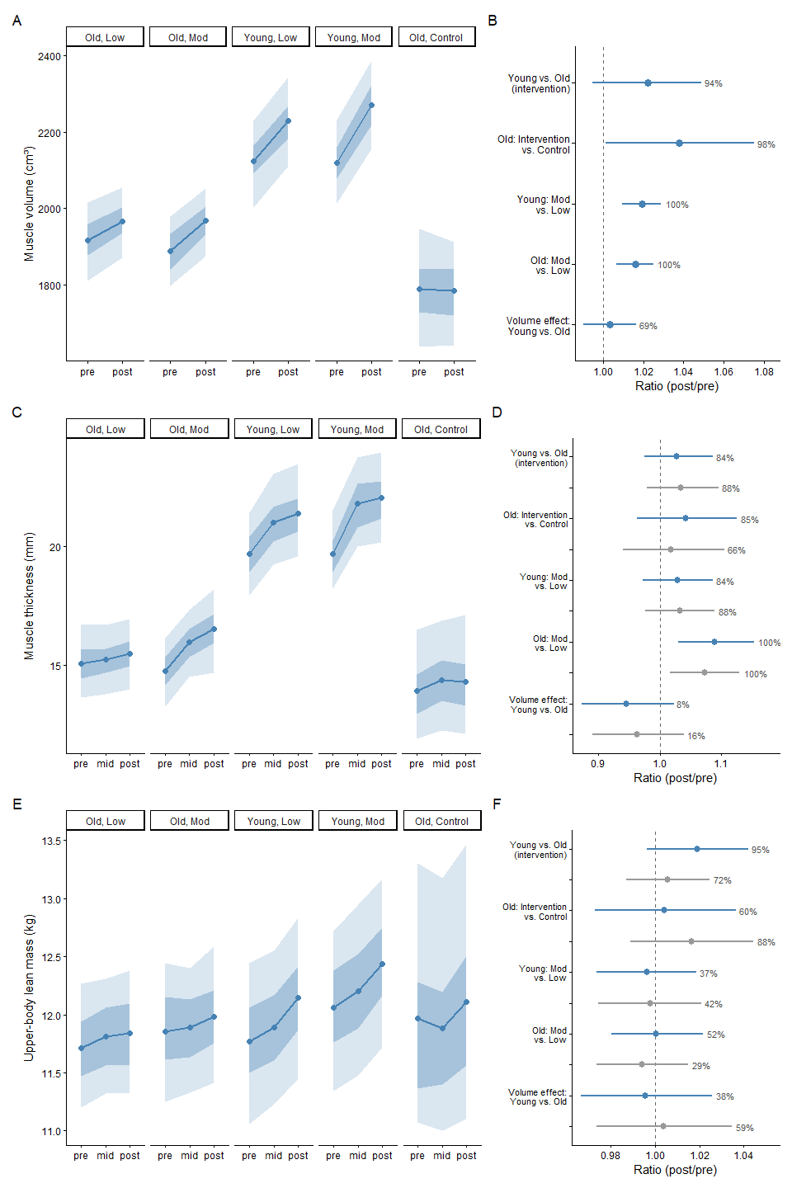

Figure 2: Body composition outcomes before, at the midpoint, and after the training intervention, by group. Muscle volume (A–B), muscle thickness (C–D), and upper-body lean mass (E–F) are shown for each group (old/young, low/moderate volume, and old control). Muscle volume was measured at two time points (pre, post); muscle thickness and upper-body lean mass were measured at three (pre, mid, post). Left panels (A, C, E): predicted values at each time point, with shaded ribbons representing the 50% and 90% credible intervals around the posterior mean (point and line). Right panels (B, D, F): posterior distributions for the same five key between-group and between-condition contrasts in each outcome — Young vs. Old (intervention), Old: Intervention vs. Control, Young: Mod vs. Low, Old: Mod vs. Low, and Volume effect: Young vs. Old — expressed as the ratio of change between the two groups or conditions being compared. For muscle thickness and upper-body lean mass, contrasts are shown at two time points: pre-to-mid change (grey) and pre-to-post change (blue); muscle volume was only measured at two time points, so only the pre-to-post contrast is shown. Points show the posterior mean ratio with 95% credible intervals; the dashed vertical line indicates no difference between groups (ratio = 1). Percentages indicate the posterior probability that the ratio exceeds 1 — i.e., the probability that the first-named group or condition in each comparison showed the larger increase in that outcome.

Thigh Muscle Volume
Overall, both young and old individuals showed credible increases in muscle volume following training (Figure 2A/B), ranging from ~3–7% depending on age group and condition. In young individuals, low-volume training was associated with a 5.0% increase (mean ratio = 1.05, 95% ETI [1.03, 1.07], pos > 99.9%), and moderate-volume training with a 7.0% increase (mean ratio = 1.07, 95% ETI [1.05, 1.09], pos > 99.9%). The moderate-volume increase was 1.9% larger than the low-volume increase (mean ratio = 1.02, 95% ETI [1.01, 1.03], pos > 99.9%). A similar pattern was observed in older individuals, where low-volume training was associated with a 2.9% increase (mean ratio = 1.03, 95% ETI [1.01, 1.05], pos = 99.9%), and moderate-volume training with a 4.6% increase (mean ratio = 1.05, 95% ETI [1.03, 1.07], pos > 99.9%) — a 1.6% difference between doses (mean ratio = 1.02, 95% ETI [1.01, 1.02], pos = 99.9%). The older intervention group increased muscle volume 3.8% more than the older control group (mean ratio = 1.04, 95% ETI [1.00, 1.08], pos = 97.9%), while the control group itself showed no credible change from baseline to post (mean ratio = 1.000, 95% ETI [0.970, 1.030], pos = 50.1%). Regarding age-related effects, there was moderate-to-strong evidence that young adults showed a larger relative increase in muscle volume than old adults in the intervention groups (mean ratio = 1.02, 95% ETI [0.994, 1.049], pos = 94.1%), although the 95% ETI still included the possibility of no difference. In contrast, there was little evidence that the volume-dose effect (moderate vs. low) itself differed between age groups (mean ratio = 1.00, 95% ETI [0.99, 1.02], pos = 69.3%), suggesting the dose-response advantage of moderate over low-volume training was broadly consistent across young and old adults.

Thigh Muscle Thickness
In muscle thickness (Figure 2C/D), both young and old individuals showed increases from baseline to post, with the young responding to both training doses and the old primarily to moderate-volume training. In young individuals, low-volume training was associated with an 8.9% increase (mean ratio = 1.09, 95% ETI [1.04, 1.14], pos > 99.9%), and moderate-volume training with a 12.1% increase (mean ratio = 1.12, 95% ETI [1.07, 1.18], pos > 99.9%), with the moderate-volume increase being 3% larger, though the direction was uncertain (mean ratio = 1.03, 95% ETI [0.97, 1.09], pos = 84.3%). A similar but more pronounced pattern was observed in older individuals, where low-volume training showed some evidence of a 3.2% increase (mean ratio = 1.03, 95% ETI [0.98, 1.08], pos = 90.7%), and moderate-volume training a clear 12.3% increase (mean ratio = 1.12, 95% ETI [1.07, 1.18], pos > 99.9%) — moderate-volume training producing an 8.9% larger increase than low-volume (mean ratio = 1.09, 95% ETI [1.03, 1.15], pos = 99.9%). The old control group showed a 3% increase from baseline to post, though the direction was uncertain (mean ratio = 1.03, 95% ETI [0.96, 1.11], pos = 83.2%), and the old intervention group’s increase was only marginally larger than control overall (mean ratio = 1.04, 95% ETI [0.96, 1.13], pos = 85.4%). As for age-related effects, there was weak evidence for a larger baseline-post increase in young compared to old (mean ratio = 1.03, 95% ETI [0.98, 1.09], pos = 83.9%). In contrast, the volume-dose effect (moderate vs. low) showed moderate evidence of being smaller in young than old adults — the opposite pattern to muscle volume — (mean ratio = 0.95, 95% ETI [0.87, 1.02], pos = 91.8%, i.e. pos = 8.2% for young > old).

Upper body lean mass
Upper-body lean mass (Figure 2E/F) increased from baseline to post in young individuals under both training doses, while evidence for an increase in older individuals was weaker and less consistent. In young individuals, low-volume training was associated with a 3.3% increase (mean ratio = 1.03, 95% ETI [1.01, 1.05], pos > 99.9%), and moderate-volume training with a 2.9% increase (mean ratio = 1.03, 95% ETI [1.01, 1.05], pos = 99.9%), with little evidence of a difference between doses (mean ratio = 1.00, 95% ETI [0.97, 1.02], pos = 37.4%). In older individuals, both low- and moderate-volume training showed some evidence of an increase — 1.1% for low-volume (mean ratio = 1.01, 95% ETI [0.99, 1.03], pos = 89.1%) and 1.2% for moderate-volume (mean ratio = 1.01, 95% ETI [0.99, 1.03], pos = 89.9%) — though the 95% ETI included the possibility of no change for both, and there was little evidence of a difference between doses (mean ratio = 1.00, 95% ETI [0.98, 1.02], pos = 52.3%). The old control group showed weaker evidence of an increase over the same period (mean ratio = 1.01, 95% ETI [0.98, 1.04], pos = 71.4%). As for age-related effects, there was moderate-to-strong evidence that young adults showed a larger baseline-post increase than old adults (mean ratio = 1.02, 95% ETI [1.00, 1.04], pos = 95.5%), although the 95% ETI still marginally included the possibility of no difference. There was little evidence of a difference between age groups in the effect of volume condition (mean ratio = 1.00, 95% ETI [0.97, 1.03], pos = 39.0%).

Isometric and Isokinetic Peak Torque
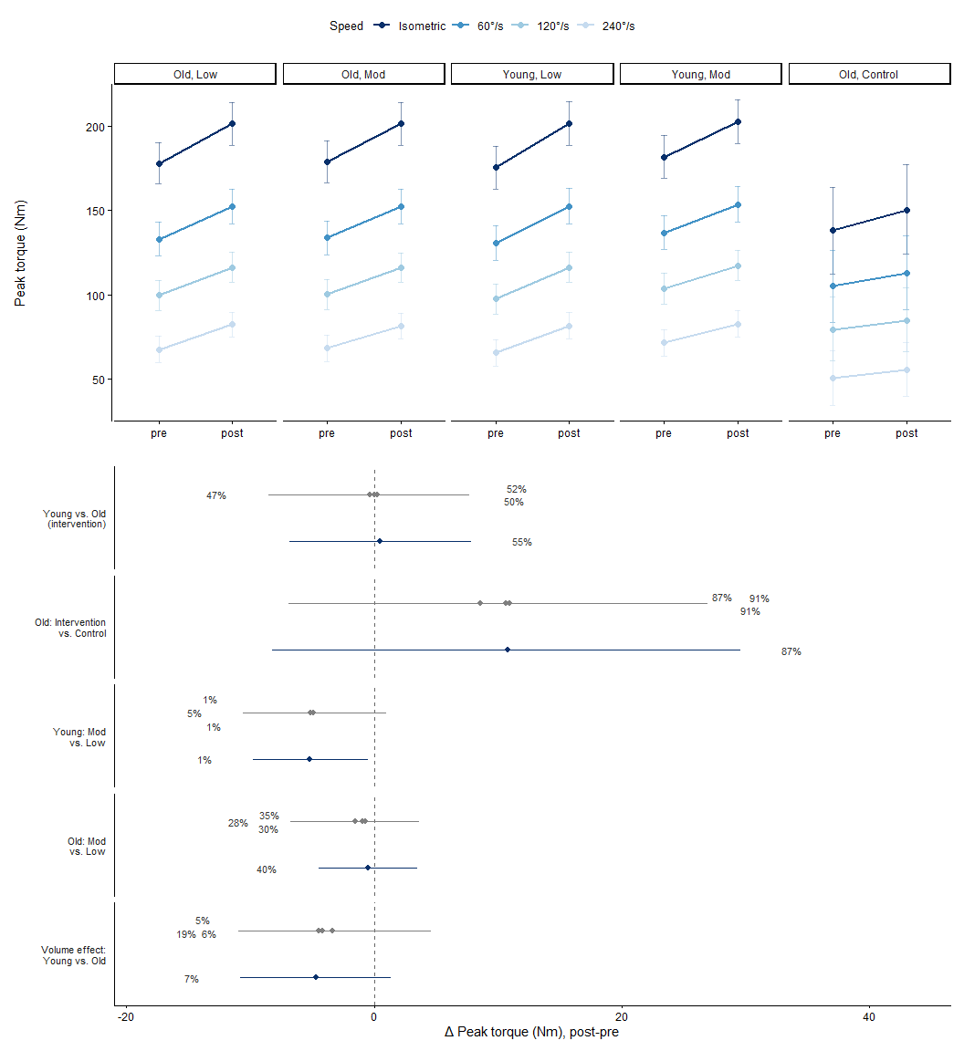
Figure 3: Isokinetic and isometric peak torque before and after the training intervention, by group and angular velocity. Top panel: predicted peak torque (Nm) at pre- and post-intervention, shown separately for each group (old/young, low/moderate volume, and old control) and at four angular velocities (isometric, 60°/s, 120°/s, 240°/s). Error bars represent the 95% credible interval around the posterior mean. Bottom panel: posterior distributions for the same five key between-group and between-condition contrasts used throughout — Young vs. Old (intervention), Old: Intervention vs. Control, Young: Mod vs. Low, Old: Mod vs. Low, and Volume effect: Young vs. Old — in the pre-to-post change in peak torque, shown separately for each angular velocity. Points show the posterior mean difference (Nm) with 95% credible intervals; the dashed vertical line indicates no difference between groups. Percentages indicate the posterior probability that the difference is positive — i.e., the probability that the first-named group or condition in each comparison showed the larger increase in peak torque.
All intervention groups showed clear increases in peak torque (Figure 3) from pre to post across every speed tested (pos > 99.7% throughout). In old low-volume, this ranged from 23.4 Nm at isometric (95% ETI [15.3, 31.6]) down to 14.7 Nm at 240°/s (95% ETI [7.5, 21.9]); a comparable pattern was observed in old moderate-volume (22.9 Nm isometric to 13.1 Nm at 240°/s), young low-volume (26.2 Nm to 16.0 Nm), and young moderate-volume (21.0 Nm to 11.1 Nm, pos = 99.7% at 240°/s — marginally lower than the other groups but still very strong evidence of an increase). Across all four groups, the magnitude of this pre-post increase attenuated progressively with speed, roughly halving between isometric and 240°/s. Comparing volumes within the old individuals, there was little evidence of a difference between moderate- and low-volume training at any speed — if anything, the point estimates weakly favored low-volume (isometric: mean = −0.5 Nm, 95% ETI [−4.5, 3.5], pos = 39.6%; 60°/s: pos = 35.2%; 120°/s: pos = 30.4%; 240°/s: mean = −1.5 Nm, 95% ETI [−6.8, 3.6], pos = 28.0%). In young individuals, by contrast, low-volume training produced a consistently larger pre-post increase in peak torque than moderate-volume training across all four speeds — a substantially stronger and more directionally consistent effect than in the old group (isometric: mean = 5.2 Nm greater for low-volume, 95% ETI [0.5, 9.8], pos = 98.6% for low > mod; 60°/s: pos = 99.2%; 120°/s: pos = 99.4%; 240°/s: mean = 4.9 Nm greater, 95% ETI [−1.0, 10.6], pos = 95.1%). The credible interval only marginally included zero at the fastest speed, where the evidence was still strong (95.1%) despite the wider interval.
Regarding age-related differences in the overall training response, there was essentially no evidence of a difference between young and old adults at any speed: isometric mean = 0.5 Nm greater in young (95% ETI [−6.9, 7.8], pos = 55.0%), 60°/s mean = 0.2 Nm (95% ETI [−6.9, 7.4], pos = 52.2%), 120°/s mean = 0.01 Nm (95% ETI [−7.1, 7.1], pos = 49.7%), and 240°/s mean = −0.3 Nm (95% ETI [−8.5, 7.7], pos = 46.9%) — the posterior probability sat essentially at chance throughout, indicating young and old adults responded similarly overall despite the opposite within-group dose patterns described above. The volume-dose effect (moderate vs. low) itself differed by age, consistent with the opposing within-group patterns already noted: the moderate-vs-low difference was more negative in young than in old adults at each speed, with moderate-to-strong evidence at the slower speeds — isometric mean = −4.7 Nm (95% ETI [−10.8, 1.4], pos = 6.6% for young > old, i.e. 93.4% for old > young), 60°/s mean = −4.5 Nm (95% ETI [−10.0, 1.0], pos = 5.4%), 120°/s mean = −4.2 Nm (95% ETI [−9.4, 1.1], pos = 5.8%) — weakening at the fastest speed (240°/s mean = −3.4 Nm, 95% ETI [−11.0, 4.6], pos = 18.9%). Comparing intervention to control, there was moderate-to-strong evidence that the older intervention groups showed a larger pre-post increase than the older control group at every speed, though the credible interval included zero throughout: isometric mean = 10.8 Nm greater (95% ETI [−8.2, 29.6], pos = 87.2%), 60°/s mean = 11.0 Nm (95% ETI [−5.5, 26.9], pos = 91.2%), 120°/s mean = 10.7 Nm (95% ETI [−5.1, 26.2], pos = 91.3%), and 240°/s mean = 8.6 Nm (95% ETI [−6.9, 24.0], pos = 86.9%). The control group showed a smaller increase that did not reach the same level of confidence, though there was still moderate-to-strong evidence of some increase rather than no change: 12.3 Nm at isometric (95% ETI [−4.9, 29.7], pos = 91.8%), weakening somewhat at higher speeds (8.0 Nm at 60°/s, pos = 86.0%; 5.4 Nm at 120°/s, pos = 77.3%; 5.3 Nm at 240°/s, pos = 77.1%).

1RM Leg Press
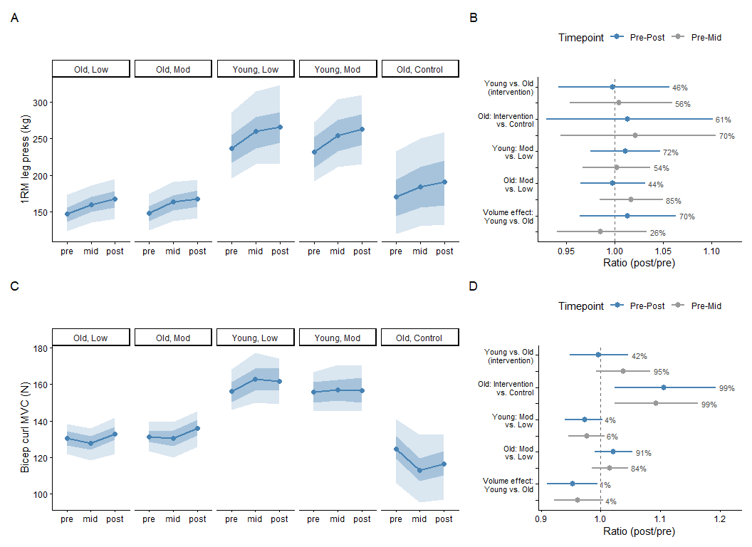
Figure 4: 1RM leg press and bicep curl maximum voluntary contraction (MVC) before, at the midpoint, and after the training intervention, by group. 1RM leg press (A–B) and bicep curl MVC (C–D) are shown for each group (old/young, low/moderate volume, and old control). Left panels (A, C): predicted 1RM leg press (kg) and bicep curl MVC (N) at pre-intervention, mid-intervention, and post-intervention. Shaded ribbons represent the 50% and 90% credible intervals around the posterior mean (point and line). Right panels (B, D): posterior distributions for the same five key between-group and between-condition contrasts in each outcome — Young vs. Old (intervention), Old: Intervention vs. Control, Young: Mod vs. Low, Old: Mod vs. Low, and Volume effect: Young vs. Old — shown at two timepoints: pre-to-mid change (grey) and pre-to-post change (blue), expressed as the ratio of change between the two groups or conditions being compared. Points show the posterior mean ratio with 95% credible intervals; the dashed vertical line indicates no difference between groups (ratio = 1). Percentages indicate the posterior probability that the ratio exceeds 1 — i.e., the probability that the first-named group or condition in each comparison showed the larger increase in that outcome.
All groups showed clear increases in 1RM leg press (Figure 4A/B) from pre to post, ranging from roughly 12–13% (pos > 99.9% for all four intervention groups). Young individuals increased 12.2% with low-volume training (mean ratio = 1.12, 95% ETI [1.07, 1.17]) and 13.4% with moderate-volume training (mean ratio = 1.13, 95% ETI [1.08, 1.19]). Old individuals increased 13.3% with low-volume training (mean ratio = 1.13, 95% ETI [1.08, 1.18]) and 13.0% with moderate-volume training (mean ratio = 1.13, 95% ETI [1.08, 1.18]). The control group also showed a clear 11.9% increase (mean ratio = 1.12, 95% ETI [1.04, 1.20], pos = 99.9%). Comparing volumes, there was little evidence of a difference between moderate- and low-volume training in older adults (mean ratio = 1.00, 95% ETI [0.97, 1.03], pos = 44.1%), but some evidence of a larger increase with moderate-volume training in young adults (mean ratio = 1.01, 95% ETI [0.98, 1.05], pos = 72.8%), though the ETI included the possibility of no difference. Comparing intervention to control in older adults, there was a weak lean toward a larger increase in the intervention groups, though the evidence was limited (mean ratio = 1.01, 95% ETI [0.93, 1.10], pos = 61.3%). There was little evidence of a difference between age groups overall (mean ratio = 1.00, 95% ETI [0.94, 1.06], pos = 44.9%), but some evidence that the volume-dose effect (moderate vs. low) was larger in young than old adults (mean ratio = 1.01, 95% ETI [0.97, 1.06], pos = 71.2%), consistent with the direction of the young volume-dose finding above.

Bicep Curl MVC
In older individuals, both training doses showed evidence of a pre-post increase in bicep curl MVC (Figure 4 C/D), with moderate-volume training producing a clearer effect: a 4.0% increase (mean ratio = 1.04, 95% ETI [1.00, 1.08], pos = 98.0%) compared to a 2.0% increase with low-volume training (mean ratio = 1.02, 95% ETI [0.98, 1.06], pos = 85.5%). Comparing the two doses directly, there was moderate-to-strong evidence favoring moderate-volume training in older adults (mean ratio = 1.02, 95% ETI [0.99, 1.05], pos = 90.6%), consistent with the dose-response pattern seen in muscle volume and thickness. In young individuals, low-volume training showed strong evidence of an increase — a 3.9% change (mean ratio = 1.04, 95% ETI [1.00, 1.08], pos = 97.4%), nearly as strong as the old moderate-volume finding despite the ETI marginally including 1.00 — while moderate-volume training showed weaker evidence of an increase (mean ratio = 1.01, 95% ETI [0.97, 1.05], pos = 70.7%). Unlike in older adults, comparing doses directly showed strong evidence favoring low-volume over moderate-volume training in young individuals (mean ratio = 0.97, 95% ETI [0.94, 1.00], pos = 95.1% for low > mod), the opposite pattern to older adults, and also opposite to the direction seen for this age group in muscle volume and thickness. The control group showed a credible 6.5% decrease from baseline to post (mean ratio = 0.94, 95% ETI [0.88, 0.99]), a clear decline rather than an absence of change. Reflecting this control-group decline, older individuals in the intervention groups showed a credible 10.2% larger change than controls (mean ratio = 1.10, 95% ETI [1.02, 1.18]). A credible difference in the volume-dose effect between age groups was also observed: young individuals showed a 4.6% smaller volume-related change than older individuals (mean ratio = 0.95, 95% ETI [0.91, 1.00]), consistent with, and likely driven by, the opposite-direction dose effects just described in each age group separately. There was little evidence of a difference between age groups in overall pre-post change (mean ratio = 1.00, 95% ETI [0.95, 1.04], pos = 42.5%).
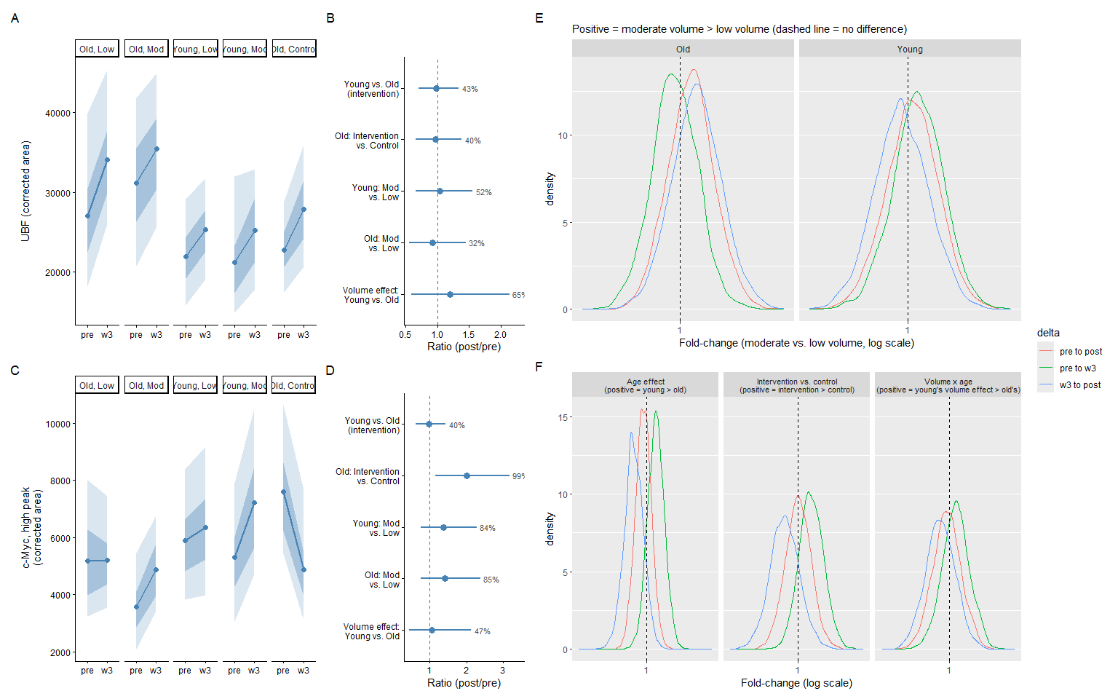
Figure 5: UBF and c-Myc (high peak, ~60 kDa) protein content, and total RNA yield, before and 3 weeks into (and after, where applicable) the training intervention. UBF (A–B) and c-Myc, high peak (C–D) are shown by group; total RNA fold-change contrasts (E–F) are shown separately, after accounting for tissue mass and technical replicate variance. Panels A and C: predicted corrected area (arbitrary units) for UBF and c-Myc respectively, at pre-intervention and week 3, shown separately for each group (old/young, low/moderate volume, and old control). Shaded ribbons represent the 50% and 90% credible intervals around the posterior mean (point and line). Panels B and D: posterior distributions for the same five key between-group and between-condition contrasts used throughout — Young vs. Old (intervention), Old: Intervention vs. Control, Young: Mod vs. Low, Old: Mod vs. Low, and Volume effect: Young vs. Old — expressed as the ratio of week 3-to-pre change between the two groups being compared, for UBF and c-Myc respectively. Points show the posterior mean ratio with 95% credible intervals; the dashed vertical line indicates no difference between groups (ratio = 1). Percentages indicate the posterior probability that the ratio exceeds 1 — i.e., the probability that the first-named group or condition in each comparison showed the larger increase. Panels E and F: posterior fold-change distributions (log scale) for group and time-window contrasts in total RNA yield; the dashed vertical line at 1 indicates no difference. Colors denote the time window being contrasted (pre-to-w3, w3-to-post, pre-to-post). Panel E shows the effect of training volume (moderate vs. low) within each age group — densities are centered near 1 across all time windows in both old and young participants, indicating no credible volume-dependent effect on RNA trajectory. Panel F shows the age effect (young vs. old, averaged across volume conditions), old intervention vs. old control, and the volume × age interaction — the age effect and intervention-vs-control contrasts show visible separation from 1 during the pre-to-w3 and w3-to-post windows, in opposite directions, but converge near 1 for the overall pre-to-post comparison, reflecting a difference in the timing rather than total magnitude of the RNA response; the volume × age contrast remains centered near 1 throughout, showing no evidence that the (null) volume effect differs by age.

Protein
UBF
UBF protein content (Figure 5A/B) showed numerically similar increases from baseline to week 3 across all groups, including the control group. Several groups showed meaningful directional evidence: the control group showed the strongest evidence of an increase of any group (25.7%, mean ratio = 1.26, 95% ETI [0.93, 1.64], pos = 93.5%), followed by old low-volume training (28.7%, mean ratio = 1.28, 95% ETI [0.90, 1.77], pos = 90.7%). Young low-volume (15.6%, mean ratio = 1.16, 95% ETI [0.86, 1.53], pos = 82.7%) and young moderate-volume (18.2%, mean ratio = 1.18, 95% ETI [0.84, 1.62], pos = 81.9%) showed weaker but still moderate evidence of an increase, while old moderate-volume showed the weakest evidence among the intervention groups (14.4%, mean ratio = 1.14, 95% ETI [0.81, 1.56], pos = 76.7%). There was little evidence of a difference between age groups (mean ratio = 0.98, 95% ETI [0.70, 1.35], pos = 41.2%) or between old intervention and old control (mean ratio = 0.97, 95% ETI [0.66, 1.39], pos = 39.8%) — consistent with the control group’s own strong evidence of change noted above. Comparing training doses, there was essentially no evidence of a difference in young individuals (mean ratio = 1.04, 95% ETI [0.67, 1.57], pos = 52.8%), while in old individuals there was a weak lean toward low-volume producing the larger change (mean ratio = 0.92, 95% ETI [0.56, 1.43], pos = 31.9%, i.e. 68.1% favoring low > moderate). The volume-dose effect showed a weak lean toward being larger in young than old adults (mean ratio = 1.20, 95% ETI [0.59, 2.17], pos = 65.6%), the largest point estimate among the interaction contrasts, but with very wide uncertainty.
c-Myc
Three of the four intervention groups showed evidence of an increase in c-Myc (high peak, Figure 5C/D) protein content from baseline to week 3. Old moderate-volume training showed the strongest evidence, a 48.8% increase (mean ratio = 1.49, 95% ETI [0.94, 2.21], pos = 95.3%), with young moderate-volume training showing a similarly strong, if somewhat smaller, increase of 36.6% (mean ratio = 1.37, 95% ETI [0.88, 2.02], pos = 90.4%). Old low-volume (8.7%, mean ratio = 1.09, 95% ETI [0.69, 1.63], pos = 60.3%) and young low-volume (4.0%, mean ratio = 1.04, 95% ETI [0.70, 1.49], pos = 53.7%) showed much smaller increases with little supporting evidence, closer to a genuine null. In contrast, the control group showed strong evidence of a 34.3% decrease (mean ratio = 0.66, 95% ETI [0.44, 0.96], pos = 98.5% for a decrease). This divergence between the moderate-volume intervention groups and the declining control group produced strong evidence of a difference between old intervention and old control overall (mean ratio = 1.99, 95% ETI [1.15, 3.24], pos = 99.3%), with old intervention participants showing a substantially larger week-3 change than old control participants. Comparing training doses, there was moderate-to-strong evidence favoring moderate-volume training over low-volume in both old (mean ratio = 1.43, 95% ETI [0.77, 2.39], pos = 86.2%) and young adults (mean ratio = 1.36, 95% ETI [0.75, 2.24], pos = 83.8%). There was little evidence of a difference between age groups in overall change (mean ratio = 0.96, 95% ETI [0.61, 1.43], pos = 38.6%, i.e. 61.5% favoring old), nor in the volume-dose effect between age groups (mean ratio = 1.03, 95% ETI [0.44, 2.09], pos = 45.6%).

Total RNA
Total RNA yield (Fig 5 E/F) increased sub-proportionally with tissue mass on the log-log scale (β = 0.83–0.86 across all model iterations, 95% ETI excluding 1 throughout), rather than the strictly proportional relationship assumed by a fixed RNA/mg ratio. This slope was stable regardless of model complexity or whether technical replicate structure was accounted for, indicating it reflects a genuine property of the tissue rather than an artifact of model specification. After accounting for tissue mass and technical replicate variance, RNA yield increased from pre to week 3 in most intervention groups: old low-volume (fold-change = 1.10, 95% ETI [0.99, 1.22], pos = 96.7%), old moderate-volume (fold-change = 1.08, 95% ETI [0.98, 1.21], pos = 93.1%), young low-volume (fold-change = 1.16, 95% ETI [1.02, 1.29], pos = 99.2%), and young moderate-volume (fold-change = 1.19, 95% ETI [1.06, 1.33], pos = 99.8%). The control group showed no credible change over this window (fold-change = 0.99, 95% ETI [0.85, 1.15], pos = 45.0%). From week 3 to post, this pattern reversed: the old groups continued to rise, credibly for moderate-volume (fold-change = 1.07, 95% ETI [0.95, 1.20], pos = 86.5%) and with a weaker lean for low-volume (fold-change = 1.02, 95% ETI [0.91, 1.15], pos = 61.8%), while both young groups showed a weak-to-moderate lean toward decline (low-volume: fold-change = 0.96, 95% ETI [0.84, 1.10], pos = 26.2%; moderate-volume: fold-change = 0.94, 95% ETI [0.83, 1.07], pos = 17.6%). The control group showed a strong increase over this same window (fold-change = 1.15, 95% ETI [0.95, 1.37], pos = 92.4%). By post, all four intervention groups showed a credible net increase from baseline: old low-volume (fold-change = 1.13, 95% ETI [1.02, 1.25], pos = 99.1%), old moderate-volume (fold-change = 1.16, 95% ETI [1.04, 1.29], pos = 99.6%), young low-volume (fold-change = 1.11, 95% ETI [0.99, 1.24], pos = 96.1%), and young moderate-volume (fold-change = 1.12, 95% ETI [1.00, 1.25], pos = 96.7%). The control group also showed a strong net increase (fold-change = 1.13, 95% ETI [0.97, 1.33], pos = 93.6%), comparable in magnitude to the intervention groups despite its markedly different time-course. Overall, the time-dependent RNA increase was broadly consistent across groups by the end of the study, though the timing of that increase differed substantially between groups.
The direction of the age-related difference in RNA trajectory reversed across the study period; from pre to week 3, younger participants showed a strong lean toward a larger increase than older participants (fold-change = 1.07, pos = 87.4%), but from week 3 to post older participants showed a weak-to-moderate lean toward a larger increase (fold-change = 0.91 for young vs. old, pos = 89%, i.e. pos = 91.1% in the old-favoring direction). The net pre-to-post age difference was a genuine null (fold-change = 0.98, pos = 33.4%). A similar timing-dependent pattern emerged when comparing the old intervention groups against the old control. From pre to week 3, the intervention groups showed a strong lean toward a larger increase than control (fold-change = 1.10, pos = 87.4%), while from week 3 to post this reversed, with control showing a moderate-to-strong lean toward catching up (fold-change = 0.91 for old vs. control, pos = 19.6%, i.e. pos = 80.4% in the control-favoring direction). The net pre-to-post comparison was a genuine null (fold-change = 1.01, pos = 53.2%), indicating that intervention and control groups reached a similar overall RNA increase by the end of the study, achieved via different time-courses. No credible evidence was found for an effect of training volume (moderate vs. low) on RNA trajectory in either age group, at any time window (pos = 40–73%), nor for the volume effect differing by age (volume × age, pos = 28–68%).

RNA seq
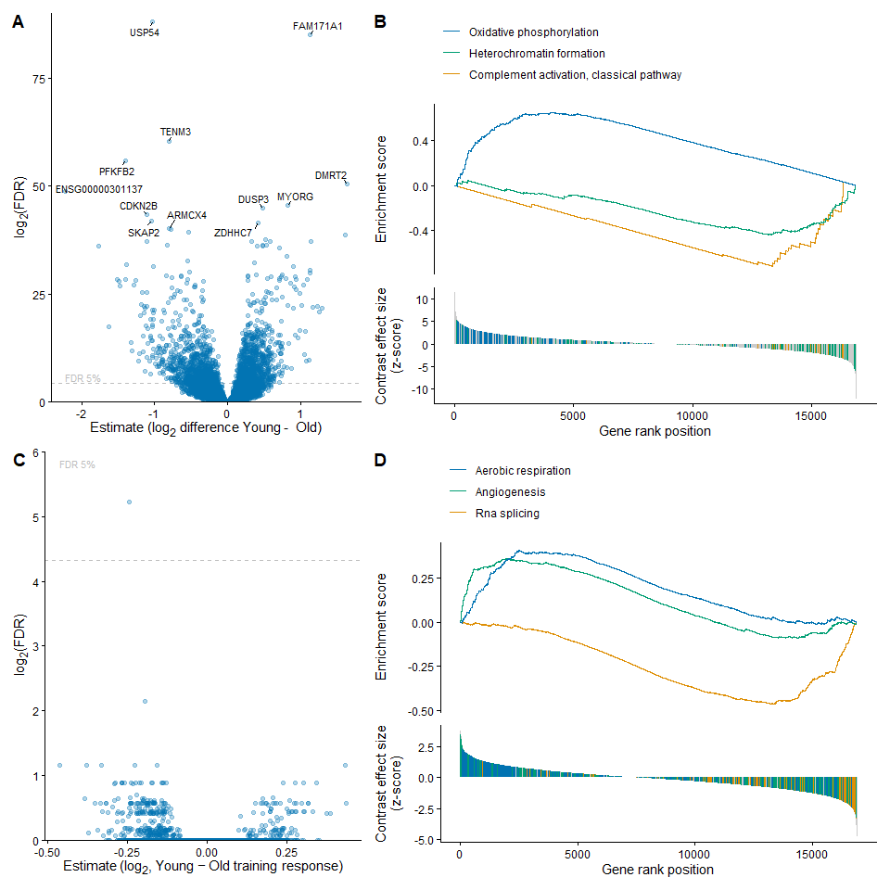
Figure 6: Baseline and training-related transcriptional differences between age groups. (A) Baseline age differences (Young − Old): volcano plot of gene-level estimates (log₂ fold-change) against FDR (log₂ scale), with the dashed line marking FDR = 5%. Genes with the strongest evidence of differential expression are labeled. (B) Rank-based gene-set enrichment analysis (GSEA) of the baseline age contrast, showing the running enrichment score (top) and per-gene contrast effect size (z-score, bottom) across gene rank position, for three representative gene sets (oxidative phosphorylation, heterochromatin formation, complement activation, classical pathway). (C) Age × training-response difference (Young − Old): volcano plot of gene-level estimates for the interaction contrast, in the same format as (A). (D) GSEA of the age × training-response interaction contrast, in the same format as (B), for three representative gene sets (RNA splicing, angiogenesis, aerobic respiration).
Comparing gene-expression profiles between age groups at baseline (Young − Old) revealed marked differences, with 2082 genes showing robust differences between the groups (FDR < 5%, Fig 6A/B). Rank-based gene-set enrichment analysis^{xu2024a?} indicated that young participants had relatively higher expression of genes related to aerobic energy metabolism (oxidative phosphorylation) and relatively lower expression of genes related to immune system activation (complement activation, classical pathway) and epigenetic regulation of gene expression (heterochromatin formation). Training induced a large, broad transcriptional response in both age groups: 3503 genes changed from baseline to post in young participants, and 4241 in old participants (FDR < 5%, Fig 6C/D). Individual genes with the strongest training-induced changes were predominantly collagen and basement-membrane genes in both groups (e.g., COL4A1, COL4A2, LAMB1, PXDN in young; COL4A1, LAMA4, COL3A1, COL1A2, SPARC in old).
Rank-based gene-set enrichment analysis^{xu2024a?} showed that the dominant biology of the training response was similar between age groups: 6 of the top 10 enriched categories were shared, with matching direction and comparable magnitude in both young and old (RNA splicing, ribonucleoprotein complex biogenesis, integrin-mediated signaling pathway, cell adhesion mediated by integrin, collagen metabolic process, and mRNA transport). Training up-regulated genes related to ECM/connective tissue remodeling (e.g., integrin-mediated signaling and adhesion, collagen metabolic process) and down-regulated genes related to RNA-processing and ribosome biogenesis (e.g., RNA splicing, ribonucleoprotein complex biogenesis, mRNA transport) in both groups. While essentially no genes (1 gene at 5% and 0 at 1%) showed a statistically significant age-dependent training response after FDR correction, gene-set enrichment analysis of the age × time interaction contrast revealed that the magnitude of the shared training response differed somewhat between age groups in specific processes: the down-regulation of RNA splicing and related mRNA-processing categories was more pronounced in young than old, while the up-regulation of angiogenesis and aerobic respiration/cellular respiration categories was more pronounced in young than old.
A smaller set of categories differed by age: young participants showed additional enrichment for cytoplasmic translation, mesenchymal cell migration, and angiogenesis, while old participants showed additional enrichment for coagulation- and vascular-related categories. In contrast to the broadly age-independent training effect, the effect of training volume (moderate vs. low) was age-dependent: a substantial number of genes differed by volume in old participants (1216 genes, FDR < 5%), while essentially no genes showed a volume effect in young participants. Among old participants, higher training volume was associated with relatively higher expression of genes related to mitochondrial biogenesis and oxidative metabolism (e.g., inner mitochondrial membrane organization, respiratory electron transport chain, purine-containing compound biosynthesis) and relatively lower expression of genes related to muscle contractile function and translation (e.g., skeletal muscle contraction, cytoplasmic translation, muscle organ development, striated muscle cell differentiation, ribosomal small subunit biogenesis). This volume effect was considerably more modest than the main training effect, both in the number of genes involved and in statistical strength.

Oral Glucose Tolerance Test
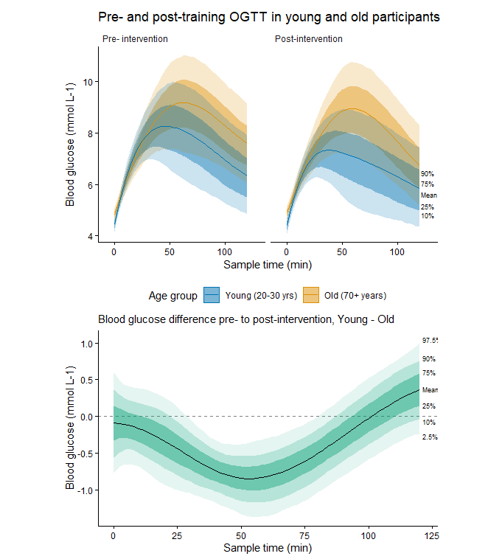
Figure 7: Oral glucose tolerance test (OGTT) responses before and after the training intervention, by age group. Top panels: blood glucose concentrations (mmol L⁻¹) across the 2-hour sampling period, shown for pre-intervention (left) and post-intervention (right) timepoints, in young (20–30 years) and old (70+ years) participants. Shaded ribbons represent the 10th, 25th, 75th, and 90th percentiles of the posterior distribution around the mean (solid line). Bottom panel: the estimated difference in training-induced change in blood glucose (post minus pre) between young and old participants, across the sampling period. Shaded ribbons represent the 2.5th, 10th, 25th, 75th, 90th, and 97.5th percentiles of the posterior distribution around the mean difference (solid line); the dashed horizontal line indicates no difference between age groups.
Both young and old participants showed reductions in the post-intervention glucose response relative to pre-intervention, but the magnitude of this training-induced change differed by age across part of the sampling window. The 95% credible interval for the young-minus-old difference excluded zero between 30 and 78 minutes post-ingestion, indicating a credible age-related difference in training response during this period, with young participants showing a greater reduction in blood glucose than old participants. The largest divergence between age groups occurred at 54 minutes (mean difference = -0.85 mmol/L, 95% ETI [-1.34, -0.36]), where the young participants’ post-intervention glucose values were reduced substantially more than old participants’ at the corresponding timepoint.
Outside this window, the young-old difference was not credible: before 30 min the point estimate trended in the same direction (greater reduction in young), but the 95% interval consistently spanned zero. After 78 min the interval widened further and the point estimate briefly crossed to the opposite sign, consistent with the age-related difference no longer being detectable by the end of the 2 h window.
For old intervention participants compared to old controls, the training-induced reduction in glucose was credible from 38 min onward and remained credible through the end of the sampling window (120 min), with old intervention participants showing a lower post-training glucose response than old controls throughout this period (mean difference at 120 min = -0.73 mmol/L, 95% ETI [-1.48, -0.02]).

Exercise Volume Load
Moderate volume exercise was estimated to ~2.8× higher than low in both age groups (young mod: 137438.7 ± 54491.7 kg, young low: 50693.5 ± 25707.7 kg, old mod: 118124.8 ± 38224.6 kg, old low: 42134.1 ± 14352.5 kg).

Discussion
This study aimed to compare muscle mass and strength accretion in healthy young and old individuals that exercised with a low and moderate training volume for 10 weeks. In addition, secondary aims were to provide insight into the effects of said intervention on ribosome biogenesis and glucose tolerance. Overall, both young and old participants in the intervention responded in terms of muscle growth and -strength, also improving their tolerance to glucose ingestion. There was weak to strong evidence that the young participants had a larger gain in measures of muscle mass compared to old, but this was mostly limited to muscle mass measurements. In terms of low vs. moderate condition, both young and old had clear benefits of a moderate training volume in muscle volume, but this was less clear in muscle thickness for the young. In upper-body lean mass, young clearly increased following both doses, but there were only weak/uncertain evidence of the same for old. In strength however, the young responded better to low vs. moderate volume at all angular velocities of isometric and isokinetic peak torque and bicep curl MVC, with no difference in 1RM. The old showed no clear dose difference in strength measures apart from bicep curl MVC, where moderate-volume training was favoured. There was however a clear and credible difference between young and old regarding their glucose tolerance, where young improved more than the old. Both young and old intervention groups increased content of total RNA, though at different times (young at week 3, old at post), UBF and c-Myc, however old control also increased content of UBF. Lastly, the RNA-seq data showed a clear difference between young and old at baseline, which turned remarkably similar after training.
While it has been suggested that older adults can gain similar improvements in both muscle mass and -strength as young [FRAGALA19], this was not clearly evident in the present study. The young participants had larger gains from pre to post in thigh muscle volume and upper-body lean mass, with some weaker evidence of the same for muscle thickness, compared to the old. However, this was not true for muscle strength, where young and old had largely similar pre to post changes across the board. Hypertrophy attenuation in older individuals (~60+ years) is a broadly used statement [BETZ25, ENDO20, STEC17], likely stemming from the classic MRI CSA study by Welle and co-workers [WELLE96], where they found that older individuals (62-72yrs) experienced lesser training-induced increases in skeletal muscle CSA in the elbow and knee flexors compared to young. However, Welle et al. also found no difference in skeletal muscle CSA between young and old in the knee extensors. In terms of strength, older individuals increased similarly to young in elbow flexors and knee extensors, and in fact surpassed young in knee flexor strength, when strength was analysed as relative change in specific tension (strength per cm2 of CSA) [WELLE96]. Based on this, while hypertrophy attenuation was present in certain skeletal muscle, it was not universal, and despite less hypertrophy, older individuals had similar and even larger gains in specific tension strength [WELLE96]. An important point here, was that hypertrophy was not universal to all skeletal muscle groups, and a later work by Greig et al. [GREIG2011] noted that the litteratur was quite equivocal on this topic, either finding skeletal muscle mass in old to be less responsive [WELLE96, KOSEK06] or similar to young [IVEY00]. Furthermore, recent work find no decline in the potential for muscle hypertrophy [KARLSEN20] or no substantial influence of age on muscle hypertrophy response to resistance training [DE SANTANA24]. Among the studies that have compared young and old head-to-head to this date, the results are inconclusive at best, with some finding less myofiber hypertrophy in old compared to young [PETRELLA06, KOSEK06], less myofiber hypertrophy but similar strength gains [BICKEL11, RAUE09], or less myofiber hypertrophy and strength after 10.5 weeks, where muscle strength caught up after 21 weeks [MERO13]. Taken together, most studies measuring hypertrophy in knee extensors via whole-muscle volume MRI find no age effect [WELLE96, IVEY00, KARLSEN20, DE SANTANA24], with the exceptions being the findings of Raue et al. [RAUE09] and Welle and co-workers data on knee and elbow flexors [WELLE96]. When hypertrophy is measured on the fiber level though, this flips, and most studies find an attenuation in old compared to young [KOSEK06, PETRELLA06, BICKEL11, MERO13], the exception here being Karlsen et al. (2020). In this regard, our data does not show a definitive age effect on training-induced hypertrophy, though the moderate-to-strong evidence that thigh muscle volume and upper-body lean mass increased more in young compared to old does indicate that an age effect was more likely than not.
While there was moderate evidence of an age effect on muscle hypertrophy, there was none for muscle strength, which lines up well with previous findings where old individuals may lag behind in hypertrophy but not in strength [WELLE96, BICKEL11, MERO13] or where both change similarly [RAUE09]. The most common explanation for a discrepancy between skeletal muscle hypertrophy and -strength, is that neural adaptation drives the early stage strength gain, while hypertrophy is lagging behind [SOURCES]. This does not fully apply here, since both young and old had gains in muscle mass and -strength, only the young had larger gains in muscle mass than old. Therefore, the old participants in the present study effectively gained similar increases in strength, with less changes in muscle mass, indeed corroborating that hypertrophy and strength does not have a 1:1 relationship. This was addressed previously by Reggiani and Schiaffino [REGGIANI20], arguing that there are three possible relationships between size change and strength change; strength can increase in proportion to, less or more than size. At the core of this concept, lies the idea that not all muscle growth is forceful, where the proportion between sarcoplasmic proteins and myofibrillar proteins can be altered during hypertrophy, producing a higher or lower density of actual force-generating molecular motors per unit of muscle size [REGGIANI20]. Therefore, theres no given % of CSA, muscle volume, lean mass that grant a proportional increase in the contractile machinery, some of the gain could be sarcoplasmic rather than myofibrillar [REGGIANI20]. Alternatively or additionally, it could stem from myosin isoform shifts and post-translational changes to the contractile machinery, affecting force generation independent of size [REGGIANI20]. Notably, myofibrillar vs. sarcoplasmic hypertrophy, myosin isoform shifts and post-translational changes are less, if at all, explored in young vs. old participants, but the notion that the skeletal muscle mass can get stronger without the same growth in size at least seems like a plausible explanation for why the old in the present study increased similarly in strength, but not size, compared to the young. Further complicating this, is that the old control group also improved several strength measures, namely the 1RM leg press, isometric and isokinetic variables. Only the 1RM change in the control group could be categorized as credible and a strong effect, while the peak torque data showed moderate evidence of a real change (not credible) at the slowest angular velocity, which weakened with increasing angular velocities. One possible explanation for this could be the well-known learning effect [SORUCE], since the present study only had 1 familiarization test prior to pre testing. If that was the only explanation though, it does not make sense that the control group decreased their bicep curl MVC credibly from pre to post.
In broad strokes, moderate-volume training was most beneficial in the hypertrophy outcomes (muscle volume, muscle thickness), for both age groups. However, looking at strength outcomes, there were more cases of low-volume training being more beneficial (peak torque, bicep curl MVC) for the young, while the old either show no difference (peak torque) or a benefit from moderate over low-volume training (bicep curl MVC). In terms of 1RM leg press and upper-body lean mass, we saw no evidence of a difference in either age group. Most studies investigating the effects of training volume on muscle mass and/or -strength, tend to find that a moderate-training volume benefits both size and strength [KRIEGER09/10, HAMMARSTROM20, ROCHA23,CHEN23, LIXANDRAO24], where Hammarström et al. demonstrated that young benefited more from a moderate volume in both muscle mass and strength, a contrast to our findings that low-volume training was more beneficial. A similar pattern to the present study was observed by Da Silva et al. [DA SILVA18], where more training volume improved hypertrophy compared to low, but no additional gain in strength/neuromuscular outcomes. Da Silva et al. (2018) notably only had old participants, and the volume manipulation was done through one group performing repetitions to failure, two groups performing submaximal repetitions, one of which doubled the amount of sets the repetitions to failure group had. Further, a recent mate-regression by Pelland et al. [PELLAND24] found a clear positive effect of volume on both hypertrophy and strength (posterior probability of 100%), but also deminishing returns in both, where he diminishing returns for strength was considerably more pronounced than for hypertrophy. As such, it seems hypertrophy could be more volume-sensitive than strength, with some evidence of strength not always following hypertrophy after increasing training volume [PELLAND24]. This could be corroborated by that strength saturates at a much lower training dose, as seen when comparing Schoenfeld et al. (2017), where volume reached a significant effect on hypertrophy at 10+ sets/week, against Krieger (2009), where strength gains only required 2-3 sets per session. Also of interest, Schoenfeld [SCHOENFELD17] found the opposite pattern when manipulating training load rather than volume, where strength was clearly load dependent and hypertophy insensitive. Furthermore, in 2019, Schoenfeld recruited 34 resistance-trained men randomized to low-volume, moderate-volum, or high-volume training, and found that while all groups experienced similar gains in muscle strength and endurance, muscle hypertrophy significantly increased with higher training volumes [SCHOENFELD19]. Thus, one could argue that the this field is quite equivocal, but that may very well stem from the wide spread in study designs.
Many of the aforementioned studies differ in population or duration, manipulate volume or intensity differently, or investigate old and young separately. The two studies including both young and old differ substantially in design, where one first implemented a volume/dose model in the maintenance phase [BICKEL11], while the other manipulated training intensity rather than training volume [LETOCART21]. Bickel et al. (2011) recruited 39 young (20-35yrs) and 31 old (60-75yrs) untrained individuals to a 16 week progressive RT program, with a 32 week detraining/maintenance training period. In the maintenance period, one group was assigned to detraining, one group to a third of the initial volume via reduced training frequency (1 session, down from 3x/w), and one group to a ninth of the initial volume via reduced sets (1 set, down from 3) and training frequency (1 session, down from 3x/w). Following this, Bickel et al. (2011) found similar relative strength gains but greater hypertrophy gains in young compared to old, during the 16-week training program, and also an equally sustained enhancement of muscle performance during the detraining/maintenance phase, while maintenance of muscle mass gains required more frequent dosing in the old. Letocart et al. (2021) recruited 11 recreationally active men and 35 sedentary elderly men to a 12-week resistance program where the young exercised with a moderate-load training intervention corresponding to 55% of 1RM, while the old were randomly assigned to either moderate (55%) or high-load (80% of 1RM). They exercised three times a week, with three exercises for the lower extremities. Letocart et al. (2021) found that the old exercising with a moderate training intensity gained more m. quadriceps and m. triceps surae volume compared to the young, with no difference between old exercising with moderate- or high-intensity. Our findings align with Bickel et al. (2011) where greater hypertrophy gains were observed in young compared to old, and moderate-volume training being more beneficial in this regard, and none of these, or the aforementioned volume-manipulating studies have found low-volume to outperform moderate-volume in terms of skeletal muscle strength. This is a novel finding indeed, and could harken back to the pattern seen when contrasting Schoenfeld et al. (2017) and Krieger (2009), suggesting strength increases saturate at a lower training volume than hypertrophy.
Briefly, both UBF and c-Myc protein increased from baseline to week 3, however UBF content increased similarly in the old control, suggesting this was a general temporal effect rather than a training-specific response. On the contrary, the old control group had credibly lower c-Myc content compared to old intervention. Total RNA also increased in most groups including control, and differed by timing and not magnitude. The young increased primarily from baseline to week 3, and the old caught up by post, with no clear difference between age groups or intervention and control, and no volume condition effect. Lastly, the RNA-seq data revealed a largly age-independent training response dominated by up-regulation of ECM/collagen genes and down-regulation of RNA-processing/ribosome-biogenesis genes from baseline to post. The Age×time interaction is essentially null at the single-gene level, but GSEA shows old adults have a smaller-magnitude version of the same shared response (less RNA-splicing down-regulation, less angiogenesis/aerobic-respiration up-regulation). Training volume was impactful in the old (mitochondrial biogenesis up, contractile/translation genes down with more volume) but not at all in young.
Findings from the present study suggests that ribosome biogenesis may be delayed rather than blunted in the elderly, as elderly reach close to the same levels of change as young, only at a later time point. The young group had the expected early rise following both moderate and low-volume exercise (19 and 16% respectively), which then declined somewhat at post (6 and 4%), a pattern consistent with previous findings from our lab [LIAN24, HAMMARSTROM]. While the elderly intervention group did not match this change after 3 weeks (mod = 8%, low = 10%), they achieved near similar increases at post (mod = 16%, low = 13%). These changes were credible at all times for both volume conditions in the young, however only at post for the elderly. It must also be noted that control had a similar baseline to post increase as old (13%), granted this was not a credible change, but the posterior probability suggested it to still be considered as moderate evidence, though not able to exclude a “no-difference” scenario. From baseline to week 3, the change in control was considered flat, at -1%. A possible explanation here could be timing of the strength tests, as post-strength testing was conducted three-four days prior to the biopsy - whereas at baseline biopsies were sampled before strength testing, and there were no strength testing at all around the week 3 biopsy sampling. Given that total RNA is quite sensitive to such stimuli [SOURCE ACUTE STUDIES], the strength testing alone may have caused the observed spike in total RNA in the control group, and does indeed present a methodological weakness of a poorly timed test.
Changes in UBF and c-Myc protein matches the total RNA pattern quite well from baseline to week 3, with UBF increasing in all intervention groups, while c-Myc did not increase following low-volume exercise in the old intervention group. While c-Myc decreased in the old control group, content of UBF increased in a similar fashion to the intervention groups. Observed changes in protein content in the intervention group matches previous short-term/acute study findings [FIGUEIREDO16, LIAN24], and the fact that low-volume exercise did not induce a credible change in the old may further corroborate the narrative that increasing RT volume is more important for the elderly [LIXANDRAO24]. What does not quite add up in this story, is the increase of UBF content in the control group, paired with a decrease in c-Myc, since UBF is expected to be a downstream and training-specific target, triggered by c-Myc’s transcriptional control [FIGUEIREDO16].
The RNA-seq pattern observed in the present study quite closely matches previous findings. An earlier metformin trial in older adults found progressive resistance training to significantly increase expression of genes involved in ECM remodelling and down-regulate genes in RNA-processing pathways [KULKARNI20], the same two dominant, opposite-direction gene sets observed in the present study. Recently, an aged-muscle reanalysis across modalities found that combined training and resistance training were mainly linked to ECM, collagen, adhesion, basement membrane, also similar to our results [YANG26]. Impaired transcriptional responses in mitochondrial, ECM and immune system genes have also been described as defining features of age-related anabolic resistance to resistance training [DEANE22], among these, baseline expression of genes related to oxidative phosphorylation was relatively lower in old compared to young, while genes related to activation of the immune system were relatively higher in the old, in the present study. These differences were not present at post, where young and old had a more similar profile than at baseline.
Glucose tolerance improved more in the young compared to the old, specifically between 30 and 78 minutes after ingesting glucose. The only previous study including both young and old in a chronic RT intervention, found only nominal improvements in glucose tolerance in both groups, where elderly remained well below the young group [CRAIG89]. Notably, Craig et al. (1989) had fewer participants, and compared pre-post points rather than the full time frame of the OGTT like the present study. Chronic RT studies with old adults alone have found lowered 2h glucose and OGTT AUC compared to control after 8 weeks of RT (3x/week) [ANDERSSON17]; decreased fasting glucose and OGTT AUC (0-30min) after high-, low- and volume-matched load for 10 weeks [TSAI21]; decreased blood glucose, basal insulin, and HOMA-IR in postmenopausal women after 12 weeks of whole-body progressive RT [OLIVEIRA15]; and a decrease in HOMA-IR in non-diabetic elderly men compared to type 2 diabetic elderly men and control, after 12 weeks of RT (3x/week)[SHABKHIZ21]. Acute studies comparing single session volume effect have found reduced glucose AUC with RT, reduced fasting glucose only after higher-volume in young women [REED12], and improved oral glucose insulin sensitivity and glucose/insulin/c-peptide AUC in insulin resistant individuals after a high-volume session only [SILVA26]. A meta-analysis by Li et al. [LI21] investigated 12 RCTs with non-athletic and aged participants (60+), and found that population, training intensity, and duration all had significant effects on HOMA-IR, with largest effect sizes for high-intensity and long-term (>12 weeks) exercise in older adults without type 2 diabetes. In the same meta-analysis, they also found that moderate-intensity and short-term (<12 weeks) had a greater effect on HbA1c, particularly in people with type 2 diabetes [LI21]. On the contrary, Zhang et al. [ZHANG25] found more inconsistent evidence for high-intensity RT, with some long-term high-intensity trials failing to improve glycemia, HbA1c, or HOMA-IR.
Taken together, the data suggest that chronic RT should improve glycemic markers in older adults, but the effect is modest and not universal. Chronic RT improved glucose/insulin/HOMA-IR in older adults in three separate studies [ANDERSSON17; TSAI21; OLIVEIRA15], with evidence from the meta-analysis by Li et al. (2021) supporting an effect, however small on average. This is corroborated by early findings from Craig et al. (1989) and more so the present study with a high resolution OGTT curve, that elderly do indeed respond in terms of improved glucose tolerance, however less than young adults undertaking the same chronic RT. Baseline metabolic health could be a moderator of the response, but in what direction is not clear. Chronic RT did not improve HOMA-IR in diabetic elderly men compared to non-diabetic elderly men, while both groups improved strength [SHABKHIZ21]. Acute RT, meanwhile, improved oral glucose sensitivity and glucose/insulin/C-peptide AUC only in the insulin resistant [SILVA26]. Notably, this may very well reflect chronic vs. acute mechanisms, but with the current findings its not a clear-cut “healthier responds more” picture. In the methodological perspective of the studies reviewed here, studies using fasting glucose/HOMA-IR [OLIVEIRA15; SHABKHIZ21; LI21] show less consistent findings and contradictory RT-intensity conclusions [LI21; ZHANG25], compared to studies using outcomes derived from the OGTT [ANDERSSON17; TSAI21]. Most of the methods used in these articles are collapsed to single-time point (fasting glucose/insulin, 2h glucose, HOMA-IR) or single summary statistics (OGTT AUC), which fails to capture the full window of post-prandial glucose clearance as the OGTT curve in the present study. This is important, since the difference between young and old in the present study would not have been detected by comparing for instance 2h glucose alone. Before 30 minutes, there was only a trend towards young having a larger improvement in glucose tolerance compared to the old, and after 78 min the we were no longer able to statistically distinguish any difference between the two intervention groups. The full OGTT curve also shows that not only has the old intervention group improved their glucose tolerance more than the old control group, but the difference remains credible to the last measured time point, whether the difference ends there or at a later time point however, we cannot tell.
There might be an argument that the larger improvement observed in the young participants between 30 and 78 min is not meaningful, since the groups are statistically indistinguishable before 30 min and after 78; there’s not a clear difference at the start or end of the test. However, there is evidence from cross-sectional/observational research that elevated 1-hour OGTT (>8.6 mmol/L) glucose identifies a higher-risk phenotype for future T2D and is independently associated with subclinical vascular damage and reduced insulin sensitivity/clearance, even in individuals who are indistinguishable from lower-risk individuals by standard fasting and 2h criteria [MARINI13; SCIACQUA12]. While this evidence concerns absolute 1h glucose level in cross-sectional cohorts rather than training-induced change, it indicates this region of the curve is not physiologically inert simply because it’s invisible to standard fasting/2h criteria — though no comparable study has yet tested whether a training-induced improvement here confers the same protective association. It should also be noted here that while the appropriate RT volume could be an important lever [LI21, ZHANG25], this was not testable in the present study since the volume conditions were done within-participant.
1 Fragala MS, Cadore EL, Dorgo S et al. Resistance Training for Older Adults: Position Statement From the National Strength and Conditioning Association. Journal of Strength and Conditioning Research. 2019;33(8):2019–2052.
2 Timmons JA, Gallagher IJ. Molecular studies of exercise, skeletal muscle, and ageing. F1000Research. 2016;5:1087.
3 Li R, Xia J, Zhang X et al. Associations of Muscle Mass and Strength with All-Cause Mortality among US Older Adults. Medicine & Science in Sports & Exercise. 2018;50(3):458–467.
4 Scheerman K, Meskers CGM, Verlaan S, Maier AB. Sarcopenia, Low Handgrip Strength, and Low Absolute Muscle Mass Predict Long-Term Mortality in Older Hospitalized Patients: An Observational Inception Cohort Study. Journal of the American Medical Directors Association. 2021;22(4):816–820.e2.
5 Chen YC, Chen W-C, Liu C-W et al. Is moderate resistance training adequate for older adults with sarcopenia? A systematic review and network meta-analysis of RCTs. European Review of Aging and Physical Activity. 2023;20(1):22.
6 Marzuca-Nassr GN, Alegría-Molina A, SanMartín-Calísto Y et al. Muscle Mass and Strength Gains Following Resistance Exercise Training in Older Adults 65–75 Years and Older Adults Above 85 Years. International Journal of Sport Nutrition and Exercise Metabolism. 2024;34(1):11–19.
7 Hamarsland H, Johansen MK, Seeberg F et al. Native Whey Induces Similar Adaptation to Strength Training as Milk, despite Higher Levels of Leucine, in Elderly Individuals. Nutrients. 2019;11(9):2094.
8 Paulussen KJM, McKenna CF, Beals JW, Wilund KR, Salvador AF, Burd NA. Anabolic Resistance of Muscle Protein Turnover Comes in Various Shapes and Sizes. Frontiers in Nutrition. 2021;8:615849.
9 Bamman MM, Petrella JK, Kim J, Mayhew DL, Cross JM. Cluster analysis tests the importance of myogenic gene expression during myofiber hypertrophy in humans. Journal of Applied Physiology. 2007;102(6):2232–2239.
10 Hammarström D, Øfsteng S, Koll L et al. Benefits of higher resistance‐training volume are related to ribosome biogenesis. The Journal of Physiology. 2020;598(3):543–565.
11 Hubal MJ, Gordish-Dressman H, Thompson PD et al. Variability in Muscle Size and Strength Gain after Unilateral Resistance Training. Medicine & Science in Sports & Exercise. 2005;37(6):964–972.
12 Stec MJ, Mayhew DL, Bamman MM. The effects of age and resistance loading on skeletal muscle ribosome biogenesis. Journal of Applied Physiology. 2015;119(8):851–857.
13 Stec MJ, Kelly NA, Many GM, Windham ST, Tuggle SC, Bamman MM. Ribosome biogenesis may augment resistance training-induced myofiber hypertrophy and is required for myotube growth in vitro. American Journal of Physiology-Endocrinology and Metabolism. 2016;310(8):E652–E661.
14 Timmons JA. Variability in training-induced skeletal muscle adaptation. Journal of Applied Physiology. 2011;110(3):846–853.
15 Hodson N, West DWD, Philp A, Burd NA, Moore DR. Molecular regulation of human skeletal muscle protein synthesis in response to exercise and nutrients: A compass for overcoming age-related anabolic resistance. American Journal of Physiology-Cell Physiology. 2019;317(6):C1061–C1078.
16 Atherton PJ, Smith K. Muscle protein synthesis in response to nutrition and exercise. The Journal of Physiology. 2012;590(5):1049–1057.
17 Wall BT, Gorissen SH, Pennings B et al. Aging Is Accompanied by a Blunted Muscle Protein Synthetic Response to Protein Ingestion. PloS One. 2015;10(11):e0140903.
18 Markofski MM, Dickinson JM, Drummond MJ et al. Effect of age on basal muscle protein synthesis and mTORC1 signaling in a large cohort of young and older men and women. Experimental Gerontology. 2015;65:1–7.
19 Chaillou T, Montiel-Rojas D. Does the blunted stimulation of skeletal muscle protein synthesis by aging in response to mechanical load result from impaired ribosome biogenesis? Frontiers in Aging. 2023;4:1171850.
20 Figueiredo VC, McCarthy JJ. Regulation of Ribosome Biogenesis in Skeletal Muscle Hypertrophy. Physiology. 2019;34(1):30–42.
21 Figueiredo VC. Revisiting the roles of protein synthesis during skeletal muscle hypertrophy induced by exercise. American Journal of Physiology-Regulatory, Integrative and Comparative Physiology. 2019;317(5):R709–R718.
22 Hammarström D, Øfsteng S, Koll L et al. Benefits of higher resistance‐training volume are related to ribosome biogenesis. The Journal of Physiology. 2020;598(3):543–565.
23 Stec MJ, Kelly NA, Many GM, Windham ST, Tuggle SC, Bamman MM. Ribosome biogenesis may augment resistance training-induced myofiber hypertrophy and is required for myotube growth in vitro. American Journal of Physiology-Endocrinology and Metabolism. 2016;310(8):E652–E661.
24 Lixandrão ME, Bamman M, Vechin FC et al. Higher resistance training volume offsets muscle hypertrophy non-responsiveness in older individuals. Journal of Applied Physiology. 2024;japplphysiol.00670.2023.
25 Bonomini F, Rodella LF, Rezzani R. Metabolic Syndrome, Aging and Involvement of Oxidative Stress. Aging and disease. 2015;6(2):109.
26 North BJ, Sinclair DA. The Intersection Between Aging and Cardiovascular Disease. Circulation Research. 2012;110(8):1097–1108.
27 Westcott WL. Resistance Training is Medicine: Effects of Strength Training on Health. Current Sports Medicine Reports. 2012;11(4):209–216.
28 Strasser B, Siebert U, Schobersberger W. Resistance Training in the Treatment of the Metabolic Syndrome: A Systematic Review and Meta-Analysis of the Effect of Resistance Training on Metabolic Clustering in Patients with Abnormal Glucose Metabolism. Sports Medicine. 2010;40(5):397–415.
29 Schindelin J, Arganda-Carreras I, Frise E et al. Fiji: An open-source platform for biological-image analysis. Nature methods. 2012;9(7):676–682.
30 Ellefsen S, Stensløkken K-O, Sandvik GK, Kristensen TA, Nilsson GE. Improved normalization of real-time reverse transcriptase polymerase chain reaction data using an external RNA control. Analytical Biochemistry. 2008;376(1):83–93.
31 Ellefsen S, Vikmoen O, Zacharoff E et al. Reliable determination of training-induced alterations in muscle fiber composition in human skeletal muscle using quantitative polymerase chain reaction: Muscle fiber typing using qPCR. Scandinavian Journal of Medicine & Science in Sports. 2014;24(5):e332–e342.

