Highlighting the Subject and Blurring the Background
Image Processing Based on MATLAB and Digital Signal Processing
College of Electronic and Information Engineering, Tongji University, Shanghai 200092, China
9 January 2023
During the shooting process, to better depict portraits, the technique of blurring the background is often used to highlight the subject. In digital signal processing, the objects being processed may be various analog signals from the real world. For images, the points on the image contain various information, including color, brightness, aperture, etc., which can be treated as raw signals. Through techniques such as FFT, FIR, IIR in digital signal processing, various image processing functions can be achieved. This article aims to discuss how to use the basic knowledge of digital signal processing and implement the image processing function of blurring the background to highlight the subject based on MATLAB.
Keywords: Digital Signal Processing (DSP), Image Processing, Matlab

1. Introduction
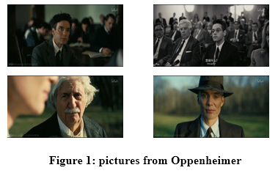
In modern photography, photographers can easily adjust the aperture value to control the amount of light entering the camera, thereby achieving different levels of background blur to highlight the subject. This technique is widely used in the filming of biographical movies and portrait photography to better depict the subject, as demonstrated in the image figure 1 from the movie Oppenheimer. By blurring the background, the overall outline of the person is more prominent, creating a better visual experience.
In digital image processing, there are main methods to achieve background blur for images with similar exposure levels of the subject and background:
The first method is based on the intrinsic depth of the image to process the image, and the core of this method is to simulate the depth of field effect in the real world using the optical imaging principles of the image. First, through mathematical modeling, we can assign an initial depth value to each pixel in the image, which requires consideration of various optical information in the image, such as focal length, aperture size, and shooting distance. Next, using a physical process similar to heat diffusion, these initial depth values are iteratively calculated, which typically involves solving partial differential equations. Through numerical methods, it is pos-sible to simulate the forward diffusion of pixel points in the image, which helps to smooth the depth field and eliminate possible noise. Finally, by using regul-arization techniques to correct the depth information, we can obtain a more accurate and coherent depth map. With this depth map, it is possible to apply multi-scale Gaussian filtering to blur the background layer by layer according to different depth levels, simulating the background blurring effect similar to that of a large aperture lens^{[1]}.
The second method is based on some algorithms of artificial intelligence technology that have emerged in recent years. With the rapid development of artificial intelligence technology, image processing algorithms based on deep learning have made significant progress in image segmentation and background blurring. These algorithms use a large amount of training data to learn how to identify the foreground and background in images. For example, through edge detection algorithms, it is possible to analyze the texture changes of pixel points to accurately determine the edge position of the image. This edge information helps to distinguish the foreground and background of the image. Once the foreground is segmented, sparse interpolation techniques can be applied to the background part, which can effectively blur the background without affecting the image quality, making the subject more prominent^{[2]}.
The third method is based on the fine segmentation of the image based on image color. Color is an important feature in images, and by analyzing color information, we can perform a more refined segmentation of the image. The local binary pattern operator is an effective tool for extracting texture information from images. Combined with color constancy algorithms, it can better handle color changes under different lighting conditions, thus achieving accurate capture of image textures. After extracting accurate texture information, bilateral filtering can be applied to the background part. This filtering technique can smooth areas with similar colors while maintaining edge sharpness, thus achieving the blurring effect of the background. Finally, by recombining the precisely segmented foreground with the blurred background, an image with both high-quality segmentation and visually natural background blurring effect can be obtained^{[3]}.
The fourth method is to utilize the human visual attention mechanism. When people observe a picture, they first focus on the area of interest, which can be considered the foreground region of the image. It is evident that the human visual attention mechanism is strongly related to the technique of background blurring in photography. Currently, Huawei's camera modules use a background blurring method based on the visual attention mechanism, and this method has been applied to Android camera applications. FGO-NET consists of three sub-modules connected in series: a feature extraction module, a feature optimization module, and a self-Gaussian module. The camera's display effect is also in line with the human visual attention mechanism, making it a valuable reference for research on the human eye fixation point model and for project deployment^{[4]}.
These are just a few commonly used methods for background blur using digital technology. In fact, there are many more complex and sophisticated alg-orithm models that can achieve this process. This aticle discusses the use of digital signal processing techniques to process the high-frequency and low-frequency components of the image to achieve background blur.
2.Method
Before discussing specific methods, we should first conduct a concrete analysis of the problem:
To achieve background blurring using digital signal processing techniques, it is essential to clarify what the processed signal is, its form, and its characteristics. When using MATLAB to read images, what we actually obtain are discrete pixels, which are very similar to discrete-time signals in digital signal processing. Moreover, these pixels contain a wealth of information, including brightness and color information. Analysis of adjacent points can also yield frequency infor-mation, which closely resembles the signals one hopes to process in digital signal processing.
After a brief analysis of the image, we need to have a clear understanding of the overall steps. After obtaining signals with frequency and intensity information, the first step we should take for the entire image is denoising. This step is unquestionably essential because the noise in the original image may significantly impact subsequent processing steps, such as causing misjudgment of the subject and background. In this research method, a FIR filter is used for image denoising, which will be explained in detail later.
After obtaining the denoised image, the next step is to separate the subject from the background. As mentioned earlier, there are many complex algo-rithms that can help us achieve this function, but since the main goal of this study is to blur the background, the separation of the subject and background is not the primary focus. Therefore, a relatively simple method is used to separate the subject and background. When reading the image, we can obtain its grayscale image, which contains brightness information. In portraits, the brightness of the human subject is usually the highest. Therefore, if we can obtain the average brightness of an image, then the largest connected area formed by points exceeding the average brightness can be considered the subject, which is the method used in this study.
Once separated, we can replace the subject part with a mask to exclude it from subsequent operations. For the background, we need to consider how to blur it. One method is to randomly add signals of any frequency and intensity to the background to achieve blurring, such as Gaussian white noise, which can easily meet the requirements for blurring the background. However, this method clearly does not utilize much digital signal processing technique. The second method, as can be seen from the previous analysis, is that the read image infor-mation includes frequency and intensity. For the original clear backg-round, there are many high-frequency components at points of dramatic change in the background, such as the intersections of contours of different background objects. This is one of the reasons why the image background is clear. Therefore, if we filter out the high-frequency components in the back-ground and combine it with the untreated subject, we should be able to achieve a blurred background image.
Next, an explanation of some MATLAB code used in this study:
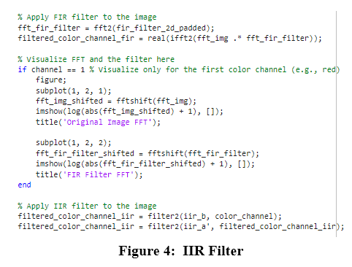
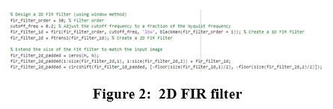
Firstly, let's discuss the FIR filter used for image denoising as mentioned in the first step of the analysis. FIR stands for Finite Impulse Response, and unlike in audio processing, in image processing, all filters should be two-dimensional, or at least perform filtering in both the horizontal and vertical directions. In the example code given in Figure 2, the fir1() function can be used to easily construct a one-dimensional FIR filter, with par-ameters including the filter order, cutoff frequency, and the Blackman window function used in this study. After constructing the one-dimensional FIR filter, the ftrans2() function can then convert it into a two-dimensional FIR filter. Filtering the entire image using this filter will result in a denoised image.
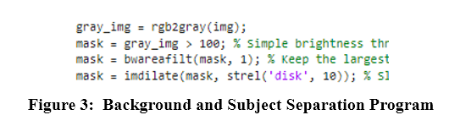
Next is the separation of the subject and background. Following the method mentioned earlier, in the example code in Figure 3, the grayscale image of the image is first obtained to extract brightness information. Assuming the average brightness is 100, the bwareafilt() function is used to find the largest connected area with brightness exceeding the average, and it is replaced with a mask. The imdilate() function is then used to slightly expand the subject area to ensure that the entire subject is included and not blurred.
For the final step of blurring the background by filtering out high-frequency components, this study uses an IIR filter. As shown in the example code in Figure 4, the IIR filter is used to filter the RGB components of the image, and the results are then combined to blur the denoised background.

3. Judging Criteria
After blurring the background, we need to evaluate the effect of highlighting the subject through background blur, which requires a set of evaluation criteria.
In practical photography, the degree of background blur is typically assessed by the aperture value. The camera's aperture value, often referred to as f-stop, is a measurement that describes the size of the lens opening that allows light to enter the camera. It is an important aspect of camera exposure settings because it directly affects the amount of light reaching the camera sensor and also influences the depth of field in the image. The aperture is usually represented by f-numbers, such as f/1.4, f/2.0, f/2.8, f/4.0, f/5.6, f/8.0, and so on. These numbers represent the ratio between the lens focal length and the aperture diameter. A lower f-number (e.g., f/1.4) indicates a larger aperture, allowing more light to pass through the lens. This is useful in low-light conditions or when a shallow depth of field is needed to separate the subject from the background, creating a more blurred background. Conversely, a higher f-number (e.g., f/16) indicates a smaller aperture, allowing less light to enter the camera but increasing the depth of field, making more parts of the image appear sharp.
However, the aperture value parameter is typically retained directly in the shooting tool, and once it undergoes editing, the aperture value is lost. Calculating the aperture value of an image using MATLAB is a very complex task, involving many other complex algorithms. Therefore, we need to find an alternative parameter to represent the aperture value.
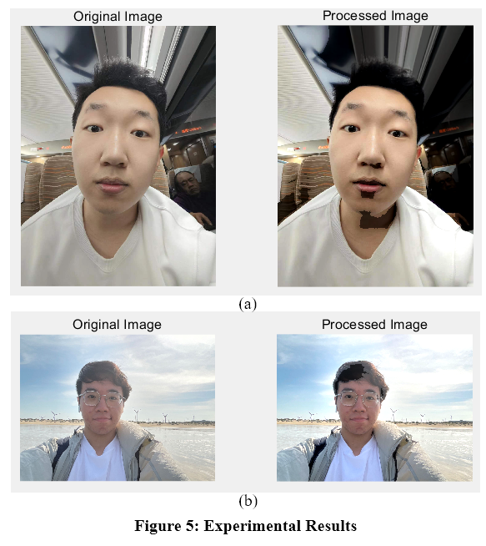
In this experiment, the brightness histogram is used to indirectly reflect the size of the aperture value. When the aperture value changes, the amount of light entering the camera also changes, directly affecting the brightness histogram of the image. The brightness histogram is a chart that displays the distribution of pixels at various brightness levels in the image. When the aperture is widened, the lens allows more light to enter the camera. This results in an overall increase in the brightness of the image, causing the brightness histogram to shift to the right, indicating an increase in the number of pixels with higher brightness. When the aperture is narrowed, the lens allows less light to enter the camera. This leads to a decrease in the overall brightness of the image, causing the brightness histogram to shift to the left, indicating an increase in the number of pixels with lower brightness. By observing the brightness histogram and its relationship with the aperture value, we can evaluate the effect of background blur based on the aperture value.

4. Experiment and Results
Next, we analyze the research results:
First, observe Figure 5, where it is clear that in Figure 5(a) the brightness of the lights in the background drops sharply, almost blending into the background color. At the same time, the edges of the image, the non-subject parts, are largely blurred, while the entire portrait part is relatively well preserved. As for Figure 5(b), its effect is not as pronounced as that of Figure 5(a), due to the second photo's overall even exposure, even exhibiting overexposure. Therefore, the effect of subject recognition is not as good as in Figure 5(a). However, it can still be clearly seen that, after processing, the background on the right side is also blurred, and the overall contour of the portrait is more pronounced than before.
Next are the results of frequency domain filtering in this study, as shown in Figures 6(a) and 6(b), which are the frequency domain filtering results of the previously mentioned Figures 5(a) and 5(b). These are two-dimensional frequ-ency domains, and here is an explanation of how to understand them.
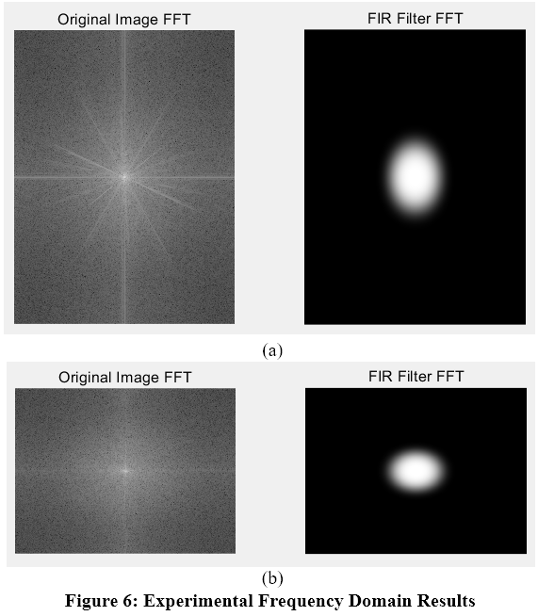
In two-dimensional Fourier tran-sformation, an image can be transformed from its spatial domain to the frequency domain. A frequency domain image shows the frequency components of a spatial domain image, including their magnitudes and directions. In the frequency domain image, each point represents a specific frequency and direction from the original image, and the brightness or color intensity of that point reflects the amplitude of that frequency component. In a frequency domain image post two-dimensional Fourier trans-formation, the low-frequency com-ponents are usually located at the center of the image. These low-frequency components correspond to the slow-changing areas in the original image, such as gradient backgrounds or large uniform areas. The edges of the frequency domain image contain high-frequency components, which cor-respond to the fast-changing areas in the original image, such as edges, details, textures, and noise. A frequency domain image usually consists of two parts—the amplitude spectrum and the phase spec-trum. The amplitude spectrum shows the intensity of each frequency component, while the phase spectrum contains the phase information of these components, i.e., their spatial positional relationships. The amplitude spectrum is often displayed in image form, while the phase spectrum is less commonly displayed visually. For images with real-value inputs, their Fourier transform frequency domain images have conjugate symmetry. This means that the left half of the frequency domain image is a mirror image of the right half, and the top half is a mirror image of the bottom half. In the frequency domain image, different directions represent different textures and structures in the original image. For example, vertical edges in the original image produce horizontal frequency components in the frequency domain image, and horizontal edges produce vertical frequency components.
For the Figure 6(a) and 6(b) obtained in this study, regarding the processing of the background, it is clear that all their high-frequency components have been filtered out, leaving only the central low-frequency components, achieving the purpose of filtering out the high frequencies.
Finally, we need to discuss the effects of the study, as shown in Figure 7(a) and 7(b). These two are brightness histo-grams, corresponding to Figure 5(a) and 5(b), respectively. Based on the previous discussion about the relationship between aperture values and brightness hist-ograms, although Figure 7(a) does not show much difference in the overall waveform compared to before processing, Figure 7(b) clearly shows that the brightness histogram has shifted to the right overall. This implies a larger aperture, a lower f-number, indicating that the effect of background blur has been improved compared to before, suggesting that the research method of this study is indeed feasible.
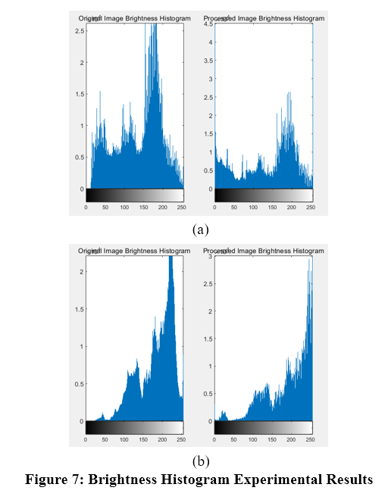
5.Future
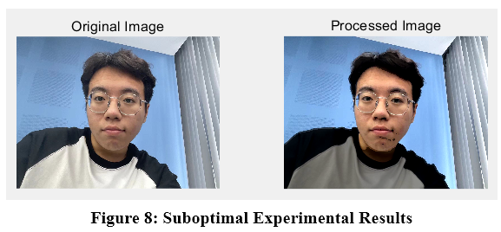
Of course, in this study, some issues were also identified. As shown in Figure 8, it is clear that some of the themes are severely blurred. This is due to the use of luminance connectivity in this study to separate the themes and the background. In grayscale images, black has the lowest luminance, so it is considered as the background during the execution process, resulting in less than ideal blurring effects.
To solve this problem, it involves a more accurate separation algorithm for the subject and the background. This may involve some deep learning edge algorithms related to artificial intelli-gence, which can more accurately separate the subject and the background. This may be one of the future directions of the research.
6.Conclusion
The above is the discussion on the image processing process that uses digital signal processing techniques to achieve subject highlighting and background blurring presented in this paper. In the course of this research, basic knowledge in digital signal processing, such as FFT, FIR, IIR, and various window functions, was comprehensively used to filter images. A two-dimensional process was implemented using MATLAB, and since the process in actual photography is measured by aperture value, this research also used a brightness histogram related to aperture values to measure the overall effect. It can be seen in this study that image information can indeed serve as the original signal for digital signal processing and may contain frequency components that are richer than audio information, which inspires researchers to discuss signals that are more abundant and complex that may arise in real-life situations. Regarding this research, in order to further improve the image processing effects, it was also proposed to apply related technologies in artificial intelligence, hoping that future research can achieve better effects in subject highlighting and background blurring.

Reference：
[1] Xiao J, Du K, Tu C, et al. Background blur display based on depth information extraction from multi-focus images[J]. Acta Automatica Sinica, 2015, 2: 304-311. DOI:10.16383/j.aas.2015.c140059.
[2] Wu C, Yang J, Leng B, et al. Image background blur method based on edge detection[J]. Information and Com-munications, 2018, 4: 128-129. DOI:10.3969/j.issn.1673-1131.2018.04.057.
[3] Li X, Li S, Hong X, et al. Synthesis method of background blur in single natural image based on precise segmentation[J]. Journal of Huaqiao University (Natural Science), 2023, 44(3): 391-397. DOI:10.11830/ISSN.1000-5013.202301002.
[4] Liu C. (2020). Research and Application of Background Blur Method Based on Visual Attention [D]. Hubei: Huazhong University of Science and Technology.

