**THESIS project description -- TEMPLATE**

**CS4490Z (Undergraduate Thesis), CS4460Z (Bioinformatics Thesis), or CS3380Z (Project)**

**DEADLINE: 30th September, 2021**

Continuing with the success of the recent years, the Department of Computer Science (CS) at Western seeks undergraduate **thesis**-projects with significant software content, in different fields such as: CS, Science, Engineering, Health, Medicine, Business, Law, Social Sciences, and others. Project supervisors can be from any academic department at Western University.

These projects will be carried out by:

* fourth year CS students enrolled in the courses cs4490Z and cs4460Z; and
* third year CS students enrolled in the course CS3380F/G/Z.

This document is in two parts. Part A describes basic information pertaining to the theses, along with the associated regulations. Part B is a template to be filled out by the supervisor prior to officially commencing the thesis work.

**Part A: Basic Information and Regulations**

**Thesis and Topic:**

* A thesis-project **must** contain an element of **novelty** in the creation of a solution or be an original investigation. It can be investigative (e.g., a controlled experiment, a case study, etc.) or development/enhancement of a software-intensive system embodying new concepts and ideas. It must contribute to the advancement of knowledge as much as is justifiably expected at the undergraduate level. For example:
  + It could lead to (or advance) novelty in a software-intensive technology (software techniques, algorithms, software concepts, findings, or application/system).

However, simply *applying* an existing machine learning algorithm to ascertain certain patterns of behaviour in a dataset is not acceptable as a research topic **unless such an investigation has never been successfully conducted before and there is a compelling reason – advocated by the supervisor -- for conducting this investigation**.

* + Please note that a significant weight will be given to the novelty factor in the assessment of the thesis.
* The thesis work **shouldn’t simply be practical development of software**. The student must be engaged in conducting research (as described above) and not be employed as a programmer simply to implement a supervisor’s solution. Where the undergraduate thesis student obtains no deeper (or theoretical) understanding of the programmed concept is not acceptable.
* **The thesis work should be rooted in the supervisor’s research agenda**. **The topic of research should generally originate from the supervisor, not the student**. The results of this work are something that the supervisor would want to (eventually) publish in the scholarly literature.
* The undergraduate thesis can indeed be exploratory to obtain a preliminary insight into the research question being explored.
* The professor commissioning the thesis is the supervisor.
  + Collaboration with other researchers is acceptable but, for the purpose of the thesis, the key contact will be one person, the supervisor.
* **Duration**: Over two semesters -- September to April.

**Supervisor’s Responsibilities:**

* The professor commissioning the thesis is the contact supervisor and takes on full responsibility to see this project through to completion and thesis submission. This includes, but is not limited to:
  + **Sharing adequate background knowledge** about the problem to be investigated or solution created for.
  + **On-going supervision** of the thesis work.
  + **Research training:** Providing research skills, including research methods, usage of tools and techniques, study design, conducting the research, background understanding, data gathering and cleaning, data analysis, analysis of the obtained results, comparisons with related work, drawing conclusions, plans for continued research, etc.
  + **Intermediate progress checks** to ensure that the student is on track to completion and taking corrective actions as necessary.
  + **Providing guidance** during thesis write-up, including: thesis structuring, technical writing, claiming novelty, etc. (Please note that for simplification, students are asked to follow a certain format in thesis structure and writing style.)
* **Registration on OWL project site:** The supervisor must register on OWL for ease of communication and information sharing. Details will be provided in the invitation call.
* **Thesis assessment:** The supervisor assesses the thesis content and the presentation. Details to be provided later.
  + **Grade submission to OWL**. Grades from the supervisor to be submitted to the OWL project site; please, not via emails – thank you in advance for your understanding.

**Missing prerequisites**

* Typically, a student is permitted to carry out the thesis even if s/he has up to one prerequisite course missing provided that:
  + The supervisor agrees in writing to this situation, and
  + That the missing prerequisite course is taken in parallel with the thesis.

The thesis course descriptions and the prerequisites are described below.

**Course Descriptions And Prerequisites:**

* The university calendar descriptions prevail but for ease of access, the associated course descriptions for cs4490Z, cs4460Z, and cs3380Z are:

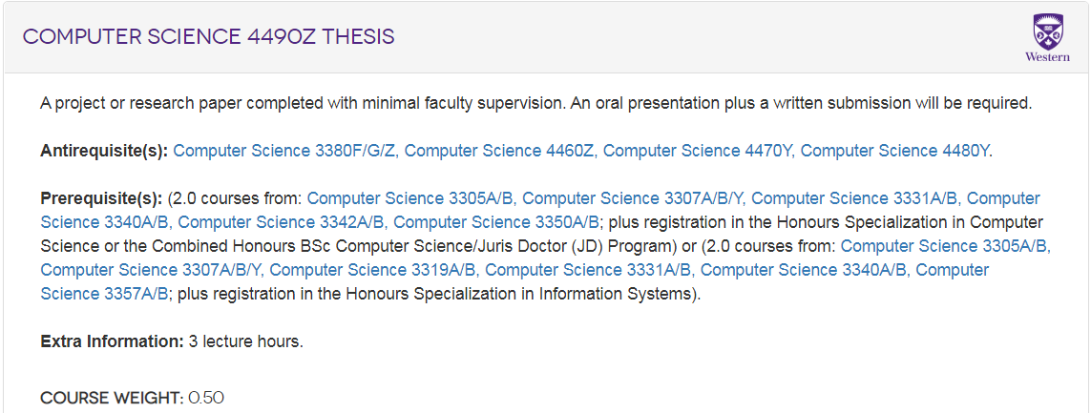

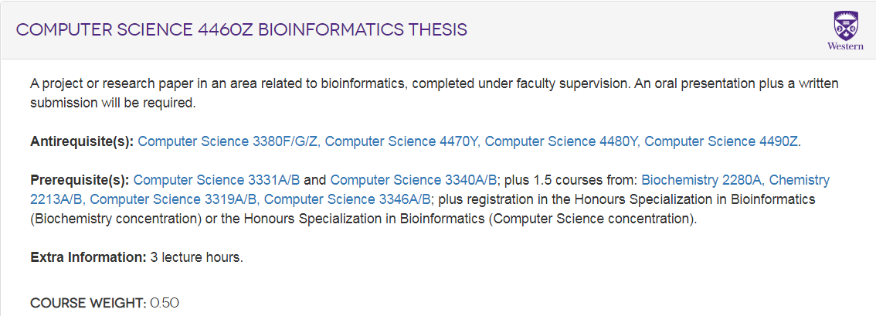

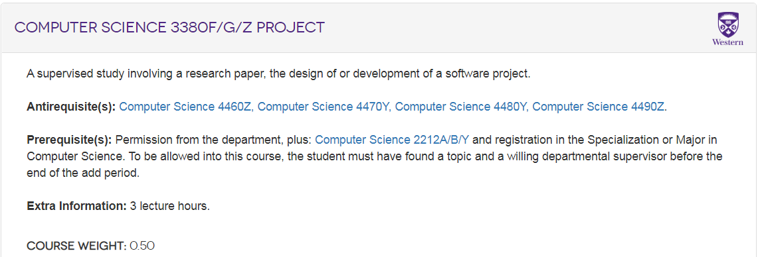

**++++++++++++++++++++++++++ CUT HERE ++++++++++++++++++++++++++**

**Part B: Project Description**

***By filling in the project description below, one project per template, the supervisor fully agrees to comply with the regulations set out in Part A.***

**The completed template must be submitted to OWL for ease of traceability (an “assignment” will be set up on OWL for this purpose, details provided in the invitation call).**

**IMPORTANT:**

* Please kindly name **this** project description file to be uploaded to OWL as:

**<Supervisor’s last name>_<”THESIS”>_<abbreviated project-title>.**

* If you upload more than one project description, please kindly ensure that each **<abbreviated project-title>** is unique to avoid mix-ups.
  + Please zip multiple proposals into a single folder.

**Thesis-project title**: __________________________________________________________

**Please select one (and delete others)**:

🞏 CS4490Z

🞏 CS4460Z

🞏 CS3380Z

**Contact details of the supervisor:**

* Name:_______________________________________________________________
* Dept.: **__________________________________________________________________**
* Email address:___________________________________________________________

**Project Description**

**(50 to 100 words)**

**NOVEL aspect of the research that the student will be engaged in. (1-5 lines)**

**(e.g., creating a new algorithm, developing a new technique, novel implementation of an old problem, new design, novel empirical study, etc.).**

**(Please note that this element will be weighted heavily in the assessment of the thesis.)**

**Intellectual Property (IP):**

*Please note that the CS Department or its representatives will not get involved in any IP related issues. The supervisor and the student are referred to the following Western University IP policy.*

*https://www.uwo.ca/research/ip.html*

**Pre-requisite COMPUTING/SOFTWARE skills and knowledge (if known):**

(Please indicate whether guidance will be given to learn these skills, if necessary)

**Pre-requisite DOMAIN/NON-COMPUTING/NON-SOFTWARE skills and knowledge:**

(Please indicate whether guidance will be given to learn these skills, if necessary)

**Critical measures that will be taken to present the spread of COVID-19:**

(please explain)

**END OF THESIS TEMPLATE.**