**Temporal responses of mammal body size to increasing temperature**

Kristina Riemer, Ethan P White

**Abstract**

**Introduction**

Current and future changes in the climate will affect the traits of organisms, which will have downstream effects on how natural systems function (source). In particular, the potential for organisms to become smaller in response to increasing global temperatures has received growing attention as one of the possible universal response to climate change (Gardner et al., 2011; Sheridan and Bickford, 2011; Smith et al., 2018). Warmer temperatures resulting in decreased body size comes from Bergmann’s rule, which is that there is a negative spatial relationship between the size of individuals of endotherm species and the temperature of the location at which they occur (Bergmann, 1847; Brown and Lee, 1969; Ashton, 2002; Freckleton et al., 2003; Meiri & Dayan, 2003). This rule has been extrapolated to predict that increasing temperatures from climate change should cause individuals of endotherm species to decrease in size as temperatures at many locations increase. This has been supported by syntheses of published studies, which suggest that endotherms have generally been decreasing in size over the last several decades (Gardner et al., 2011; Sheridan and Bickford, 2011; Yom-Tov and Geffen, 2011). Because organismal size is an important ecological characteristic that affects many aspects of ecosystems, including metabolic rates (Brown et al., 2004), food web structure (Woodward et al., 2005), and energy flux (Dickie et al., 1987), changes in size due to climate change could result in drastic changes in ecosystem structure and function.

The general relationship between endotherm size and temperature on which predictions for decreasing size have been based on has, however, been questioned due to data-intensive analyses that evaluate this relationship for many species simultaneously (McNab, 1971; Meiri et al., 2004; Riemer et al., 2018). For example, when this relationship was recently examined for nearly 1,000 bird and mammal species using a century of global data, most species had weak relationships (Riemer et al., 2018). While this suggests that Bergmann’s rule is not as generally applicable as previously believed, the analysis included data for spatial and temporal variation in size. Because responses of ecosystems across time do not necessarily match their responses across space (Fukami and Wardle, 2005), the predicted general decline in size could still occur. In order to understand how species may respond to climate change, this relationship needs to be examined in a similar data-intensive fashion with a focus explicitly on changes through time. Recent studies that have suggested that species are getting smaller are limited by small numbers of species (Teplitsky et al., 2008; Husby et al., 2011; Canale et al., 2016), small numbers of sites (Van Buskirk et al., 2010; Salewski et al., 2010), and data that is collected over short time periods (Smith et al., 1998). Syntheses of these results (e.g., source) are potentially affected by both limitations of individual studies and potential publication bias due to negative results being less frequently published (Korichev et al., 2013; Riemer et al., 2018).

We directly assessed temporal shifts in body size due to temperature in a data-intensive manner by compiling long-term time series data on mammal communities from three geographic locations. This consisted of size measurements for 128,710 individuals, which were used to determine the average annual mass of 32 unique species-site combinations with observations for at least five years spread across at least ten years. This was combined with a global temperature dataset. We determined how both temperature and species mass changed through time for each species at each site, and assessed the strength and direction of the relationship between mass and temperature. This data-intensive approach addresses limitations of previous work on the temperature-mass relationship, which consisted of studies on single species and meta-analyses derived from those studies. We were able to show how mammal size is impacted by temperature over time.

**Methods**

*Datasets*

Data for size came from small mammal time series datasets, which had to contain mass measurements for individuals and have at least ten years of continuous data. Two of the sites, Portal and Fray Jorge, are long term experimental plots that are used to examine and manipulate community dynamics in mammal and plant communities. Portal is located in the United States in southeastern Arizona while Fray Jorge is in the national park of the same name in Chile. These two mammal time series datasets (Ernest et al., 2016, Kelt et al., 2013) were downloaded using the Data Retriever (Senyondo et al., 2017), with additional metadata taken from Ecological Archives. The Sevilleta dataset is from a Long Term Ecological Research project in the southwestern United States, which is collected because it is at the intersection of several major biomes. This mammal time series is collected at eight sites that are in close proximity, and was downloaded, along with metadata, from the University of New Mexico digital repository (Newsome, 2016). The locations of the three sites are shown in Figure 1.

The final dataset compiled and cleaned from these three sites consisted of 25 species, with 32 unique site by species combinations (Table 1), from 128,710 individual records (Table 2). From each dataset, we retained only individual records that were identified as a rodent species, had an associated mass measurement, and were indicated as adults. For the two experimental sites, Portal and Fray Jorge, only individuals collected from control treatments were included. We kept all instances of the same individual being recaptured, which is common at these sites. We additionally only included individuals from species for which we had at least 15 individuals collected that year, as it has been shown that a signal of temporal size change is noticeable with a minimum of 14 specimens per year for mammals (Yom-Tov & Geffen, 2011), and species that had at least five years of data with a sufficient number of individuals. The final mass dataset contained the mean and standard deviation of mass for each species in each year at each site.

This mass dataset was combined with a temperature dataset to extract relevant temperatures at each site for each species. The temperature dataset was a global raster of temperature values, with a grid cell size of 0.5 degrees latitude by 0.5 degrees longitude with monthly average values from 1900 to 2014. It is created and maintained by the University of Delaware and National Oceanic and Atmospheric Administration (Willmott and Matsuura, 2001). The coordinates for each of the three sites were determined from metadata or related citations (Aguilera et al., 2016), and were used to extract all of the monthly temperatures for each site from the temperature dataset. Mean annual temperatures were calculated from the monthly temperatures, and then were combined with the mass dataset so that each species had the corresponding temperature for that year.

*Analysis*

We visually examined how both temperature and mass varied over time at each site, and compared each species mean mass with the corresponding average annual temperature using linear regression. We calculated and compiled the r values from all regressions to evaluate the strength and direction of the temperature-mass relationship among all species at each site. To examine how mass and temperature concurrently changed over time, we compared the percent change in each species mass to the absolute change in temperature over the years with sufficient data.

We additionally used a dynamic regression model of the mass time series for each species to determine the effect that temperature had. We did so with an ARIMA model with an automatically chosen order, after confirming that this order was what we would have chosen. After adding temperature as an external variable, the model residuals were reviewed. All model diagnostics are in Supplement 1. To determine the effect of temperature on mass, we calculated the p-value for each species, which were adjusted to take into account the impact of multiple comparisons (Benajmini & Hochberg, 1995), and chose an alpha cut-off of 0.05. All cleaning and analysis was completed using R (R Core Team, 2017), with code and data downloads provided reproducibly on GitHub (https://github.com/KristinaRiemer/temporal_MRT) and archived on Zenodo (citation).

**Results**

Most species had a positive relationship between mean annual mass and mean annual temperature, instead of the expected negative relationship. Temperatures increased at all sites (Fig. 2A, B, C) in accordance with climate change trends. Species masses increased and decreased at all sites (Fig. 2D, E, F; Table 1), thought the majority (69%) of species increased (Fig. 2G, H, I; Supplement 2). This resulted in more species with positive than negative temperature-mass relationships (19 species and 13 species, respectively; Fig. 3; Supplement 3). The prevalence of positive relationships is also shown in the comparison of absolute change in temperature with percent change in each species mass (Fig. 4). Most values are in the upper right quadrant, instead of the lower right or upper left which would indicate negative temperature-mass relationships.

While more species had positive temperature-mass relationships, all species exhibited weak relationships. Temperature explained less than 10% of the variance in mean annual mass for most species (66%; Fig. 3D, E, F), and explained only 54% of the variance for the species with the strongest relationship. According to the dynamic regression models, temperature had a statistically significant effect on the mass time series for 11 of the 32 species.

**Discussion**

Though temperatures increased at all sites, there were species at each that increased and decreased in size. This variability in size response across time has been previously documented (Gardner et al., 2011; Yom-Tov & Geffen, 2011; Sheridan & Bickford, 2011). The lack of relationship between temperature and species mass indicates that directional change in temperature is likely not a stronger driver of shifts in size. Body size has been shown to be affected by a wide variety of biotic and abiotic factors, including resource availability (McNab, 2010), anthropogenic fragmentation (Lomolino & Perault, 2007), and island size (Lomolino, 2005). Even if temperature in isolation has a strong impact on size variation over time, these other factors may have a greater impact. For example, a marmot species was bigger from later plant emergence (Canale et al., 2016) and available sea ice was associated with declining polar bear size (Stirling and Derocher, 2012).

Though empirical evidence of a negative temperature-mass relationship has been documented for over a century, a mechanistic link between them has not been established. Many hypotheses have been proposed, including starvation resistance and dispersal (Blackburn et al., 1999). The initial and most commonly referenced hypothesis is that it is beneficial for individuals to be bigger in warmer environments because they have an increasing surface area to volume ratio and therefore lose heat relatively more quickly (Bergmann, 1847), though there is no evidence for this (McNab, 2010). It has been shown that other morphological changes, including fat and plumage, are more effective for heat regulation (source).

While it seems unlikely that mammal species will get smaller in response to climate change, the variation in size due to temperature across time should be further confirmed. Mammals in a greater diversity of sites should be examined, especially sites that have constant or decreasing temperatures and have greater precipitation. Documenting size shifts in the same species at more locations would also confirm the variability of temperature-mass relationships. While seven species in this study occurred in sufficient numbers at more than one site, three species had opposite size responses at these sites. This type of analysis should also be extended to time series of bird species, as recent decreases in mass have been documented in these species (Van Buskirk et al., 2010; Husby et al., 2011; Teplitsky et al., 2008).

Based on the variable size response to temperature across time for the mammal species in this study, it seems unlikely that species will generally get smaller in response to climate change as has been proposed (Gardner et al., 2011; Sheridan and Bickford, 2011). Body sizes are likely responding to many additional factors, and the difficulty of determining which factors are most important and how they impact size means that predicting size response to climate change in general will be difficult. This should be a priority due to the importance of size in ecological systems.

**References**

Aguilera, L.E., Armas, C., Cea, A.P., Gutiérrez, J.R., Meserve, P.L. & Kelt, D.A. (2016) Rainfall, microhabitat, and small mammals influence the abundance and distribution of soil microorganisms in a Chilean semi-arid shrubland. *Journal of Arid Environments*, **126**, 37–46.

Ashton, K. (2002) Patterns of within‐species body size variation of birds: strong evidence for Bergmann’s rule. *Global Ecology and Biogeography*, **11**, 505–523.

Benajmini, Y. & Hochberg, Y. (1995) Controlling the False Discovery Rate : A Practical and Powerful Approach to Multiple Testing Author ( s ): Yoav Benjamini and Yosef Hochberg Source : Journal of the Royal Statistical Society . Series B ( Methodological ), Vol . 57 , No . 1 Published by : *J R Statist Soc B*, **57**, 289–300.

Bergmann, C. (1847) Ueber die Verhältnisse der Wärmeökonomie der Thiere zu ihrer Grösse. *Gottinger Studien*, **1**, 595–708.

Blackburn, T., Gaston, K. & Loder, N. (1999) Geographic gradients in body size: a clarification of Bergmann’s rule. *Diversity and distributions*, 165–174.

Brown, J.H., Gillooly, J.F., Allen, A.P., Savage, V.M. & West, G.B. (2004) Toward a metabolic theory of ecology. *Ecology*, **85**, 1771–1789.

Brown, J.H. & Lee, A.K. (1969) Bergmann ’ s Rule and Climatic Adaptation in Woodrats ( Neotoma ). *Evolution*, **23**, 329–338.

Canale, C.I., Ozgul, A., Allain??, D. & Cohas, A. (2016) Differential plasticity of size and mass to environmental change in a hibernating mammal. *Global Change Biology*, **22**, 3286–3303.

Dickie, L.M., Kerr, S.R. & P.R., B. (2018) Size-Dependent Processes Underlying Regularities in Ecosystem Structure. **57**, 233–250.

Freckleton, R.P., Harvey, P.H. & Pagel, M. (2003) Bergmann ’ s Rule and Body Size in Mammals. *American Naturalist*, **161**, 821–825.

Gardner, J.L., Peters, A., Kearney, M.R., Joseph, L. & Heinsohn, R. (2011) Declining body size: a third universal response to warming? *Trends in ecology & evolution*, **26**, 285–91.

Husby, A., Hille, S.M. & Visser, M.E. (2011) Testing Mechanisms of Bergmann’s Rule: Phenotypic Decline but No Genetic Change in Body Size in Three Passerine Bird Populations. *The American Naturalist*, **178**, 202–213.

Kelt, D.A., Meserve, P.L., Gutiérrez, J.R., Milstead, W.B. & Previtali, M.A. (2013) Long-term monitoring of mammals in the face of biotic and abiotic influences at a semiarid site in north-central Chile. *Ecology*, **94**, 977.

Kironde, H., D. Morris, B., Goel, A., Zhang, A., Narasimha, A., Negi, S., J. Harris, D., Gertrude Digges, D., Kumar, K., Jain, A., Pal, K., Amipara, K., Simran Singh Baweja, P. & P. White, E. (2017) Retriever: Data Retrieval Tool. *The Journal of Open Source Software*, **2**, 451.

Lomolino, M. V. (2005) Body size evolution in insular vertebrates: Generality of the island rule. *Journal of Biogeography*, **32**, 1683–1699.

Lomolino, M. V. & Perault, D.R. (2007) Body size variation of mammals in a fragmented, temperate rainforest. *Conservation Biology*, **21**, 1059–1069.

McNab, B.K. (2010) Geographic and temporal correlations of mammalian size reconsidered: a resource rule. *Oecologia*, **164**, 13–23.

Meiri, S. & Dayan, T. (2003) On the validity of Bergmann’s rule. *Journal of Biogeography*, 331–351.

Morgan Ernest, S.K., Yenni, G.M., Allington, G., Christensen, E.M., Geluso, K., Goheen, J.R., Schutzenhofer, M.R., Supp, S.R., Thibault, K.M., Brown, J.H. & Valone, T.J. (2016) Long- term monitoring and experimental manipulation of a Chihuahuan desert ecosystem near Portal , Arizona ( 1977 – 2013 ). *Ecology*, **97**, 2115.

Newsome, S. (2016) Small Mammal Mark-Recapture Population Dynamics at Core Research Sites at the Sevilleta National Wildlife Refuge, New Mexico (1989 - present).

Riemer, K., Guralnick, R.P. & White, E.P. (2018) No general relationship between mass and temperature in endothermic species. *eLife*, **7**, 1–16.

Salewski, V., Hochachka, W.M. & Fiedler, W. (2010) Global warming and Bergmann’s rule: do central European passerines adjust their body size to rising temperatures? *Oecologia*, **162**, 247–260.

Sheridan, J.A. & Bickford, D. (2011) Shrinking body size as an ecological response to climate change. *Nature Climate Change*, **1**, 401–406.

Smith, F., Browning, H. & Shepherd, U. (1998) The influence of climate change on the body mass of woodrats Neotoma in an arid region of New Mexico, USA. *Ecography*.

Stirling, I. & Derocher, A.E. (2012) Effects of climate warming on polar bears: A review of the evidence. *Global Change Biology*, **18**, 2694–2706.

Team, R.C. (2016) R: A Language and Environment for Statistical Computing.

Teplitsky, C., Mills, J. a, Alho, J.S., Yarrall, J.W. & Merilä, J. (2008) Bergmann’s rule and climate change revisited: disentangling environmental and genetic responses in a wild bird population. *Proceedings of the National Academy of Sciences of the United States of America*, **105**, 13492–6.

Van Buskirk, J., Mulvihill, R.S. & Leberman, R.C. (2010) Declining body sizes in North American birds associated with climate change. *Oikos*, **119**, 1047–1055.

Willmott, C.J. & Matsuura, K. (2001) Terrestrial Air Temperature and Precipitation: Monthly and Annual Time Series (1950-1999).

Woodward, G., Ebenman, B., Emmerson, M., Montoya, J.M., Olesen, J.M., Valido, A. & Warren, P.H. (2005) Body size in ecological networks. *Trends in Ecology and Evolution*, **20**, 402–9.

Yom-Tov, Y. & Geffen, E. (2011) Recent spatial and temporal changes in body size of terrestrial vertebrates: Probable causes and pitfalls. *Biological Reviews*, **86**, 531–541.

**Main figures**

* Figure 1: Site location map

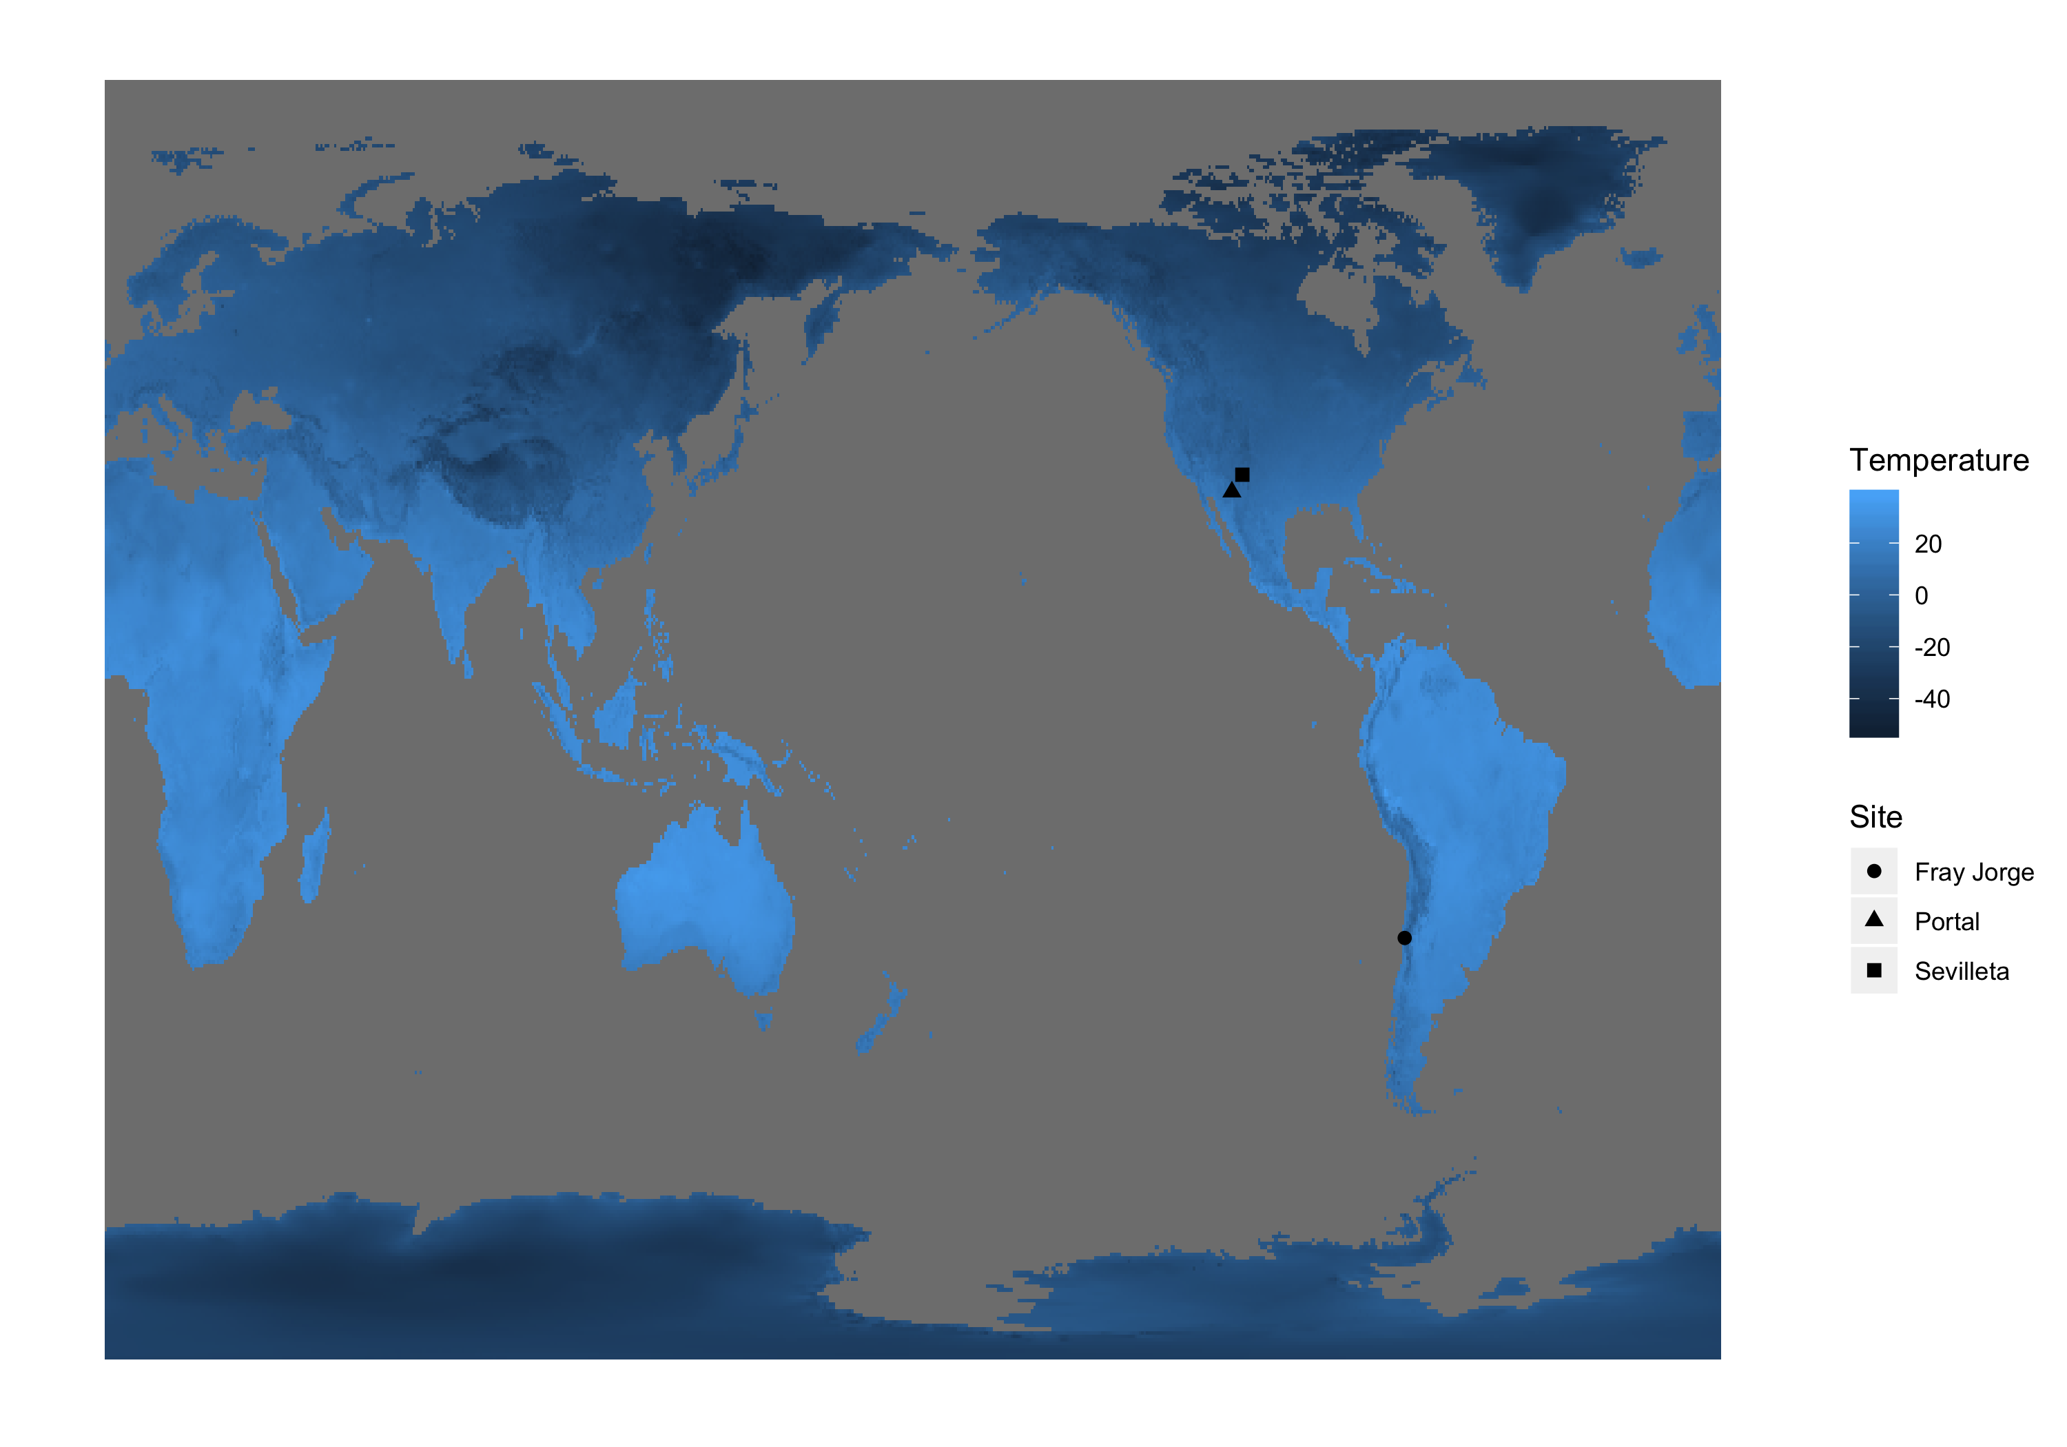

* Table 1: Species codes and corresponding scientific names

| Site | Species Code | Scientific Name |
| --- | --- | --- |
| Fray Jorge | AB | *Abrocoma bennetti* |
| Fray Jorge | AL | *Abrothrix longipilis* |
| Fray Jorge | AO | *Abrothrix olivaceus* |
| Fray Jorge | ME | *Thylamys [Marmosa] elegans* |
| Fray Jorge | OD | *Octodon degus* |
| Fray Jorge | OL | *Oligoryzomys longicaudatus* |
| Fray Jorge | PD | *Phyllotis darwini* |
| Portal | DM | *Dipodomys merriami* |
| Portal | DO | *Dipodomys ordii* |
| Portal | DS | *Dipodomys spectabilis* |
| Portal | OL | *Onychomys leucogaster* |
| Portal | OT | *Onychomys torridus* |
| Portal | PB | *Chaetodipus baileyi* |
| Portal | PE | *Peromyscus eremicus* |
| Portal | PF | *Perognathus flavus* |
| Portal | PP | *Chaetodipus penicillatus* |
| Portal | RM | *Reithrodontomys megalotis* |
| Sevilleta | chin | *Chetodipus intermedius* |
| Sevilleta | dime | *Dipodomys merriami* |
| Sevilleta | dior | *Dipodomys ordii* |
| Sevilleta | disp | *Dipodomys spectabilis* |
| Sevilleta | neal | *Neotoma albigula* |
| Sevilleta | onar | *Onychomys arenicola* |
| Sevilleta | onle | *Onychomys leucogaster* |
| Sevilleta | pgfl | *Perognathus flavescens* |
| Sevilleta | pgfv | *Perognathus flavus* |
| Sevilleta | pmbo | *Peromyscus boylii* |
| Sevilleta | pmer | *Peromyscus eremicus* |
| Sevilleta | pmle | *Peromyscus leucopus* |
| Sevilleta | pmtr | *Peromyscus truei* |
| Sevilleta | remg | *Reithrodontomys megalotis* |
| Sevilleta | spsp | *Spermophilus spilosoma* |

* Table 2: Site dataset metrics

| Individuals | Species |
| --- | --- |
| 128710 | 32 |

| Site | Individuals | Species | Years | Individuals (min) | Individuals (max) | Years (min) | Years (max) |
| --- | --- | --- | --- | --- | --- | --- | --- |
| Fray Jorge | 83670 | 7 | 17 | 15.000 | 9613.000 | 6.000 | 17.000 |
| Portal | 28293 | 10 | 38 | 15.000 | 635.000 | 13.000 | 38.000 |
| Sevilleta | 16747 | 15 | 26 | 15.000 | 706.000 | 5.000 | 26.000 |

* Figure 2: Yearly temp, yearly mass, and yearly mass slope distribution

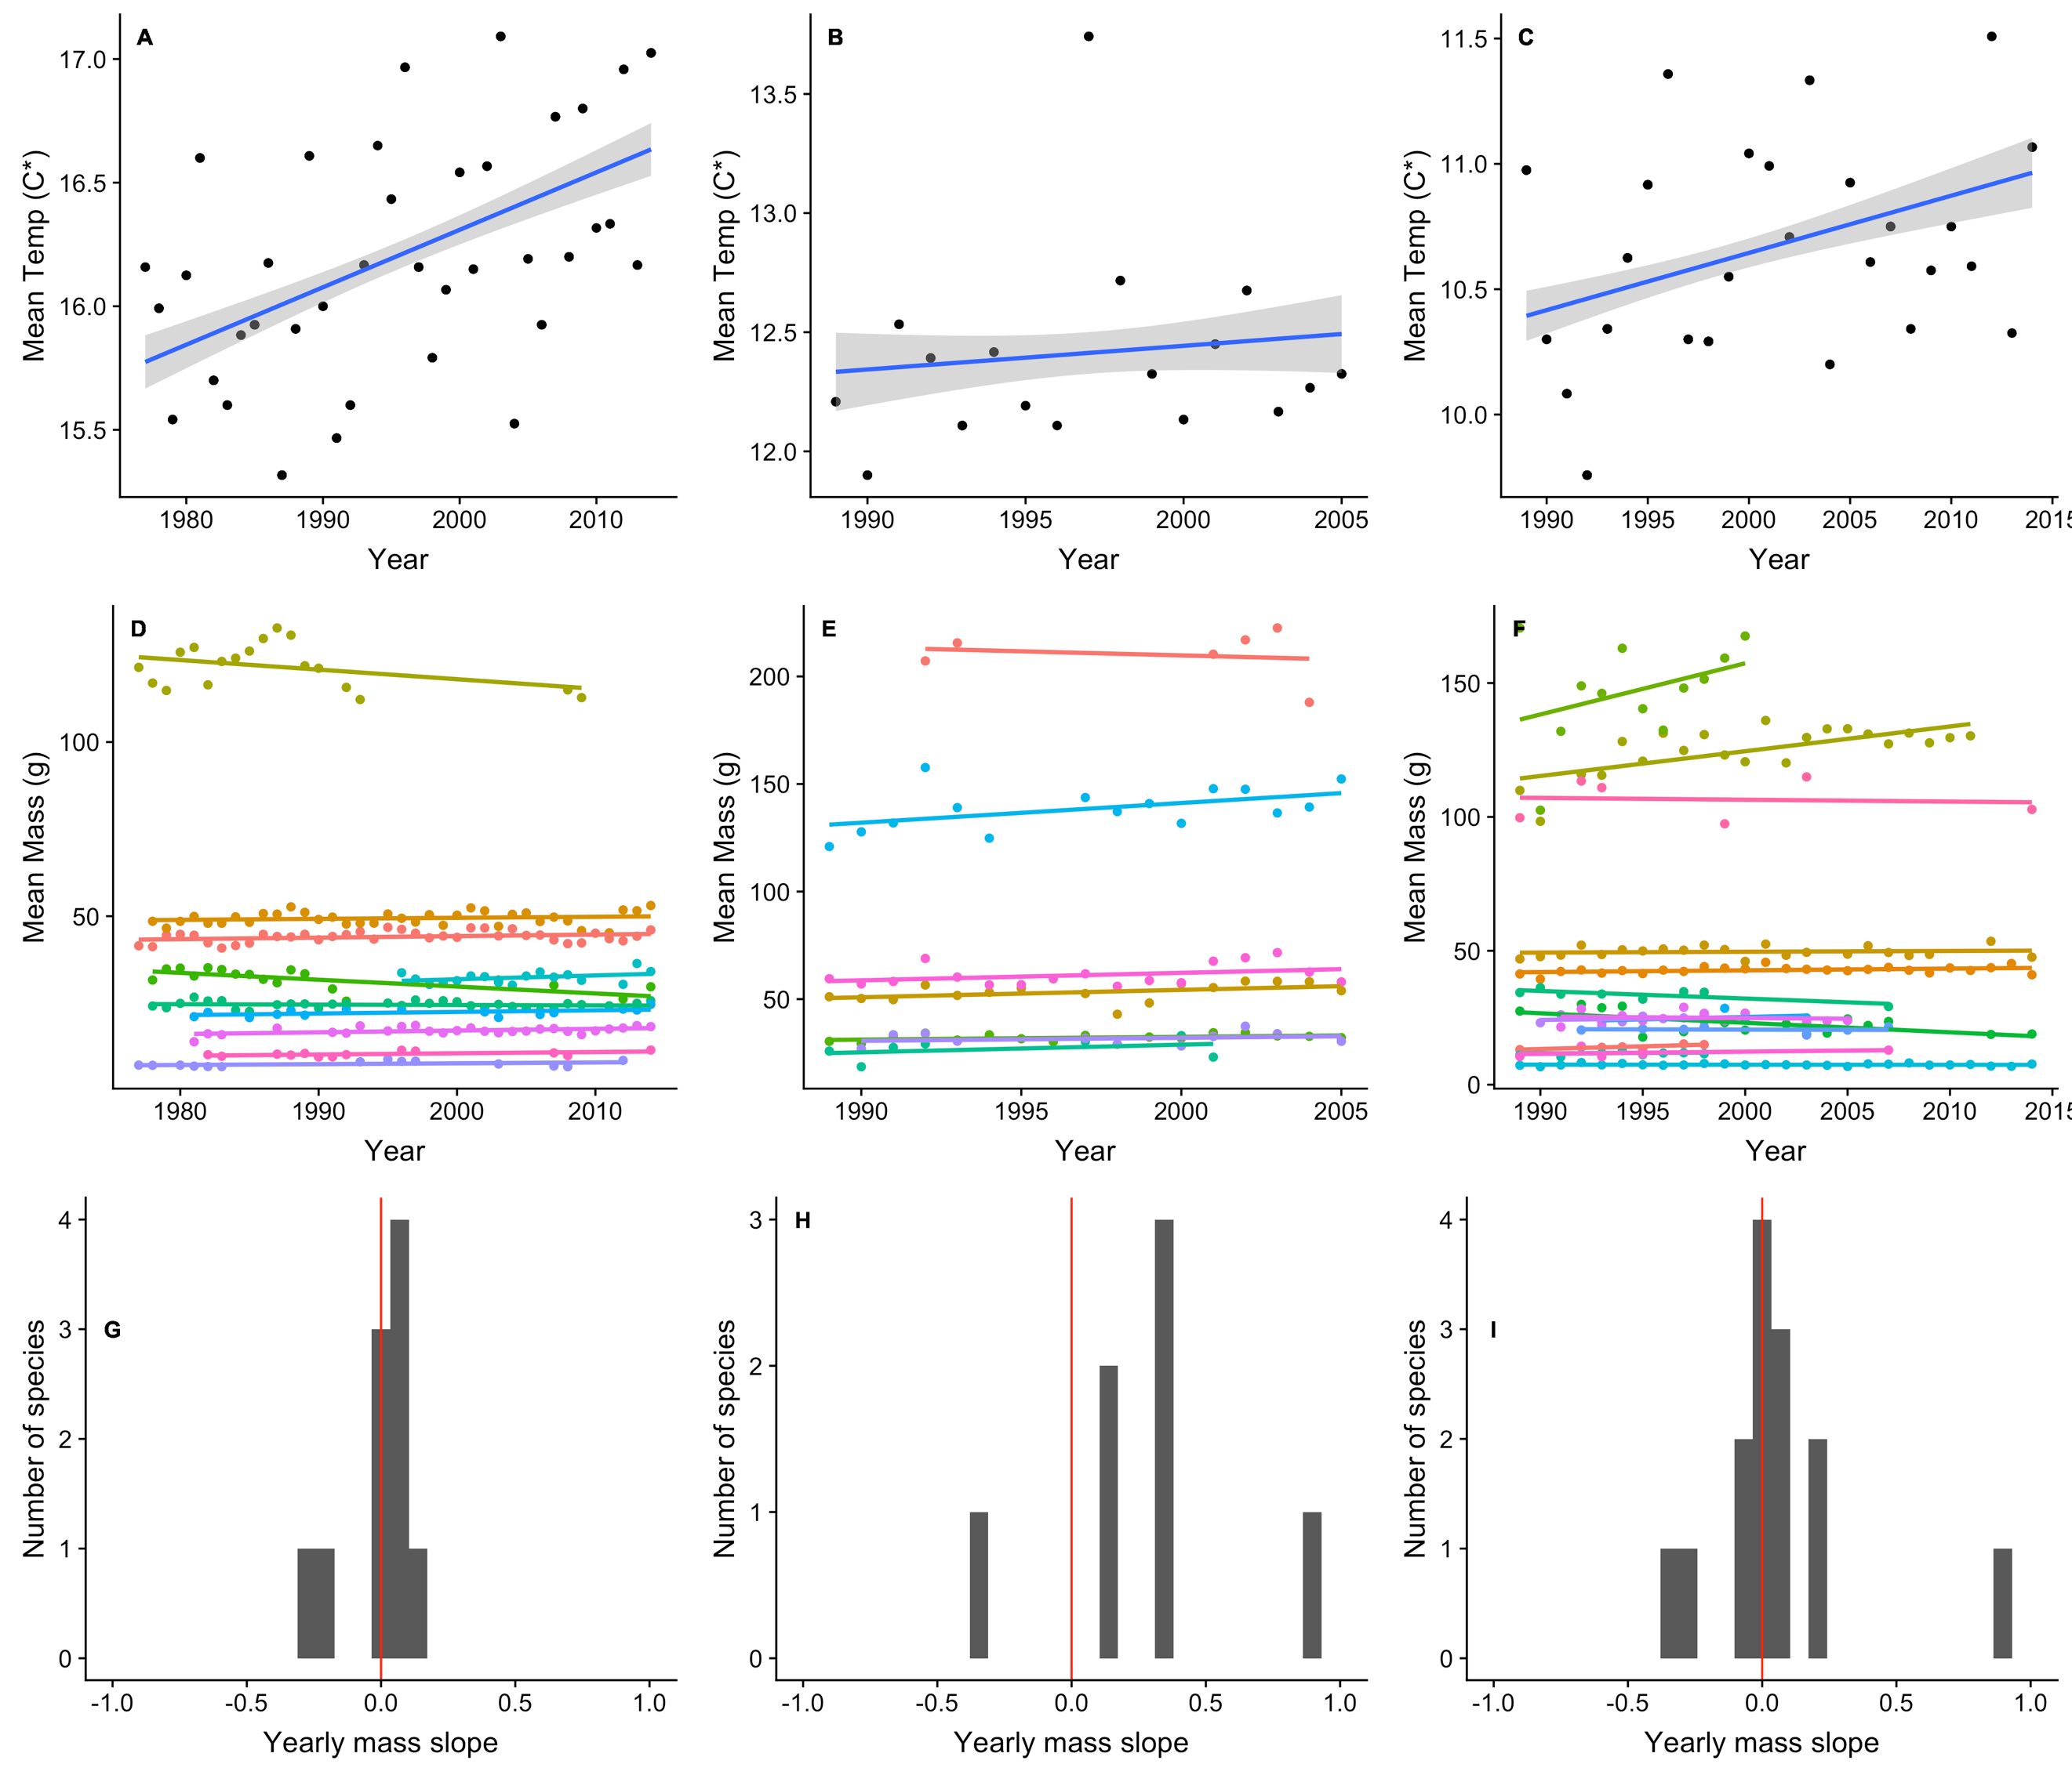

* Figure 3: Temp-mass relationship and r distribution (green = statistically significant p-values; purple = not statistically significant p-values)

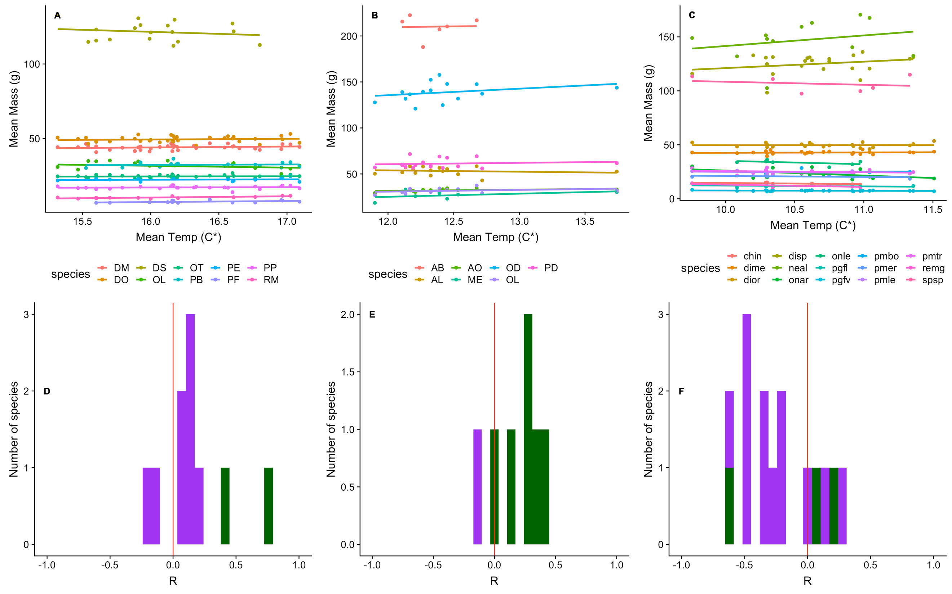

* Figure 4: Mass change over time compared to temp change over time by species

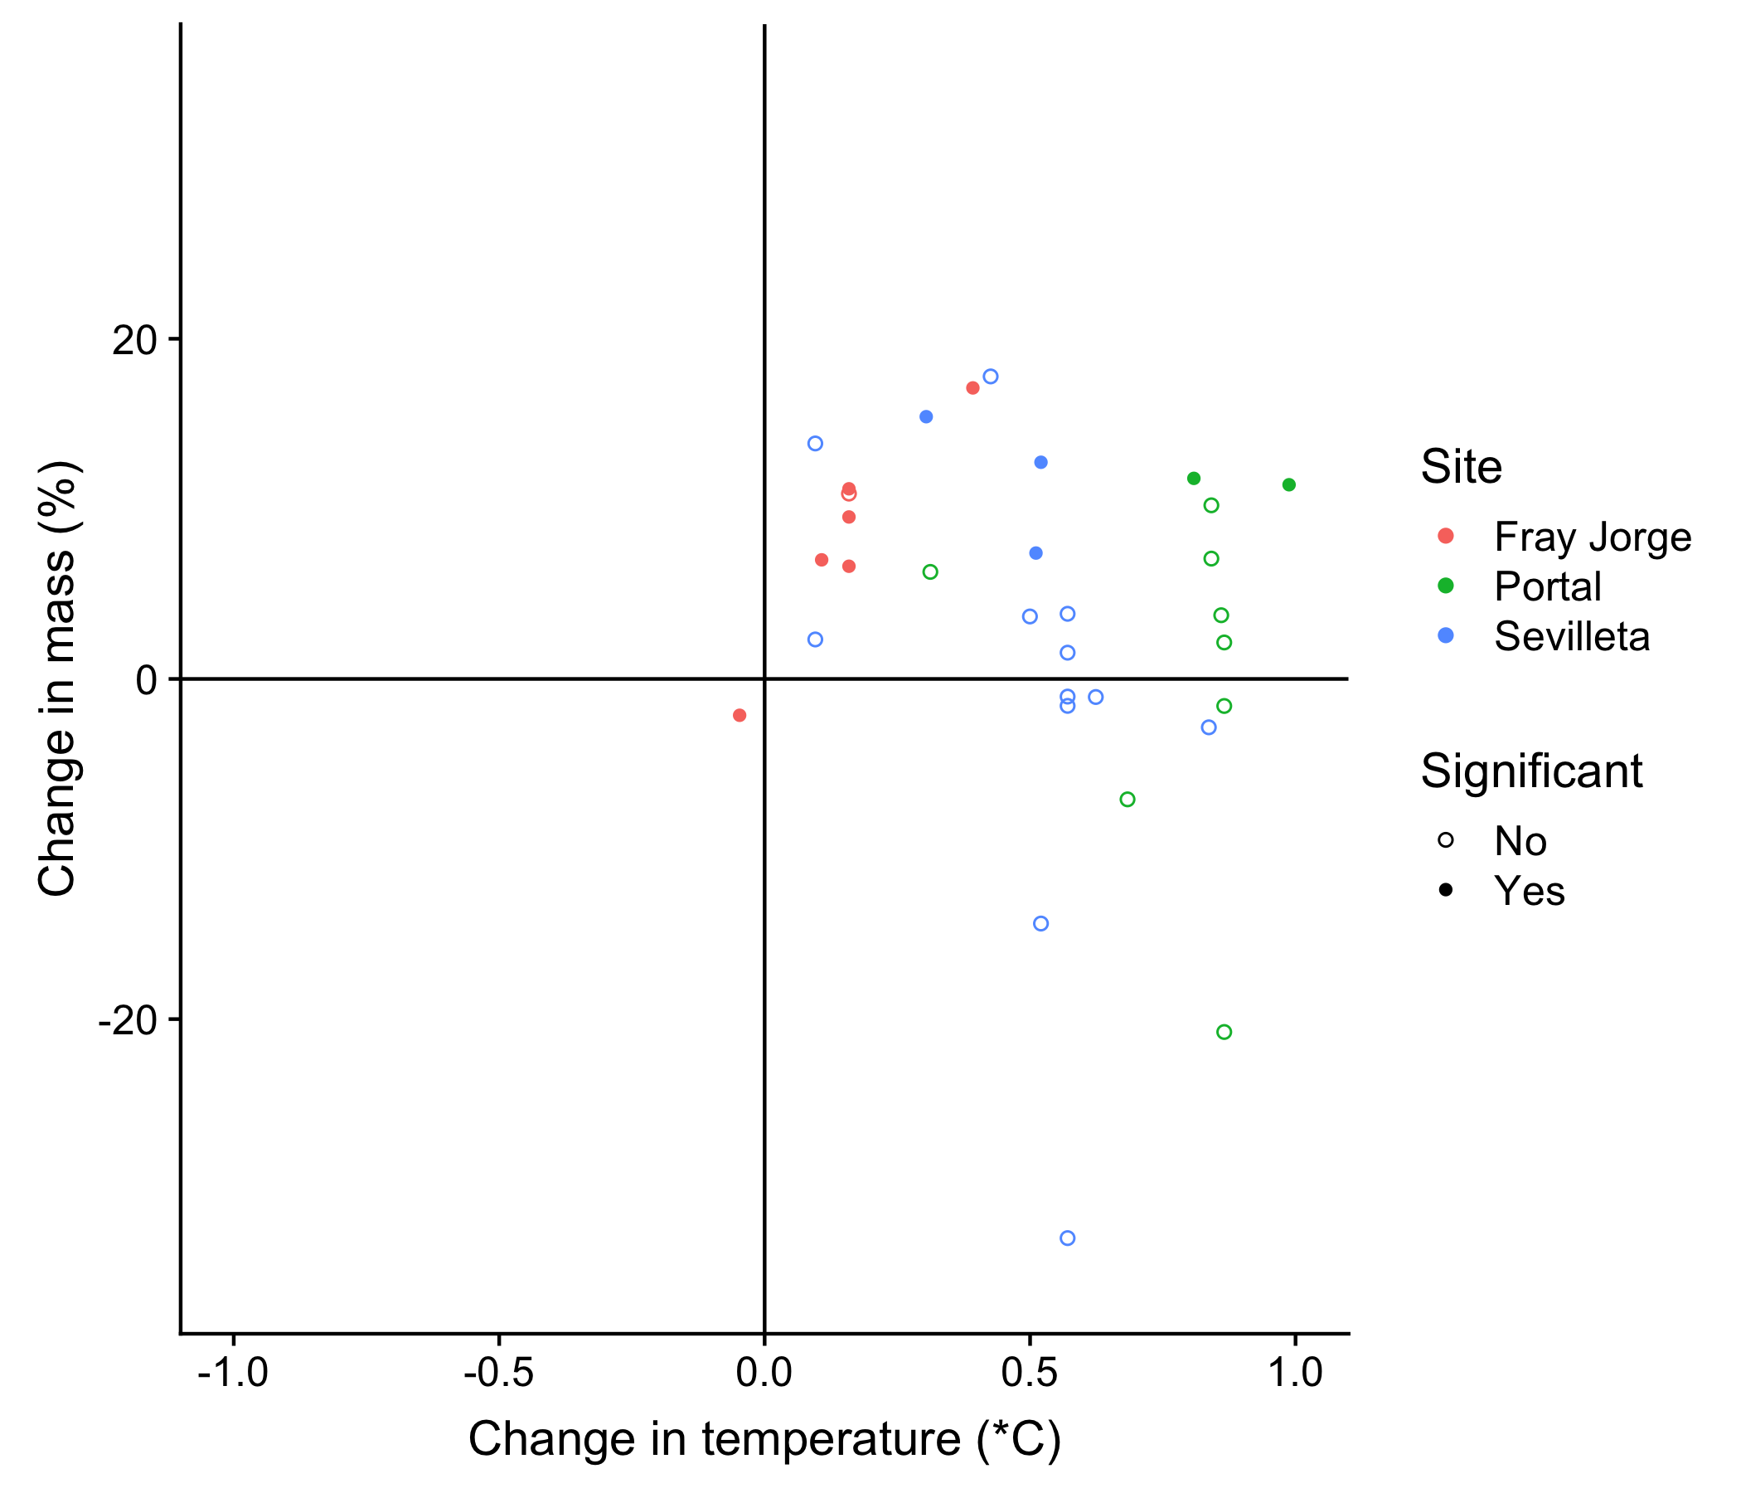

**Supplemental figures**

* Supp 1: Figures of ARIMA model diagnostics by species
* Supp 2: Yearly mass split out by species
* Supp 3: Mrt split out by species