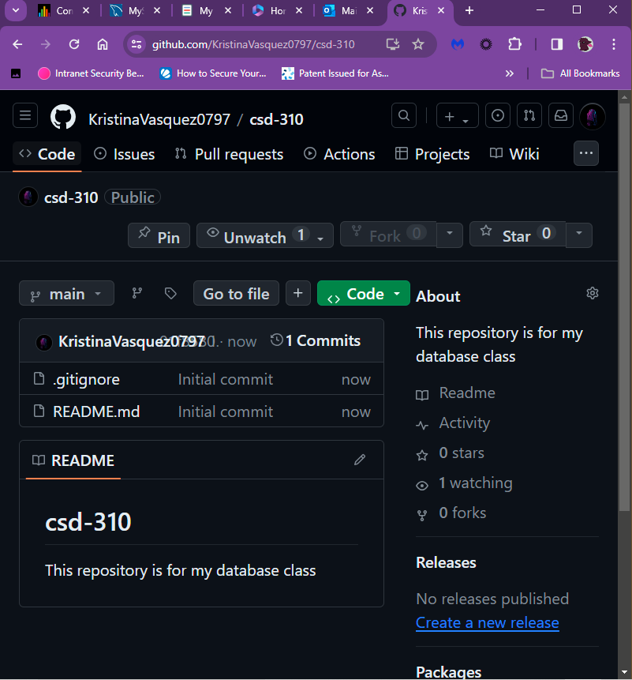

GitHub link: <https://github.com/KristinaVasquez0797/csd-310>

