Romany Manriquez

Outhayvanh Somchaleun

Kristina Vasquez

Milestone 3 - Bacchus Winery Reports

**Bacchus Winery Supplies Inventory Report:**

This report provides an overview of the current inventory levels of the supplies and components required for winemaking at Bacchus Winery, such as grapes, bottles, corks, labels, vats, and tubing. It includes information about the quality of each item in stock and the delivery schedule for pending supplier orders.

The Supplies Inventory Report is important for maintaining efficient operations in the winery. By having detailed and accurate information about inventory levels, Bacchus Winery can ensure they have an adequate supply of materials to meet production requirements. It also helps manage cash flow by avoiding overstocking or stockouts, optimizing storage space, and identifying any potential shortage or excess inventory that may impact production schedules and overall business performance.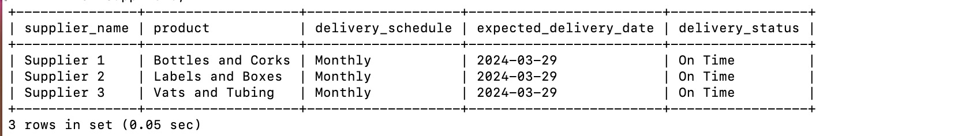

**Bacchus Winery Distributor Report:**

This report provides a comprehensive overview of the Distributors and distributor sales at Bacchus Winery, including details about each one individually.

The Distributor Report is essential for monitoring and optimizing the company's sales. By analyzing sales data, Bacchus Winery can identify trends, assess the efficiency of producing more sales, and make data-driven decisions to improve quality, reduce waste, and enhance overall sales.

Editor note: Revised our distributor MySQL report to reflect the same outcome our already turned in python script shows, the total sales with a $ indicator.

**Bacchus Winery Employee Time Report:**

This report provides insights into employee time management at Bacchus Winery, focusing on the total hours worked by Janet Collins, Roz Murphy, Bob Ulrich, Henry Doyle, Maria Costanza, and the 20 employees under Henry’s supervision.

This report is crucial for the owners, Stan and Davis, to evaluate employee performance and ensure optimization utilization of the workforce resources. By analyzing employee work hours over multiple quarters, Bacchus Winery can identify trends, assess workload distribution, and address any issues related to employee productivity or scheduling. This information enables Bacchus Winery to make informed decisions regarding staffing levels, resource allocation, and employee management to improve overall efficiency and productivity.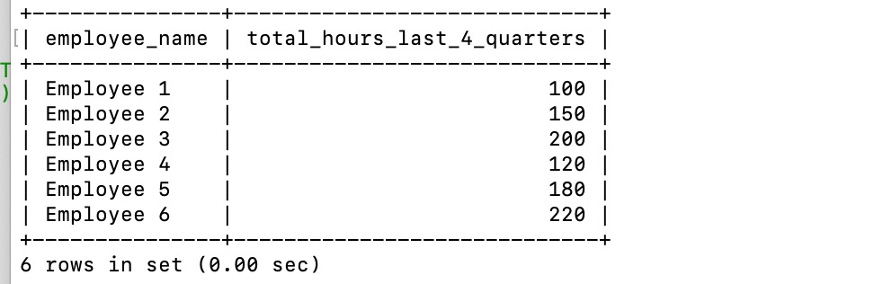

**Bacchus Winery End of Year Evaluation Derived from Other Three Reports:**

This evaluation provides a complete summary of Bacchus Winery's performance and financial status at the end of the fiscal year. It draws upon data and insights collected from the Bacchus Winery Supplies Inventory Report, Bacchus Winery Distributor Report, and Bacchus Winery Employee Time Report to gather critical metrics such as Sales Revenue, Expenses, inventory levels, Sales, and any significant events achieved during the year.

The end-of-year evaluation summary is vital for assessing the winery's overall performance and financial health. It provides stakeholders, including owners, investors, and financial institutions, valuable insight into Bacchus Winery's profitability and outlook. By analyzing this report, Bacchus Winery can identify areas of strength for improvement, set strategic goals and priorities for the upcoming year, and make informed decisions to drive the business forward. Furthermore, Bacchus Winery can assess labor costs, identify staffing needs, and optimize workforce management strategies. Additionally, it helps fulfill reporting requirements for regulatory compliance and facilitates communication with potential future partners or investors.