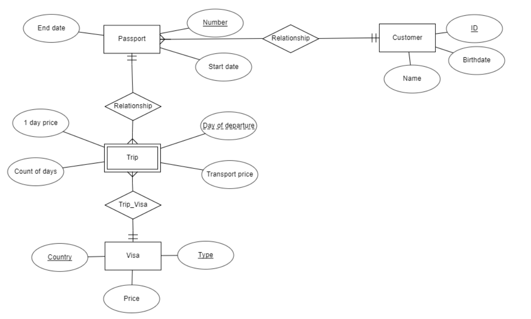

**Customer** (ID, Name, Birthdate)

**Passport** (Number, Start date, End date, Customer ID)

**Trip** (Pass_no, Day of departure, Country, Type, 1 day price, Count of days, Transport price)

**Visa** (Country, Type, Price)