Assignment 1

# Christopher Budd

# 218919068

## Question 1

## Question 2

### Pictures

### Code

Build_tower.py

import sys

import os

import time

import threading

from kortex_api.autogen.client_stubs.BaseClientRpc import BaseClient

from kortex_api.autogen.client_stubs.BaseCyclicClientRpc import BaseCyclicClient

from kortex_api.autogen.messages import Base_pb2, BaseCyclic_pb2, Common_pb2

# Maximum allowed waiting time during actions (in seconds)

TIMEOUT_DURATION = 20

# Create closure to set an event after an END or an ABORT

def check_for_end_or_abort(e):

    """Return a closure checking for END or ABORT notifications

    Arguments:

    e -- event to signal when the action is completed

        (will be set when an END or ABORT occurs)

    """

    def check(notification, e = e):

        print("EVENT : " + \

              Base_pb2.ActionEvent.Name(notification.action_event))

        if notification.action_event == Base_pb2.ACTION_END \

        or notification.action_event == Base_pb2.ACTION_ABORT:

            e.set()

    return check

def set_gripper(base, position):

    gripper_command = Base_pb2.GripperCommand()

    finger = gripper_command.gripper.finger.add()

    # Close the gripper with position increments

    print("Performing gripper test in position...")

    gripper_command.mode = Base_pb2.GRIPPER_POSITION

    finger.value = position

    print(f"Going to position {position}")

    base.SendGripperCommand(gripper_command)

def get_gripper(base):

    gripper_request = Base_pb2.GripperRequest()

    gripper_request.mode = Base_pb2.GRIPPER_POSITION

    gripper_measure = base.GetMeasuredGripperMovement(gripper_request)

    if len (gripper_measure.finger):

        print(f"Current position is : {gripper_measure.finger[0].value}")

        return gripper_measure.finger[0].value

    return None

def example_move_to_home_position(base):

    # Make sure the arm is in Single Level Servoing mode

    base_servo_mode = Base_pb2.ServoingModeInformation()

    base_servo_mode.servoing_mode = Base_pb2.SINGLE_LEVEL_SERVOING

    base.SetServoingMode(base_servo_mode)

    # Move arm to ready position

    print("Moving the arm to a safe position")

    action_type = Base_pb2.RequestedActionType()

    action_type.action_type = Base_pb2.REACH_JOINT_ANGLES

    action_list = base.ReadAllActions(action_type)

    action_handle = None

    for action in action_list.action_list:

        if action.name == "Home":

            action_handle = action.handle

    if action_handle == None:

        print("Can't reach safe position. Exiting")

        return False

    e = threading.Event()

    notification_handle = base.OnNotificationActionTopic(

        check_for_end_or_abort(e),

        Base_pb2.NotificationOptions()

    )

    base.ExecuteActionFromReference(action_handle)

    finished = e.wait(TIMEOUT_DURATION)

    base.Unsubscribe(notification_handle)

    if finished:

        print("Safe position reached")

    else:

        print("Timeout on action notification wait")

    return finished

def example_angular_action_movement(base, angles=[0.0, 0.0, 0.0, 0.0, 0.0, 0.0]):

    print("Starting angular action movement ...")

    action = Base_pb2.Action()

    action.name = "Example angular action movement"

    action.application_data = ""

    actuator_count = base.GetActuatorCount()

    # Place arm straight up

    print(actuator_count.count)

    if actuator_count.count != len(angles):

        print(f"bad lengths {actuator_count.count} {len(angles)}")

    for joint_id in range(actuator_count.count):

        joint_angle = action.reach_joint_angles.joint_angles.joint_angles.add()

        joint_angle.joint_identifier = joint_id

        joint_angle.value = angles[joint_id]

    e = threading.Event()

    notification_handle = base.OnNotificationActionTopic(

        check_for_end_or_abort(e),

        Base_pb2.NotificationOptions()

    )

    print("Executing action")

    base.ExecuteAction(action)

    print("Waiting for movement to finish ...")

    finished = e.wait(TIMEOUT_DURATION)

    base.Unsubscribe(notification_handle)

    if finished:

        print("Angular movement completed")

    else:

        print("Timeout on action notification wait")

    return finished

def example_cartesian_action_movement(base, base_cyclic):

    print("Starting Cartesian action movement ...")

    action = Base_pb2.Action()

    action.name = "Example Cartesian action movement"

    action.application_data = ""

    feedback = base_cyclic.RefreshFeedback()

    cartesian_pose = action.reach_pose.target_pose

    cartesian_pose.x = feedback.base.tool_pose_x          # (meters)

    cartesian_pose.y = feedback.base.tool_pose_y - 0.1    # (meters)

    cartesian_pose.z = feedback.base.tool_pose_z - 0.2    # (meters)

    cartesian_pose.theta_x = feedback.base.tool_pose_theta_x # (degrees)

    cartesian_pose.theta_y = feedback.base.tool_pose_theta_y # (degrees)

    cartesian_pose.theta_z = feedback.base.tool_pose_theta_z # (degrees)

    e = threading.Event()

    notification_handle = base.OnNotificationActionTopic(

        check_for_end_or_abort(e),

        Base_pb2.NotificationOptions()

    )

    print("Executing action")

    base.ExecuteAction(action)

    print("Waiting for movement to finish ...")

    finished = e.wait(TIMEOUT_DURATION)

    base.Unsubscribe(notification_handle)

    if finished:

        print("Cartesian movement completed")

    else:

        print("Timeout on action notification wait")

    return finished

def main():

    sys.path.insert(0, os.path.join(os.path.dirname(__file__), ".."))

    import utilities

    # Parse arguments

    args = utilities.parseConnectionArguments()

    # Create connection to the device and get the router

    with utilities.DeviceConnection.createTcpConnection(args) as router:

        # Create required services

        base = BaseClient(router)

        base_cyclic = BaseCyclicClient(router)

        success = True

        set_gripper(base, 0.0)

        time.sleep(2)

        success &= example_move_to_home_position(base)

        #First Block

        success &= example_angular_action_movement(base, [48,-58,78,0,0,0])

        set_gripper(base, 1.0)

        time.sleep(2)

        success &= example_angular_action_movement(base, [0,0,78,0,0,0])

        # Stack Spot

        success &= example_angular_action_movement(base, [0,-58,78,0,0,0])

        set_gripper(base, 0.0)

        time.sleep(2)

        # No hit

        success &= example_angular_action_movement(base, [0,0,60,0,0,0])

        # 2 Block

        success &= example_angular_action_movement(base, [-4,-37,126,0,0,0])

        set_gripper(base, 1.0)

        time.sleep(2)

        success &= example_angular_action_movement(base, [0,0,126,0,0,0])

        # Stack Spot

        success &= example_angular_action_movement(base, [0,-52,83,0,0,0])

        set_gripper(base, 0.0)

        time.sleep(2)

        # Reset For next

        success &= example_angular_action_movement(base, [0,-40,80,0,0,0])

        # 3 Block

        success &= example_angular_action_movement(base, [-9,-47,98,0,0,30])

        set_gripper(base, 1.0)

        time.sleep(2)

        # Reset and setup

        success &= example_angular_action_movement(base, [0,-40,80,0,0,0])

        # Last Drop

        success &= example_angular_action_movement(base, [0,-47,84,0,0,0])

        set_gripper(base, 0.0)

        time.sleep(2)

        return 0 if success else 1

if __name__ == "__main__":

    exit(main())

### How successful were you in this task?

I would say 70% successful as although it does work, it could be better. The tower itself was stable enough but if I had adjusted the arm more, it would have been better.

## Question 3

### Pictures

### Code

import math

import numpy as np

import rclpy

from rclpy.node import Node

from rclpy.parameter import Parameter

from rcl_interfaces.msg import SetParametersResult

from nav_msgs.msg import Odometry

from geometry_msgs.msg import Twist, Pose, Point, Quaternion

from nav_msgs.msg import Odometry

def euler_from_quaternion(quaternion):

    """

    Converts quaternion (w in last place) to euler roll, pitch, yaw

    quaternion = [x, y, z, w]

    """

    x = quaternion.x

    y = quaternion.y

    z = quaternion.z

    w = quaternion.w

    sinr_cosp = 2 * (w * x + y * z)

    cosr_cosp = 1 - 2 * (x * x + y * y)

    roll = np.arctan2(sinr_cosp, cosr_cosp)

    sinp = 2 * (w * y - z * x)

    pitch = np.arcsin(sinp)

    siny_cosp = 2 * (w * z + x * y)

    cosy_cosp = 1 - 2 * (y * y + z * z)

    yaw = np.arctan2(siny_cosp, cosy_cosp)

    return roll, pitch, yaw

class MoveToGoal(Node):

    def __init__(self):

        super().__init__('move_robot_to_goal')

        self.get_logger().info(f'{self.get_name()} created')

        self.declare_parameter('goal_x', 0.0)

        self._goal_x = self.get_parameter('goal_x').get_parameter_value().double_value

        self.declare_parameter('goal_y', 0.0)

        self._goal_y = self.get_parameter('goal_y').get_parameter_value().double_value

        self.declare_parameter('goal_t', 0.0)

        self._goal_t = self.get_parameter('goal_t').get_parameter_value().double_value

        self.declare_parameter('max_vel', 0.4)

        self._max_vel = self.get_parameter('max_vel').get_parameter_value().double_value

        self.declare_parameter('cmd_gain', 5.0)

        self._cmd_gain = self.get_parameter('cmd_gain').get_parameter_value().double_value

        self.add_on_set_parameters_callback(self.parameter_callback)

        self.get_logger().info(f"initial goal {self._goal_x} {self._goal_y} {self._goal_t}")

        self.get_logger().info(f"maximum velocity {self._max_vel}")

        self._subscriber = self.create_subscription(Odometry, "/odom", self._listener_callback, 1)

        self._publisher = self.create_publisher(Twist, "/cmd_vel", 1)

    def _listener_callback(self, msg, vel_gain=5.0, max_vel=0.2, max_pos_err=0.05):

        pose = msg.pose.pose

        max_vel = self._max_vel

        vel_gain = self._cmd_gain

        cur_x = pose.position.x

        cur_y = pose.position.y

        o = pose.orientation

        roll, pitchc, yaw = euler_from_quaternion(o)

        cur_t = yaw

        x_diff = self._goal_x - cur_x

        y_diff = self._goal_y - cur_y

        dist = math.sqrt(x_diff * x_diff + y_diff * y_diff)

        twist = Twist()

        if dist > max_pos_err:

            x = max(min(x_diff * vel_gain, max_vel), -max_vel)

            y = max(min(y_diff * vel_gain, max_vel), -max_vel)

            twist.linear.x = x * math.cos(cur_t) + y * math.sin(cur_t)

            twist.linear.y = -x * math.sin(cur_t) + y * math.cos(cur_t)

        angle_diff = math.atan2(math.sin(self._goal_t - cur_t), math.cos(self._goal_t - cur_t))

        if abs(angle_diff) > max_pos_err:

            self.get_logger().info(f"Twist {angle_diff}")

            twist.angular.z = max(min(angle_diff * vel_gain*4, max_vel*5), -max_vel*5)

            self.get_logger().info(f"Twist ang {twist.angular.z}")

        self.get_logger().info(f"at ({cur_x},{cur_y},{cur_t}) goal ({self._goal_x},{self._goal_y},{self._goal_t})")

        self._publisher.publish(twist)

    def parameter_callback(self, params):

        self.get_logger().info(f'move_robot_to_goal parameter callback {params}')

        for param in params:

            self.get_logger().info(f'move_robot_to_goal processing {param.name}')

            if param.name == 'goal_x' and param.type_ == Parameter.Type.DOUBLE:

                self._goal_x = param.value

            elif param.name == 'goal_y' and param.type_ == Parameter.Type.DOUBLE:

                self._goal_y = param.value

            elif param.name == 'goal_t' and param.type_ == Parameter.Type.DOUBLE:

                self._goal_t = param.value

            else:

                self.get_logger().warn(f'{self.get_name()} Invalid parameter {param.name}')

                return SetParametersResult(successful=False)

            self.get_logger().warn(f"Changing goal {self._goal_x} {self._goal_y} {self._goal_t}")

        return SetParametersResult(successful=True)

def main(args=None):

    rclpy.init(args=args)

    node = MoveToGoal()

    try:

        rclpy.spin(node)

    except KeyboardInterrupt:

        pass

    rclpy.shutdown()

if __name__ == '__main__':

    main()

## Question 4

### Layout

If not at goal(if dist > max_pos_err)

Drive towards goal

For object in object list

If an object in the way of the robot within a range

Follow the obstacle boundary moving to the left or right.  
or based on the lab 1 code

For o in map

Check if in range and in the way

InWay = true

If inway

Follow the obstacle boundary

Else

Drive towards goal

### Explanation

Using _listener_callback, if the robot has not reached its goal, move towards the goal until an object is in its way. It checks the list when it moves to simulate it discovering the object by sensors or hitting it. It then follows the object boundary until it can move towards the goal.

## Question 5

### Pictures

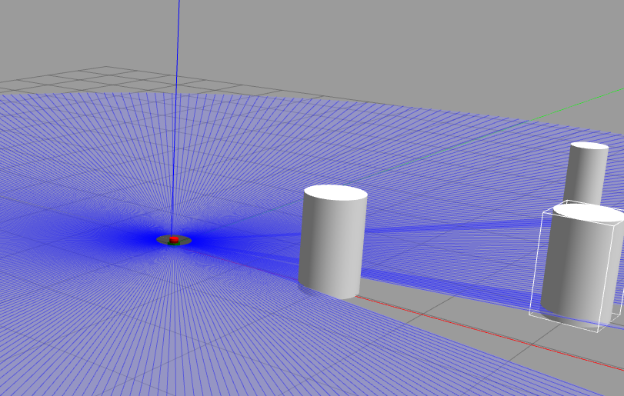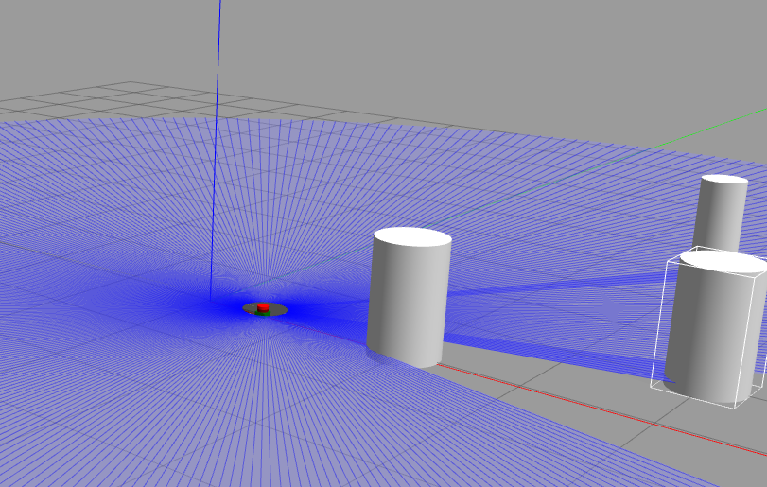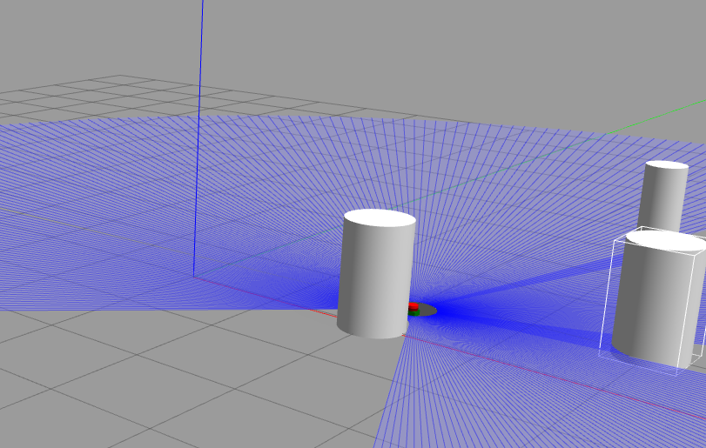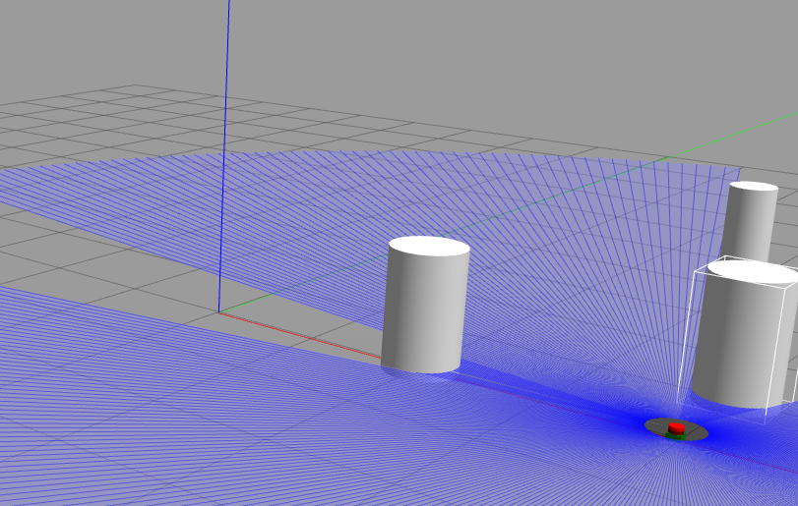

### Code

    def _listener_callback(self, msg, vel_gain=5.0, max_vel=0.2, max_pos_err=0.05):

        pose = msg.pose.pose

        max_vel = self._max_vel

        vel_gain = self._cmd_gain

        cur_x = pose.position.x

        cur_y = pose.position.y

        o = pose.orientation

        roll, pitchc, yaw = euler_from_quaternion(o)

        cur_t = yaw

        x_diff = self._goal_x - cur_x

        y_diff = self._goal_y - cur_y

        dist = math.sqrt(x_diff * x_diff + y_diff * y_diff)

        twist = Twist()

        obstacle_detected = False

        for o in self._map.keys():

            obj_x, obj_y, obj_r = self._map[o]['x'], self._map[o]['y'], self._map[o]['r']

            obj_dist = math.sqrt((cur_x - obj_x)**2 + (cur_y - obj_y)**2)

            self.get_logger().info(f"Obstacle States {o} {obj_dist}")

            if obj_dist <= obj_r + 0.3:  # 0.5 is a safety margin

                obstacle_detected = True

                break

        if obstacle_detected:

            angle_to_obj = math.atan2(obj_y - cur_y, obj_x - cur_x)

            tangent_angle = angle_to_obj + math.pi/2

            x_tangent = math.cos(tangent_angle)

            y_tangent = math.sin(tangent_angle)

            x = max(min(x_tangent * vel_gain, max_vel), -max_vel)

            y = max(min(y_tangent * vel_gain, max_vel), -max_vel)

            twist.linear.x = x * math.cos(cur_t) + y * math.sin(cur_t)

            twist.linear.y = -x * math.sin(cur_t) + y * math.cos(cur_t)

            self.get_logger().info(f"Obstacle detected")

        elif dist > max_pos_err:

            x = max(min(x_diff * vel_gain, max_vel), -max_vel)

            y = max(min(y_diff * vel_gain, max_vel), -max_vel)

            twist.linear.x = x * math.cos(cur_t) + y * math.sin(cur_t)

            twist.linear.y = -x * math.sin(cur_t) + y * math.cos(cur_t)

        angle_diff = math.atan2(math.sin(self._goal_t - cur_t), math.cos(self._goal_t - cur_t))

        if abs(angle_diff) > max_pos_err:

            self.get_logger().info(f"Twist {angle_diff}")

            twist.angular.z = max(min(angle_diff * vel_gain*4, max_vel*5), -max_vel*5)

            self.get_logger().info(f"Twist ang {twist.angular.z}")

        self.get_logger().info(f"at ({cur_x},{cur_y},{cur_t}) goal ({self._goal_x},{self._goal_y},{self._goal_t})")

        self._publisher.publish(twist)