Name: Christopher Budd

Student Number: 218919068

Before Movement:

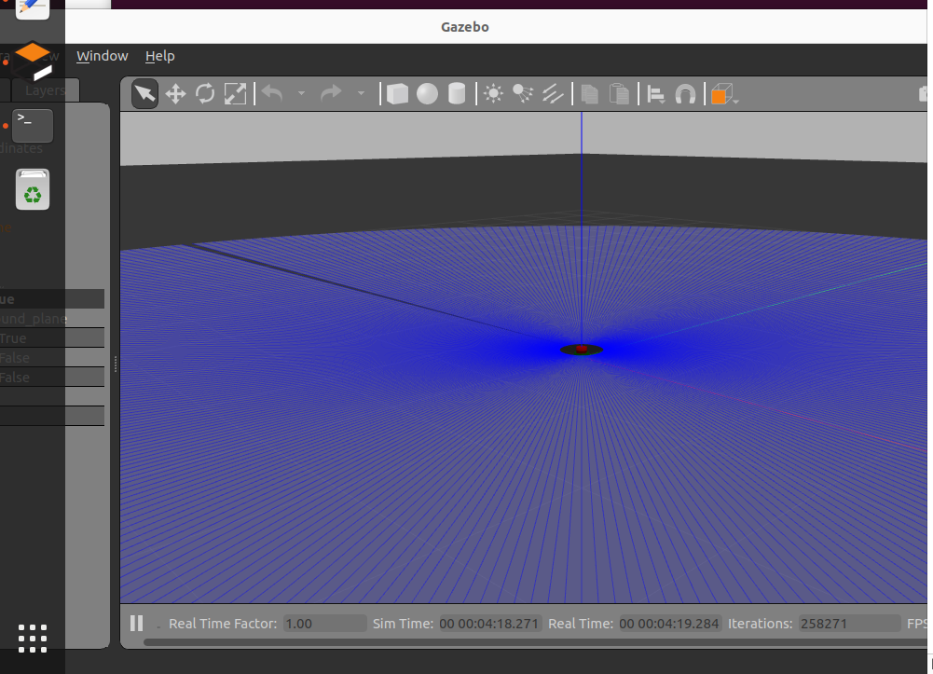

After Movement:

Python File: drive_to_goal

import math

import numpy as np

import rclpy

from rclpy.node import Node

from rclpy.parameter import Parameter

from rcl_interfaces.msg import SetParametersResult

from nav_msgs.msg import Odometry

from geometry_msgs.msg import Twist, Pose, Point, Quaternion

from nav_msgs.msg import Odometry

def euler_from_quaternion(quaternion):

    """

    Converts quaternion (w in last place) to euler roll, pitch, yaw

    quaternion = [x, y, z, w]

    """

    x = quaternion.x

    y = quaternion.y

    z = quaternion.z

    w = quaternion.w

    sinr_cosp = 2 * (w * x + y * z)

    cosr_cosp = 1 - 2 * (x * x + y * y)

    roll = np.arctan2(sinr_cosp, cosr_cosp)

    sinp = 2 * (w * y - z * x)

    pitch = np.arcsin(sinp)

    siny_cosp = 2 * (w * z + x * y)

    cosy_cosp = 1 - 2 * (y * y + z * z)

    yaw = np.arctan2(siny_cosp, cosy_cosp)

    return roll, pitch, yaw

class MoveToGoal(Node):

    def __init__(self):

        super().__init__('move_robot_to_goal')

        self.get_logger().info(f'{self.get_name()} created')

        self.declare_parameter('goal_x', 0.0)

        self._goal_x = self.get_parameter('goal_x').get_parameter_value().double_value

        self.declare_parameter('goal_y', 0.0)

        self._goal_y = self.get_parameter('goal_y').get_parameter_value().double_value

        self.declare_parameter('goal_t', 0.0)

        self._goal_t = self.get_parameter('goal_t').get_parameter_value().double_value

        self.declare_parameter('max_vel', 0.2)

        self._max_vel = self.get_parameter('max_vel').get_parameter_value().double_value

        self.declare_parameter('cmd_gain', 5.0)

        self._cmd_gain = self.get_parameter('cmd_gain').get_parameter_value().double_value

        self.add_on_set_parameters_callback(self.parameter_callback)

        self.get_logger().info(f"initial goal {self._goal_x} {self._goal_y} {self._goal_t}")

        self.get_logger().info(f"maximum velocity {self._max_vel}")

        self._subscriber = self.create_subscription(Odometry, "/odom", self._listener_callback, 1)

        self._publisher = self.create_publisher(Twist, "/cmd_vel", 1)

    def _listener_callback(self, msg, vel_gain=5.0, max_vel=0.2, max_pos_err=0.05):

        pose = msg.pose.pose

        max_vel = self._max_vel

        vel_gain = self._cmd_gain

        cur_x = pose.position.x

        cur_y = pose.position.y

        o = pose.orientation

        roll, pitchc, yaw = euler_from_quaternion(o)

        cur_t = yaw

        x_diff = self._goal_x - cur_x

        y_diff = self._goal_y - cur_y

        dist = math.sqrt(x_diff * x_diff + y_diff * y_diff)

        twist = Twist()

        if dist > max_pos_err:

            x = max(min(x_diff * vel_gain, max_vel), -max_vel)

            y = max(min(y_diff * vel_gain, max_vel), -max_vel)

            twist.linear.x = x * math.cos(cur_t) + y * math.sin(cur_t)

            twist.linear.y = -x * math.sin(cur_t) + y * math.cos(cur_t)

        angle_diff = math.atan2(math.sin(self._goal_t - cur_t), math.cos(self._goal_t - cur_t))

        if abs(angle_diff) > max_pos_err:

            self.get_logger().info(f"Twist {angle_diff}")

            twist.angular.z = max(min(angle_diff * vel_gain*4, max_vel*5), -max_vel*5)

            self.get_logger().info(f"Twist ang {twist.angular.z}")

        self.get_logger().info(f"at ({cur_x},{cur_y},{cur_t}) goal ({self._goal_x},{self._goal_y},{self._goal_t})")

        self._publisher.publish(twist)

    def parameter_callback(self, params):

        self.get_logger().info(f'move_robot_to_goal parameter callback {params}')

        for param in params:

            self.get_logger().info(f'move_robot_to_goal processing {param.name}')

            if param.name == 'goal_x' and param.type_ == Parameter.Type.DOUBLE:

                self._goal_x = param.value

            elif param.name == 'goal_y' and param.type_ == Parameter.Type.DOUBLE:

                self._goal_y = param.value

            elif param.name == 'goal_t' and param.type_ == Parameter.Type.DOUBLE:

                self._goal_t = param.value

            else:

                self.get_logger().warn(f'{self.get_name()} Invalid parameter {param.name}')

                return SetParametersResult(successful=False)

            self.get_logger().warn(f"Changing goal {self._goal_x} {self._goal_y} {self._goal_t}")

        return SetParametersResult(successful=True)

def main(args=None):

    rclpy.init(args=args)

    node = MoveToGoal()

    try:

        rclpy.spin(node)

    except KeyboardInterrupt:

        pass

    rclpy.shutdown()

if __name__ == '__main__':

    main()