**www.4wheels.bg**

The website is created to provide a easy way for the user to find a needed car. The purpose of that is accomplished with ratings. They help’s to the user to see which vehicle is better, according to the other users. The Rating also protects the user form incorrect sellers.

The website also gives information about auto services. Each auto service has rating so the user can find the best one to repair your car.

**Home Page**

On the Home page you can find navigation bar with links that allows you access to all pages in the website (fig.1). There is also Log in and Register buttons and panel with tabs that facilitate you to find, sell or repair a car (fig.2). On the right side is a box which shows cars with currently highest rating (fig.3).

(fig.1)

C:\Users\Parapanov\Desktop\Resources\Navigation Bar.JPG

(fig.2)

C:\Users\Parapanov\Desktop\Resources\tabs.JPG

(fig.3)

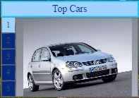

Navigation bar buttons:

* [Home] – takes you to the Home page.
* [Cars] – shows you a list of cars sorted by rating.
* [Sellers] – shows you a list of cars dealers sorted by rating.
* [Auto services] – shows you a list of auto services sorted by rating.
* [About] – shows you information about the webpage.

**Registered User**

If you want to use the full opportunity of the website you should register. This can happen when you press [Register] button in the Home page, and then fill the form.

**User Profile**

When you enter your username and password and click on CaptureIf the password is correct you will enter in your profile page.

On the top you have navigation bar:

- link to Home profile page

-link to Add Car Page

-link to Add Service Page

- link to My Cars

 -link to My Services

 - log out of profile and go to Home Page

Under the navigation bar user have information about profile



-User rating from 1 to 5.

-User type

- Location

- User phone Number

- Button to edit Profile

The profile page has the top cars of the user sorted by views and rating:

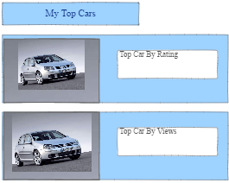

**Add Car**

Add Car Page – on this page user add new car for sale. On the top of the page have navigation bar

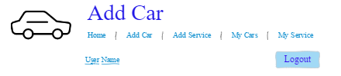

User enter Make , Model ,Version and Type:

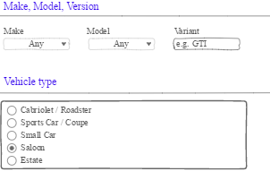

Then write information about Engine

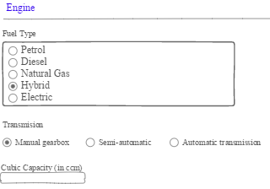

After that, write information for Location and Color:

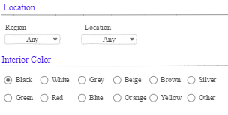

Features :

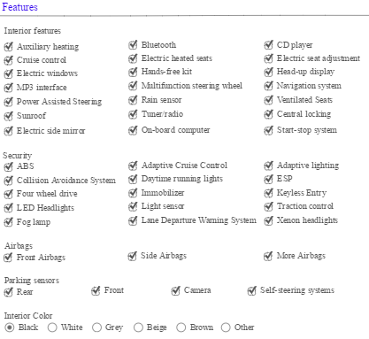

User add pictures and give more information about car

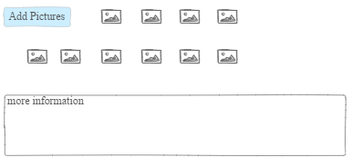

In the end click on  and the car is added in the sale list.

**Search Car**

When you want to search for a car you can do this by going in Home page -> Find Car tab and fill the form. If you want more specific search you can click on “Detailed search” link in Find Car tab. This will take you in Detailed Search page where you can check for specific characteristics.