Robo Sport - *User Guide*

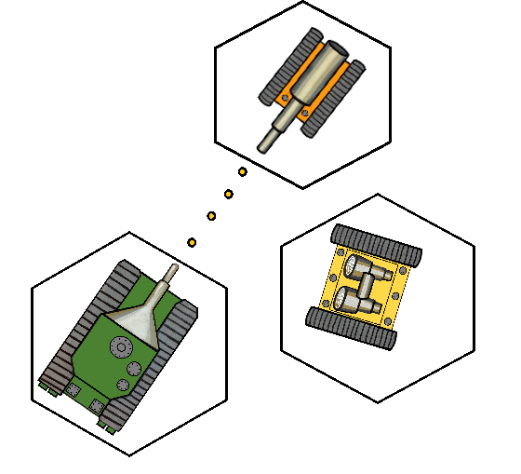

Software Engineering Team:

Arianne Butler, Michael Graham,

Samuel Horovatin, Kristof Mercier,

Christopher Mykota-Reid

Contents

Getting Started 2

System requirements 2

Installing Robo Sport 2

Introduction 2

Game Set Up 2

# Getting Started

## System requirements:

To install and run Robo Sport you will need:

1. A computer running Windows 7 or higher

2. A computer that has Java SDK 1.8 or higher installed

3. Around 50 MB of available system memory

## Installing Robo Sport:

To install using Gitlab:

1. Insure that git is installed on the computer you wish to play on, or that there is access to the internet.

2. Using the terminal, type in the following:

git clone https://git.cs.usask.ca/370-16/370-16D2.git

(Valid gitlab login credentials are required to clone from gitlab)

If using the internet version of gitlab, navigate to:

<https://git.cs.usask.ca/370-16/370-16D2/tree/Implementation>

- click download zip button and unzip

3. Once a copy of the project is obtained, open it in your favourite IDE and play from there. Intellij or Eclipse are recommended.

# Introduction

Enter Robo Sport and take control. Become the commander of an elite squad of Robotic war machines. Start your career as a master tactician on a futuristic hexagonal battlefield. Your squad of Robotic minions depends on sharp wit and cunning tactics to help guide them to victory against your foes. Engage in small skirmishes to grand wars against teams of human and AI players. Use your three distinct Robotic warriors to turn the tide of the battle and burn your own trail to victory.

# Game Set-Up

Upon start-up, Robo Sport will display the following title screen:

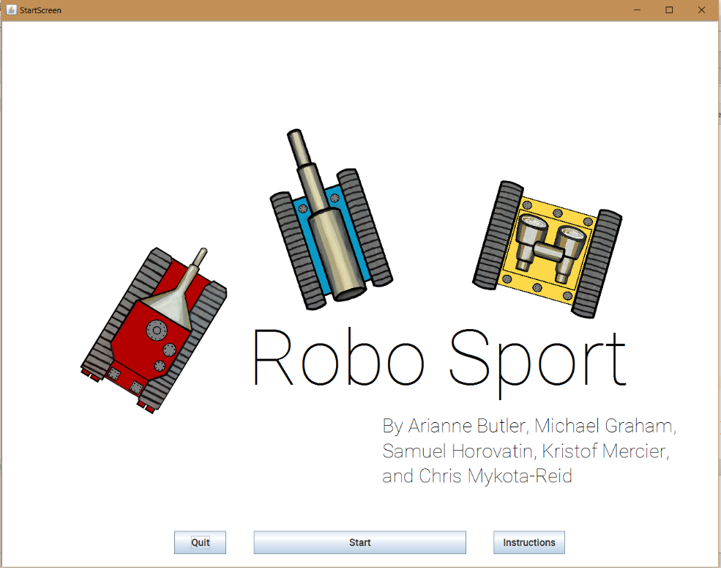

From this screen you can quit the application, start a new Game, or read the instructions. Once you have perused the instructions, you are ready to start your first game of Robo Sport.

**Select the Start Button** which will bring you to the Set-Up screen:

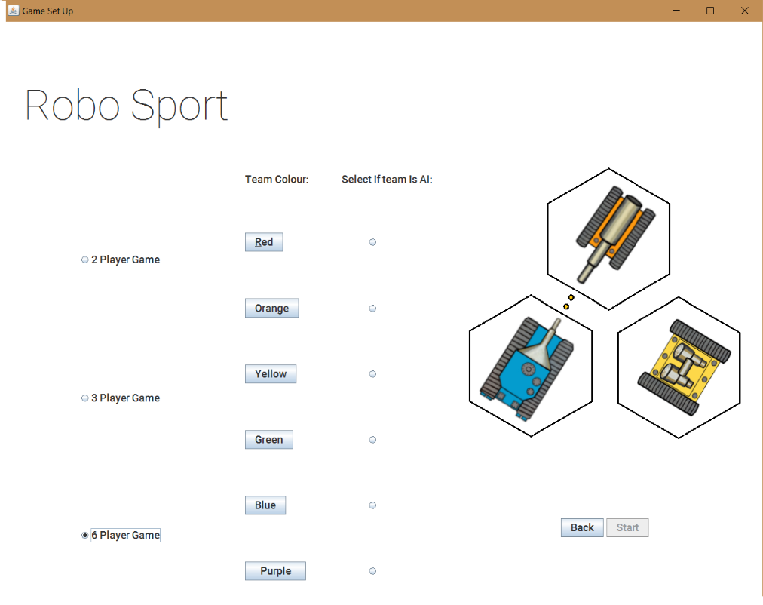

From the Set-Up screen, you can start to set up game details. You can **choose from a two, three, or six player battle**. Don’t have any friends to play with? No worries! **Simply select the AI check box for computer controlled teams** and the application will take care of the rest. Now that you have decided how many teams will play and who will control them, you must populate the teams with robot warriors. To do so, **select the team color** you wish to populate.

Upon selecting the team color, the following team building screen will open:

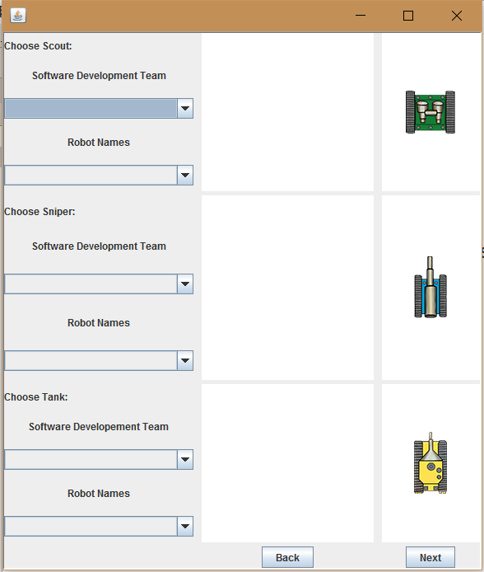You’re almost there! To populate a team, **select a software development team** to recruit robots from. Once you have selected a development team, you may now select a particular **tank, sniper, and scout** to be added to your team. **Select from the Robot names**; this will populate the stats display on the right with the robot battle statistics. Once you have selected all the robots for a team, that team is ready for battle! Simply repeat for all other teams. Once all teams have been populated with robots, **select start in the Set Up Screen** which will start the main game!