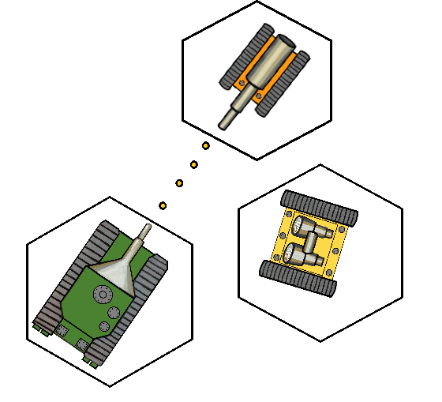

Robo Sport

*User Guide*

|  |
| --- |
| TABLE OF CONTENTS |

**Getting Started …**…… ……………………………………………**3**

System requirements 3

Installing Robo Sport 3

**Introduction**…………………………………………………........**4**

**Tutorial – How to set up a game**……………………………..**6**

**User Reference**…..………………………………………………..**8**

Robot Statistics 9

The Map 9

Moving a robot 10

Attacking 10

|  |
| --- |
| **Getting Started** |

|  |
| --- |
| **System requirements** |

**To install and run Robo Sport you will need:**

1. A computer running Windows 7 or higher
2. A computer that has Java SDK 1.8 or higher installed
3. Around 50 MB of available system memory

|  |
| --- |
| **Installing Robo Sport** |

**To install using Gitlab:**

1. Insure you have git installed on the computer you wish to play on or have access to the internet.
2. Using the terminal, you must type in the following:

git clone https://git.cs.usask.ca/370-16/370-16D2.git

(Valid gitlab login credentials are needed to clone from gitlab)

If using the internet version of gitlab, navigate to <https://git.cs.usask.ca/370-16/370-6D2/tree/Implementation> , click download zip button and unzip.

1. Once a copy of the project is obtained, you must open it in your favourite IDE and play it from there. Intellij or Eclipse are recommended IDE choices.

|  |
| --- |
| **Introduction** |

Enter Robo Sport and take control. Become the commander of an elite squad of Robotic war machines.

Start your career as a master tactician on the hexagonal battlefield of the future. Your squad of Robotic minions depends on your sharp wit and cunning tactics to help guide them to victory against your foes.

Engage in small skirmishes to grand wars against teams of human and AI players. Use your three distinct Robotic warriors to turn the tide of the battle and burn your own trail to victory.



|  |
| --- |
| **How to set up a game** |

Upon starting up Robo sport you will be greeted by the following title screen:

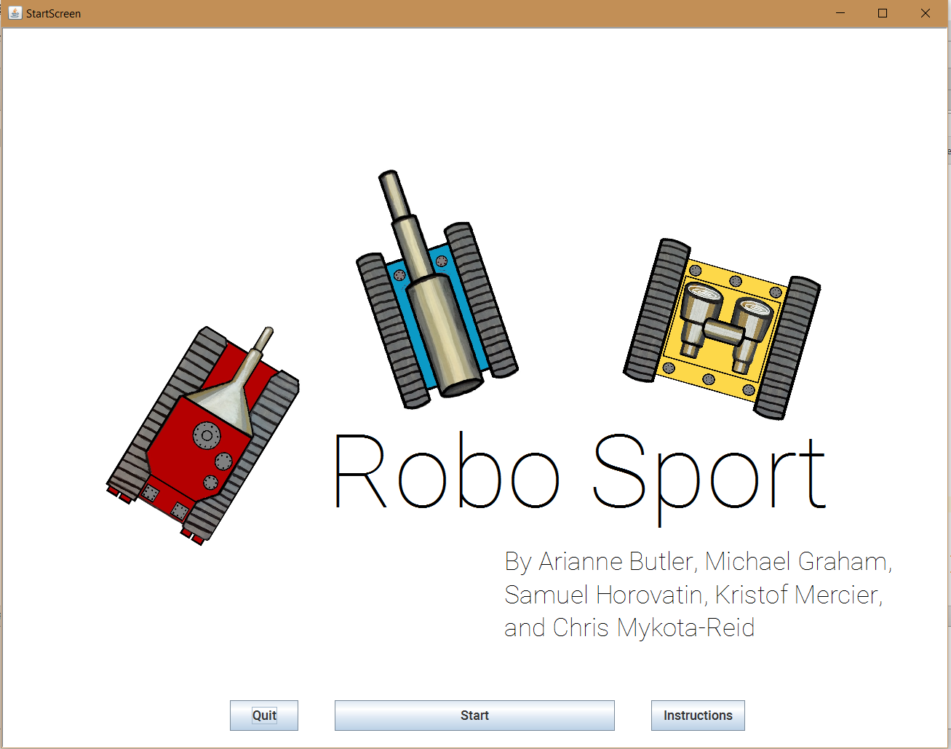

From this screen you can Quit the application, Start a Game, or read instructions. Once you have perused the instructions, you are ready to start your first game of Robo Sport.

Simply **select the Start Button,** which will bring you to the team building screen:

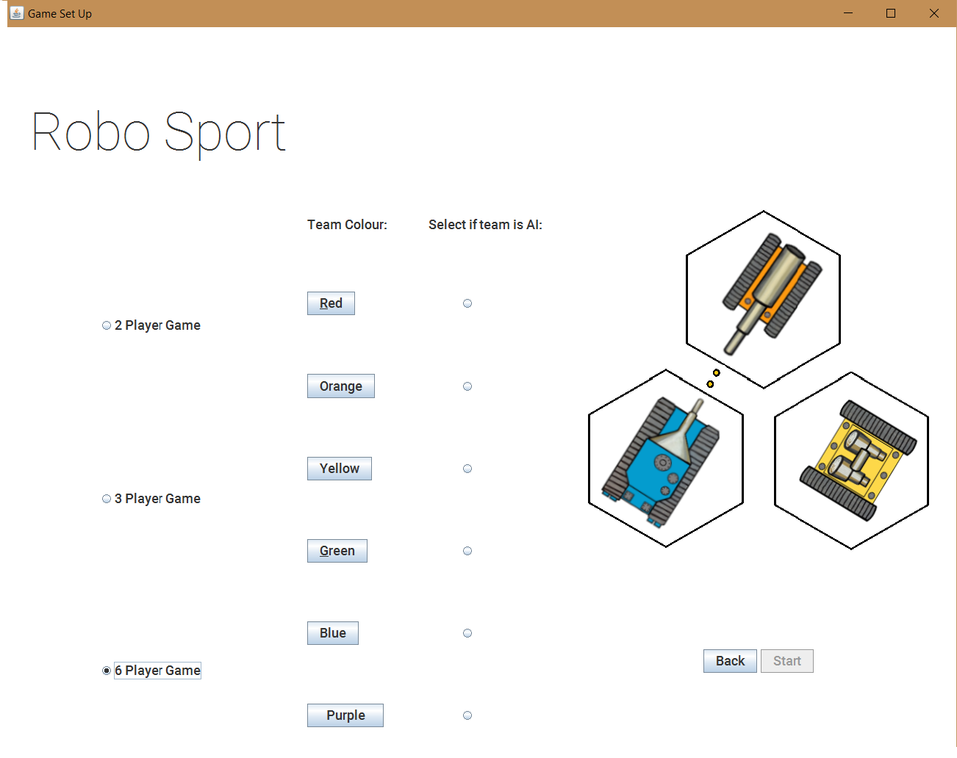

From the game set up screen you can do just as the name implies. You can **chose from 2, 3, and 6 player battle**. Don’t have any friends to play with? No worries! **Simply select AI for all teams you do not wish to play** and the application will take care of that robots turn. Now that you have decided upon the details off the game, you must populate the teams with robot warriors. To do so, **select the team color** you wish to populate with robots.

Upon selecting the team color you wish to populate with robots, you will be greeted by the following team building screen:

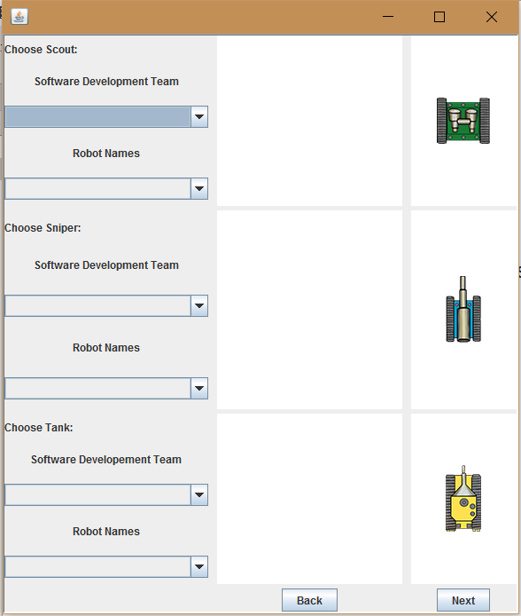

You’re almost there from this point! To populate a team you **select a development team** to recruit robots from. These are army’s prepopulated with battle harden robots to pull from. Once you have selected your favourite development team, you may now select the particular tank from the team to be added to your team. To do so **select Robot names**; this will populate the stats display with the robots battle stats. Once you have selected all the robots for the team, that team is ready for battle! Simply repeat for all other teams. Once all teams have robots, **select start** which will start the main game!