Lacson, Kristoffer C.

WD-301

Midterm Case Study

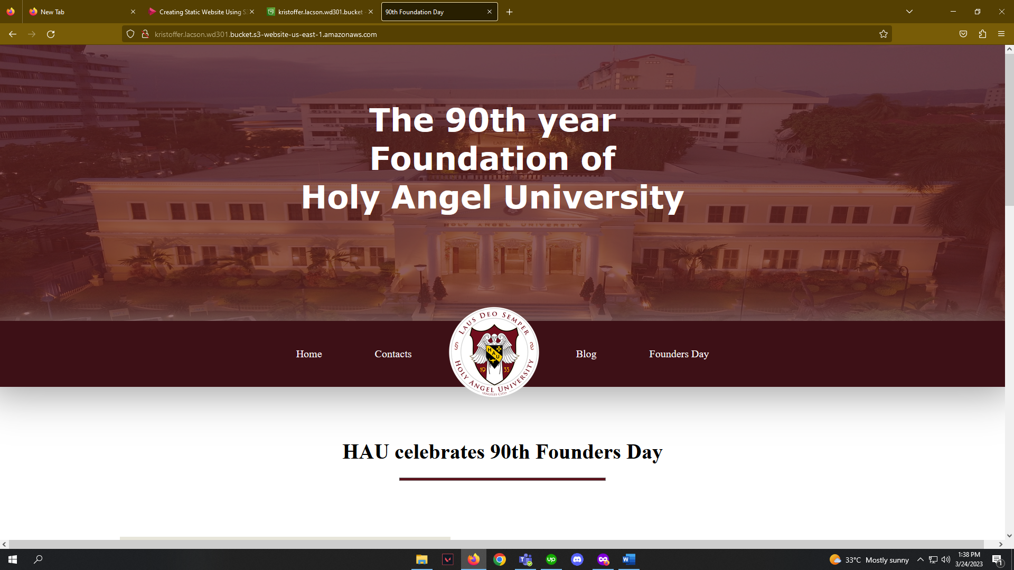

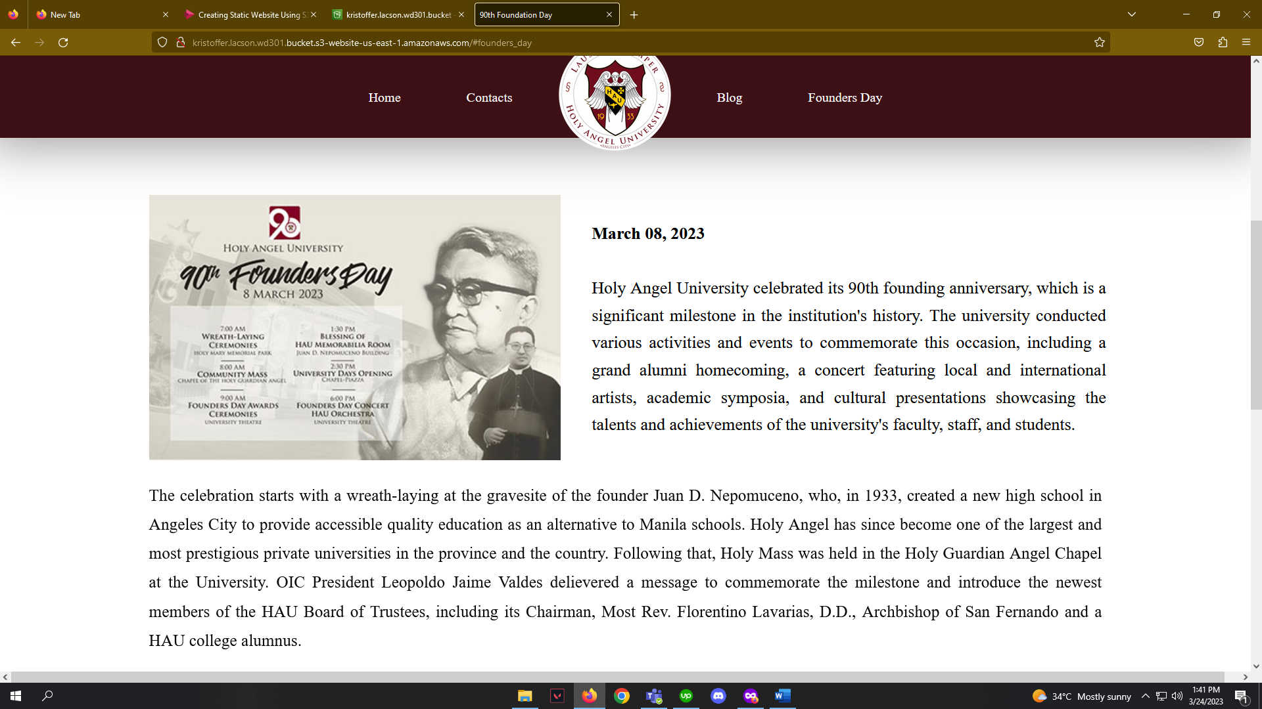

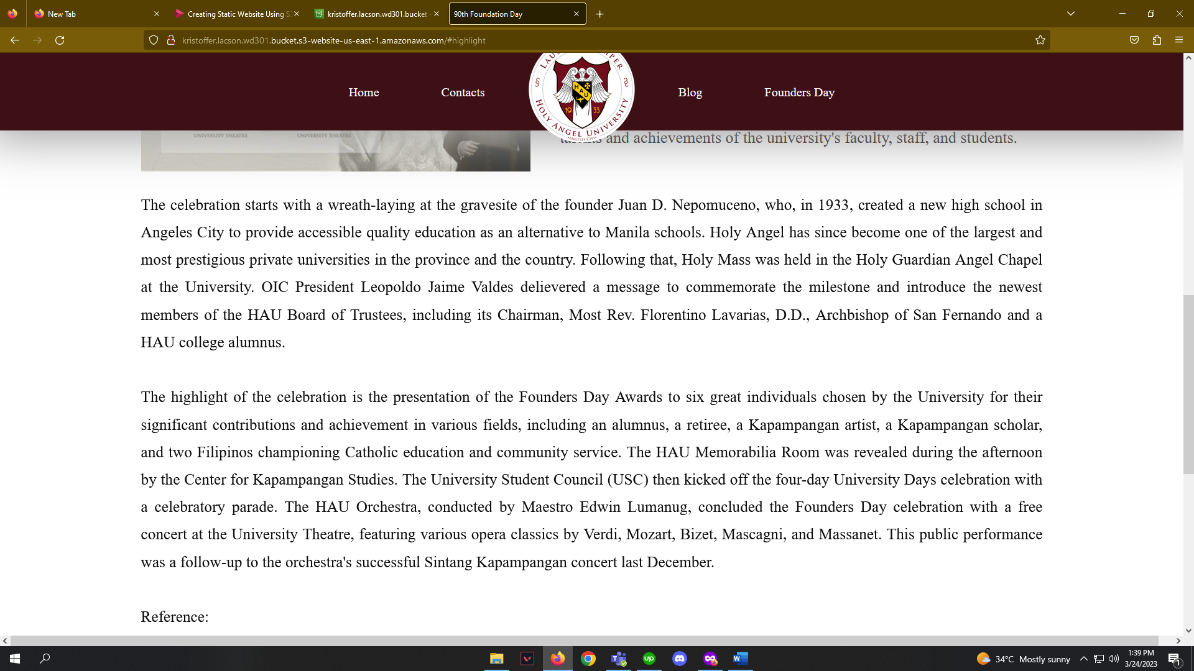

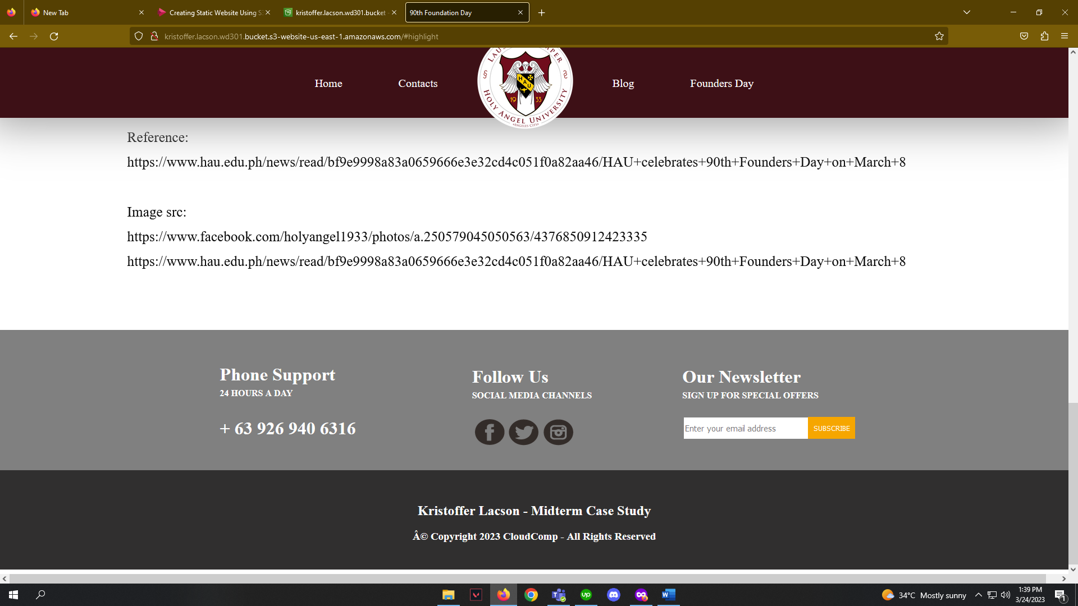

Link: http://kristoffer.lacson.wd301.bucket.s3-website-us-east-1.amazonaws.com