DATA 608

The Contradictory Mandate: Why Policy Lags and Market Shocks Prevent Simultaneous Price Stability and Full Employment
Kristoff Oliphant

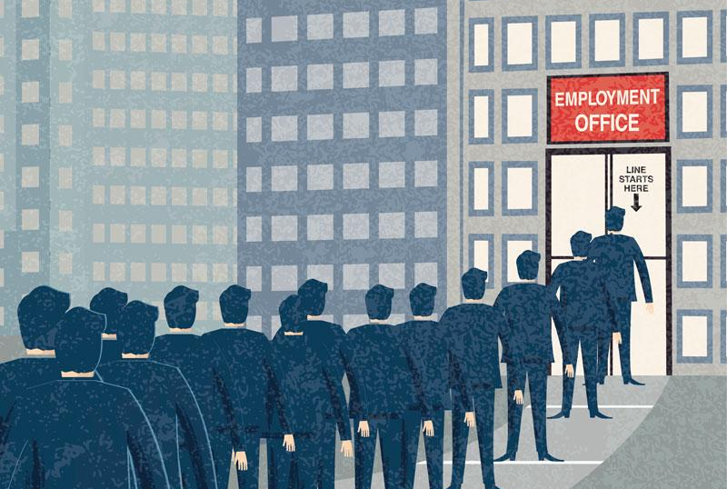
Introduction:
In the past 25 years of the history of the United States, the havoc caused by The Great Recession, The Dot-Com Crash, COVID-19, unemployment, rising interest rates, and increased cost of living cannot be erased, but it’s easy to forget when everything is going well. The average U.S. citizen may not be fully aware of how or who handles the economy when it’s growing and also during its collapse. Today, we’ll learn more about how these situations are handled by the Federal Reserve Board with the information provided by the Bureau of Labor Statistics, and whether or not the economic mandate of controlling inflation and maintaining low unemployment can simultaneously be accomplished.

What is the purpose of the Federal Reserve System?
The Federal Reserve may not hold much of a public facing position, but it plays a key role in the fluctuations of the economy and employment of U.S. citizens ever since its establishment in 1913. Per the Federal Reserve’s website, “ ‘the Fed,’ is the central bank of the United States. It was created by the Congress to provide the nation with a safer, more flexible, and more stable monetary and financial system.” The four main functions provided by the Federal Reserve’s official website are the following:
- Conducting the nation's monetary policy by influencing money and credit conditions in the economy in pursuit of full employment and stable prices.
- Supervising and regulating banks and other important financial institutions to ensure the safety and soundness of the nation's banking and financial system and to protect the credit rights of consumers.
- Maintaining the stability of the financial system and containing systemic risk that may arise in financial markets.
- Providing certain financial services to the U.S. government, U.S. financial institutions, and foreign official institutions, and playing a major role in operating and overseeing the nation's payments systems.
This provides an overview on the role the Federal Reserve system plays, but we will be focusing on the first role, which involves its influence on money and credit conditions in the economy for the pursuit of full employment and stable prices.
Evaluating Mandate Execution: Why the Federal Reserve Cannot Simultaneously Satisfy Both Goals
To assist with the evaluation on if the Federal Reserve can satisfy both goals, monthly economic data from 2001 to 2026 was pulled from the Federal Reserve Bank of St. Louis FRED API using Python. Time series line charts were selected for the first two figures since the impact of interest rates on price stability and employment develops across multiple years and cycles. Plotting the trends over a 25 year timeline with target benchmark lines and recession visuals helps reveal the lag between policy shifts and market outcomes.
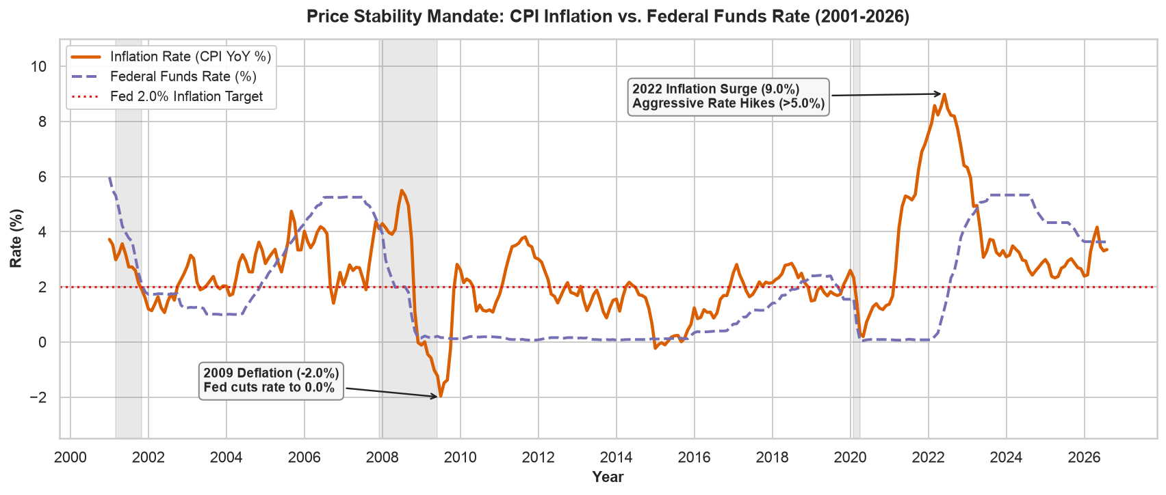
In the graph shown above we can see the Price Stability Mandate for CPI Inflation against the Federal Funds Rate. This visualizes the inflation rates for the Consumer Price Index over the span of 25 years with the solid orange line, and the Federal Funds rate percentage tracked with the dashed purple line. The dotted red line at the 2.0% mark is the target inflation rate the Federal Reserve aims for each year. As annotated in the graph, the Fed lowered interest rates to 0% during the 2009 deflation which is marked at (-2.0%), and later executed aggressive rate hikes greater than 5.0% in response to the 2022 inflation surge.
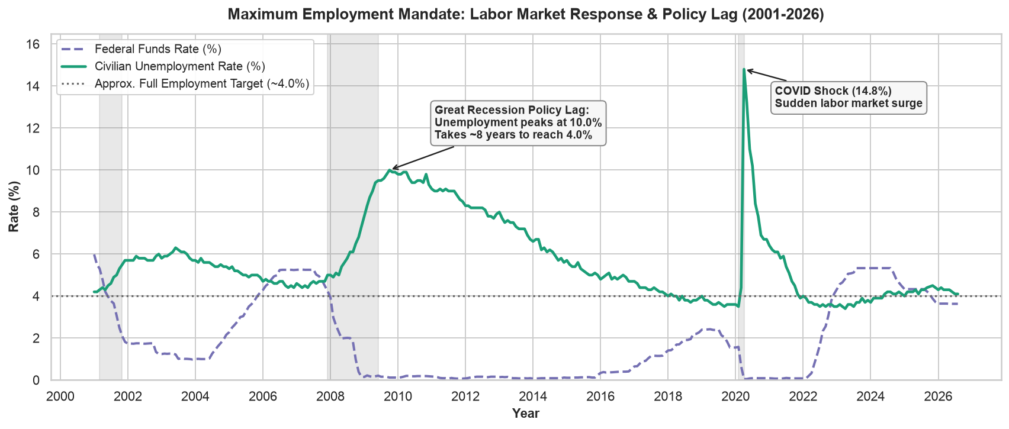
In the graph shown above, we can see the Maximum Employment Mandate and the lagged economic impact that occurs between the Federal Funds rate in dashed purple and the Civilian Unemployment Rate in solid green. The gray dotted line at the 4.0% shows the approximate full employment target the Federal Reserve looks to maintain. To decipher whether the Fed can maintain full employment during crises, we’ll review the Great Recession which reached its peak after the housing bubble burst in 2008. As shown in the chart, after the Fed slashed the federal funds rate to 0% to help stimulate the economy, unemployment still rose and peaked around 10% in 2009. Even with the interest rates staying near zero for years, unemployment did not return to around its 4% baseline until around 2018, which shows a recovery lag of close to 8 years. This demonstrates the policy lag of monetary actions and that lowering borrowing costs does not immediately create jobs. It appears that business hiring decisions can take a few years to make meaningful changes to the full picture of the economy.
We can also see this be displayed during the COVID-19 era in 2020. With the lockdowns of jobs, unemployment rose to 14.8%, which marked the highest single month rate recorded over the past 25 years. Although the Fed cut rates back to 0%, the unexpected surge showcases how unplanned shocks to the economy can overwhelm economic policies and mandates, which prevents the Fed from stabilizing employment in real time.

Conclusion:
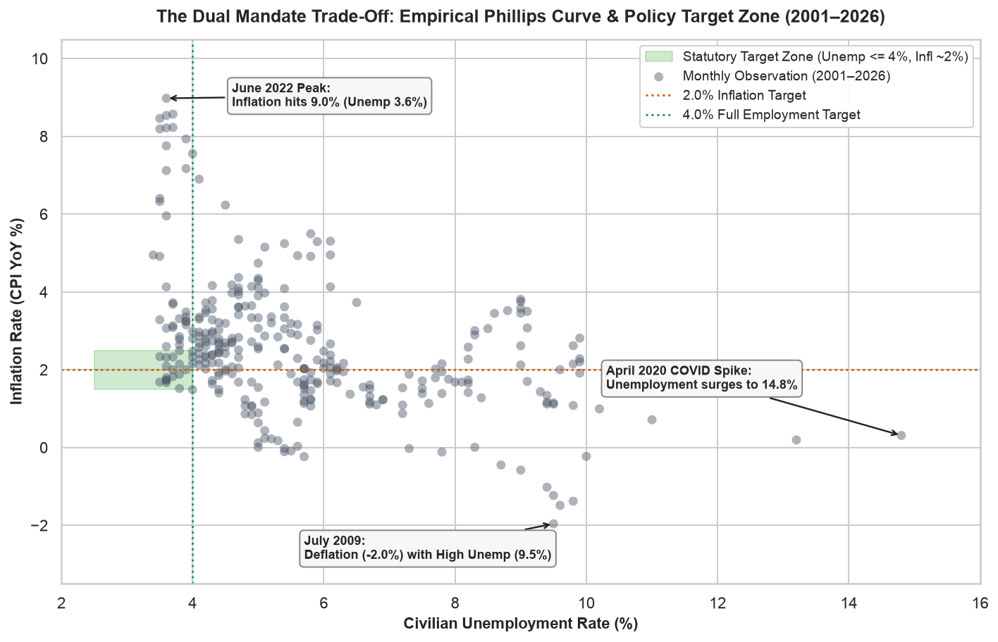
The scatterplot above shows the empirical relationship between Civilian Unemployment Rate on the horizontal axis and CPI Inflation Rate on the vertical axis for every month between 2001 to 2026. The green box shows the target zone for where unemployment stays at 4% or below and annual inflation stays on and/or around the 2% target.
The following findings shown from the scatterplot are:
- The target zone is rarely reached with the majority of the plots sitting far outside the green target zone. This shows how difficult it is for the Fed to hit both targets simultaneously.
- Extreme economic crises force the economy out of ideal alignment. For example, the July 2009 civilian unemployment rate percentage rose to 9.5%, regardless of the deflation reaching -2% in the same time period.
Over the past 25 years, the data show that the Federal Reserve rarely managed to meet both goals at the same time. Raising interest rates to bring down inflation tends to reduce consumer spending, which slows business hiring and can push unemployment higher. Because policy changes take years to work through the economy, and shocks arrive faster than the Fed can respond, balancing inflation and full employment in real time is extremely difficult. This is shown by the Great Recession, when unemployment took roughly eight years to return to 4%, and by the COVID-19 pandemic, when a sudden shock overwhelmed policy in real time. The main exception was 2018-2019, when both goals were met for an extended stretch.

References
Board of Governors of the Federal Reserve System. (2021). The Federal Reserve System: Purposes & functions (10th ed.) [Policy guide]. Board of Governors of the Federal Reserve System Publications. https://www.federalreserve.gov/aboutthefed/pf.htm
Board of Governors of the Federal Reserve System. (2026). Federal funds effective rate (FEDFUNDS) [Data set]. Federal Reserve Bank of St. Louis FRED Economic Data. https://fred.stlouisfed.org/series/FEDFUNDS
Federal Reserve Bank of St. Louis. (2026). Federal Reserve Economic Data (FRED) API [Web service and data interface]. Federal Reserve Bank of St. Louis Web Services. https://fred.stlouisfed.org/docs/api/fred/
U.S. Bureau of Labor Statistics. (2026). Consumer price index for all urban consumers: All items in U.S. city average (CPIAUCSL) [Data set]. Federal Reserve Bank of St. Louis FRED Economic Data. https://fred.stlouisfed.org/series/CPIAUCSL
U.S. Bureau of Labor Statistics. (2026). Unemployment rate (UNRATE) [Data set]. Federal Reserve Bank of St. Louis FRED Economic Data. https://fred.stlouisfed.org/series/UNRATE

