Stats_homework_3

Kristopher C. Toll

February 9, 2018

### Problem 65

I used Rmarkdown for this

library(readr)  
cancer <- (read.table("C:/Users/Kristopher/odrive/Box/Mathmatical Stats/cancer.txt"))

# Part a

hist(cancer[,1], breaks = 100, main = "Histogram of the Population", xlab = "Number of deaths by breast cancer")

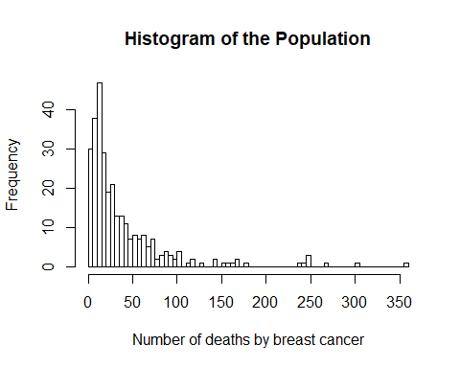

# Part b.

Mu = mean(cancer[,1])  
print(c(Mu, "Population mean"))

## [1] "39.8571428571429" "Population mean"

total = sum(cancer[,1])  
print(c(total, "Population total"))

## [1] "11997" "Population total"

N = length(cancer[,1])  
PopVar = (1/(N)) * sum((cancer[,1] - Mu)^2)  
print(c(PopVar, "Population Variance"))

## [1] "2590.10251542477" "Population Variance"

PopStd = sqrt(PopVar)  
print(c(PopStd, "Population Standard Deviation"))

## [1] "50.8930497752372" "Population Standard Deviation"

# Part C

means <- rep(0,1000)  
for(i in 1:1000){  
 means[i] = mean(sample(cancer[,1], 25, replace=FALSE))  
}  
hist(means, breaks = 100, main = " Histogram of Means with n=25")

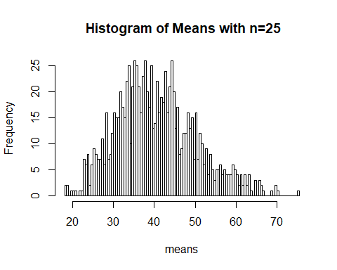

# Part d

mysamp = sample(cancer[,1], 25, replace = FALSE)  
N = length(cancer[,1])  
  
  
xbar = mean(mysamp)  
print(c(xbar, "sample Mean"))

## [1] "35.96" "sample Mean"

EstTotal = N * xbar  
print(c(EstTotal, "Estimated Total"))

## [1] "10823.96" "Estimated Total"

# Part e

n = length(mysamp)  
sampleVar = (1/(n-1)) * sum((mysamp - xbar)^2)  
EstVar_xbar = (sampleVar/n)*(1-n/N) # Done with the population correction  
print(c(EstVar_xbar, "Estimated Variance of xbar"))

## [1] "48.1501714285714" "Estimated Variance of xbar"

EstStd_xbar = sqrt(EstVar_xbar)  
print(c(EstStd_xbar, "Estimated Standard Deviation of xbar"))

## [1] "6.93903245622698"   
## [2] "Estimated Standard Deviation of xbar"

# Part f

C.I <- c(xbar - 1.96 * (sqrt(PopVar/n)), xbar + 1.96 * (sqrt(PopVar/n)))  
print(c(C.I, "Confidence Interval for Mu which is does contain"))

## [1] "16.009924488107"   
## [2] "55.910075511893"   
## [3] "Confidence Interval for Mu which is does contain"

C.I2 <- c(EstTotal - 1.96 * sqrt(N^2 * EstVar_xbar), EstTotal + 1.96 * sqrt(N^2 * EstVar_xbar))  
print(c(C.I2, "Confidence Interval for the total which is does contain."))

## [1] "6730.20841212433"   
## [2] "14917.7115878757"   
## [3] "Confidence Interval for the total which is does contain."

# Part g

mysamp2 = sample(cancer[,1], 100, replace = FALSE)  
hist(mysamp2, main = "Histogram with n=100", breaks = 100)

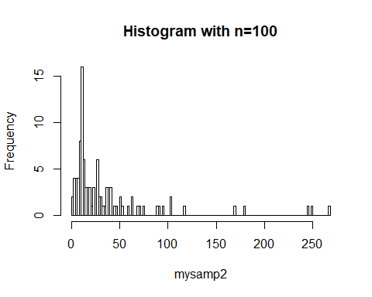

N = length(cancer[,1])  
  
xbar = mean(mysamp2)  
print(c(xbar, "sample Mean"))

## [1] "37.33" "sample Mean"

EstTotal = N * xbar  
print(c(EstTotal, "Estimated Total"))

## [1] "11236.33" "Estimated Total"

n = length(mysamp2)  
sampleVar = (1/(n-1)) * sum((mysamp - xbar)^2)  
EstVar_xbar = (sampleVar/n)*(1-n/N) # Done with the population correction  
print(c(EstVar_xbar, "Estimated Variance of xbar"))

## [1] "2.12837020789288" "Estimated Variance of xbar"

EstStd_xbar = sqrt(EstVar_xbar)  
print(c(EstStd_xbar, "Estimated Standard Deviation of xbar"))

## [1] "1.45889348750787"   
## [2] "Estimated Standard Deviation of xbar"

C.I <- c(xbar - 1.96 * (sqrt(PopVar/n)), xbar + 1.96 * (sqrt(PopVar/n)))  
print(c(C.I, "Confidence Interval for Mu which is does contain"))

## [1] "27.3549622440535"   
## [2] "47.3050377559465"   
## [3] "Confidence Interval for Mu which is does contain"

C.I2 <- c(EstTotal -1.96 * sqrt(N^2 * EstVar_xbar), EstTotal + 1.96 * sqrt(N^2 * EstVar_xbar))  
print(c(C.I2, "Confidence Interval for the total which it barely barely falls within"))

## [1] "10375.6411981099"   
## [2] "12097.0188018901"   
## [3] "Confidence Interval for the total which it barely barely falls within"

Compareing the two sampling distributions, it is clear that the random sample of 100 will get closer estimates to what the true populations parameters are. It is alwasy better to go for a bigger sample size when estimating parameters. This is because when you have larger sample size, the margin of error will reduce and the distribtution of xbar will follow a bell shape more closely.