TDD_Test_Report_004-3_Session1_(Shogun)
Feature | Expected output | Test Case Number | Test Case Name | Dev | Test Date
004-3 | Heat equal to limit: heat_exceeded=False | 1 | Heat equals limit | Shogun | Not recorded
004-3 | Heat above limit: heat_exceeded=True | 2 | Heat above limit | Shogun | Not recorded
004-3 | Freeze equal to limit: freeze_exceeded=False | 3 | Freeze equals limit | Shogun | Not recorded
004-3 | Freeze above limit: freeze_exceeded=True | 4 | Freeze above limit | Shogun | Not recorded
004-3 | Heat exceeded True; freeze at limit False | 5 | Heat and freeze compared independently | Shogun | Not recorded

Testcase 1 Try heat_s = heat_limit_s expected : heat exceeded => False
Red - Not yet implement comparison.py
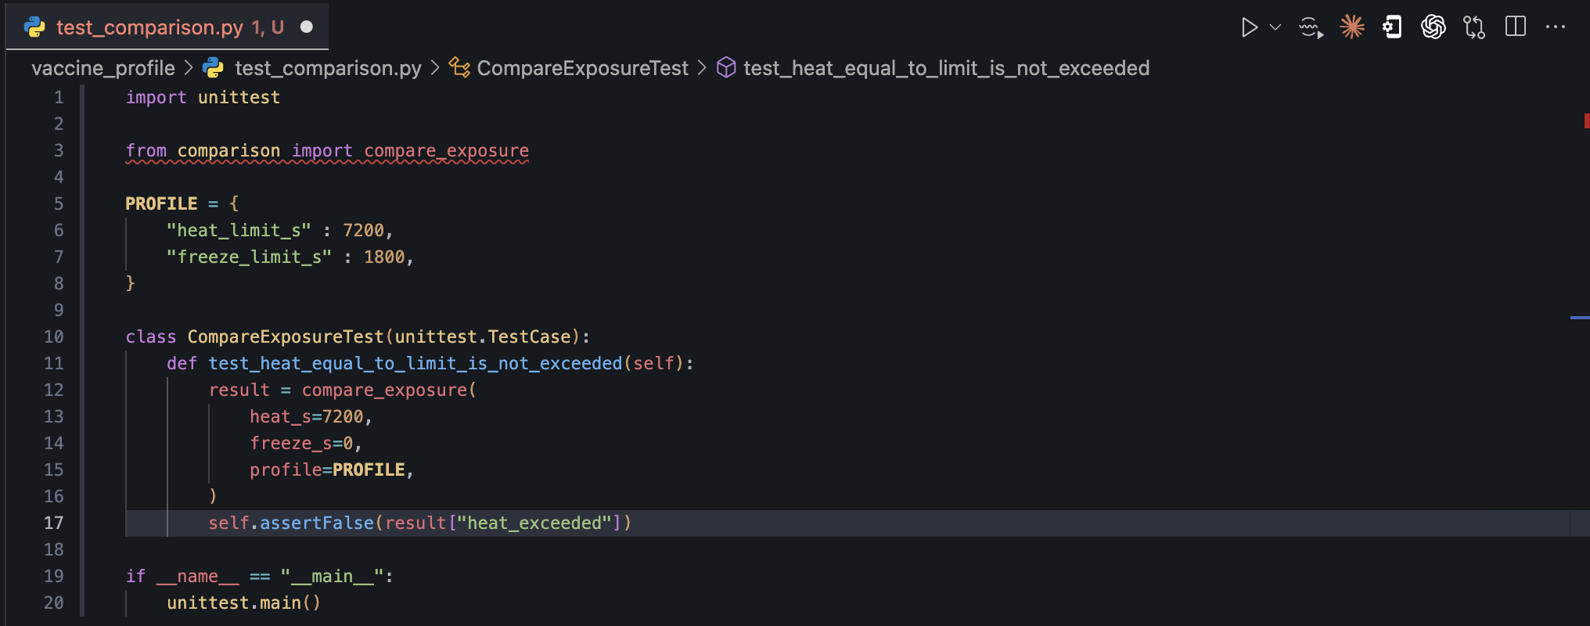
result:
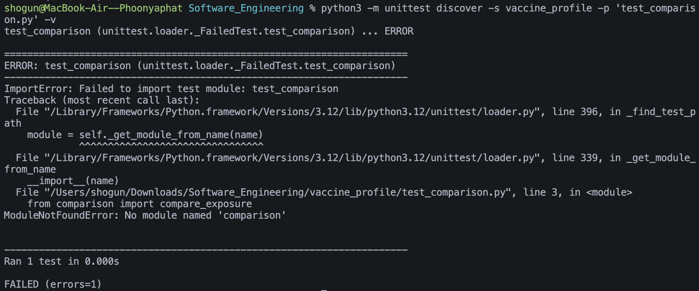
Green - Implement comparison.py
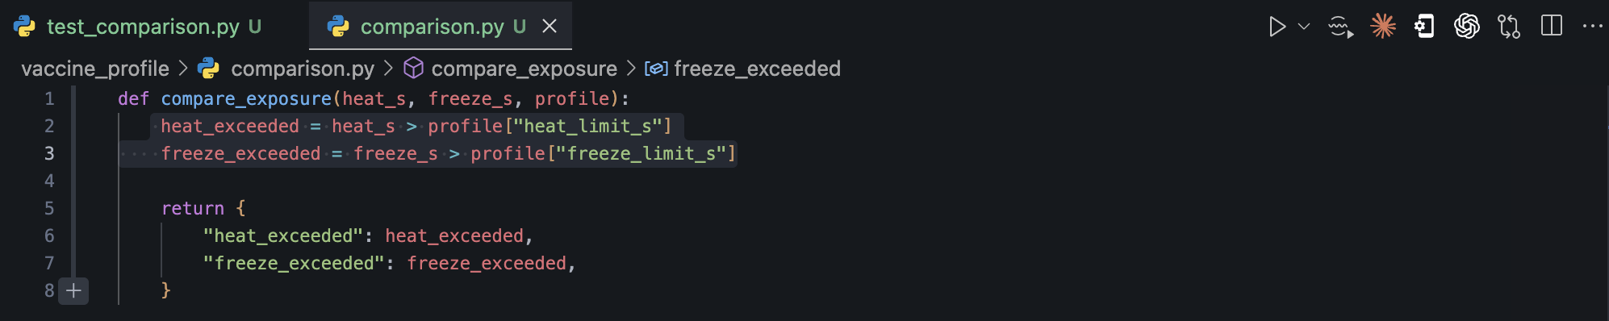
result:
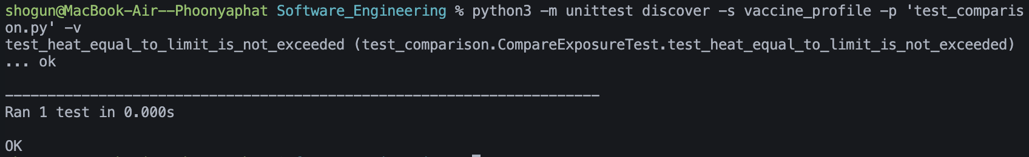
Refactor - Not yet need to refactor
Testcase 2 Try heat_s > heat_limit_s expected : heat exceeded => True
Green
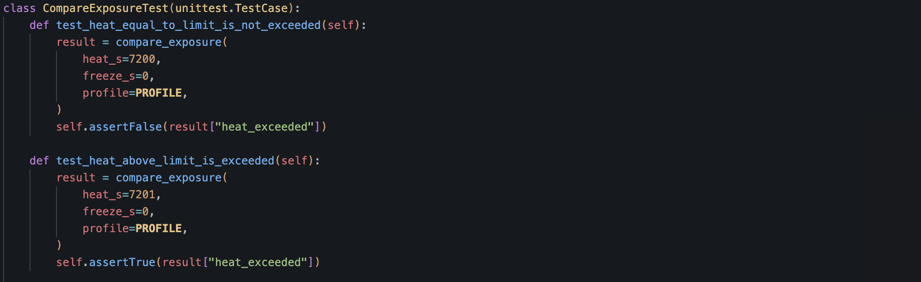
result: 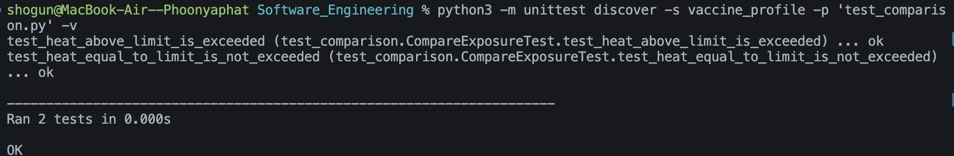

Testcase 3 Try freeze_s = freeze_limit_s expected : freeze exceeded => False
Green
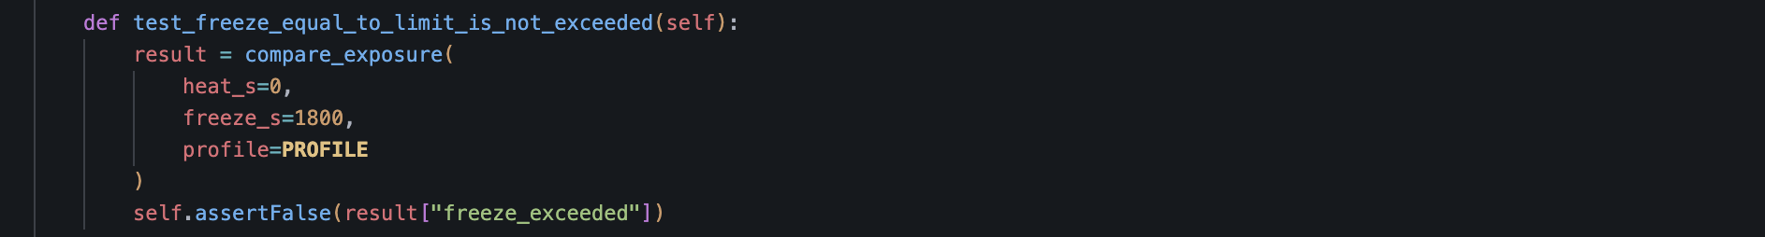
result:
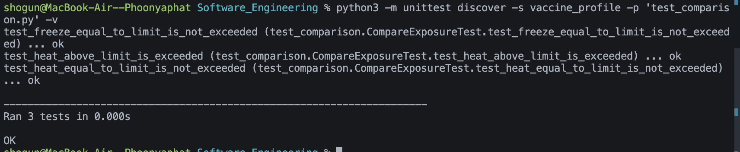

Testcase 4 Try freeze_s > freeze_limit_s expected : freeze exceeded => True
Green
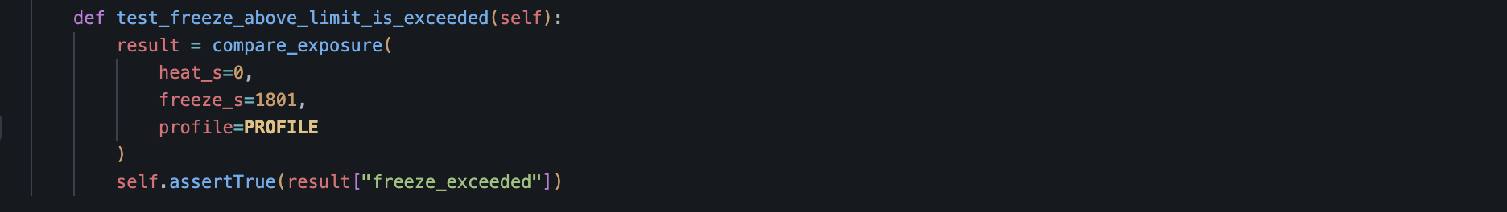
result:
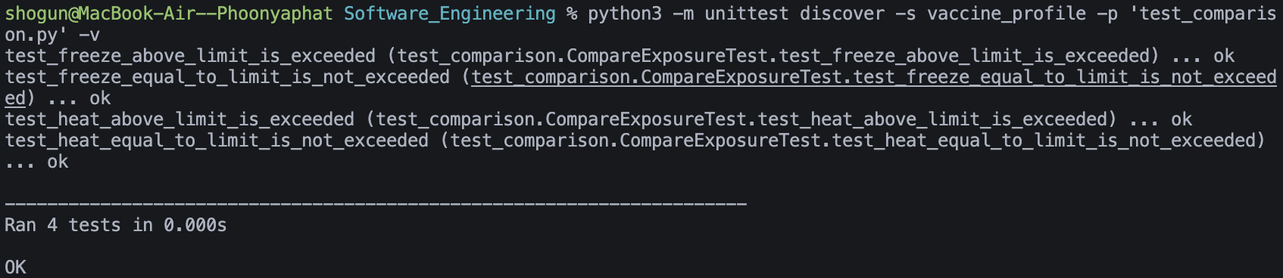

Testcase 5 Check if heat_limit_s and freeze_limit_s work separately
Green
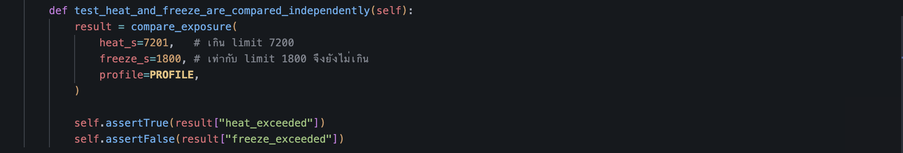
result


