middlesex Community College

Week 3 Homework

How to Connect to an Excel file in Tableau

Version 1.0

Contents

Introduction 3

Why Visualize Data? 3

Why Use Tableau? 3

Prerequisites 3

Procedure 3

Glossary 4

Resources and Acknowledgements 5

# Introduction

Welcome! This user manual will introduce Tableau software to you and explain how to easily connect to a data set in Excel. Tableau is used more and more by various corporations to get a picture of what generated data looks like. You can easily create a visualization (also known as a “viz”) in Tableau from your Excel data. It is a unique and versatile software that is user friendly and useful.

# Why Visualize Data?

Technology is moving at a rapid pace across the world. As data becomes more accessible to us, there is a great need to “showcase” our data in a way that makes it look visually appealing. Today, we generate more data in a day than ever before. In fact, Forbes reports that there are 2.5 quintillion bytes of data generated per day, and that number is only growing. It is an exciting time to learn how to use new data tools and technologies.

In the past, we were only able to create charts and graphs in Excel. However, the world of data is changing at a rapid pace. This manual will demonstrate to you how to get started and connect to a basic Excel file in a visualization software called Tableau. Tableau helps you to transform your data and develop beautiful, captivating visualizations for your audience.

# Why Use Tableau?

If you want to impress your employer with data visualizations, you will want to learn how to use Tableau software. It is an indispensable tool for your team.

## Prerequisites

You will need the following:

• A Windows or Macintosh computer with at least 4-16 GB of memory available

• Access to the internet

• General knowledge of statistical procedures

## Procedure

* 1.) Open the Tableau Public icon
* 2.) See the open page as shown in **Figure 1**.

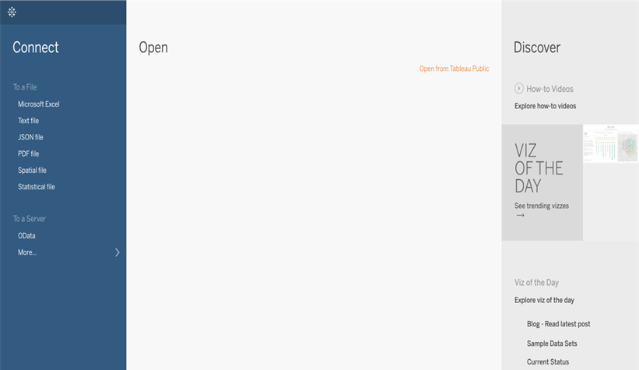

**Figure 1**.

* 3.) The **Connect Pane** allows you to connect to **Excel, Text, JSON, or PDF files**.
* 4.) The **Open Pane** allows you to open files that you have already created.
* 5.) The **Discover Pane** allows you to Connect to sample data sets, or to see the visualization of the day.
* 6.) **Connect to a File** by clicking on the **Microsoft Excel** option in the **Connect** pane.
* 7.) Choose the Excel file that you want to use from your computer. The page opens as shown in **Figure 2.**

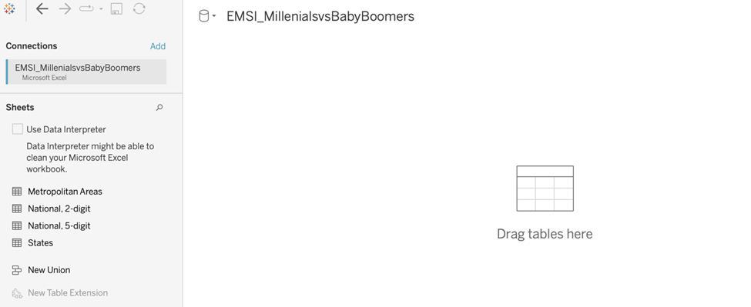

**Figure 2**.

* 8.) You can now drag the **Metropolitan Areas** table to the **Drag Tables** here section. The **Data Source** page opens. See **Figure 3**.
* 9. The **Data Source** page contains a view of the **Metadata** (see glossary). See **Figure 3**.

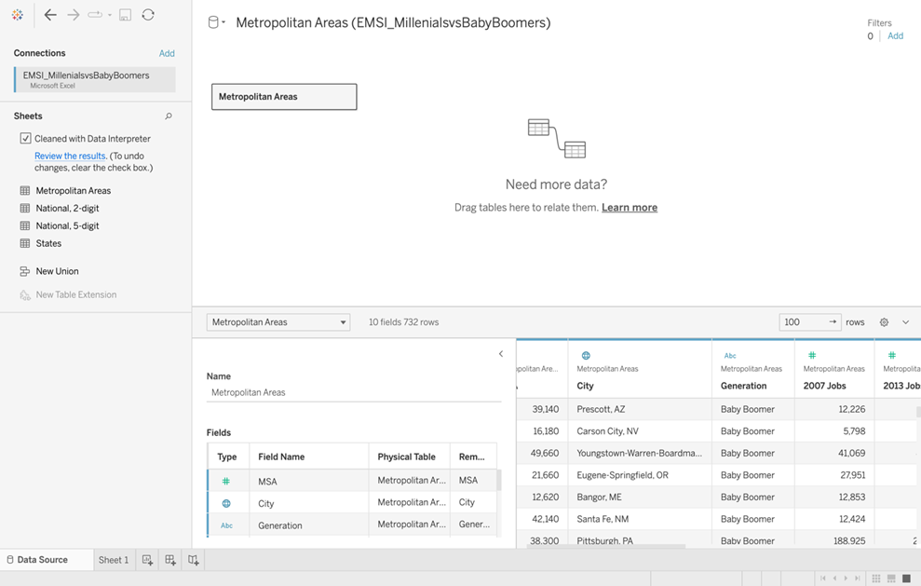

**Figure 3.**

* 10.) At the bottom left of the Data Source page as shown in **Figure 3**, click on **Sheet 1**.

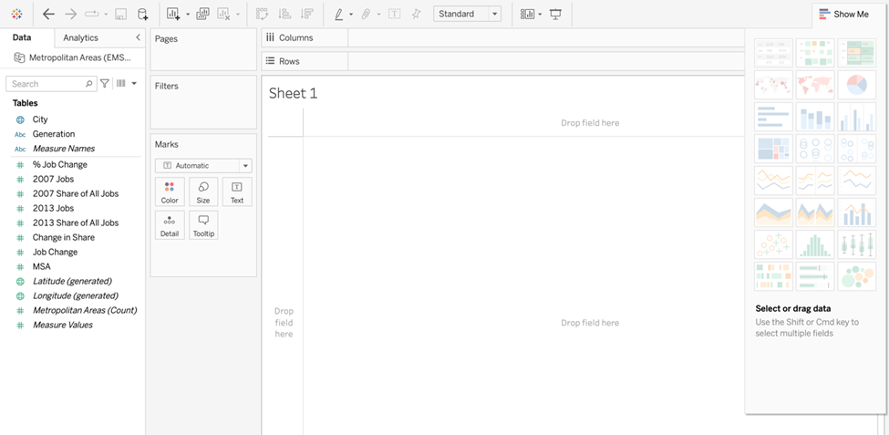

**Figure 4**.

The **Sheet** opens, as shown in **Figure 4**. The Excel table is now broken down into **Dimensions** and **Measures.** You are now ready to begin your data analysis an begin making stunning visualizations! Be on the lookout for more of my user’s guides on how to do more with Tableau!

# Glossary

**Dashboard**: A collection of worksheets.

**Dimensions**: Usually Blue in color. Contain qualitative values, such as names, dates, or geographical data.

**Measures:**  Usually Green in color. Contain quantitative or numeric values, such as profit, sales, or cost.

**Metadata:**  Data that describes other data. A summary that is used to classify, organize, label, and understand data.

**Worksheet**: Where you build views of your data.

# Resources and Acknowledgements

Bernard Marr, http://forbes.com/

Tableau, http://tableau.com/