Do-it-Yourself At-Home TCA Peels

By KS

Table of Contents

About TCA Peels 1

Options: Professional vs. Do-it-Yourself 1

What You Will Need 1

!!Warning!! 3

Peel Application 3

# About TCA Peels

A Trichloroacetic Acid (TCA) Peel is a cosmetic procedure usually performed by a licensed skin care professional in a doctor's office. A chemical solution is applied to the face, which causes the top superficial layer of skin to peel off over a period of days, revealing fresher, healthier-looking skin underneath.

TCA peels are used on the face to:

* treat acne.
* reduce acne scarring.
* reduce fine lines and wrinkles from the effects of aging.
* even out skin tone.
* improve skin texture.

# Options: Professional vs. Do-it-Yourself

Professional TCA peels can cost an average of $150 to $1,500 per peel for a light to medium depth peel. They are usually done in a series of applications, spaced four weeks apart, often requiring a commitment for a series of peels. Self-performed at-home TCA peels are a much less expensive option, ranging under $100 for multiple peels. Because they are considerably less expensive, more applications may be available to you over time, which may ultimately lead to better results.

At-home TCA peels are usually buffered for safety, which means the pH balance has been altered to make the peel less irritating to the skin. This results in less strength than a professional peel done in a doctor's office but is a safer option for home use. If you follow the instructions and use caution, at-home peels can provide very effective results. At-home TCA peel solution percentage strengths usually range from 7 to 30%. You can purchase the peels online. Use caution to research sellers and purchase products from a well-researched and reputable company.

# What You Will Need

You should have the following ready before beginning your peel:

* Hair clips and elastic
* Gel cleanser
* Towel
* Rubbing alcohol
* Gauze pads
* Tissues
* Cotton swabs
* Petroleum jelly
* Timer
* Vinyl or latex gloves
* Access to water from a sink
* TCA peel
* Neutralizing solution (available where at-home TCA peels are sold)
* Gentle cleanser
* Hyaluronic acid serum

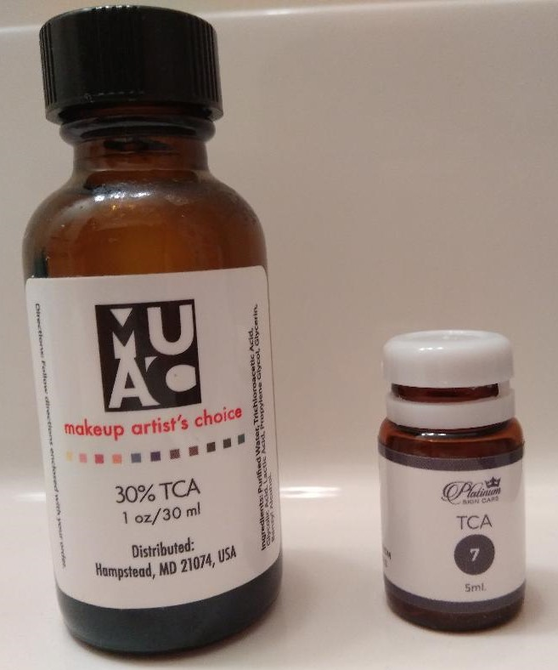

Figure 1 At-home TCA Peels are available in a variety of percentages and volumes.

!!Warning!! **Trichloroacetic Acid is a chemical acid solution. Adhere to all safety measures!**

* It is recommended that you have previous experience receiving professional peels by a licensed skin care professional before trying at-home peels by yourself.
* Use caution when handling TCA peels.
* TCA peels are recommended for users with lighter skin tones. Check the Fitzpatrick Scale <https://en.wikipedia.org/wiki/Fitzpatrick_scale> to determine your skin tone level. If your skin tone is higher than 3 on the Fitzpatrick Scale, at-home TCA peels may not be recommended, because results may cause scarring or post-inflammatory pigmentation. Check with a licensed skin care professional for advice.
* If misused, TCA peels could cause burns, scars, or other serious harm.
* If burning or scarring occurs, flush with water and call your doctor immediately.
* If you have herpes or cancer, or you are allergic to trichloroacetic acid, then TCA peels are not recommended for you.
* Only adults should use TCA peels. Keep out of the reach of children.
* Do not swallow the TCA peel solution. If ingested, call 911 and poison control immediately.
* If the TCA solution gets into your eyes, flush your eyes immediately with cold water, then call your doctor.
* If you have trouble breathing or have a serious allergic reaction when applying TCA peels, call 911 or go to the nearest emergency room.
* Never use more than 25% at-home TCA for the face. 30% TCA is only for body peels. Do not use 30% TCA solution on your face.
* Do not space TCA peels less than 4 weeks apart.

# Peel Application

### **Important: Follow these steps in order.**

1. Clip your hair away from your face.
2. Wash your face with a gel cleanser to remove any makeup or residue.
3. Dry your face with a towel.
4. Apply rubbing alcohol to a gauze pad or tissue.
5. Sweep the pad across all areas of your face, avoiding your eyes, nostrils, and mouth.
6. Apply petroleum jelly with a cotton swab to the edges and corners of your eyes, the edges of your nostrils, and the corners of your mouth.
7. Put on vinyl or latex gloves.
8. Apply the TCA solution to a gauze pad and squeeze out the excess. Beginners should start with a 7% solution. When 7% is tolerated with multiple layers in future peels, then you may gradually increase percentages up to 25%.
9. Sweep the pad over your face, avoiding your eyes, nostrils, and mouth. Redness may occur and the solution may tingle or cause a slight burning sensation.
10. Set the timer for 1 minute for your first peel. See the table below.

|  |  |
| --- | --- |
| First Peel | Leave on 1 minute or until your skin frosts |
| Second or Third Peel | Leave on 2-4 minutes or until your skin frosts |
| Fourth Peel and After | Leave on 5 minutes or until your skin frosts. Second layer may be applied if no frosting occurs |

1. If areas of your face frost (turn white), then apply the neutralizer immediately to that area.
2. Beginning with your fourth peel, if no frosting occurs, then you may apply a second layer.
3. When the time is up, neutralize your skin with the neutralizing solution.
4. Wash your face with a gentle cleanser.
5. Dry your face with a towel.
6. Apply hyaluronic acid serum or another non-irritating gentle moisturizer to your face.
7. On nights 2 and 3, apply petroleum jelly, emu oil, or argan oil to your face before bed.
8. Your face may begin to peel or flake about day 3 and continue peeling for 7-10 days.
9. Wash your face twice daily and keep moisturized.
10. If your face does not peel or flake, the peel is still effective on the skin.
11. Space TCA peels at least 4 weeks apart.