TASK 1

Question 1.1
Summer Music Festival
Summer Music Festival is an18+ indoor(in a tent) and outdoor music festival with three main performance areas: the Main Stage, River Stage and Techno Stage. Each stage has a different type of music genre and atmosphere. The River Stage is located close to the water, while the Techno Stage focuses on electronic music, inside a tent, and the Main Stage hosts the main headline performances outside.
All visitors enter through the main festival entrance. The Entrance Gate checks identification to make sure that everyone entering the festival is 18 years or older. Each stage area also has its own Stage Gate. These gates monitor how many people are inside the stage area. If the stage reaches its maximum capacity, the gate stops allowing people to enter until space becomes available.
Each stage area contains a Stage, Stage Gate and Bar. The festival also has Food Vendors, Security Teams and Medical Teams. These units all have different responsibilities. For example, Security Teams help control crowds and respond to safety problems, while Medical Teams remain available to treat injured or sick attendees.
The festival is divided into different groups that form the Composite structure. These include the Festival Grounds, the different Stage Zones, and Service Areas. These groups may contain smaller groups or individual event unit, such as Main Stage Zone, River Stage Zone and Techno Stage Zone.
The main concrete event units are Stage, EntranceGate, StageGate, Bar, FoodVendor, SecurityTeam and MedicalTeam.
During the festival, the control centre can send notices such as weather warnings, capacity alerts, schedule changes, pauses, evacuations and resume notices. Different units respond differently to the same notice. For example, a Stage may pause a performance during an evacuation, a Stage Gate may stop admitting people, a Bar may stop serving, while a Medical Team remains operational.
This gives the event enough nested structure and changing behaviour to make use of both the Composite and Observer patterns.
Question 1.2
Composite Pattern:
Component - EventComponent
EventComponent is the common base class for everything that forms part of the festival structure. It provides operations such as open(), close(), reportStatus() and getCapacity().
Composite - EventGroup
EventGroup represents a group or area in the festival. Examples include the Festival Grounds, Main Stage Zone, River Stage Zone, Techno Stage Zone and Service Area. An EventGroup can contain both other EventGroup objects and individual event units.
Leaf - Concrete Event Units
The Leaf classes are Stage, EntranceGate, StageGate, Bar, FoodVendor, SecurityTeam and MedicalTeam. These are individual units and do not contain other event components.
Client - main.cpp
main.cpp creates the festival structure and interacts with the event through the common EventComponent interface.
Observer Pattern:
Subject - Subject
Subject provides the operations needed to register and remove observers using attach(), detach() and notify().
Concrete Subject - EventControl
EventControl represents the central festival control centre. It creates and sends notices to registered observers.
Observer - Observer
Observer provides the common update() operation used by objects that receive notices.
Concrete Observers - Event Units
The concrete event units such as Stage, StageGate, Bar, FoodVendor, SecurityTeam and MedicalTeam act as observers. Each one responds differently when it receives a notice.
EventGroup as Observer and Subject
EventGroup has more than one role. It acts as an Observer when it receives a notice from another Subject. It then acts as a Subject by passing that notice to its own registered observers.
This is not a conflict because the roles are used for different purposes. The Composite role describes where the group exists in the festival structure

Question 1.3

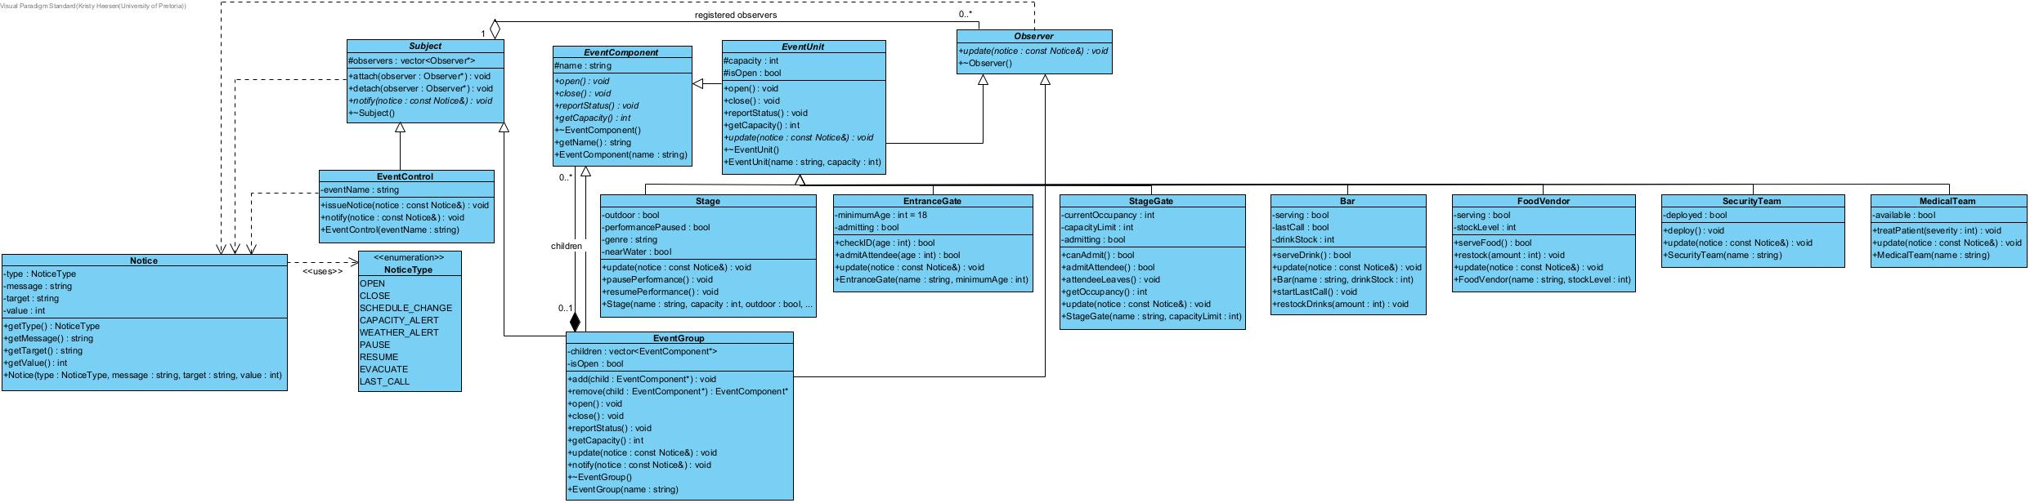

Question 1.4
The Composite pattern is suitable for the Summer Music Festival because the event naturally forms a part-whole structure. The Festival Grounds contain different Stage Zones and Service Areas, while these groups can contain smaller groups or individual event units such as Stages, Bars, Stage Gates, Security Teams and Medical Teams. Since an EventGroup can contain any EventComponent, including another EventGroup, the structure forms a genuine Composite tree. This also allows operations such as opening, closing, reporting status and calculating capacity to be performed through the common EventComponent interface.
The Observer pattern is needed because the central control system should not have to make direct hard-coded calls to every individual event unit. If EventControl had to directly call each Stage, Bar, Gate, Security Team and Medical Team whenever something changed, the system would become difficult to maintain and extend. By using Observer, interested objects register with a Subject and are notified automatically when a notice is issued. This also allows observers to be attached and detached while the festival is running.
Ownership of event components is handled by EventGroup. An EventGroup owns the EventComponent objects that it contains. This is shown as composition in the UML using a filled diamond. When an EventGroup is destroyed, it is responsible for destroying the child components that it owns. If a component is moved from one group to another, it must first be removed from the old group before being added to the new group so that the same object is not owned or deleted twice.
Observer references are not owned by the Subject. A Subject stores pointers to the Observer objects that are currently registered with it, but those objects are allowed to exist independently. The Subject therefore does not delete its observers. The design must ensure that observers are detached before they are destroyed so that the Subject does not keep dangling pointers. This follows the Observer structure used in the course notes, where the Subject stores references to registered observers without strongly owning them.
EventGroup can correctly act as both a Subject and an Observer because these roles are used for different purposes. It acts as an Observer when it receives a notice from a higher level of the festival, such as EventControl or another EventGroup. It then acts as a Subject when it forwards that notice to observers registered below it. This allows notices to move through several levels of the festival while keeping the notification system separate from the Composite ownership structure. Therefore, using both roles in EventGroup is not a misuse of either design pattern.

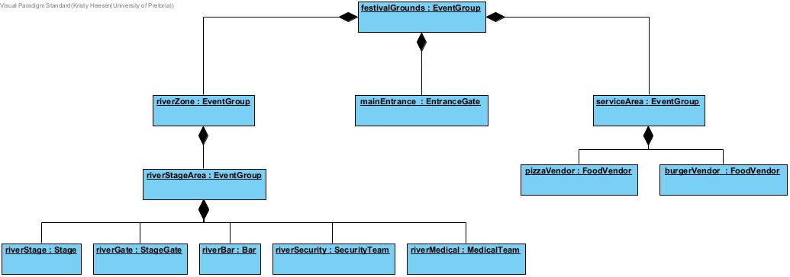
Question 2.3

Question 2.4
festivalGrounds is the root EventGroup and owns the components below it. When delete festivalGrounds; is called, its destructor deletes its children. If a child is another EventGroup, that group deletes its own children. This continues until the whole Composite tree is destroyed. Each component has only one owning group, so it is deleted exactly once. EventComponent has a virtual destructor so that the correct destructor is called. Valgrind is used to check that no memory leaks remain.
When a component is moved to another group, remove() removes it from the old group's children vector without deleting it. The component is then passed to the new group using add(). The new group becomes its owner. A component must not be owned by two groups at the same time, because this could cause double deletion. If the component is also an Observer, its old registration must be detached and its new registration attached.

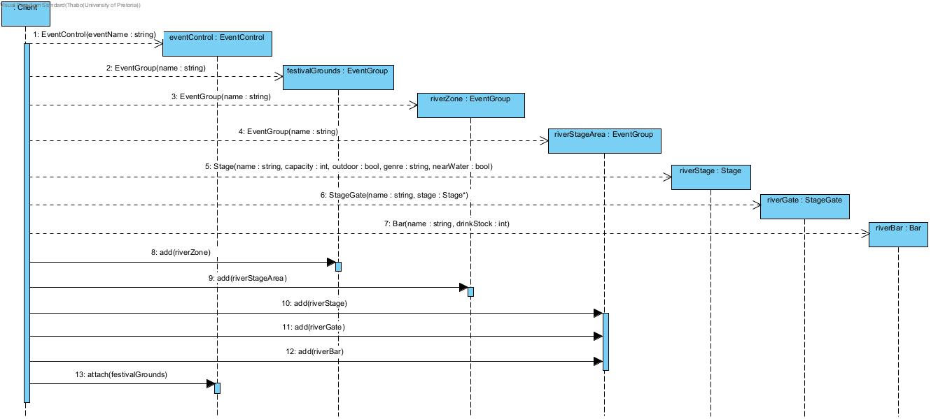
Question 5.1

Question 5.2

