Practical 4
COS214
Event Name:
TaskForge Logistics Domain
Group Members:
Maeryn Pillay- u25146484
Kristy Heesen- u24702341
Livhuwani Munyai- u25449029

TASK 1
Event Description:
TaskForge is a corporate facilities complaint and maintenance management system designed for companies that operate one or more buildings or sites. The system allows employees, tenants or facility staff to log and manage complaints relating to building maintenance, equipment, cleaning, safety, access control and other facility-related issues. Complaints are organised hierarchically by site, department or floor, complaint category and individual complaint.
Each complaint follows a defined lifecycle consisting of Logged, Assigned, In Progress, Resolved and Closed. The behaviour of a complaint depends on its current state, ensuring that only valid actions and transitions can occur.
The system supports two main traversal methods. A complete traversal visits all complaints in the hierarchy, while an unresolved traversal visits only complaints that have not yet reached the Resolved or Closed states. Complaints are processed according to the date and time at which they were logged, with older complaints receiving attention first.
Complaints are normally processed in the order in which they are logged. An Urgent Complaint decorator can be applied dynamically to give a complaint higher processing priority, causing urgent complaints to be processed before normal complaints while still preserving first-logged, first-processed ordering among complaints of the same priority. A Notification decorator can also be applied dynamically to add notification behaviour when important actions occur on a complaint. These decorators can be stacked on the same complaint without changing the underlying complaint class.
Go4 Participant Identification:
Composite
Component - ComplaintComponent
Leaf - Complaint
Composite - ComplaintGroup
Concrete Composites - Company, Building, FloorDepartment, ComplaintCategory
Client - main.cpp
Iterator
Iterator - ComplaintIterator
Concrete Iterators - AllIterator, UnresolvedIterator
Aggregate - ComplaintGroup
Client - main.cpp
State
Context - Complaint
State - ComplaintState
Concrete States - LoggedState, AssignedState, InProgressState, ResolvedState, ClosedState
Decorator
Component - ComplaintComponent
Concrete Component - Complaint
Decorator - ComplaintDecorator
Concrete Decorators - UrgentComplaintDecorator, NotificationDecorator
Client - main.cpp

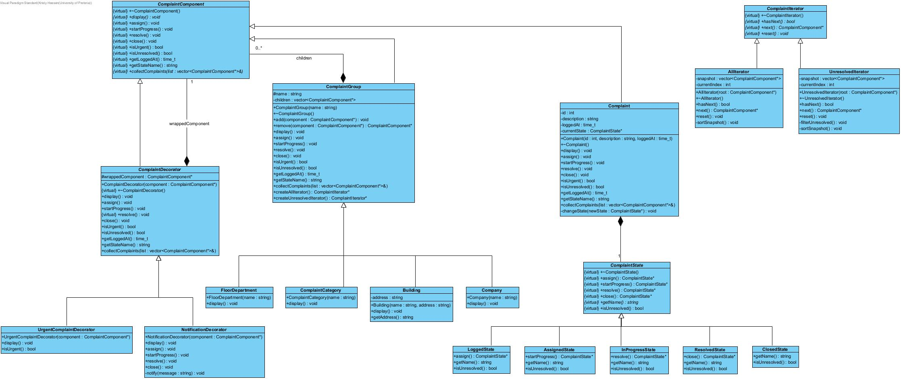

Inheritance, Associations, Multiplicities and Ownership:
ComplaintComponent provides the common abstraction used throughout the complaint hierarchy. Complaint represents an individual leaf, while ComplaintGroup represents a composite capable of containing other ComplaintComponent objects. Company, Building, FloorDepartment and ComplaintCategory specialise ComplaintGroup and form the nested hierarchy of the system.
A ComplaintGroup owns zero or more ComplaintComponent children, represented by a composition relationship with multiplicity 0..*. This ownership allows the root company to recursively destroy the complete hierarchy when it is deleted.
Each Complaint owns exactly one ComplaintState at a time. When a valid state transition occurs, the existing state is replaced by the next state. This relationship is represented as composition with multiplicity 1.
A ComplaintDecorator owns exactly one wrapped ComplaintComponent. Concrete decorators may be stacked, allowing an urgent complaint to also contain notification behaviour. Deleting the outer decorator recursively destroys the wrapped decorator or complaint.
The iterators do not own the complaints they traverse. They maintain their own traversal snapshot and position, allowing two iterators to traverse the same hierarchy independently without transferring ownership of any complaints.
Concrete Domain Classes:
The design contains concrete domain classes representing the organisation of a corporate facilities complaint system. A Company contains one or more Building objects, which may contain FloorDepartment objects. These contain ComplaintCategory groups, which finally contain individual Complaint objects. This creates a meaningful recursive hierarchy with both nested groups and individual work items.
Individual complaints progress through the concrete lifecycle states LoggedState, AssignedState, InProgressState, ResolvedState and ClosedState. UrgentComplaintDecorator and NotificationDecorator provide additional runtime behaviour without requiring separate complaint subclasses.
Design and Ownership Rationale:
The Composite pattern was selected because complaints naturally belong to a nested organisational structure. Using a common ComplaintComponent abstraction allows both individual complaints and complete groups to be treated uniformly while keeping the internal child container hidden from client code.
The State pattern separates complaint lifecycle behaviour from the Complaint class. A complaint progresses through Logged, Assigned, In Progress, Resolved and Closed states, with each state controlling the valid transition to the next stage. Invalid transitions are handled by the current state rather than through a large conditional statement.
The Decorator pattern allows additional responsibilities to be applied dynamically. A normal complaint is represented by an undecorated Complaint. Applying an UrgentComplaintDecorator gives it higher processing priority, while a NotificationDecorator adds notification behaviour. The decorators may be stacked while the underlying complaint remains unchanged.
The Iterator pattern prevents client code from accessing the internal containers of the hierarchy directly. AllIterator traverses all complaints, while UnresolvedIterator returns only complaints that have not reached the Resolved or Closed states. Both traversals prioritise urgent complaints before normal complaints. Within each priority group, complaints are processed from oldest to newest according to the time they were logged.
Each iterator maintains its own snapshot and current position, allowing multiple independent traversals of the same hierarchy. If new complaints are added after an iterator has been created, they are not included in that existing snapshot and a new iterator must be created to see them. Moving an existing complaint between groups does not affect an existing snapshot because the complaint object itself remains alive. Objects are not deleted while an iterator containing them is active.
Ownership is kept hierarchical. main.cpp owns the root Company, complaint groups own their children, complaints own their current state, and decorators own their wrapped component. This provides a clear destruction path and allows the complete system to be cleaned up without memory leaks.

