CS 340 README – Project One: CRUD Python Module

About the Project
This project is a full-stack, dashboard application created for the Grazioso Salvare search-and-rescure animal training organization in Austin, TX. Grazioso Salvare required a user-friendly dashboard application that would be connected to a MongoDB Database and help them interact with that database while gathering key insights about their animals and being able to quickly navigate to specific classifications of animals.

Features and Functionality
The dashboard currently offers the following functionality:
- Interactive Filtering – Provides the user the ability to filter each column of the data table as well as apply quick filters via specific radio buttons added to the dashboard.
- Dynamic Data Table – The interactive data table features native pagination, column sorting, and single-row selection.
- Breed Demographic Breakdown Visualization – Based on the selected data table, a Pie Chart will populate automatically that provides a breakdown of the breed demographic within the user’s search.
- Interactive Map – Based on selected row, a map will populate a pin and recenter upon that pin.
- Interactive Branding - The Grazioso Salvare Logo has been embedded with a hyperlink that, when clicked, navigates to the snhu.edu webpage.

Tools Used and Rationale
MongoDB: MongoDB was chosen for the database because it stores data natively in JSON/BSON documents which are significantly more flexible and scalable for datasets like Grazioso Salvare’s where significant structure is not needed as would be more beneficial from a traditional SQL database.
Python Integration: Python code interfaces directly with MongoDB via importable libraries like “pymongo.” A dedicated CRUD module was created to handle the database connection logic and authentication, executing queries that support the dashboard’s interactive filtering and data retrieval capabilities.
Dash: Dash is a python library that allows for the rapid development of reactive full-stack web apps without the need for front-end JavaScript code. It can be written entirely in Python and is built on top of other libraries like Flask and Plotly which allow the use of functions and classes contained within those libraries to create visualizations, maps, and much more.

Development Process
The development process for this project began with the initialization of the MongoDB database, importing the Austin Animal Center dataset, and establishing database credentials. Following this, an iterative approach was used to build a Python CRUD module that connects to the database and supports data retrieval and manipulation. Once core CRUD functionality was established, the dashboard layout was initialized, connecting authentication parameters and base components such as the data table and geolocation map. In later iterations, advanced features—including interactive radio filters, data visualizations, the Grazioso Salvare logo with anchor tags, and customized tooltips were integrated and styled. Finally, this README was authored to document the development process, tools, and technical instructions for the project.

Challenges in the Development Process
Many of the challenges I faced during the development of this dashboard really came to learning opportunities when it comes to first-time full-stack applications development. Understanding how the authentication works/needs to work when implementing an external module to handle this was a bit confusing to me, but after tinkering and researching I was able to determine how to properly configure this item. I also had a bit of trouble with the filtering logic breaking down when radio buttons were in use. Ultimately, I had to write down the logic onto a visual medium (MS Paint) and I was able to properly configure the code so that there are no bugs.

Screenshots
Initial State:
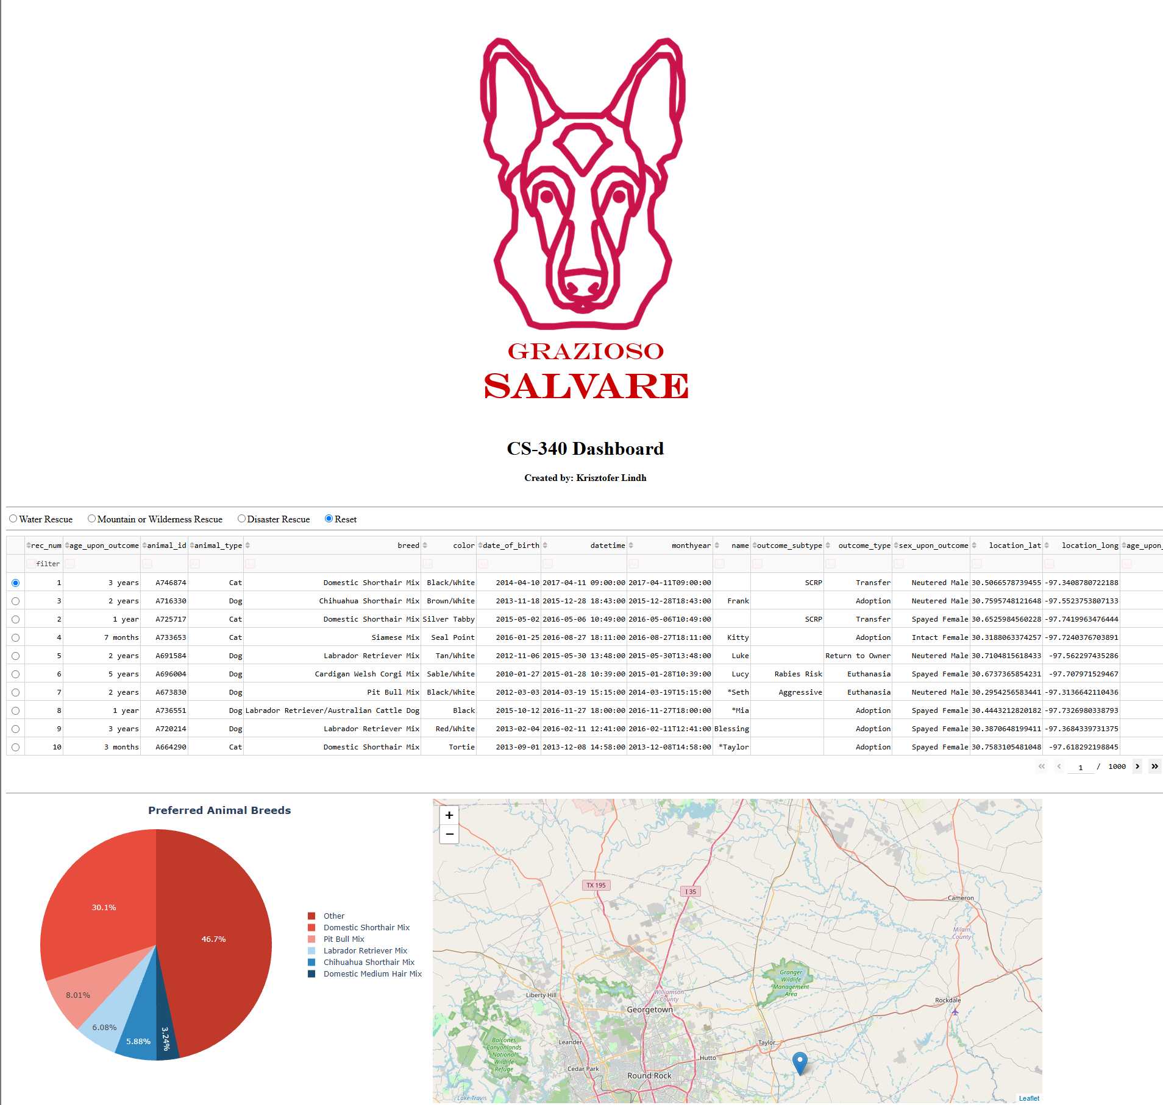

Example Radio Button Clicked:
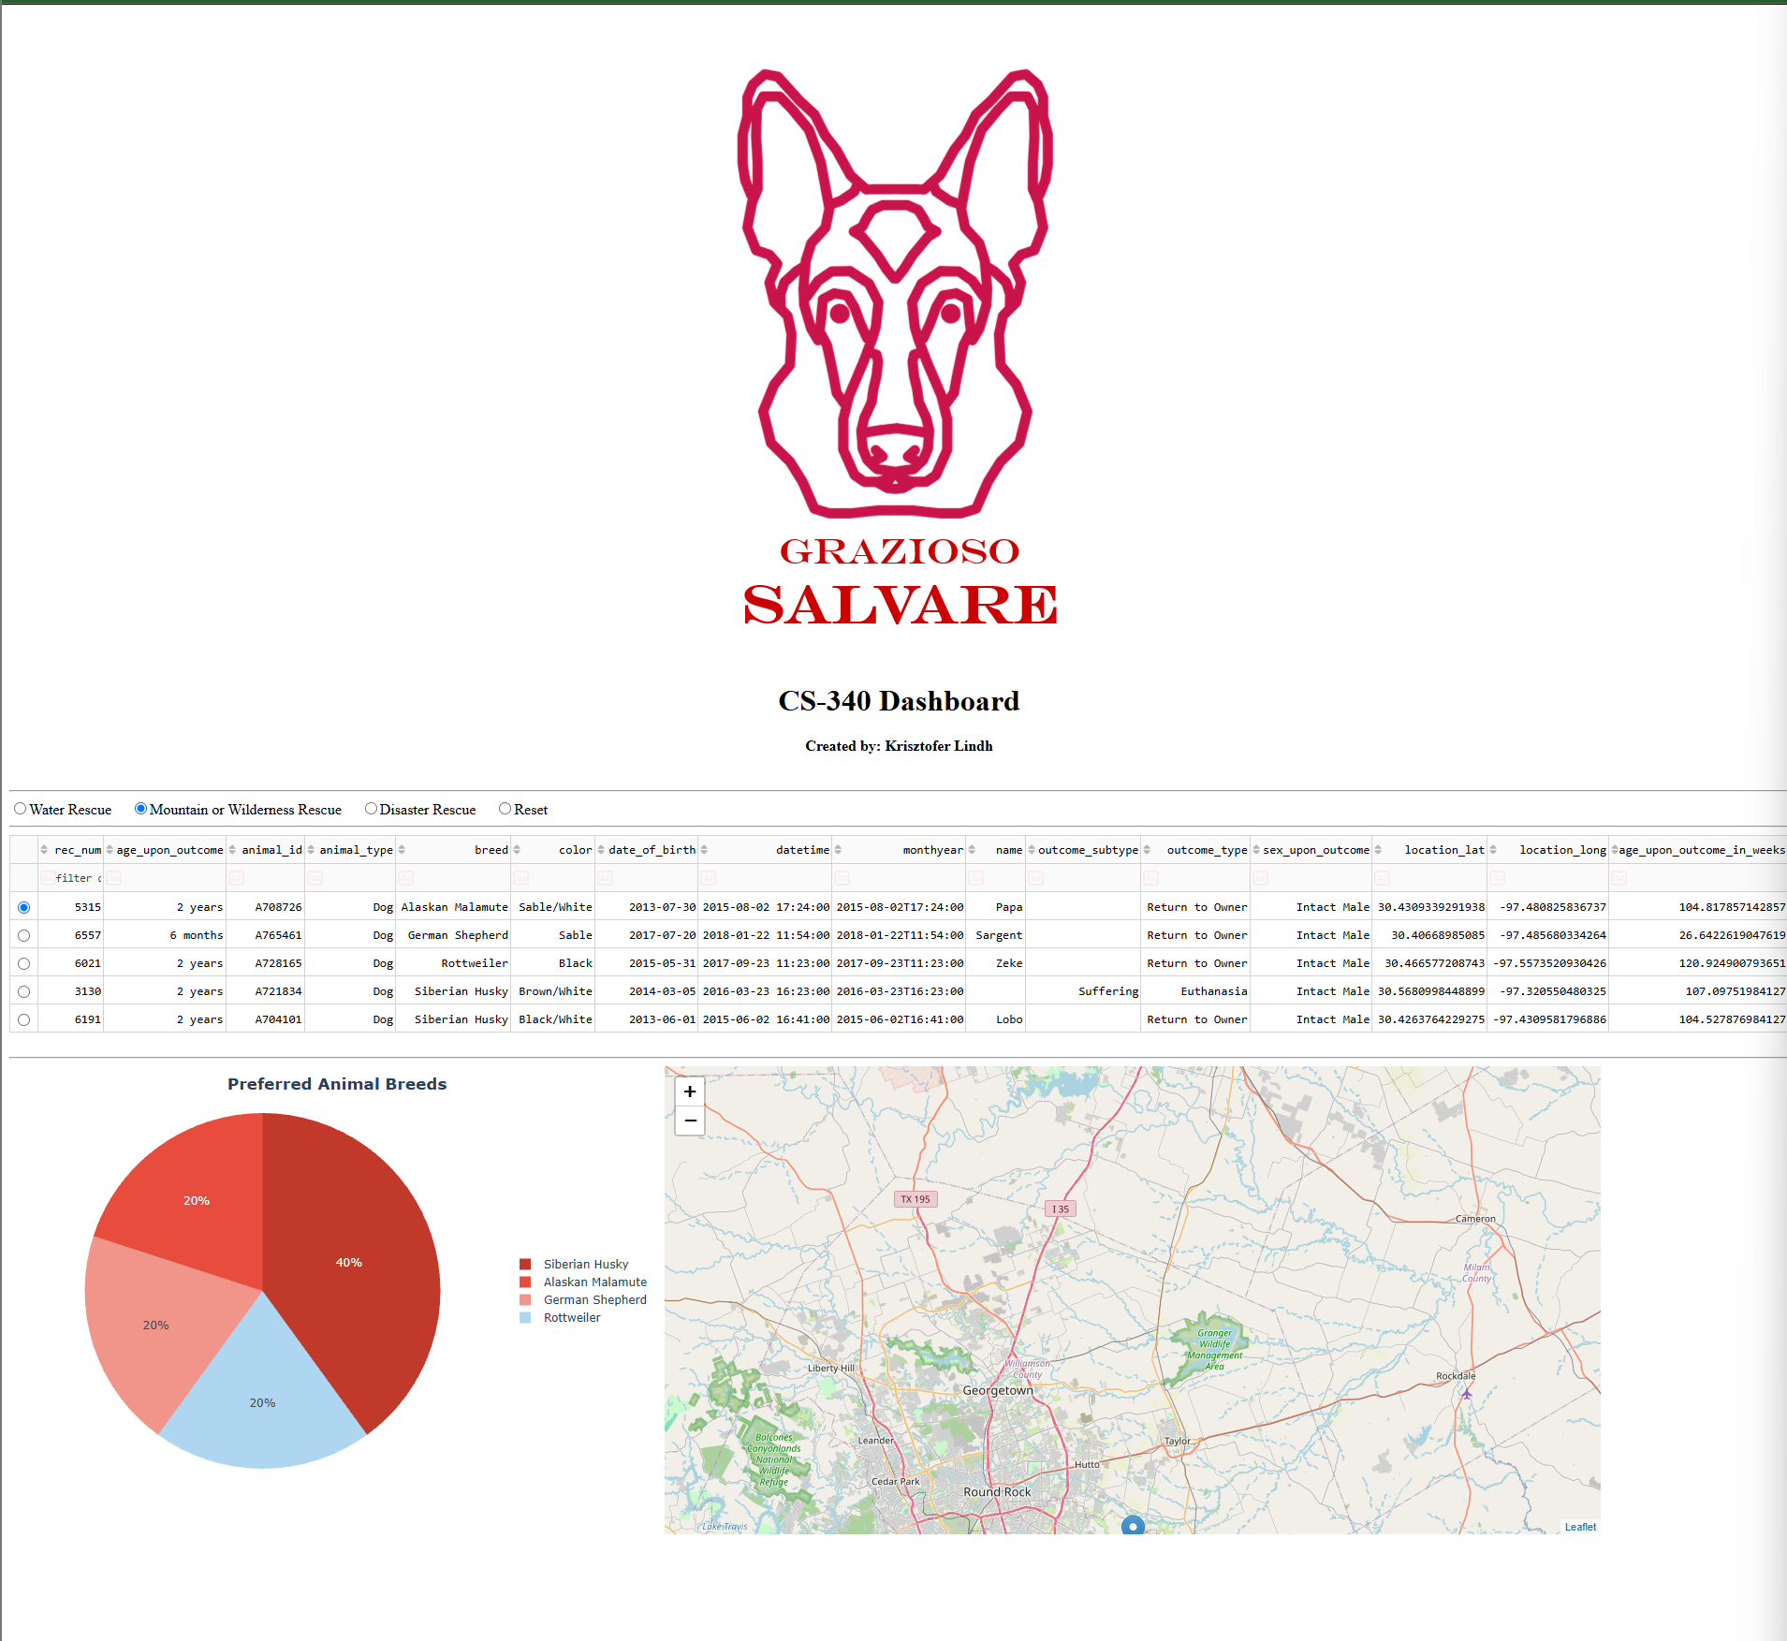

Example In-Column Filter:
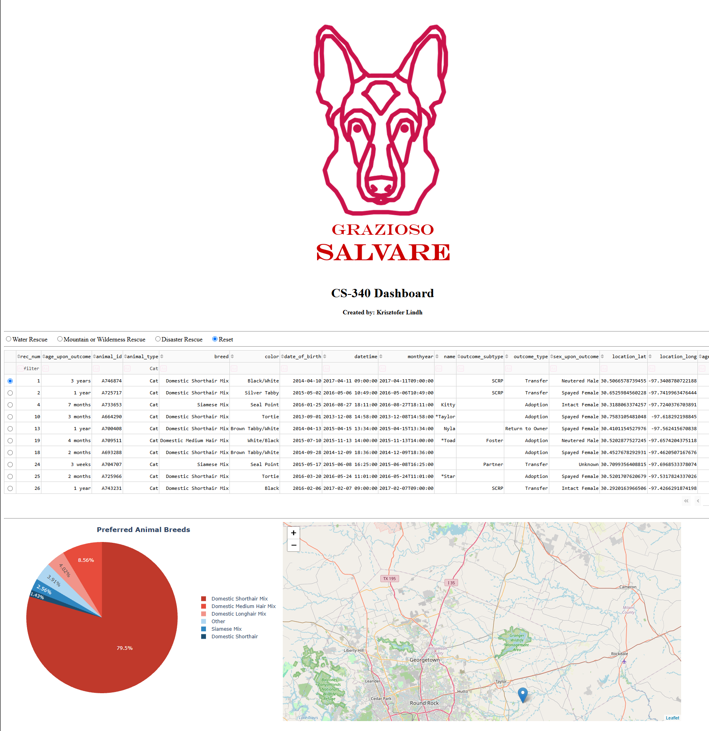

Pie Chart Hover Functionality:
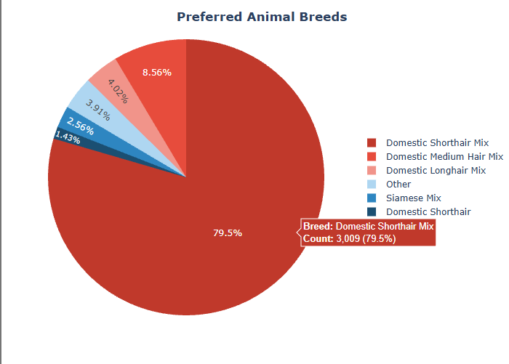
Upon hovering the different breeds, the user can see specific metadata pertaining to the hovered breed.
Map Pin Functionality:
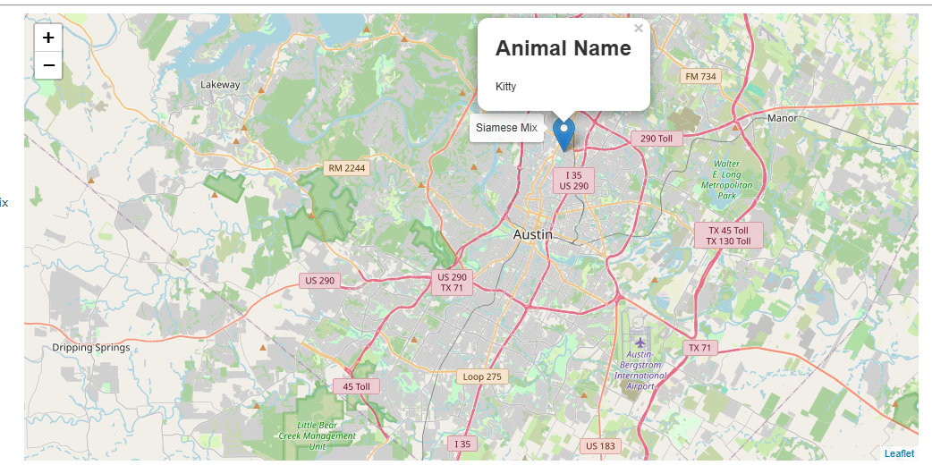
When hovering the pin, the user can see the breed. Upon clicking, the name will appear.
Contact:
Krisztofer Lindh

