1)Install MongoDB database server
Solution:
$ sudo apt-get install gnupg curl
$ curl -fsSL https://pgp.mongodb.com/server-7.0.asc | \sudo gpg -o /usr/share/keyrings/mongodb-server-7.0.gpg \--dearmor

2) Create a directory/folder to store MongoDB datafiles
Solution :
$ echo "deb [ arch=amd64,arm64 signed-by=/usr/share/keyrings/mongodb-server-7.0.gpg ] https://repo.mongodb.org/apt/ubuntu jammy/mongodb-org/7.0 multiverse" | sudo tee /etc/apt/sources.list.d/mongodb-org-7.0.list

3) Set necessary path environment variable
Solution
title:'MySQL programming', authors:['Jack','Jill'], likes:200Solution
$ echo "deb [ arch=amd64,arm64 signed-by=/usr/share/keyrings/mongodb-server-7.0.gpg ] https://repo.mongodb.org/apt/ubuntu jammy/mongodb-org/7.0 multiverse" | sudo tee /etc/apt/sources.list.d/mongodb-org-7.0.list

4) Startup MongoDB database
Solution
$ sudo systemctl start mongod

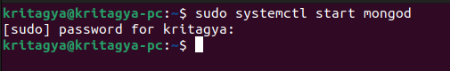

5) Connect to MongoDB database through the MongoDB shell command line interface

Solution

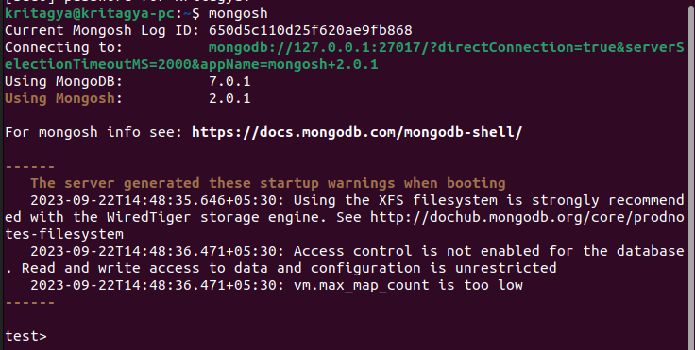

6) View list of available databases
Solution
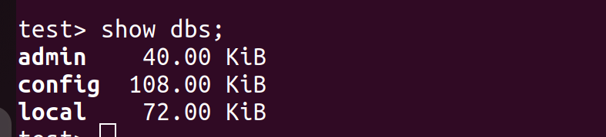

7) Create a new database named CDAC and connect to it
Solution

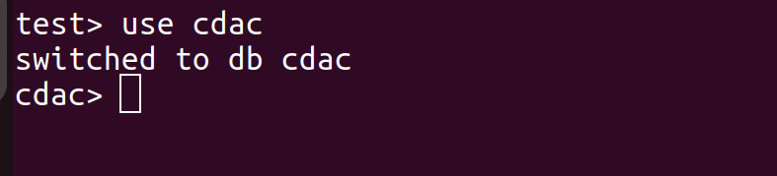

8) View list of available collections in CDAC database
Solution

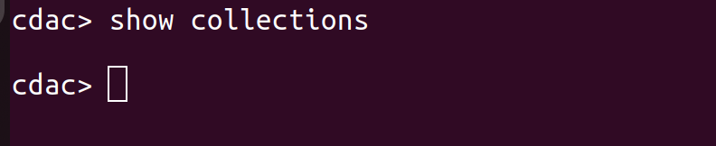

9) Create a new collection by the name of LIBRARY
Solution:
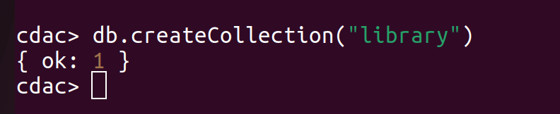

10) Insert the following document in the LIBRARY collection:-
title:'MongoDB programming', author:'Sameer', likes:100
Solution

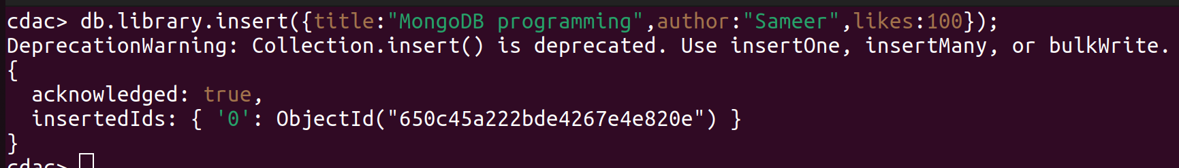
11) View the recently inserted document and note the _id field
Solution

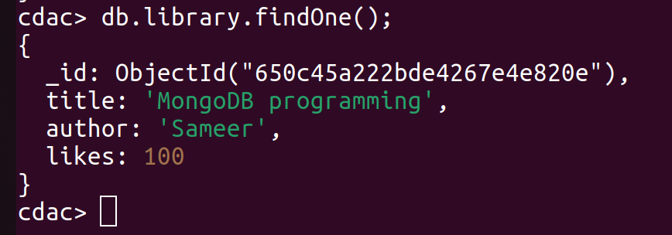
12) Insert another document in the LIBRARY collection as follows:-
Solution

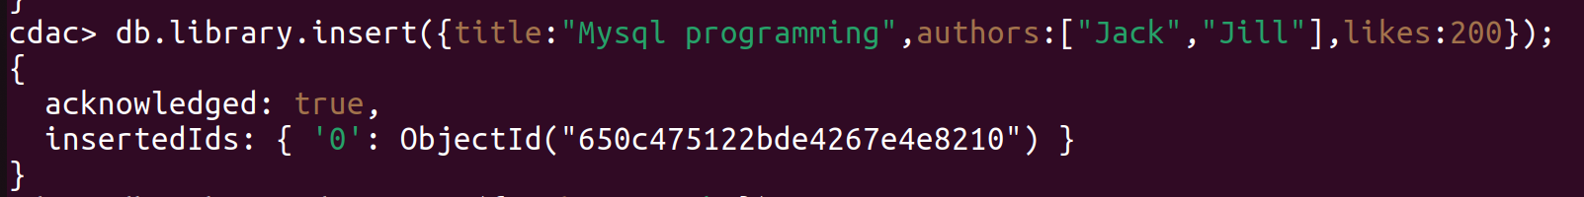
13) View the inserted documents
Solution
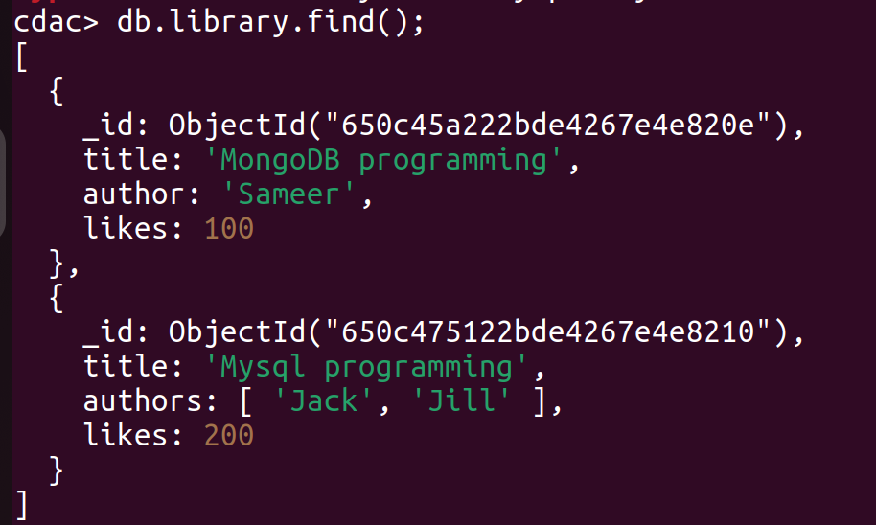

14) View only the first inserted document
Solution

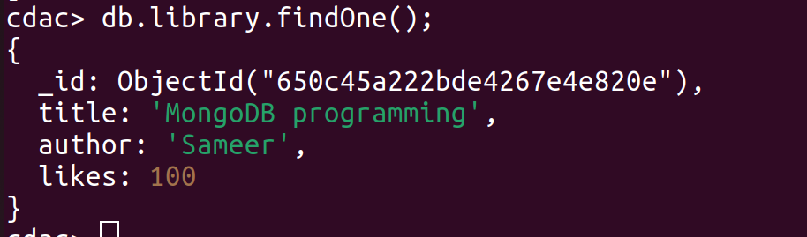

15) View the documents using the pretty() method
Solution

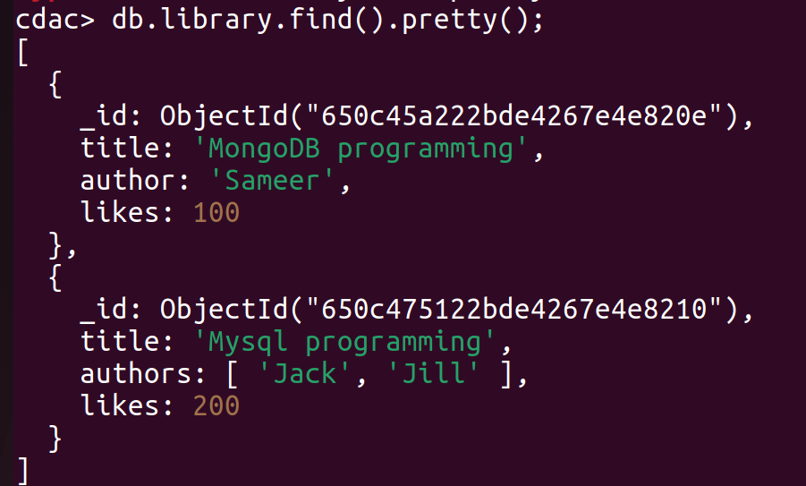

16) Update the document where author name = Sameer and change it to Sameer Dehadrai
Solution
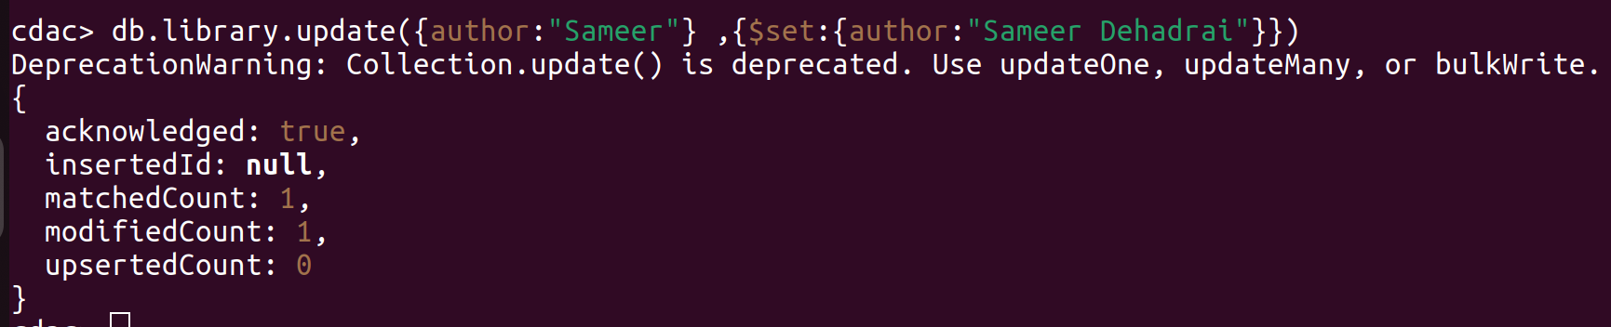

17) Delete all documents that have 100 likes
Solution

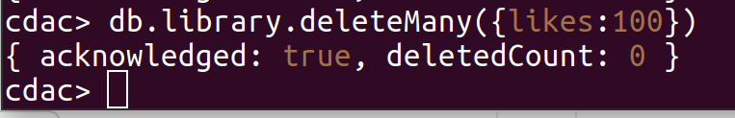

18) Drop the LIBRARY collection
Solution:
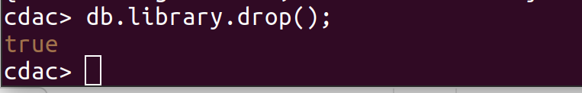

19) Drop the CDAC database
Solution
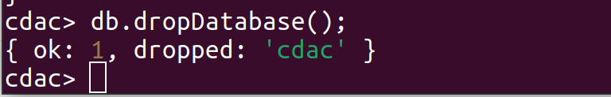

20) Exit from MongoDB shell
Solution

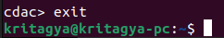

21) Stop MongoDB server
Solution

