📊 AI Investor - Complete Project Architecture & Overview

Table of Contents
(Table of contents will be generated when you open the document in Word)
Contents
Table of Contents 1
🎯 Project Summary 4
📈 Stock Availability 4
Total Stocks Available: 10,000+ 4
🏗️ System Architecture 4
Frontend: 4
Backend: 4
AI Providers: 5
External APIs: 5
📂 Project Structure 5
🗄️ Database Schema 6
Tables: 6
🔄 Complete Data Flow 8
1. User Authentication Flow 8
2. Stock Search & Analysis Flow 10
3. Token System Flow 12
🤖 AI Integration Architecture 13
Configuration: src/lib/ai-config.ts 13
Claude Integration (/api/buffett/claude) 13
Gemini Integration (/api/buffett/gemini) 14
📡 Complete API Reference 14
1. Stock Search 14
2. Stock Profile 15
3. Financial Statements 16
4. AI Analysis (Claude) 16
5. AI Analysis (Gemini) 17
6. Reports - Get All 17
7. Reports - Get By ID 18
8. Reports - Save 18
9. Reports - Delete 19
10. Tokens - Get Balance 19
11. Stripe - Checkout 19
12. Stripe - Webhook 20
🧮 Buffett Algorithm Deep Dive 20
File: src/agents/buffett.ts 20
Analysis Methodology: 20
Signal Generation: 21
🎨 Frontend Components 21
Key Components: 21
🔐 Authentication & Middleware 22
Clerk Integration: 22
💳 Payment System 22
Stripe Integration: 22
📊 State Management (Redux) 22
Stock Data Slice (redux/slices/stockDataSlice.ts) 22
Tokens Slice (redux/slices/tokensSlice.ts) 23
🧪 Testing the Application 23
1. Environment Setup 23
2. Database Setup 23
3. Run Development Server 23
4. Test Flow: 23
📈 Performance Optimizations 24
1. Caching: 24
2. Lazy Loading: 24
3. Server Components: 24
4. Database Indexing: 24
🚨 Error Handling 24
Common Errors: 24
🔒 Security Considerations 25
1. Environment Variables: 25
2. API Route Protection: 25
3. Database Security: 25
4. Payment Security: 25
📊 Key Metrics & Limits 25
API Rate Limits: 25
Application Limits: 25
🎯 Future Enhancements 25
Potential Features: 25
📚 Additional Resources 26
Documentation Files: 26
External Documentation: 26
✅ Summary 26
Core Capabilities: 26
Tech Stack: 26

🎯 Project Summary
AI Investor (Invest Squid) is a Next.js-based investment analysis platform that provides Warren Buffett-style stock analysis using AI (Claude/Gemini) and custom algorithms. The application fetches financial data, analyzes it using Buffett's investment principles, and provides actionable investment signals (bullish/neutral/bearish).

📈 Stock Availability

Total Stocks Available: 10,000+

Supported Exchanges:
- NASDAQ - ~3,500 stocks
- NYSE - ~2,800 stocks
- Total Combined: 10,000+ publicly traded companies

Coverage Includes:
- All major US stocks (Apple, Microsoft, Google, etc.)
- Mid-cap companies
- Small-cap companies
- ETFs and indices

Search Capability:
- Real-time search across all NASDAQ and NYSE listings
- Search by company name or ticker symbol
- Auto-suggestion based on partial matches
Data Source API: Financial Modeling Prep (FMP)
- Free Tier Limit: 250 API calls per day
- Endpoint: https://financialmodelingprep.com/stable/search-name
- Parameters: query={stockName}&exchange=NASDAQ,NYSE

🏗️ System Architecture

Frontend:
- Framework: Next.js 15.2.4 (App Router)
- UI Framework: React 19
- Styling: TailwindCSS 4 + ShadCN UI components
- State Management: Redux Toolkit
- Animations: GSAP 3.12.7
- Type Safety: TypeScript 5

Backend:
- API Routes: Next.js Server Components & Server Actions
- Database: Neon PostgreSQL (serverless)
- ORM: Drizzle ORM 0.41.0
- Authentication: Clerk
- Payments: Stripe

AI Providers:
- Claude 3.7 Sonnet (Anthropic) - Premium quality
- Gemini 1.5 Pro (Google) - Free tier available
- Configurable via src/lib/ai-config.ts

External APIs:
- Financial Modeling Prep - Stock data & financials
- Claude API - AI investment analysis
- Gemini API - Alternative AI analysis
- Clerk - User authentication
- Stripe - Payment processing

📂 Project Structure
ai-investor/
├── src/
│ ├── agents/
│ │ └── buffett.ts # Buffett algorithm implementation
│ ├── app/
│ │ ├── (auth)/ # Authentication pages
│ │ │ ├── sign-in/
│ │ │ └── sign-up/
│ │ ├── api/ # API Routes
│ │ │ ├── buffett/
│ │ │ │ ├── claude/route.ts # Claude AI endpoint
│ │ │ │ └── gemini/route.ts # Gemini AI endpoint
│ │ │ ├── financials/[id]/ # Financial data endpoint
│ │ │ ├── search/[name]/ # Stock search endpoint
│ │ │ ├── stock/[id]/ # Stock profile endpoint
│ │ │ ├── reports/ # Report CRUD operations
│ │ │ ├── tokens/ # Token balance endpoint
│ │ │ └── webhooks/stripe/ # Stripe webhook handler
│ │ ├── private/ # Protected routes
│ │ │ ├── search/ # Stock search page
│ │ │ ├── [stockId]/ # Stock analysis page
│ │ │ ├── list/ # Saved reports
│ │ │ └── tokens/ # Buy tokens page
│ │ ├── globals.css # Global styles
│ │ ├── layout.tsx # Root layout
│ │ └── page.tsx # Landing page
│ ├── components/
│ │ ├── stock/ # Stock-related components
│ │ │ ├── AiReport.tsx # AI analysis display
│ │ │ ├── AiReportConfidenceChart.tsx
│ │ │ ├── CalculationReport.tsx # Custom algorithm display
│ │ │ ├── StockCard.tsx # Stock info card
│ │ │ └── ...
│ │ ├── tokens/
│ │ │ └── BuyTokensCards.tsx # Pricing cards
│ │ ├── loading/ # Loading states
│ │ ├── ui/ # ShadCN components
│ │ └── MobileNavigation.tsx
│ ├── drizzle/
│ │ ├── db.ts # Database client
│ │ └── schema.ts # Database schema
│ ├── hooks/
│ │ └── useBuffettAiReport.ts # AI report hook
│ ├── lib/
│ │ ├── ai-config.ts # AI provider configuration
│ │ └── utils.ts # Utility functions
│ ├── redux/
│ │ ├── slices/
│ │ │ ├── stockDataSlice.ts # Stock data state
│ │ │ └── tokensSlice.ts # Token state
│ │ └── store.ts # Redux store
│ ├── server/
│ │ └── actions/
│ │ ├── stripe.ts # Stripe actions
│ │ └── tokens.ts # Token operations
│ ├── types/ # TypeScript types
│ ├── utils/ # Helper functions
│ └── middleware.ts # Clerk middleware
├── public/ # Static assets
├── .env.local # Environment variables (not in repo)
├── .env.example # Environment template
├── package.json
├── drizzle.config.ts # Drizzle configuration
├── next.config.ts
└── tsconfig.json

🗄️ Database Schema

Tables:

1. UserTable (user)
{
id: text, // Clerk User ID (unique)
email: text,
createdAt: timestamp,
tokens: integer // Token balance
}
Purpose: Store user profiles and token balances

2. ListItemTable (listItem)
{
id: text (PK),
userId: text, // Foreign key to user
createdAt: timestamp,
stockName: text,
reasoning: text, // AI reasoning
signal: text, // bullish/neutral/bearish
confidence: text,
calculationData: jsonb, // Full analysis data
investor: text // AI provider used
}
Purpose: Store saved investment reports
Index: userIdCloseDateIndex on (userId, createdAt)

3. TransactionsTable (transactions)
{
id: uuid (PK),
userId: text,
createdAt: timestamp,
plan: text // "5", "10", or "20"
}
Purpose: Store purchase history

🔄 Complete Data Flow

1. User Authentication Flow
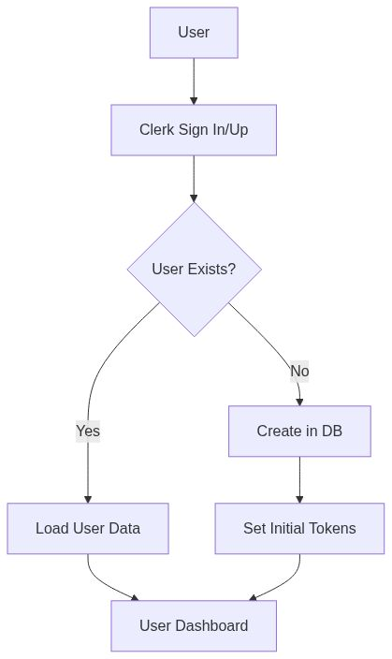
Mermaid Diagram 1
Steps:
1. User clicks "Sign In" → Clerk modal opens
2. User authenticates via Clerk
3. Middleware checks auth status
4. If new user, create entry in UserTable
5. Load user's token balance
6. Redirect to /private/search

2. Stock Search & Analysis Flow
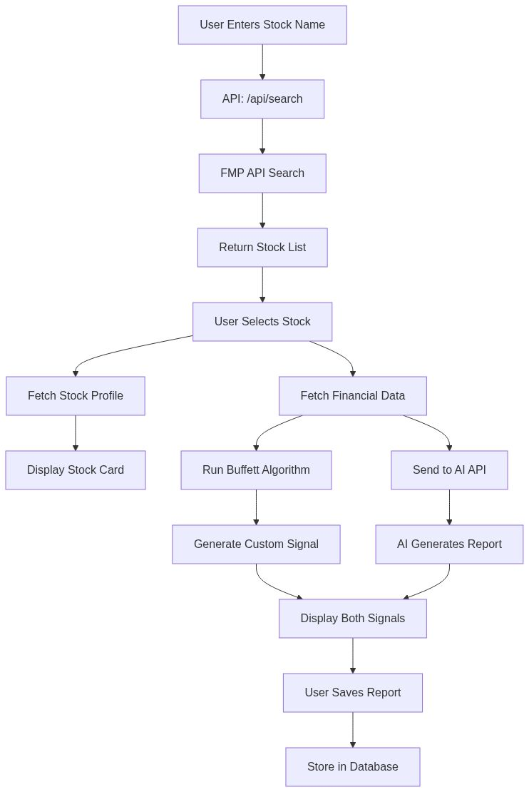
Mermaid Diagram 2
Detailed Steps:

Step 1: Stock Search
- User Action: Types stock name in search box
- API Call: POST /api/search/[name]
- External API: FMP Search API
- Returns: List of matching stocks (name, ticker, exchange)

Step 2: Stock Selection
- User Action: Clicks on a stock
- Redirect: /private/[stockId] (e.g., /private/AAPL)
- Parallel API Calls:
- /api/stock/[id] - Stock profile (price, market cap, description)
- /api/financials/[id] - Financial statements (5 years)

Step 3: Data Processing
- Custom Algorithm: src/agents/buffett.ts runs locally
- Analyzes 5 key metrics (fundamentals, consistency, moat, management, intrinsic value)
- Generates signal (bullish/neutral/bearish)
- Calculates confidence score
- AI Analysis: Sends filtered data to AI endpoint
- Endpoint: /api/buffett/gemini or /api/buffett/claude
- AI generates Buffett-style reasoning
- Returns JSON: {signal, confidence, reasoning}

Step 4: Display Results
- Left Panel: Custom algorithm report
- Right Panel: AI report with reasoning
- Both show: Signal, confidence, detailed analysis

Step 5: Save Report (Optional)
- User Action: Clicks "Save to List"
- API Call: POST /api/reports/save-report
- Database: Insert into ListItemTable

3. Token System Flow
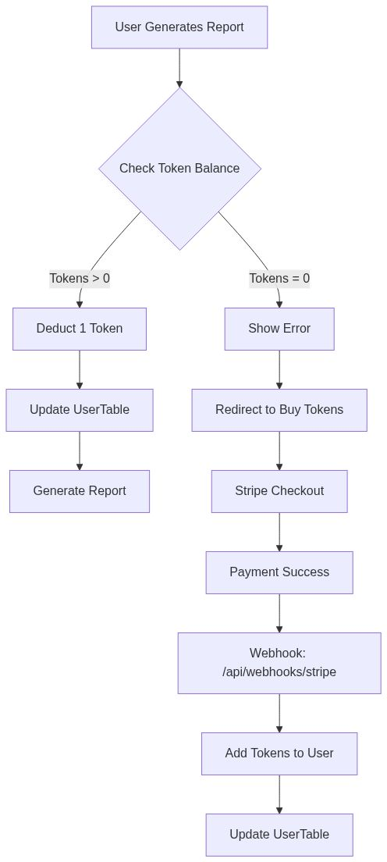
Mermaid Diagram 3
Token Pricing:
- $5 → 50 tokens (10¢ per report)
- $10 → 200 tokens (5¢ per report) ⭐ Popular
- $20 → 500 tokens (4¢ per report)
Token Deduction Points:
1. /api/buffett/claude/route.ts (lines 42-49)
2. /api/buffett/gemini/route.ts (lines 42-49)
Token Addition:
- Stripe webhook calls createTransaction()
- createTransaction() calls updateTokens()
- updateTokens() adds tokens based on plan

🤖 AI Integration Architecture

Configuration: src/lib/ai-config.ts
export const AI_CONFIG = {
provider: 'gemini', // or 'claude'
endpoints: {
claude: '/api/buffett/claude',
gemini: '/api/buffett/gemini',
},
models: {
claude: 'Claude 3.7 Sonnet',
gemini: 'Gemini 1.5 Pro',
}
}

Claude Integration (/api/buffett/claude)
Request:
{
"ticker": "AAPL",
"analysisData": {
"fundamentalAnalysis": {...},
"consistencyAnalysis": {...},
"moatAnalysis": {...},
"managementAnalysis": {...},
"intrinsicValueAnalysis": {...}
}
}
Model: claude-3-7-sonnet-20250219
Pricing: ~$3 per million tokens
Response Time: 3-6 seconds
Response:
{
"content": [{
"type": "text",
"text": "{\"signal\":\"bullish\",\"confidence\":85,\"reasoning\":\"...\"}"
}]
}

Gemini Integration (/api/buffett/gemini)
Request: Same as Claude
Model: gemini-1.5-pro
Pricing: FREE (1,500 requests/day)
Response Time: 2-4 seconds
Response:
{
"content": [{
"type": "text",
"text": "{\"signal\":\"bullish\",\"confidence\":85,\"reasoning\":\"...\"}"
}]
}
Key Feature: responseMimeType: "application/json" ensures structured output

📡 Complete API Reference

1. Stock Search
GET /api/search/[name]
Parameters:
- name (path): Stock name or partial name
External Call:
GET https://financialmodelingprep.com/stable/search-name
?query={stockName}
&exchange=NASDAQ,NYSE
&apikey={FMP_API_KEY}
Response:
[
{
"symbol": "AAPL",
"name": "Apple Inc.",
"currency": "USD",
"stockExchange": "NASDAQ",
"exchangeShortName": "NASDAQ"
}
]

2. Stock Profile
GET /api/stock/[id]
Parameters:
- id (path): Stock ticker symbol
External Call:
GET https://financialmodelingprep.com/stable/profile
?symbol={stockId}
&apikey={FMP_API_KEY}
Response:
[
{
"symbol": "AAPL",
"price": 189.50,
"beta": 1.24,
"volAvg": 54000000,
"mktCap": 2950000000000,
"lastDiv": 0.96,
"range": "164.08-199.62",
"changes": 2.15,
"companyName": "Apple Inc.",
"currency": "USD",
"cik": "0000320193",
"isin": "US0378331005",
"cusip": "037833100",
"exchange": "NASDAQ",
"exchangeShortName": "NASDAQ",
"industry": "Consumer Electronics",
"website": "https://www.apple.com",
"description": "Apple Inc. designs...",
"ceo": "Timothy D. Cook",
"sector": "Technology",
"country": "US",
"fullTimeEmployees": "164000",
"phone": "14089961010",
"address": "One Apple Park Way",
"city": "Cupertino",
"state": "CA",
"zip": "95014",
"image": "https://financialmodelingprep.com/image-stock/AAPL.png",
"ipoDate": "1980-12-12"
}
]
Caching: 24 hours (86400 seconds)

3. Financial Statements
GET /api/financials/[id]
Parameters:
- id (path): Stock ticker symbol
External Call:
GET https://financialmodelingprep.com/stable/financial-statement-full-as-reported
?symbol={stockId}
&limit=5
&apikey={FMP_API_KEY}
Response: Complete financial statements (5 years)
- Income Statement
- Balance Sheet
- Cash Flow Statement
Caching: 24 hours

4. AI Analysis (Claude)
POST /api/buffett/claude
Headers:
Content-Type: application/json
Cookie: __session={clerk_session}
Request Body:
{
"ticker": "AAPL",
"analysisData": {
"fundamentalAnalysis": {
"score": 7,
"maxScore": 7,
"details": ["..."]
},
"consistencyAnalysis": {...},
"moatAnalysis": {...},
"managementAnalysis": {...},
"intrinsicValueAnalysis": {...},
"score": 15.5,
"maxScore": 18,
"signal": "bullish",
"marketCap": 2950000000000,
"marginOfSafety": 0.45
}
}
Response:
{
"content": [{
"type": "text",
"text": "{\"signal\":\"bullish\",\"confidence\":85,\"reasoning\":\"I'm particularly impressed with Apple's consistent ROE above 150%, reminiscent of our See's Candies investment...\"}"
}]
}
Authentication: Required (Clerk)
Token Cost: 1 token

5. AI Analysis (Gemini)
POST /api/buffett/gemini
Same as Claude endpoint, different AI model

6. Reports - Get All
GET /api/reports/get-all-reports
Authentication: Required
Response:
{
"success": true,
"reports": [
{
"id": "uuid-...",
"created": "2025-01-20T10:30:00Z",
"name": "Apple Inc.",
"investor": "gemini",
"signal": "bullish"
}
]
}
Limit: 50 most recent reports
Sorting: Descending by createdAt

7. Reports - Get By ID
GET /api/reports/get-report-by-id/[id]
Parameters:
- id (path): Report UUID
Response:
{
"success": true,
"report": {
"id": "uuid-...",
"userId": "user_...",
"stockName": "Apple Inc.",
"signal": "bullish",
"confidence": "85",
"reasoning": "...",
"calculationData": {...},
"investor": "gemini",
"createdAt": "2025-01-20T10:30:00Z"
}
}

8. Reports - Save
POST /api/reports/save-report
Request Body:
{
"stockName": "Apple Inc.",
"signal": "bullish",
"confidence": "85",
"reasoning": "...",
"reportData": {...},
"investor": "gemini"
}
Response:
{
"success": true,
"reportId": "uuid-..."
}

9. Reports - Delete
DELETE /api/reports/delete/[id]
Parameters:
- id (path): Report UUID
Response:
{
"success": true,
"message": "Report deleted successfully"
}

10. Tokens - Get Balance
GET /api/tokens
Authentication: Required
Response:
{
"success": true,
"tokens": 100
}

11. Stripe - Checkout
Server Action: checkoutCredits()
Parameters:
{
plan: "5" | "10" | "20",
buyerId: string
}
Process:
1. Create Stripe checkout session
2. Redirect to Stripe payment page
3. On success, redirect to /private/tokens?success=true
4. On cancel, redirect to /private/tokens?canceled=true

12. Stripe - Webhook
POST /api/webhooks/stripe
Event: checkout.session.completed
Process:
1. Verify webhook signature
2. Extract metadata (plan, credits, buyerId)
3. Call createTransaction()
4. Add tokens to user via updateTokens()

🧮 Buffett Algorithm Deep Dive

File: src/agents/buffett.ts

Analysis Methodology:

1. Fundamental Analysis (7 points max)
Criteria:
- ROE > 15% → +2 points
- Debt-to-Equity < 0.5 → +2 points
- Operating Margin > 15% → +2 points
- Current Ratio > 1.5 → +1 point

2. Consistency Analysis (3 points max)
Criteria:
- Consistent earnings growth (all periods increasing) → +3 points
- Long-term growth rate calculation

3. Economic Moat Analysis (3 points max)
Criteria:
- Stable ROE > 15% (3+ periods) → +1 point
- Stable Operating Margin > 15% (3+ periods) → +1 point
- Both criteria met → +1 bonus point

4. Management Quality (2 points max)
Criteria:
- Share buybacks (negative issuance) → +1 point
- Dividend payments → +1 point

5. Intrinsic Value Calculation
Formula:
- Owner Earnings = Net Income + Depreciation - (CapEx * 0.75)
- DCF with 10-year projection
- Growth Rate: 5% (conservative)
- Discount Rate: 9%
- Terminal Multiple: 12x

Signal Generation:
if (score >= 70% of maxScore && marginOfSafety >= 30%) {
signal = "bullish"
} else if (score <= 30% of maxScore || marginOfSafety < -30%) {
signal = "bearish"
} else {
signal = "neutral"
}
Margin of Safety: (intrinsicValue - marketCap) / marketCap

🎨 Frontend Components

Key Components:

1. StockCard (components/stock/StockCard.tsx)
- Displays stock profile information
- Shows company logo, name, price, market cap
- Includes "Save to List" functionality
- GSAP animations for scroll effects

2. AiReport (components/stock/AiReport.tsx)
- Displays AI-generated analysis
- Dynamic provider icon (Claude/Gemini)
- Shows signal, confidence, and reasoning
- Typing animation for new reports

3. CalculationReport (components/stock/CalculationReport.tsx)
- Displays custom algorithm analysis
- Shows all 5 analysis categories
- Expandable sections for detailed metrics
- Visual score representation

4. BuyTokensCards (components/tokens/BuyTokensCards.tsx)
- Three pricing tiers
- Stripe checkout integration
- Success/cancel toast notifications

5. MobileNavigation (components/MobileNavigation.tsx)
- Responsive navigation menu
- Token balance display
- Sign out functionality

🔐 Authentication & Middleware

Clerk Integration:
Middleware: src/middleware.ts
export default clerkMiddleware((auth, req) => {
// Protect all /private routes
if (req.nextUrl.pathname.startsWith('/private')) {
auth().protect()
}
})
publicRoutes: ["/", "/sign-in", "/sign-up"]
User Session:
- Stored in __session cookie
- Automatically managed by Clerk
- Refreshed on each request

💳 Payment System

Stripe Integration:
Flow:
1. User clicks "Buy Tokens"
2. checkoutCredits() server action called
3. Stripe session created with metadata
4. User redirects to Stripe checkout
5. On payment success, Stripe sends webhook
6. Webhook handler verifies signature
7. createTransaction() logs transaction
8. updateTokens() adds tokens to user
Security:
- Webhook signature verification
- Server-side only operations
- No client-side token manipulation

📊 State Management (Redux)

Stock Data Slice (redux/slices/stockDataSlice.ts)
State:
- stockDataForUi: StockProfile[]
- stockDataForBuffettCalc: AnalysisDataResult | null

Tokens Slice (redux/slices/tokensSlice.ts)
State:
- tokens: number
Actions:
- spentOneToken(): Decrements token count

🧪 Testing the Application

1. Environment Setup
# Copy environment template
cp .env.example .env.local
# Fill in API keys
GEMINI_API_KEY=AIzaSy...
CLERK_PUBLISHABLE_KEY=pk_test...
CLERK_SECRET_KEY=sk_test...
DATABASE_URL=postgresql://...
FMP_API_KEY=...
STRIPE_SECRET_API_KEY=sk_test...
NEXT_PUBLIC_PUBLISHABLE_STRIPE_API_KEY=pk_test...
STRIPE_WEBHOOK_SECRET=whsec_...
NEXT_PUBLIC_SERVER_URL=http://localhost:3000

2. Database Setup
npm run db:generate
npm run db:migrate

3. Run Development Server
npm run dev

4. Test Flow:
- Sign Up: Create account at /sign-up
- Search Stock: Type "Apple" in search
- Analyze Stock: Click on AAPL
- Wait for Analysis: Both reports generate
- Save Report: Click "Save to List"
- View Saved Reports: Navigate to "My List"
- Buy Tokens: Go to Tokens page, test with Stripe test card
Stripe Test Card:
Number: 4242 4242 4242 4242
Expiry: Any future date
CVC: Any 3 digits

📈 Performance Optimizations

1. Caching:
- Session Storage: AI reports cached by ticker
- Next.js Cache: Stock data cached for 24 hours
- Prevents: Redundant API calls

2. Lazy Loading:
- Dynamic imports for heavy components
- Code splitting per route

3. Server Components:
- Most rendering happens server-side
- Reduced JavaScript bundle size

4. Database Indexing:
- Index on (userId, createdAt) for reports
- Fast query performance

🚨 Error Handling

Common Errors:

1. "Publishable key not valid"
- Cause: Missing or incorrect Clerk API key
- Fix: Check .env.local CLERK keys

2. "You don't have enough tokens"
- Cause: Token balance = 0
- Fix: Buy tokens or reset via SQL

3. "Failed to fetch stock data"
- Cause: FMP API limit reached (250/day) or invalid ticker
- Fix: Wait 24 hours or upgrade FMP plan

4. "AI is busy"
- Cause: AI provider rate limiting (Gemini: 15/min, 1500/day)
- Fix: Wait and retry, or switch providers

🔒 Security Considerations

1. Environment Variables:
- Never commit .env.local
- Use different keys for dev/production
- Rotate keys if exposed

2. API Route Protection:
- All /api/buffett routes check authentication
- Token validation on each request
- No client-side API keys

3. Database Security:
- Connection string includes SSL
- User data isolated by Clerk ID
- No SQL injection (using Drizzle ORM)

4. Payment Security:
- Stripe handles all payment data
- Webhook signature verification
- Server-side only token updates

📊 Key Metrics & Limits

API Rate Limits:
Service | Free Tier Limit | Cost Beyond
FMP | 250 calls/day | $14/month for 750/day
Gemini | 1,500 calls/day15 calls/min | Paid tier via Google Cloud
Claude | No free tier | ~$3 per 1M tokens
Clerk | 5,000 MAU | $25/month for 10,000 MAU
Neon | 0.5 GB storage | $19/month for 10 GB

Application Limits:
- Saved Reports per User: Unlimited (database constraint)
- Report History: Last 50 shown
- Financial Data: 5 years of statements
- Search Results: All matching stocks returned

🎯 Future Enhancements

Potential Features:
- More Investor Styles:
- Peter Lynch algorithm
- Benjamin Graham algorithm
- Ray Dalio principles
- Advanced Analytics:
- Portfolio tracking
- Watchlists with price alerts
- Comparison tool (multiple stocks)
- Social Features:
- Share reports
- Community discussions
- Follow other investors
- Mobile App:
- React Native version
- Push notifications

📚 Additional Resources

Documentation Files:
- API_SETUP_GUIDE.md - How to get all API keys
- SWITCHING_AI_PROVIDERS.md - Claude vs Gemini guide
- SETUP_SUMMARY.md - Quick setup overview
- README.md - Project introduction

External Documentation:
- Next.js Docs
- Drizzle ORM
- Clerk Auth
- Stripe API
- FMP API
- Gemini API
- Claude API

✅ Summary

Core Capabilities:
✅ Stock Coverage: 10,000+ stocks (NASDAQ + NYSE)
✅ AI Analysis: Dual provider support (Claude + Gemini)
✅ Custom Algorithm: Warren Buffett principles implementation
✅ User System: Authentication, tokens, saved reports
✅ Payments: Stripe integration for token purchases
✅ Database: PostgreSQL with optimized queries
✅ Performance: Caching, lazy loading, server components

Tech Stack:
- Frontend: Next.js 15 + React 19 + TypeScript
- Styling: TailwindCSS + ShadCN
- State: Redux Toolkit
- Backend: Next.js API Routes
- Database: Neon PostgreSQL + Drizzle ORM
- Auth: Clerk
- Payments: Stripe
- AI: Claude + Gemini
- Data: Financial Modeling Prep
Project Version: 0.1.0
Last Updated: 2025-01-21
Status: ✅ Fully Operational
© 2025 Invest Squid - Educational Investment Analysis Platform

