Edge Intelligence
Video Analysis
Krithana A
25MML0054
05.03.2026

- Extracting Dimenesions and pixel matrix of a frame and coverted to Grayscale and visualizing dimension and matrix(Converting 3D to 1 D)
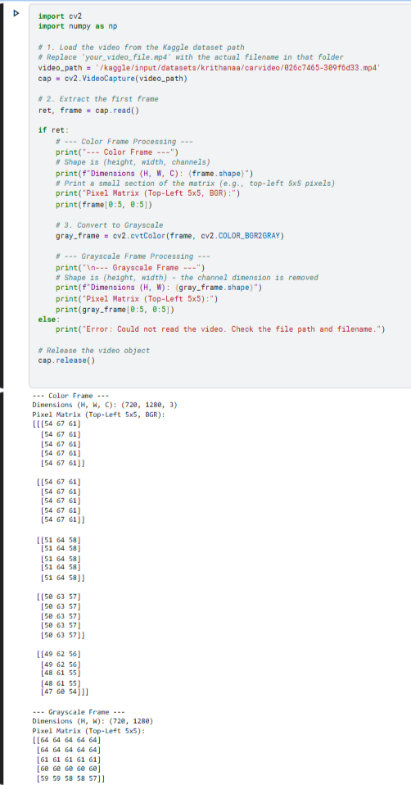

- Visualising original frame and grayscale frame
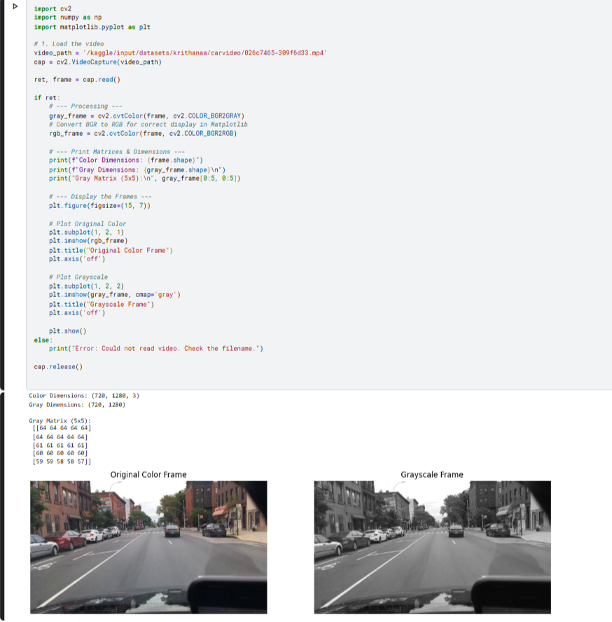
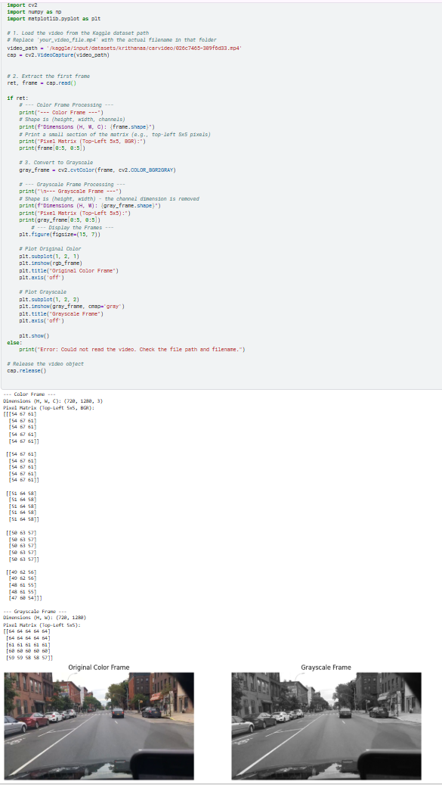
- Original frame is converted to Canny frame
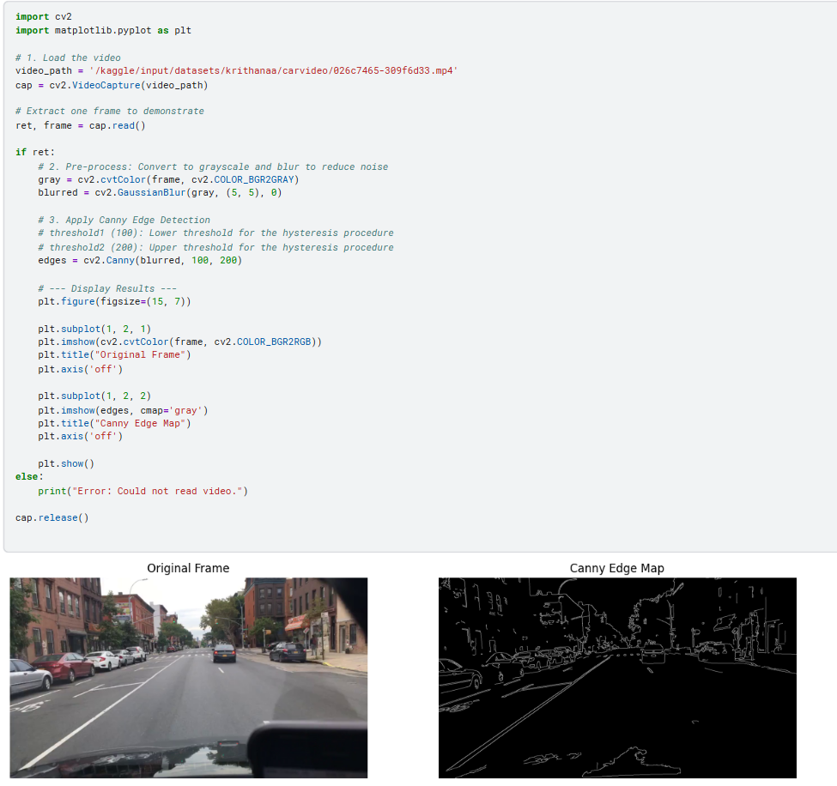

- Video is converted to Canny video
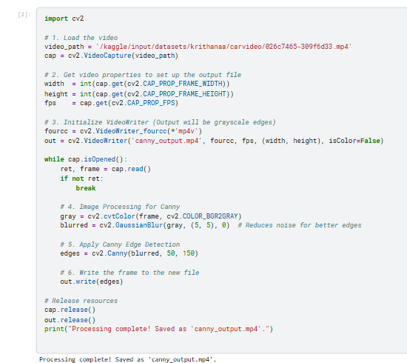
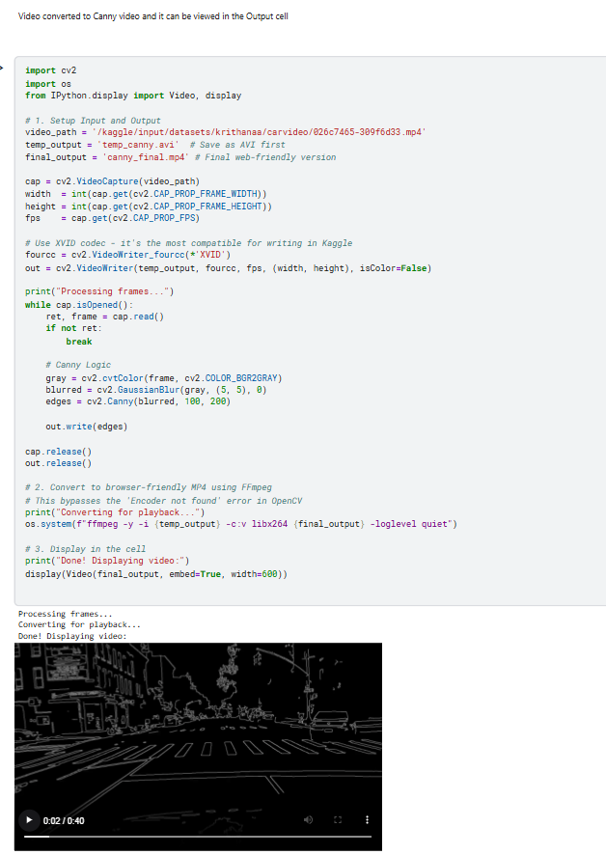

- Finding difference between canny with negative pixels

