# This Python 3 environment comes with many helpful analytics libraries installed
# It is defined by the kaggle/python Docker image: https://github.com/kaggle/docker-python
# For example, here's several helpful packages to load
import numpy as np # linear algebra
import pandas as pd # data processing, CSV file I/O (e.g. pd.read_csv)
# Input data files are available in the read-only "../input/" directory
# For example, running this (by clicking run or pressing Shift+Enter) will list all files under the input directory
import os
for dirname, _, filenames in os.walk('/kaggle/input'):
for filename in filenames:
print(os.path.join(dirname, filename))
# You can write up to 20GB to the current directory (/kaggle/working/) that gets preserved as output when you create a version using "Save & Run All"
# You can also write temporary files to /kaggle/temp/, but they won't be saved outside of the current session
Extracting Dimenesions and pixel matrix of a frame and coverted to Grayscale and visualizing dimension and matrix(Converting 3D to 1 D)
import cv2
import numpy as np
# 1. Load the video from the Kaggle dataset path
# Replace 'your_video_file.mp4' with the actual filename in that folder
video_path = '/kaggle/input/datasets/krithanaa/carvideo/026c7465-309f6d33.mp4'
cap = cv2.VideoCapture(video_path)
# 2. Extract the first frame
ret, frame = cap.read()
if ret:
# --- Color Frame Processing ---
print("--- Color Frame ---")
# Shape is (height, width, channels)
print(f"Dimensions (H, W, C): {frame.shape}")
# Print a small section of the matrix (e.g., top-left 5x5 pixels)
print("Pixel Matrix (Top-Left 5x5, BGR):")
print(frame[0:5, 0:5])
# 3. Convert to Grayscale
gray_frame = cv2.cvtColor(frame, cv2.COLOR_BGR2GRAY)
# --- Grayscale Frame Processing ---
print("\n--- Grayscale Frame ---")
# Shape is (height, width) - the channel dimension is removed
print(f"Dimensions (H, W): {gray_frame.shape}")
print("Pixel Matrix (Top-Left 5x5):")
print(gray_frame[0:5, 0:5])
else:
print("Error: Could not read the video. Check the file path and filename.")
# Release the video object
cap.release()
--- Color Frame ---
Dimensions (H, W, C): (720, 1280, 3)
Pixel Matrix (Top-Left 5x5, BGR):
[[[54 67 61]
[54 67 61]
[54 67 61]
[54 67 61]
[54 67 61]]
[[54 67 61]
[54 67 61]
[54 67 61]
[54 67 61]
[54 67 61]]
[[51 64 58]
[51 64 58]
[51 64 58]
[51 64 58]
[51 64 58]]
[[50 63 57]
[50 63 57]
[50 63 57]
[50 63 57]
[50 63 57]]
[[49 62 56]
[49 62 56]
[48 61 55]
[48 61 55]
[47 60 54]]]
--- Grayscale Frame ---
Dimensions (H, W): (720, 1280)
Pixel Matrix (Top-Left 5x5):
[[64 64 64 64 64]
[64 64 64 64 64]
[61 61 61 61 61]
[60 60 60 60 60]
[59 59 58 58 57]]
Visualising original frame and grayscale frame
import cv2
import numpy as np
import matplotlib.pyplot as plt
# 1. Load the video
video_path = '/kaggle/input/datasets/krithanaa/carvideo/026c7465-309f6d33.mp4'
cap = cv2.VideoCapture(video_path)
ret, frame = cap.read()
if ret:
# --- Processing ---
gray_frame = cv2.cvtColor(frame, cv2.COLOR_BGR2GRAY)
# Convert BGR to RGB for correct display in Matplotlib
rgb_frame = cv2.cvtColor(frame, cv2.COLOR_BGR2RGB)
# --- Print Matrices & Dimensions ---
print(f"Color Dimensions: {frame.shape}")
print(f"Gray Dimensions: {gray_frame.shape}\n")
print("Gray Matrix (5x5):\n", gray_frame[0:5, 0:5])
# --- Display the Frames ---
plt.figure(figsize=(15, 7))
# Plot Original Color
plt.subplot(1, 2, 1)
plt.imshow(rgb_frame)
plt.title("Original Color Frame")
plt.axis('off')
# Plot Grayscale
plt.subplot(1, 2, 2)
plt.imshow(gray_frame, cmap='gray')
plt.title("Grayscale Frame")
plt.axis('off')
plt.show()
else:
print("Error: Could not read video. Check the filename.")
cap.release()
Color Dimensions: (720, 1280, 3)
Gray Dimensions: (720, 1280)
Gray Matrix (5x5):
[[64 64 64 64 64]
[64 64 64 64 64]
[61 61 61 61 61]
[60 60 60 60 60]
[59 59 58 58 57]]
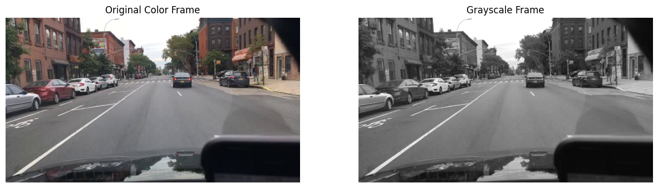
import cv2
import numpy as np
import matplotlib.pyplot as plt
# 1. Load the video from the Kaggle dataset path
# Replace 'your_video_file.mp4' with the actual filename in that folder
video_path = '/kaggle/input/datasets/krithanaa/carvideo/026c7465-309f6d33.mp4'
cap = cv2.VideoCapture(video_path)
# 2. Extract the first frame
ret, frame = cap.read()
if ret:
# --- Color Frame Processing ---
print("--- Color Frame ---")
# Shape is (height, width, channels)
print(f"Dimensions (H, W, C): {frame.shape}")
# Print a small section of the matrix (e.g., top-left 5x5 pixels)
print("Pixel Matrix (Top-Left 5x5, BGR):")
print(frame[0:5, 0:5])
# 3. Convert to Grayscale
gray_frame = cv2.cvtColor(frame, cv2.COLOR_BGR2GRAY)
# --- Grayscale Frame Processing ---
print("\n--- Grayscale Frame ---")
# Shape is (height, width) - the channel dimension is removed
print(f"Dimensions (H, W): {gray_frame.shape}")
print("Pixel Matrix (Top-Left 5x5):")
print(gray_frame[0:5, 0:5])
# --- Display the Frames ---
plt.figure(figsize=(15, 7))
# Plot Original Color
plt.subplot(1, 2, 1)
plt.imshow(rgb_frame)
plt.title("Original Color Frame")
plt.axis('off')
# Plot Grayscale
plt.subplot(1, 2, 2)
plt.imshow(gray_frame, cmap='gray')
plt.title("Grayscale Frame")
plt.axis('off')
plt.show()
else:
print("Error: Could not read the video. Check the file path and filename.")
# Release the video object
cap.release()
--- Color Frame ---
Dimensions (H, W, C): (720, 1280, 3)
Pixel Matrix (Top-Left 5x5, BGR):
[[[54 67 61]
[54 67 61]
[54 67 61]
[54 67 61]
[54 67 61]]
[[54 67 61]
[54 67 61]
[54 67 61]
[54 67 61]
[54 67 61]]
[[51 64 58]
[51 64 58]
[51 64 58]
[51 64 58]
[51 64 58]]
[[50 63 57]
[50 63 57]
[50 63 57]
[50 63 57]
[50 63 57]]
[[49 62 56]
[49 62 56]
[48 61 55]
[48 61 55]
[47 60 54]]]
--- Grayscale Frame ---
Dimensions (H, W): (720, 1280)
Pixel Matrix (Top-Left 5x5):
[[64 64 64 64 64]
[64 64 64 64 64]
[61 61 61 61 61]
[60 60 60 60 60]
[59 59 58 58 57]]

import cv2
# 1. Load the video
video_path = '/kaggle/input/datasets/krithanaa/carvideo/026c7465-309f6d33.mp4'
cap = cv2.VideoCapture(video_path)
while cap.isOpened():
ret, frame = cap.read()
if not ret:
break
# 2. Draw Shapes
# Rectangle: cv2.rectangle(img, top_left, bottom_right, color_bgr, thickness)
cv2.rectangle(frame, (50, 50), (250, 150), (0, 255, 0), 3) # Green rectangle
# Circle: cv2.circle(img, center, radius, color_bgr, thickness)
# Use thickness = -1 to fill the shape
cv2.circle(frame, (400, 300), 50, (255, 0, 0), -1) # Filled Blue circle
# Line: cv2.line(img, start, end, color_bgr, thickness)
cv2.line(frame, (0, 0), (200, 200), (0, 0, 255), 5) # Red line
# Text: cv2.putText(img, text, position, font, scale, color, thickness)
cv2.putText(frame, 'Tracking Car', (60, 45),
cv2.FONT_HERSHEY_SIMPLEX, 0.7, (255, 255, 255), 2)
# 3. Display (Note: For Kaggle, use cv2.imwrite or display specific frames with plt)
cv2.imshow('Video with Shapes', frame)
# Press 'q' to exit early
if cv2.waitKey(1) & 0xFF == ord('q'):
break
cap.release()
cv2.destroyAllWindows()
Original frame is converted to Canny frame
import cv2
import matplotlib.pyplot as plt
# 1. Load the video
video_path = '/kaggle/input/datasets/krithanaa/carvideo/026c7465-309f6d33.mp4'
cap = cv2.VideoCapture(video_path)
# Extract one frame to demonstrate
ret, frame = cap.read()
if ret:
# 2. Pre-process: Convert to grayscale and blur to reduce noise
gray = cv2.cvtColor(frame, cv2.COLOR_BGR2GRAY)
blurred = cv2.GaussianBlur(gray, (5, 5), 0)
# 3. Apply Canny Edge Detection
# threshold1 (100): Lower threshold for the hysteresis procedure
# threshold2 (200): Upper threshold for the hysteresis procedure
edges = cv2.Canny(blurred, 100, 200)
# --- Display Results ---
plt.figure(figsize=(15, 7))
plt.subplot(1, 2, 1)
plt.imshow(cv2.cvtColor(frame, cv2.COLOR_BGR2RGB))
plt.title("Original Frame")
plt.axis('off')
plt.subplot(1, 2, 2)
plt.imshow(edges, cmap='gray')
plt.title("Canny Edge Map")
plt.axis('off')
plt.show()
else:
print("Error: Could not read video.")
cap.release()
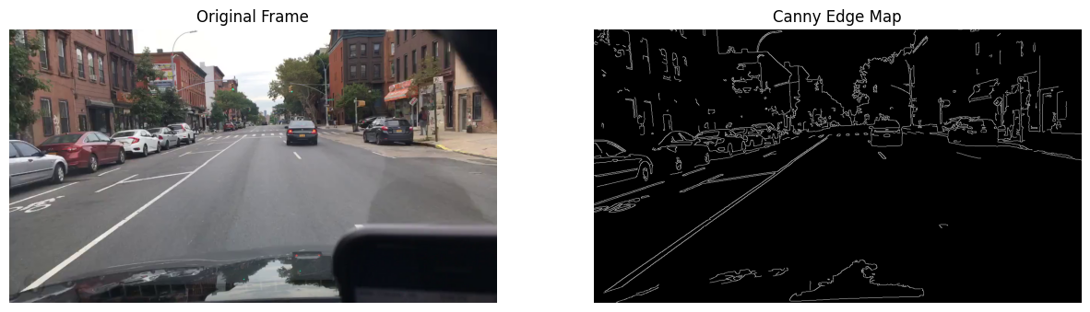
Video is converted to Canny video
import cv2
# 1. Load the video
video_path = '/kaggle/input/datasets/krithanaa/carvideo/026c7465-309f6d33.mp4'
cap = cv2.VideoCapture(video_path)
# 2. Get video properties to set up the output file
width = int(cap.get(cv2.CAP_PROP_FRAME_WIDTH))
height = int(cap.get(cv2.CAP_PROP_FRAME_HEIGHT))
fps = cap.get(cv2.CAP_PROP_FPS)
# 3. Initialize VideoWriter (Output will be grayscale edges)
fourcc = cv2.VideoWriter_fourcc(*'mp4v')
out = cv2.VideoWriter('canny_output.mp4', fourcc, fps, (width, height), isColor=False)
while cap.isOpened():
ret, frame = cap.read()
if not ret:
break
# 4. Image Processing for Canny
gray = cv2.cvtColor(frame, cv2.COLOR_BGR2GRAY)
blurred = cv2.GaussianBlur(gray, (5, 5), 0) # Reduces noise for better edges
# 5. Apply Canny Edge Detection
edges = cv2.Canny(blurred, 50, 150)
# 6. Write the frame to the new file
out.write(edges)
# Release resources
cap.release()
out.release()
print("Processing complete! Saved as 'canny_output.mp4'.")
Processing complete! Saved as 'canny_output.mp4'.
import cv2
import os
from IPython.display import Video, display
# 1. Setup Input and Output
video_path = '/kaggle/input/datasets/krithanaa/carvideo/026c7465-309f6d33.mp4'
output_path = 'canny_result.mp4'
cap = cv2.VideoCapture(video_path)
width = int(cap.get(cv2.CAP_PROP_FRAME_WIDTH))
height = int(cap.get(cv2.CAP_PROP_FRAME_HEIGHT))
fps = cap.get(cv2.CAP_PROP_FPS)
# Use 'avc1' or 'mp4v' for the codec
fourcc = cv2.VideoWriter_fourcc(*'avc1')
out = cv2.VideoWriter(output_path, fourcc, fps, (width, height), isColor=False)
# 2. Process Every Frame
print("Processing video... please wait.")
while cap.isOpened():
ret, frame = cap.read()
if not ret:
break
# Canny Logic
gray = cv2.cvtColor(frame, cv2.COLOR_BGR2GRAY)
blurred = cv2.GaussianBlur(gray, (5, 5), 0)
edges = cv2.Canny(blurred, 100, 200)
out.write(edges)
cap.release()
out.release()
print("Processing finished!")
# 3. View Video in Cell
display(Video(output_path, embed=True, width=600))
Processing video... please wait.
[ERROR:0@126.587] global cap_ffmpeg_impl.hpp:3207 open Could not find encoder for codec_id=27, error: Encoder not found
[ERROR:0@126.587] global cap_ffmpeg_impl.hpp:3285 open VIDEOIO/FFMPEG: Failed to initialize VideoWriter
Processing finished!
<IPython.core.display.Video object>
Video converted to Canny video and it can be viewed in the Output cell
import cv2
import os
from IPython.display import Video, display
# 1. Setup Input and Output
video_path = '/kaggle/input/datasets/krithanaa/carvideo/026c7465-309f6d33.mp4'
temp_output = 'temp_canny.avi' # Save as AVI first
final_output = 'canny_final.mp4' # Final web-friendly version
cap = cv2.VideoCapture(video_path)
width = int(cap.get(cv2.CAP_PROP_FRAME_WIDTH))
height = int(cap.get(cv2.CAP_PROP_FRAME_HEIGHT))
fps = cap.get(cv2.CAP_PROP_FPS)
# Use XVID codec - it's the most compatible for writing in Kaggle
fourcc = cv2.VideoWriter_fourcc(*'XVID')
out = cv2.VideoWriter(temp_output, fourcc, fps, (width, height), isColor=False)
print("Processing frames...")
while cap.isOpened():
ret, frame = cap.read()
if not ret:
break
# Canny Logic
gray = cv2.cvtColor(frame, cv2.COLOR_BGR2GRAY)
blurred = cv2.GaussianBlur(gray, (5, 5), 0)
edges = cv2.Canny(blurred, 100, 200)
out.write(edges)
cap.release()
out.release()
# 2. Convert to browser-friendly MP4 using FFmpeg
# This bypasses the 'Encoder not found' error in OpenCV
print("Converting for playback...")
os.system(f"ffmpeg -y -i {temp_output} -c:v libx264 {final_output} -loglevel quiet")
# 3. Display in the cell
print("Done! Displaying video:")
display(Video(final_output, embed=True, width=600))
Processing frames...
Converting for playback...
Done! Displaying video:
<IPython.core.display.Video object>
Finding difference between canny with negative pixels
import cv2
import matplotlib.pyplot as plt
# 1. Load the video
video_path = '/kaggle/input/datasets/krithanaa/carvideo/026c7465-309f6d33.mp4'
cap = cv2.VideoCapture(video_path)
# 2. Extract a single frame (e.g., the first frame)
ret, frame = cap.read()
if ret:
# 3. Convert to Grayscale and apply Canny Edge Detection
gray = cv2.cvtColor(frame, cv2.COLOR_BGR2GRAY)
blurred = cv2.GaussianBlur(gray, (5, 5), 0)
edges = cv2.Canny(blurred, 100, 200) # Binary image: Edges=255, Background=0
# 4. Generate the "Negative" or Inverted Edge Map
# Subtracting from 255 flips white (255) to black (0) and vice versa
negative_edges = cv2.bitwise_not(edges)
# 5. Display the original, Canny edges, and negative edges
plt.figure(figsize=(18, 6))
# Original Frame
plt.subplot(1, 3, 1)
plt.imshow(cv2.cvtColor(frame, cv2.COLOR_BGR2RGB))
plt.title("1. Original Frame")
plt.axis('off')
# Standard Canny (White edges on Black)
plt.subplot(1, 3, 2)
plt.imshow(edges, cmap='gray')
plt.title("2. Canny Edges (Standard)")
plt.axis('off')
# Negative Canny (Black edges on White)
plt.subplot(1, 3, 3)
plt.imshow(negative_edges, cmap='gray')
plt.title("3. Negative Edges (Inverted)")
plt.axis('off')
plt.tight_layout()
plt.show()
else:
print("Error: Could not read frame from video.")
cap.release()
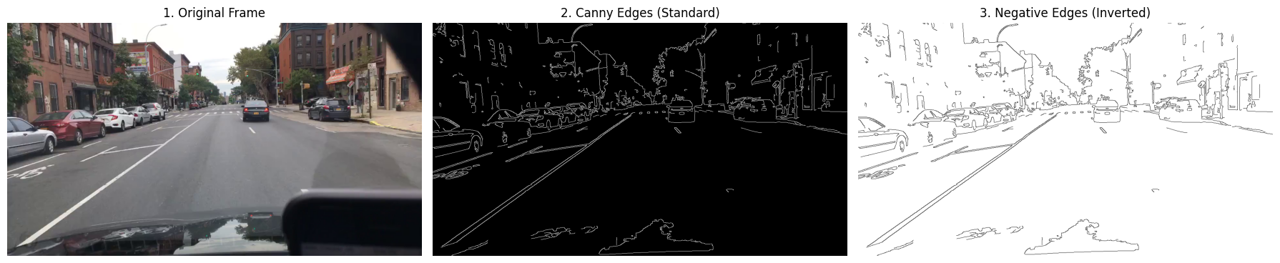
import cv2
import numpy as np
import matplotlib.pyplot as plt
# 1. Load the video and grab one frame
video_path = '/kaggle/input/datasets/krithanaa/carvideo/026c7465-309f6d33.mp4'
cap = cv2.VideoCapture(video_path)
ret, frame = cap.read()
cap.release()
if ret:
# 2. Process for Canny
gray = cv2.cvtColor(frame, cv2.COLOR_BGR2GRAY)
edges = cv2.Canny(gray, 100, 200)
# 3. Create the "Negative" (Inverted) pixels
# This turns the 255 (white) edges into 0 (black) and 0 background into 255 (white)
negative_edges = cv2.bitwise_not(edges)
# 4. Display the Results
plt.figure(figsize=(20, 10))
# Standard Canny (White lines on Black)
plt.subplot(1, 3, 1)
plt.imshow(edges, cmap='gray')
plt.title("Standard Canny (Edges = 255)")
plt.axis('off')
# Negative Canny (Black lines on White)
plt.subplot(1, 3, 2)
plt.imshow(negative_edges, cmap='gray')
plt.title("Negative Canny (Edges = 0)")
plt.axis('off')
# Printing a small matrix sample to show the "Negative" pixel values
print("Sample Matrix of Negative Canny (Top 5x5):")
print(negative_edges[0:5, 0:5])
# Overlay: Show original color only where edges are
edge_colors = cv2.bitwise_and(frame, frame, mask=edges)
plt.subplot(1, 3, 3)
plt.imshow(cv2.cvtColor(edge_colors, cv2.COLOR_BGR2RGB))
plt.title("Original Pixels on Edge Mask")
plt.axis('off')
plt.show()
else:
print("Could not find the video file.")
Sample Matrix of Negative Canny (Top 5x5):
[[255 255 255 255 255]
[255 255 255 255 255]
[255 255 255 255 255]
[255 255 255 255 255]
[255 255 255 255 255]]
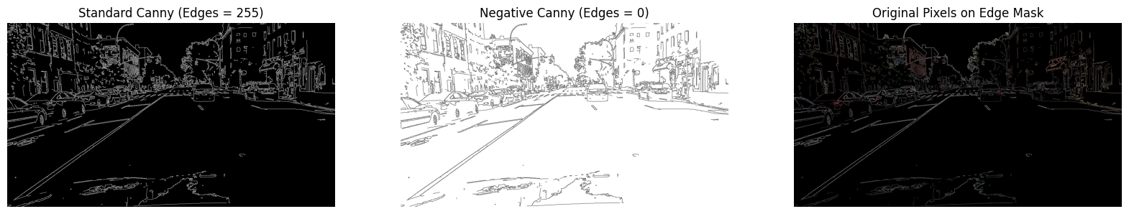
Negative Pixel = 255 - Original Pixel
- The Matrix Transformation If you look at the raw data (the numbers), here is what happens to the pixels: Feature Standard Canny Negative (Inverted) Canny Detected Edges Value: 255 (High Intensity) Value: 0 (No Intensity) Empty Space Value: 0 (No Intensity) Value: 255 (High Intensity)
- Why use Negative Pixels? Visual Clarity: In a car video, the standard Canny shows thin white lines on a black screen. A negative shows black outlines on a white background, which looks like a pencil sketch. This is often easier for human eyes to track lane markings and car shapes. Masking: If you want to "remove" the edges from a color video, you use the Negative Canny as a mask. Since the edges are now 0, multiplying the original frame by this mask "erases" the edges and leaves the rest of the image intact.
- How the Computer "Sees" It If you print the matrix of a Negative Canny frame, you will see a sea of 255s (the white background) with occasional 0s (the black edges of the car).

