Edge Intelligence
25MML0054
Krithana.A
Working with Edge Impulse.
1.Click Data Acquisition: Navigate to the section of Data Acquisition ,and choose the option to connect device for data collection,select the mobile phone option and scan the displayed QR code using your phone and establish connection.
2.Once connected, the mobile phone camera act as a input device.Now, capture the images under different angle to improve model robustness.
3.Collect images for training and testing:Capture a sufficient number of images and split them into training and testing datasets for proper model evaluation.
4.Rename images with meaning names but its not necessary. It works without renaming.
5.Label the images correctly:Apply accurate label to each image ,it is very important ,so the model can correctly learn and distinguish between different classes.
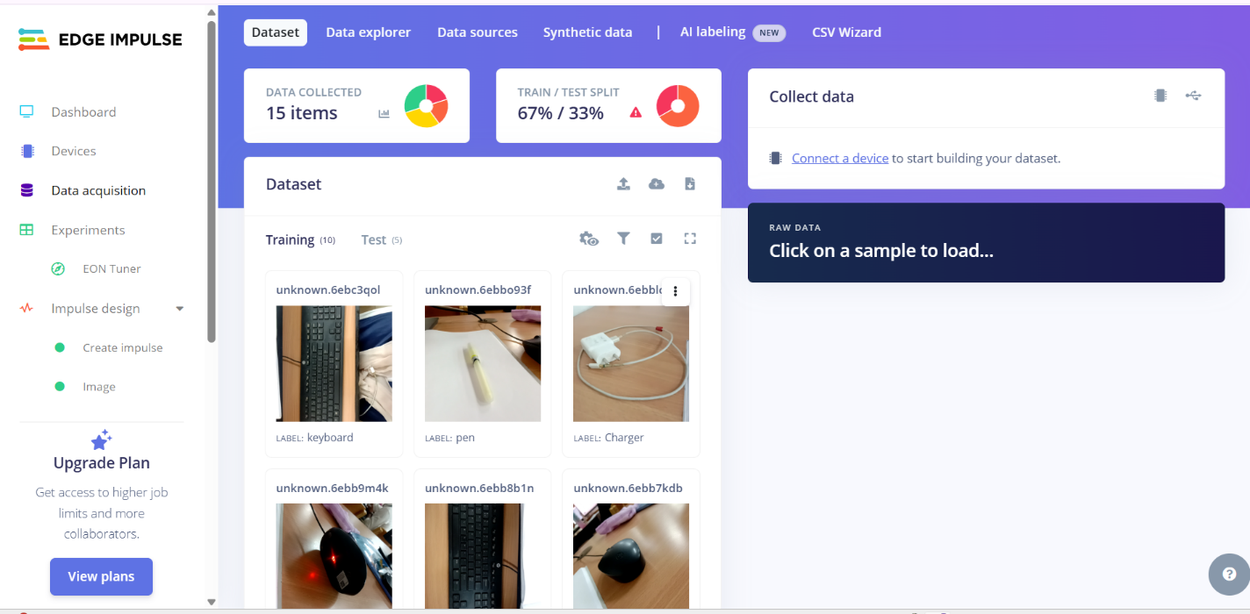

6.Impulse design: Navigate to impulse design and click create impulse.click “Add a processing block”and select image processing block to convert raw image data into features suitable for learning.
7.Add a Learning block: In learning block choose the image classification learning block to enable the system to classify images into predefined categories. If needed choose Transfer learning block or Object detection block. Atlast Save impulse.
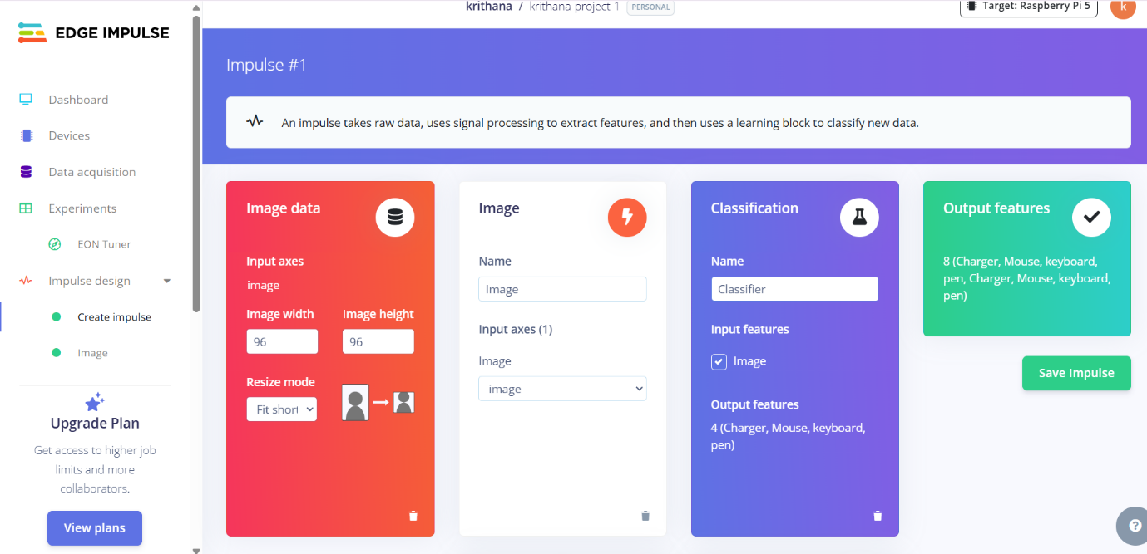
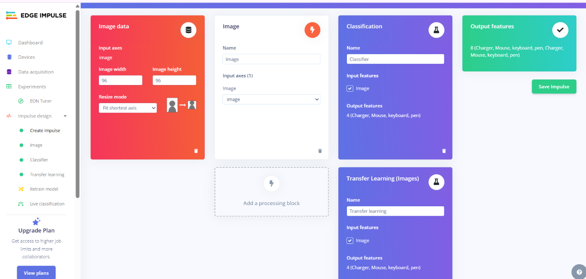8.In Impulse Design,click on image.open the image processing page to configure parameters such as image size and color depth.Click on Generate Features to extract image features.
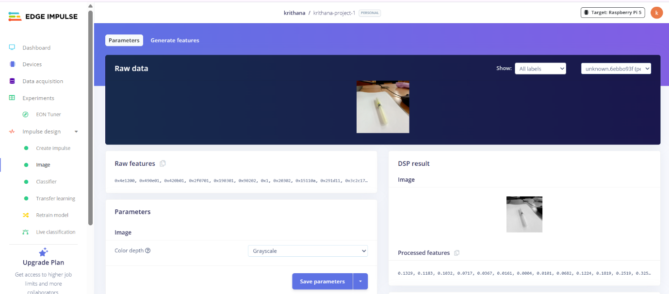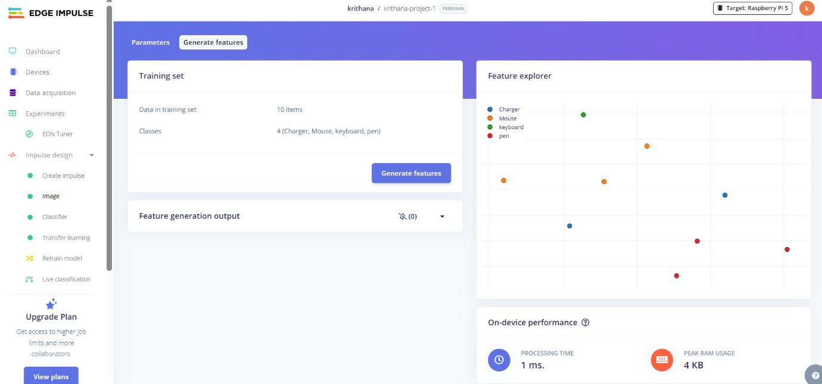9.Now navigate to classifier and prepare the model for traing using the extracted features.And start traing the process,once it finished,the model accuracy is displayed for the uploaded images.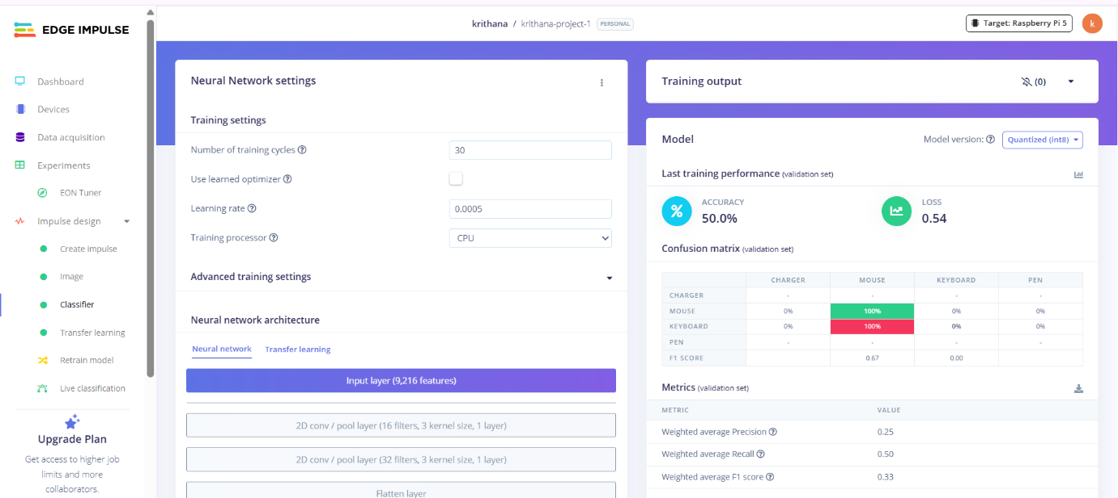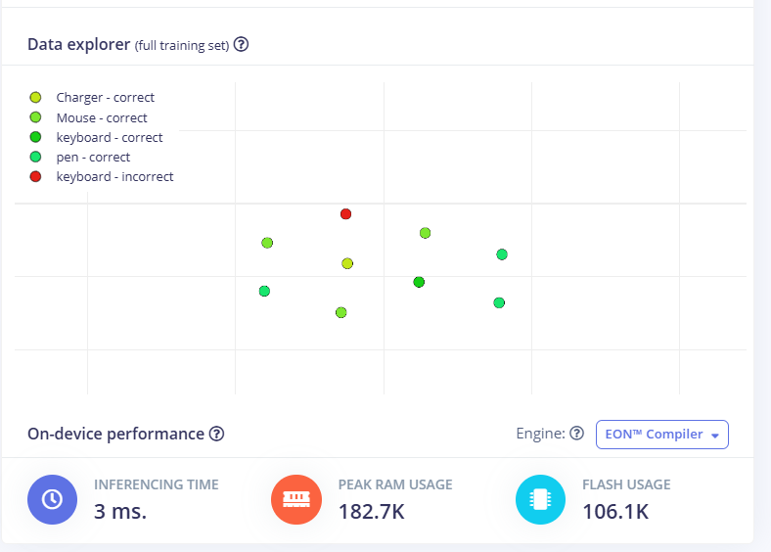10.Navigate to Transfer learning and done as like in Classifier.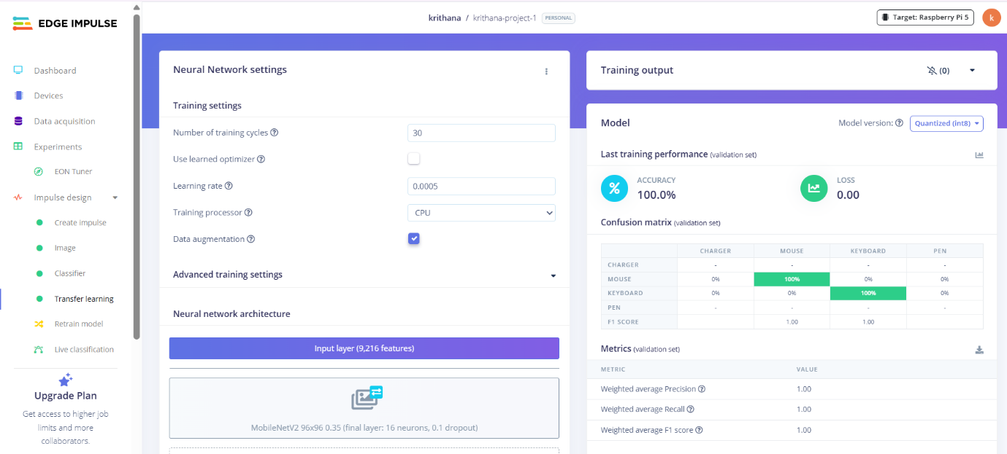11.Test the model with Live Classification.