Aim:

Write a Python program (function) to print a single string from two set of strings received from user and swap the first two characters of each string.

Program:

def convert(s):

new=""

for x in s:

new+=x

return new

o=input()

p=input()

s1=o.strip()

s2=p.strip()

if(len(s1)>=2 and len(s2)>=2):

a1=list(s1)

a2=list(s2)

c1=a1[0]

c2=a1[1]

a1[0]=a2[0]

a1[1]=a2[1]

a2[0]=c1

a2[1]=c2

s1=convert(a1)

s2=convert(a2)

print(s1," ",s2)

else:

print("Invalid")

Link: <http://103.53.53.18/mod/vpl/forms/edit.php?id=234&userid=1680#>

Output:

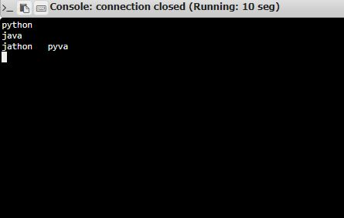

Result:

Thus the Python program (function) to print a single string from two set of strings received from user and swap the first two characters of each string is written and the Output is taken and verified