REGNO:1518102062

DATE:13.10.2020

EXNO:5

AIM:

To write a Python function to print missing characters to make string pangram.

PROGRAM:

a=input()

a=set(a.strip())

a.remove(chr(32))

b="abcdefghijklmnopqrstuvwxyz"

b=set(b)

b=b.difference(a)

b=list(b)

b.sort()

print("".join(b))

Link: [http://103.53.53.18/mod/vpl/forms/edit.php?id=235&userid=1680#](http://103.53.53.18/mod/vpl/forms/edit.php?id=235&userid=1680)

Output:

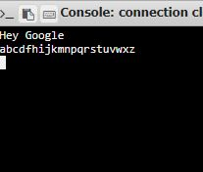

Result: Thus the Program is Executed and the missing letters were printed