

**AUTOMOTIVE ELECTRONICS (20ECE32)**

**Mini Project Report on**

**“BREAK FAILURE INDICATOR WITH**

**SPEED LIMITER”**

**Submitted by**

|  |  |
| --- | --- |
| Student name | USN |
| Krithik K | 4NM20EC051 |
| Manna Mohammed Zishan | 4NM20EC055 |
| Padmashree P.V | 4NM20EC065 |

**DEPARTMENT OF ELECTRONICS & COMMUNICATION ENGINEERING**

**2022-2023**

**TABLE OF CONTENT**

|  |  |  |
| --- | --- | --- |
| 1. | Introduction | 3 |
| 2. | Block diagram | 4 |
| 3. | Software | 5 |
| 4. | System Implementation | 6 |
| 5.  6.  7. | Advantages and Disadvantages  Simulation Results  Simulation Link | 7  9  9 |
|  | References | 10 |

**INTRODUCTION**

One of the safety features that has been implemented in the vehicle is a brake failure indicator with a speed limiter. This feature is designed to prevent accidents caused by brake failures, particularly in heavy vehicles such as trucks and buses, where the weight and momentum of the vehicle can cause catastrophic consequences. The brake failure indicator constantly monitors the hydraulic pressure in the brake system and alerts the driver if there is a problem. This can be in the form of a warning light on the dashboard or an audible alarm. If the brake failure indicator is triggered, the speed limiter engages to restrict the vehicle’s maximum speed to a safe level. In the event of a brake failure, this safety feature can reduce the speed of the vehicle to prevent accidents and save lives.

The speed limiter can also be adjusted to different speeds depending on the type of vehicle and the driving conditions. Overall, the brake failure indicator with a speed limiter is an essential safety feature that can prevent accidents and save lives on the road.

**BLOCK DIAGRAM**

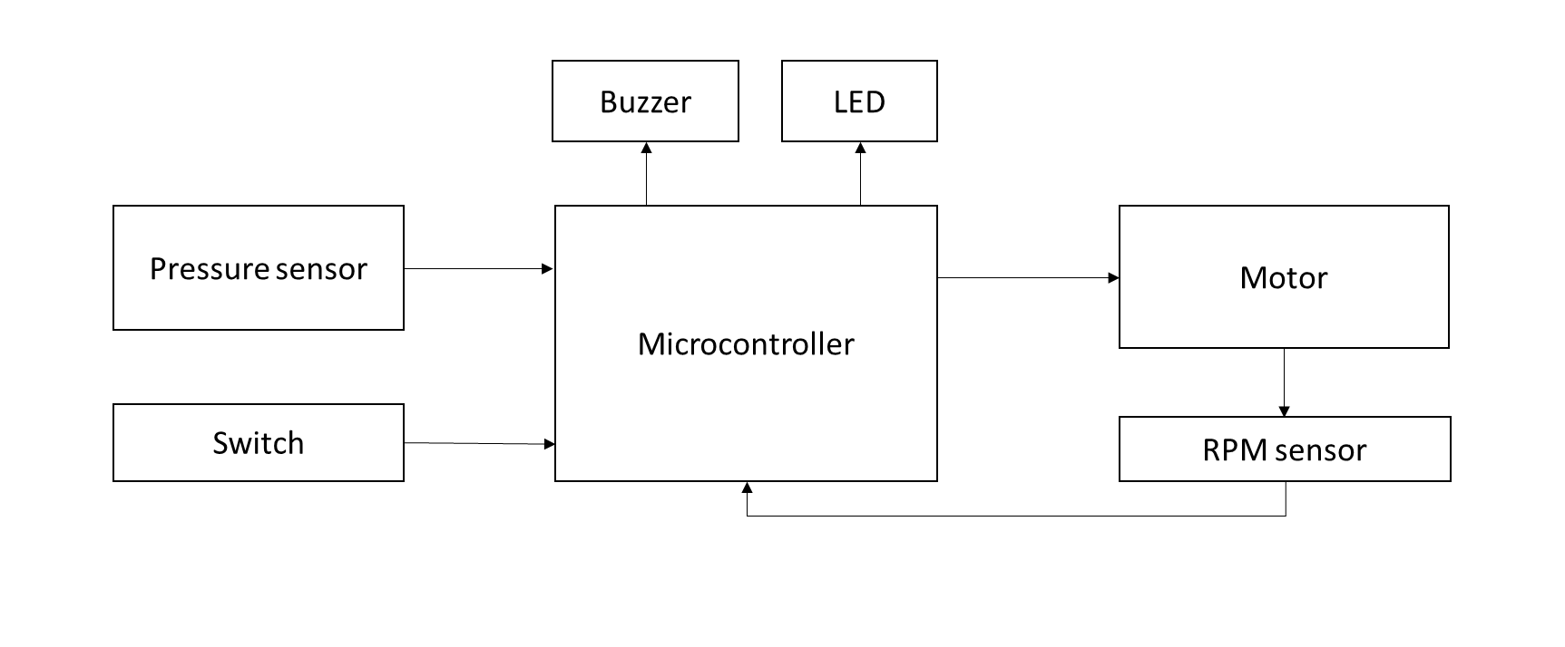 Fig. 1 Block diagram of brake failure indicator system with extended speed limiter

**SOFTWARE**

TinkerCad

Tinkercad is a web-based software tool primarily used for 3D modeling and design. This is simulation software that can be used for modeling and simulating the implementation of a brake failure indicator with an extended speed limiter.

**SYSTEM IMPLEMENTATION**

* Sensor Integration: The system begins with the installation of sensors to monitor the hydraulic pressure in the brake system. These sensors can be connected to the vehicle's electronic control unit (ECU) or a dedicated control module.
* Data Processing and Analysis: The sensor data is processed and analyzed by the control module or ECU to detect any abnormalities or indications of brake failure. Algorithms and logic are implemented to interpret the sensor data and determine if a brake failure is occurring.
* Warning Indicator: Upon detecting a brake failure, the system activates a warning indicator to alert the driver. This can be in the form of a dashboard warning light, an audible alarm, or a combination of both. The warning indicator should be clearly visible or audible to ensure the driver can quickly respond to the situation.
* Speed Limiter Activation: In conjunction with the brake failure warning, the system engages the extended speed limiter functionality. This involves limiting the vehicle's maximum speed to a safe level. The speed limiter can be achieved through engine control, fuel delivery, or electronic throttle control, depending on the vehicle's architecture.

**ADVANTAGES**

* Enhanced Safety: The extended speed limiter provides an additional layer of safety by further restricting the maximum speed of the vehicle in the event of a brake failure. This helps to mitigate the risks associated with brake system malfunctions, reducing the likelihood of accidents and potential injuries.
* Increased Reaction Time: By promptly alerting the driver to a brake failure, the brake failure indicator allows for quicker response and corrective action. The extended speed limiter gives the driver more time to assess the situation, potentially preventing panic and enabling them to apply alternative braking techniques or maneuvers to bring the vehicle to a safe stop.
* Improved Control: The extended speed limiter ensures that the vehicle remains within a safe speed range after a brake failure. This helps the driver maintain better control over the vehicle and reduces the chances of skidding or losing stability, particularly in situations where sudden braking is necessary.
* Tailored Adaptability: The extended speed limiter can be customized to suit specific vehicle types, driving conditions, or regulatory requirements. This adaptability allows for fine-tuning the speed restrictions to optimize safety based on factors such as vehicle weight, load, or environmental conditions.
* Preventative Maintenance: Some brake failure indicator models with extended speed limiters can provide diagnostic information and alerts related to the brake system's health. This feature allows for proactive maintenance, enabling early detection of potential issues and prompt servicing, reducing the risk of brake failures in the first place.

**DISADVANTAGES**

* False Alarms: There is a possibility of false alarms with the brake failure indicator, where it may indicate a brake failure when there is no actual issue with the braking system. This can lead to unnecessary panic and potentially distract the driver from focusing on the road.
* Over-Reliance on Technology: Drivers may become overly reliant on the technology of the brake failure indicator with an extended speed limiter. This can lead to complacency and reduced vigilance, as they may assume that the system will always detect and prevent brake failures. It is crucial to maintain driver awareness and readiness to respond in case of emergency situations.
* Limited Effectiveness at High Speeds: While the speed limiter is effective in reducing the speed of the vehicle after a brake failure, it may have limitations in high-speed scenarios. The reduced speed may still be too fast to safely control the vehicle, especially on highways or in situations where sudden stops are required.
* Dependency on Proper Maintenance: The brake failure indicator model with an extended speed limiter relies on regular maintenance and calibration to function correctly. Neglecting maintenance or failing to address any issues promptly could lead to the system not operating as intended, reducing its effectiveness.
* Cost Considerations: Implementing a brake failure indicator model with an extended speed limiter may increase the cost of the vehicle. The installation, maintenance, and periodic system checks may involve additional expenses, which can be a disadvantage for budget-conscious buyers.

**SIMULATION RESULTS**



**SIMULATION LINK**

**https://www.tinkercad.com/things/btepH7a4s0l-automotiveproject/editel?sharecode=810sk4a-TLt-8cwSOnjScomLtlh2Cw9vBEx3LBoDzdg**

**REFERENCES**

1. https://www.researchgate.net/publication/341407743_Rahman_et_al2016.
2. https://www.researchgate.net/publication/337608535_Li_et_al_2018_JOB
3. “Design and Development of a Brake Failure Indicator with Extended Speed Limiter System" by P. C. Nagaraja and V. V. Rao(Research paper)
4. Development of a Brake Failure Indicator System with Speed Limiter for Passenger Cars" by S. M. Farukuzzaman, M. M. Islam, and M. S. Hossain.(Research paper)