OFFICE CARE:

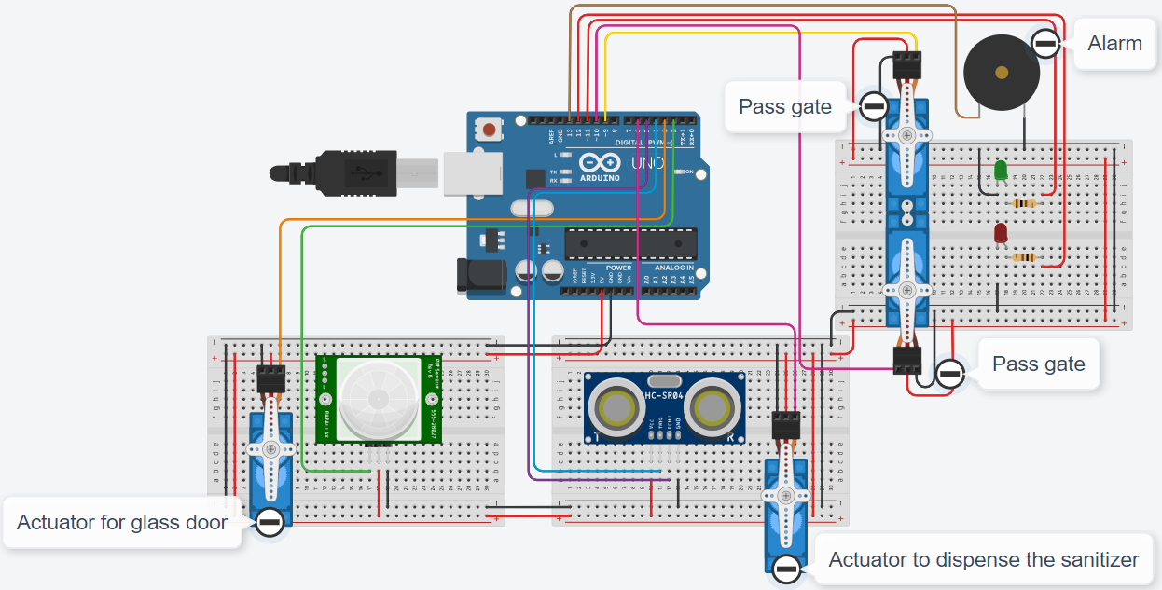

SIMULATION CIRCUIT