LAB 1 :

Q1) Setup the spring boot application and print the hello world message

soln:

Go to spring boot, add all the required dependencies under maven

Generate and extract the zip file and add to a folder on the PC

Go to eclipse ->file->import->browse for the zip file->open src/main/java->go to MyProjectApplication.java file and run it

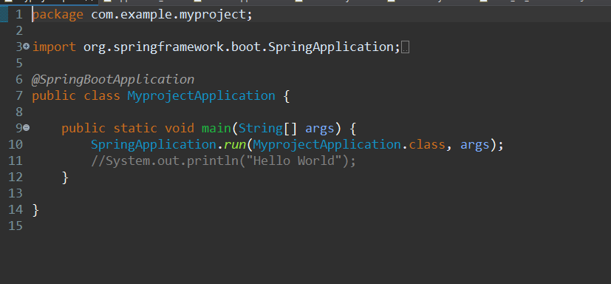

Create a new class named controller

And the run the following code

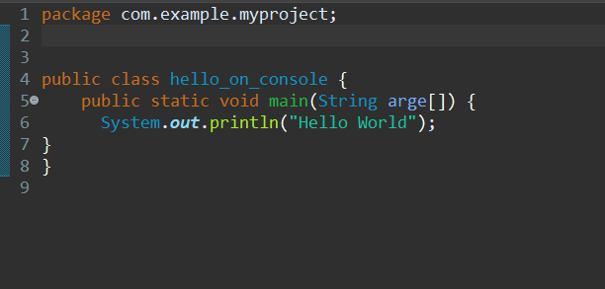

Console output:

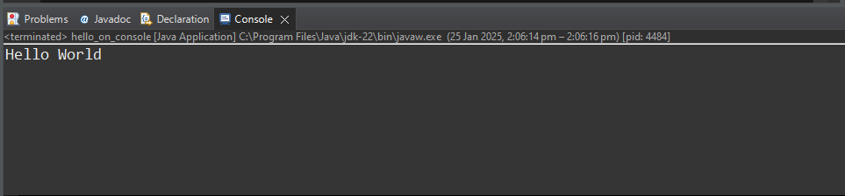

Q2) Setup the spring boot application with hello world message in separate package named controller

Go to spring boot, add dependencies under maven as spring web

Generate and extract the zip file and add to a folder on the PC

Go to eclipse ->file->import->browse for the zip file->open src/main/java->go to controller.java

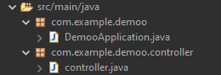

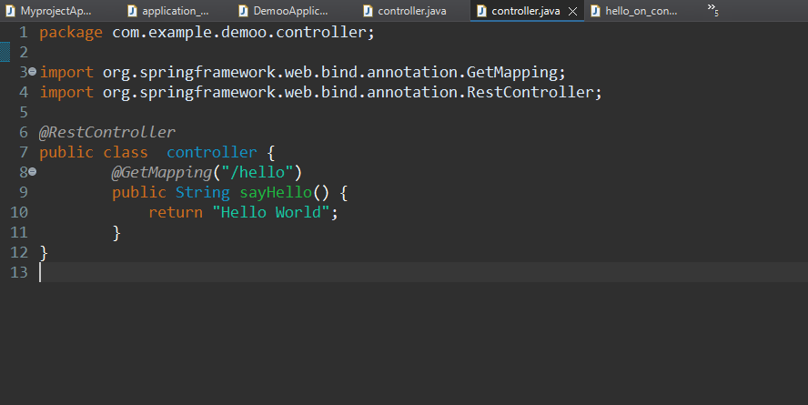

Create a new class called controller .

Go to local host -> [http://:localhost:8080/hello](NULL)

You will get this on the output

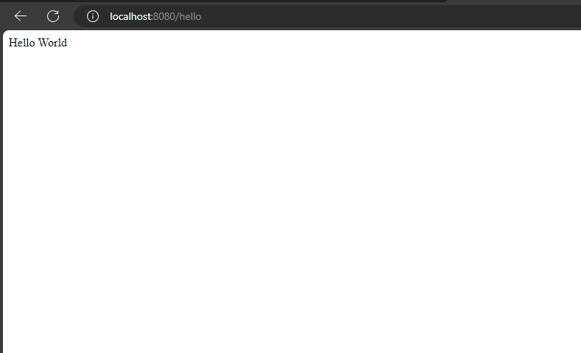

Q3) Test the above application in POSTMAN

Run your application and controller then add the open postman and under get add the [http://:localhost:8080/hello](NULL)

You will get hello wold in your body

