**Task:** To run GUI application on Docker

Let’s see how Firefox application can be run in docker like the native application.

🡪Let’s check the internet connectivity by pinging to google

#ping goo.gle

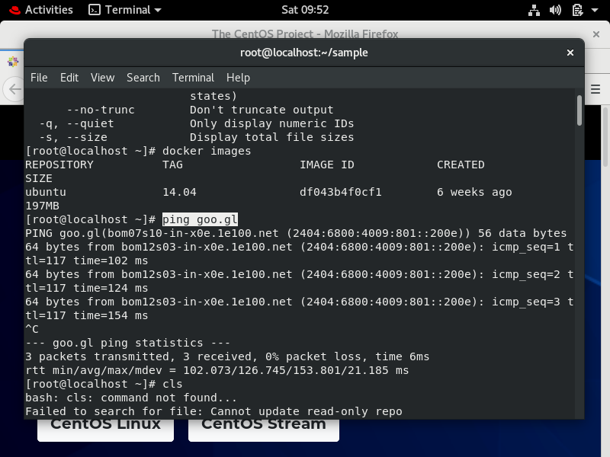

* Restarting docker services

#systemctl restart docker

In my case docker is already enabled, let’s see if it’s running or not.

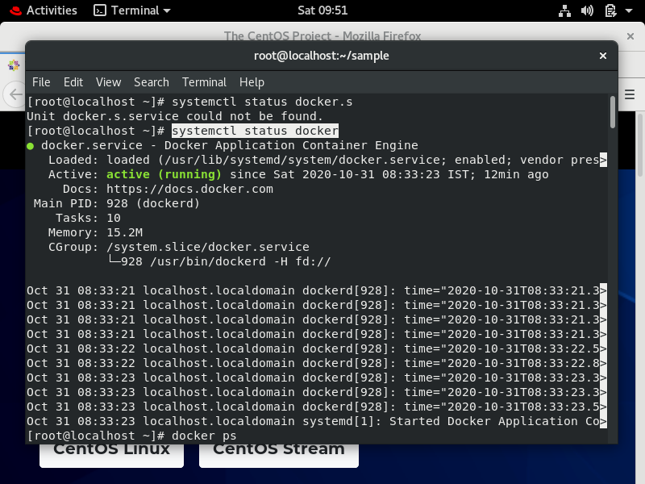

* Let’s check what all images we have.

#docker images

We only have Ubuntu.14.04 image

* Let’s pull centos 7 image

#docker pull centos:7

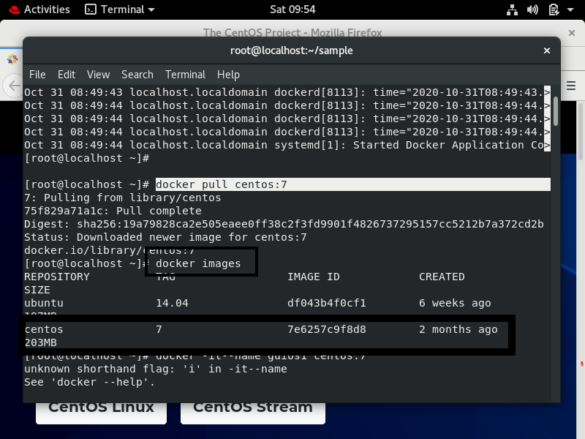

* Now let’s run the os of centos

#docker run –it centos:7

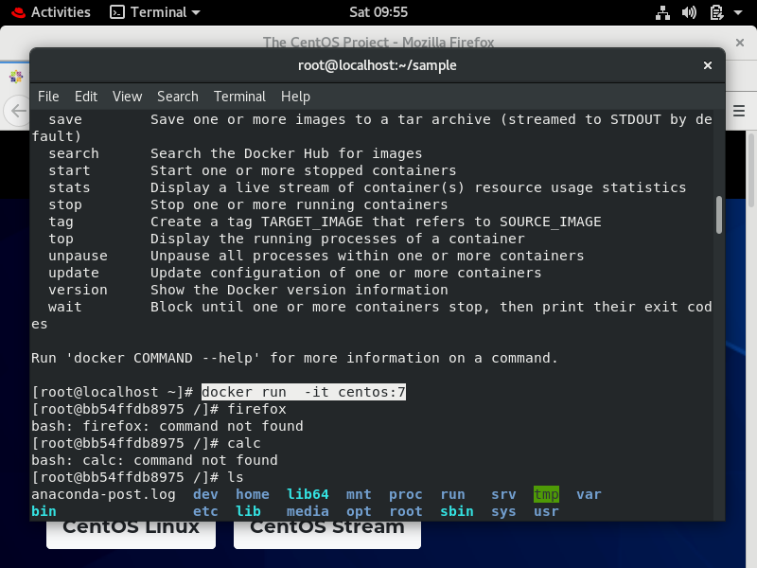

* Let’s install firefox and check if this GUI app is running or not.

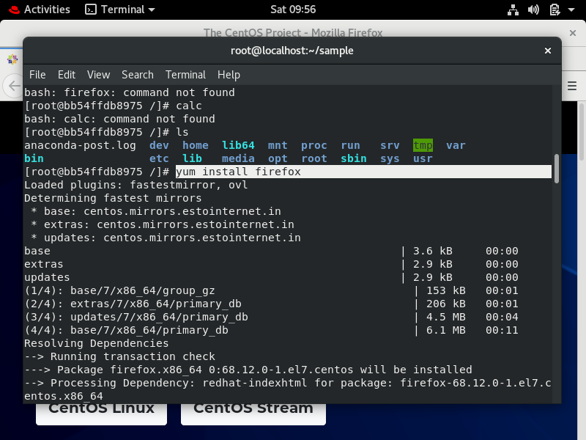

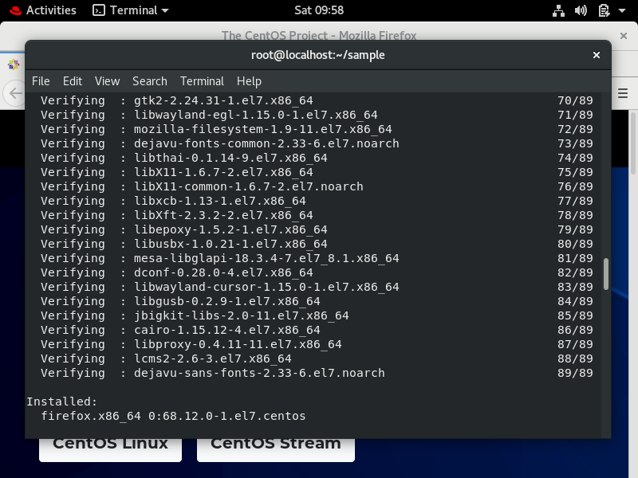

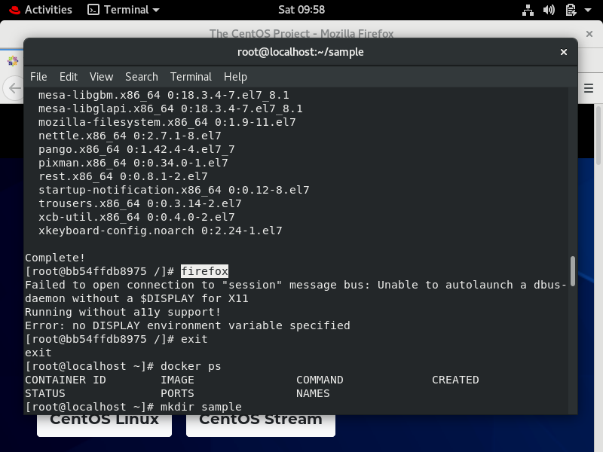

Firefox cannot run, it displays an error showing “ no DISPLAY environment variable specified”.

🡪Now after exiting docker, let’s create a named sample, and in that let’s create a file named “dockerfile” and put these 3 lines in it.

FROM centos:7

RUN yum install firefox –y

CMD [“/usr/bin/firefox”]

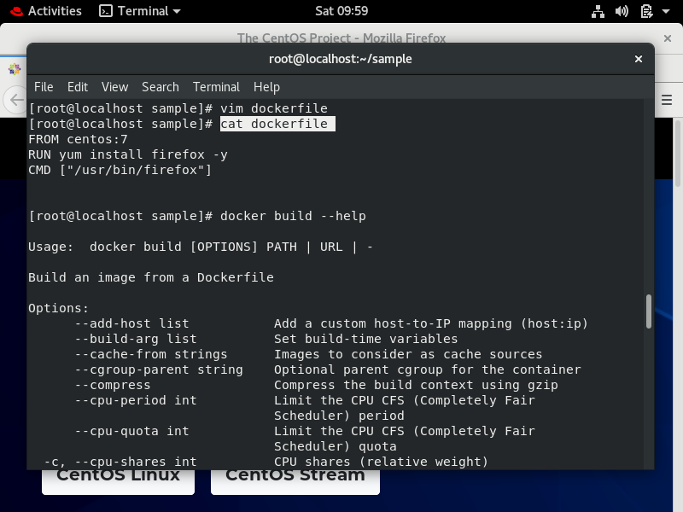

🡪Now let’s build n tag the file as firefox

#docker build –t firefox .

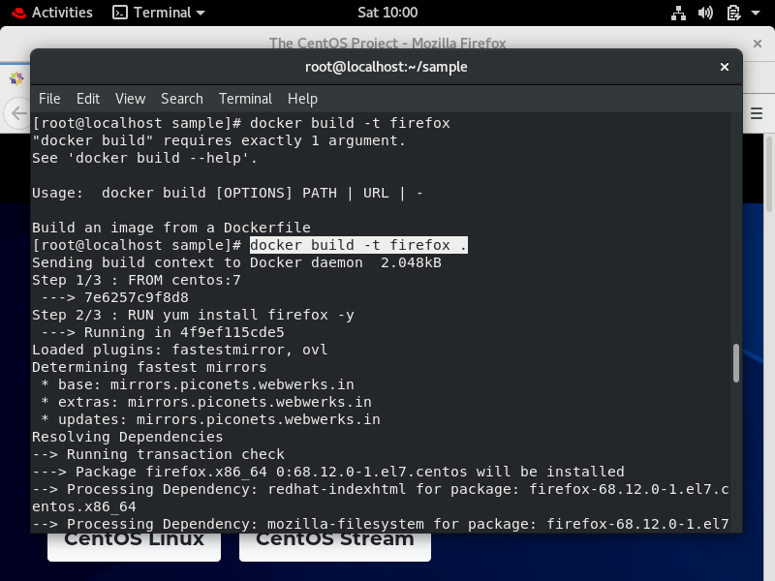

-->Now let’s check images :

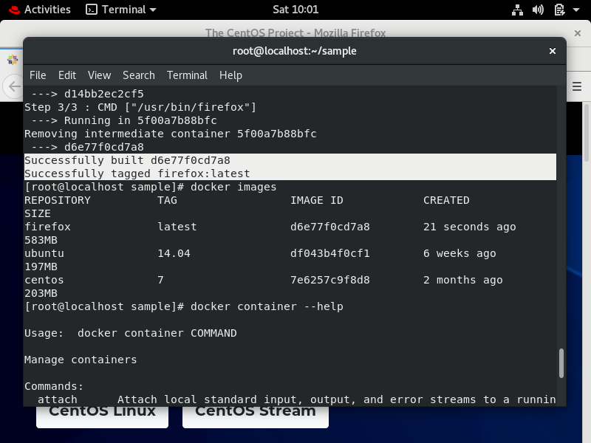

-->setting DISPLAY environment

#docker container run –it –env=”DISPLAY” --net=host firefox

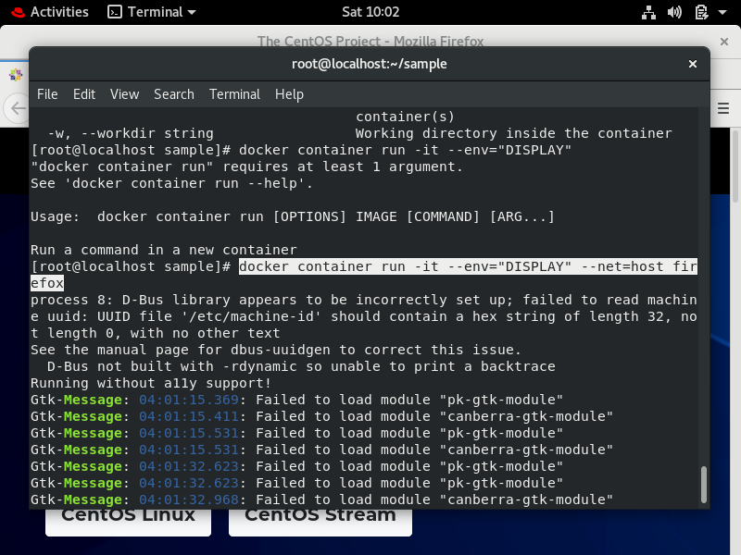

Firefox is now opened as the native application!!

