NAME: KRITHIKA U
SRN: PES2UG25CS265

NAME: ISHITA SARAWAGI
SRN: PES2UG25CS221

NAME: JAFFAR SADIQ M
SRN: PES2UG25CS225

SECTION: D

PROBLEM STATEMENT:

QOS Traffic Management System
Develop a UDP-based application that generates different classes of traffic and uses SDN to dynamically prioritize selected flows during network congestion.

Generate multiple UDP traffic classes
Classify different application flows
Implement SDN-based priority policies
Create controlled congestion
Measure throughput, latency and packet loss
Analyze fairness between traffic classes
Dynamically modify traffic policies -UDP

OVERVIEW

The project addresses the problem of managing different types of network traffic that share limited network resources. Voice, video, and bulk data traffic have different performance requirements. When these traffic types compete for network resources, congestion can cause increased latency, packet loss, and reduced throughput.

The proposed QoS Traffic Management System classifies traffic into three categories—voice, video, and bulk—and applies separate packet queues and weighted scheduling at the receiving server. It also uses an SDN controller to manage traffic-specific forwarding rules dynamically.
- Develop UDP client-server communication using Python socket programming.
- Generate voice, video, and bulk traffic from multiple network hosts.
- Classify packets using traffic identifiers and UDP destination ports.
- Maintain separate queues for each traffic class.
- Apply weighted packet scheduling at the server.
- Create a virtual network using Mininet and Open vSwitch.
- Integrate the network with the Ryu SDN controller.
- Dynamically update traffic policies and OpenFlow rule priorities.
- Evaluate throughput, latency, packet loss and fairness

System architecture
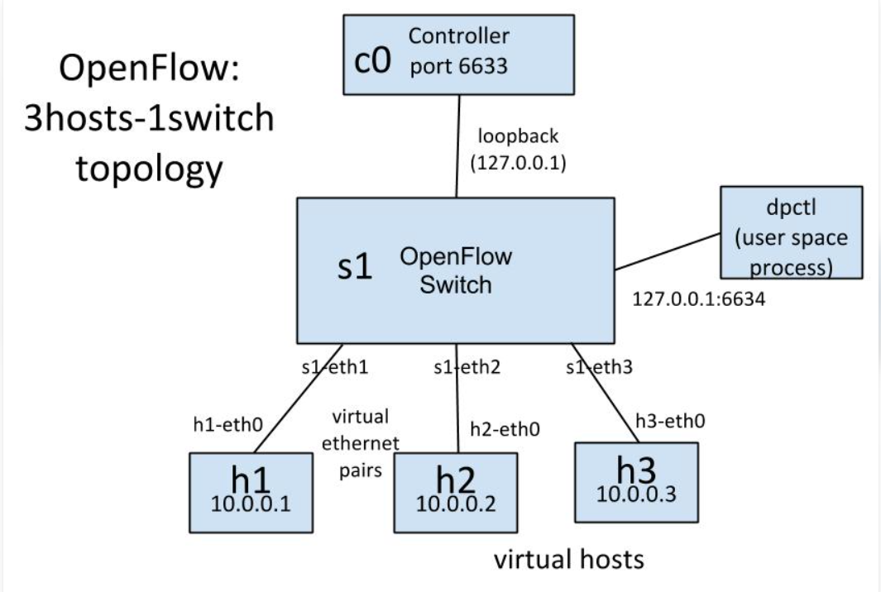

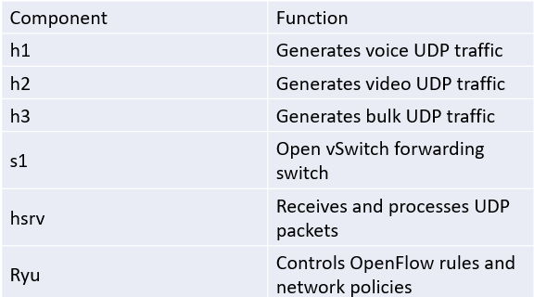

COMMUNICATION FLOW
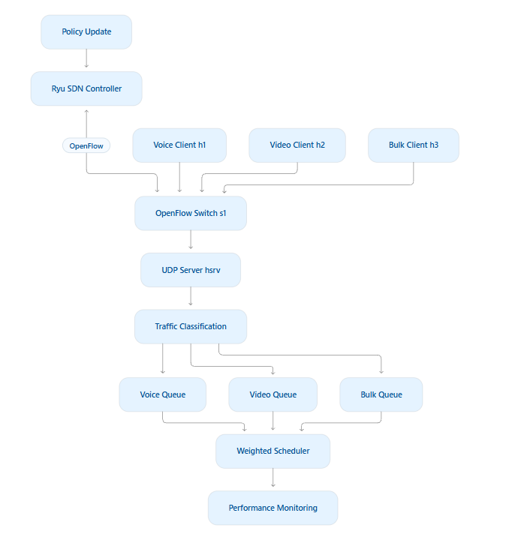
- Each client generates UDP packets belonging to its assigned traffic class.
- Packets are transmitted through the Mininet network.
- The Open vSwitch forwards packets according to installed OpenFlow rules.
- The server validates packet headers and identifies traffic classes.
- Packets are placed into their corresponding queues.
- The weighted scheduler selects packets for processing.
- The server records performance measurements.
- The Ryu controller accepts policy updates and modifies the corresponding flow priorities.

IMPLEMENTATION AND RESULTS
Components used:
Docker container, Ryu SDN controller, Mininet network emulator, and UDP traffic generators,
1. Container Management & Environment Setup
Checking Docker Containers
Lists all Docker containers on the host machine.
docker ps -a
Starting the QoS Lab Container
Boots up the container named 'qos-lab' which contains all required networking packages, Mininet, Open vSwitch, and Python QoS scripts.
docker start qos-lab
Accessing Container Terminal
Opens an interactive bash terminal session inside the running 'qos-lab' container, allowing you to execute environment commands.
docker exec -it qos-lab bash
Verifying Workspace Directory Contents
Displays all files in the current working directory ‘/app’, confirming the presence of `mininet_qos.py`, `qos_udp.py`, and `ryu_qos_controller.py`
Ls

2. Starting the SDN Controller
Launching the Ryu SDN Controller
Starts the Ryu OpenFlow SDN controller running the custom QoS control logic (`ryu_qos_controller.py`). It initializes a REST API server on port `8080` to manage switch flow rules and queue configurations
ryu-manager ryu_qos_controller.py
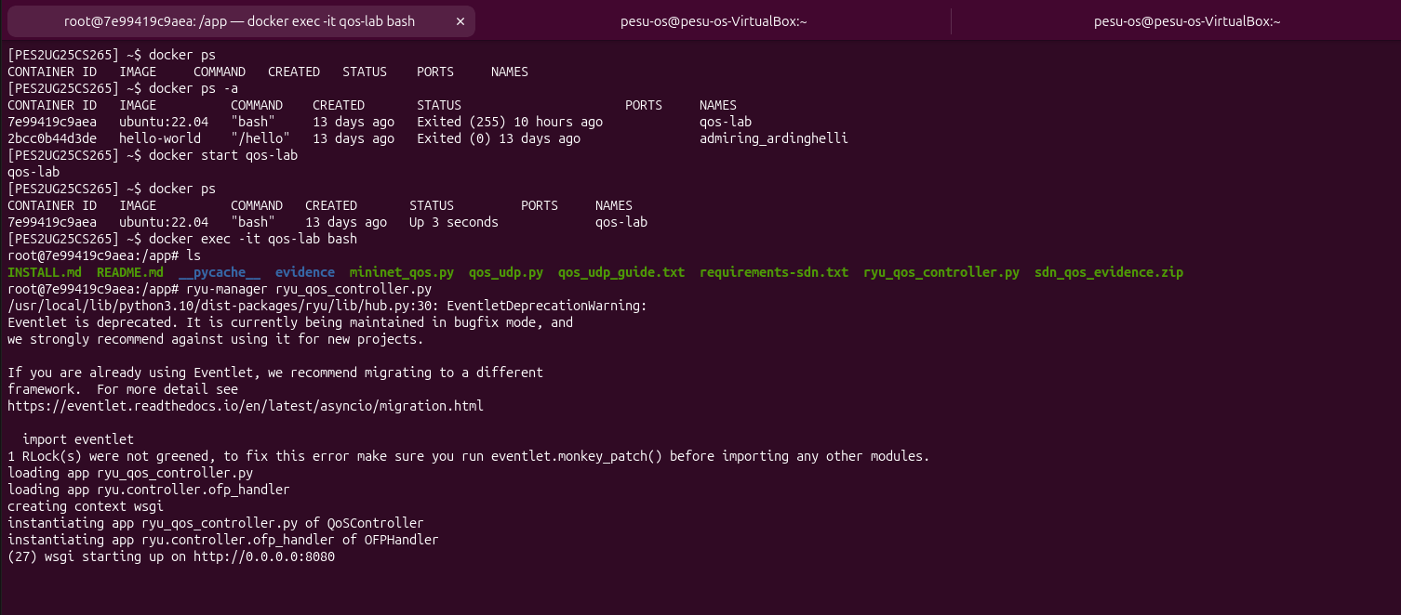
3. Initializing Mininet Topology & Open vSwitch
Starting Open vSwitch Service
Ensures the Open vSwitch daemon (`ovs-vswitchd`) and database server (`ovsdb-server`) are running inside the container.
service openvswitch-switch start
Launching the Mininet Topology
Executes the topology script which builds the virtual network containing hosts (`h1`, `h2`, `h3`), server (`hsrsv`), and OpenFlow switch (`s1`) with configured link bandwidths and delays, starting the Mininet CLI (`mininet’)
python3 mininet_qos.py
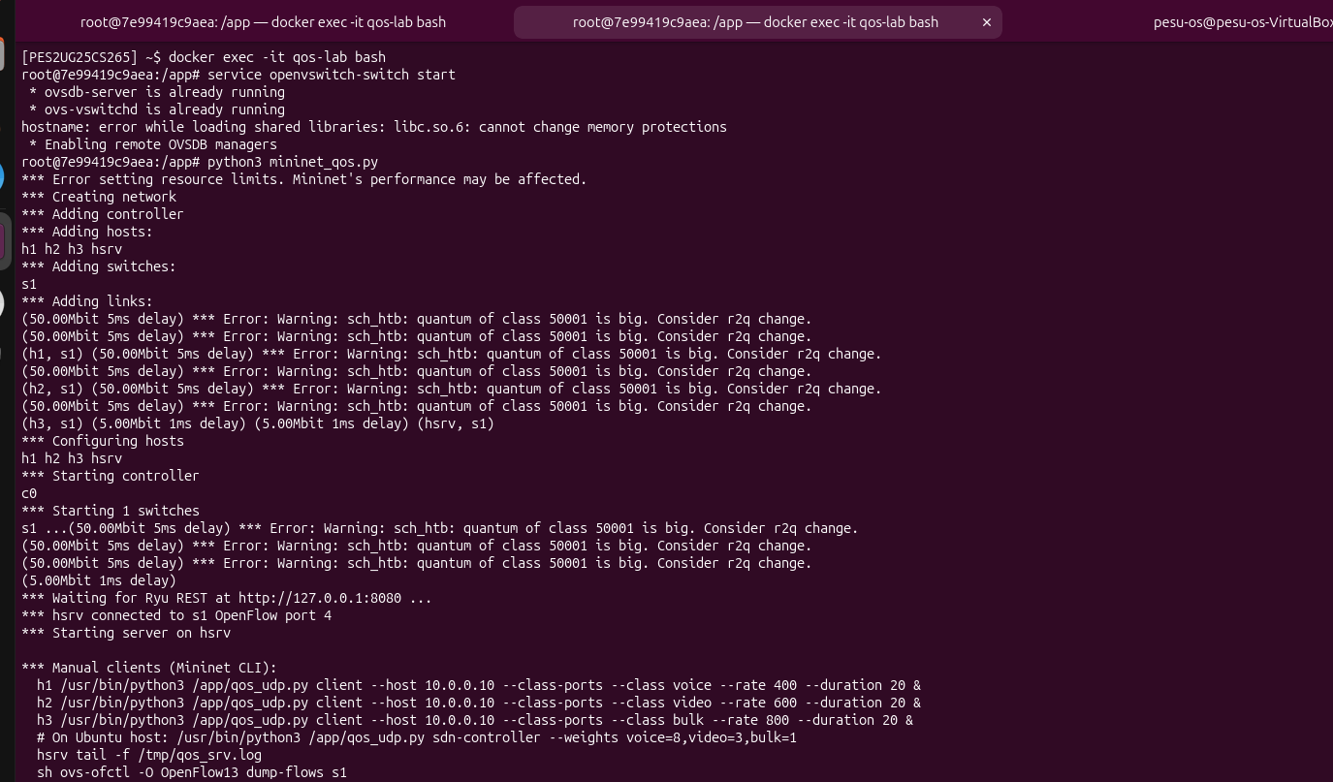
4. Network Verification (Ping Test)
Testing End-to-End Reachability
Tests bi-directional ICMP connectivity across all network nodes in Mininet. A result of 0% packet loss confirms that all host-to-host and host-to-server paths are fully active and correctly connected
mininet> pingall
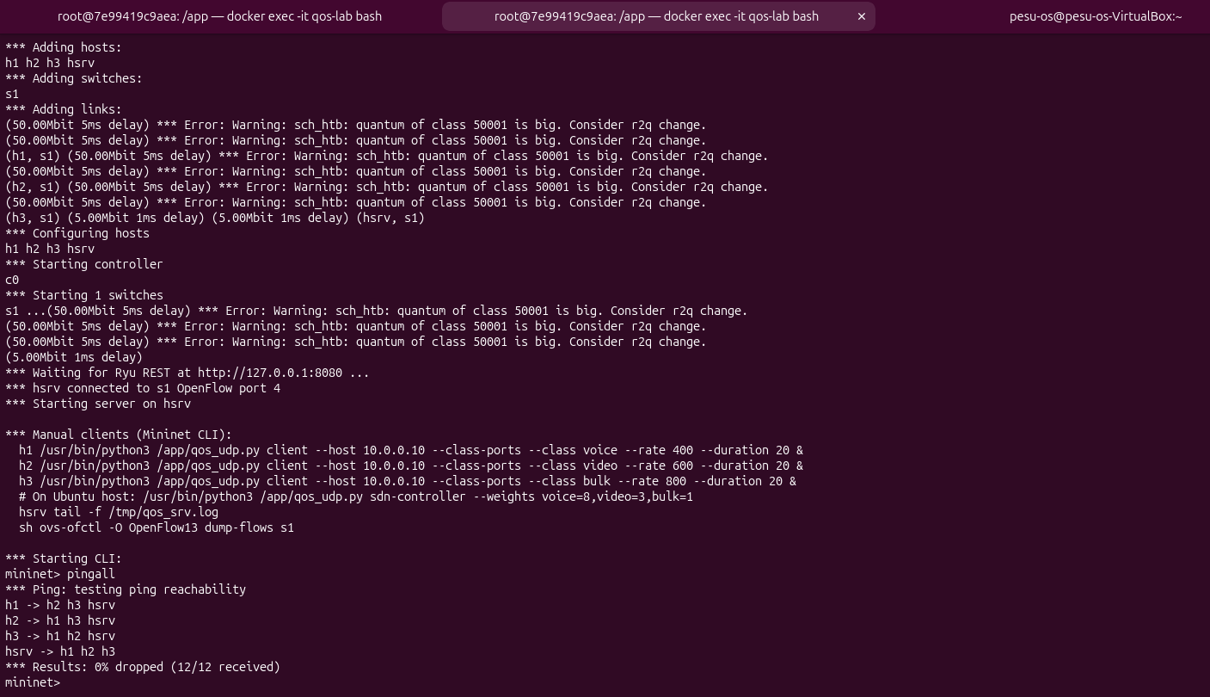
python3 qos_udp.py sdn-controller --weights voice=1,video=1,bulk=1
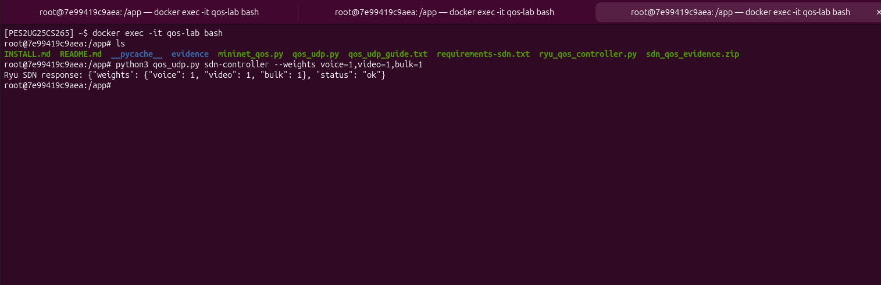
5. Simultaneous Traffic Generation & QoS Testing
Running Concurrent UDP Client Streams
Uses Python's `exec()` and Mininet's non-blocking `sendCmd()` method to launch voice, video, and bulk UDP client streams simultaneously at the exact same millisecond. Each stream runs at a rate of 1200 kbps for 180 seconds, generating controlled network congestion.
py exec("h1.sendCmd('/usr/bin/python3 /app/qos_udp.py client --host 10.0.0.10 --class-ports --class voice --rate 1200 --duration 180'); h2.sendCmd('/usr/bin/python3 /app/qos_udp.py client --host 10.0.0.10 --class-ports --class video --rate 1200 --duration 180'); h3.sendCmd('/usr/bin/python3 /app/qos_udp.py client --host 10.0.0.10 --class-ports --class bulk --rate 1200 --duration 180')")
Monitoring Live Server Metrics
Tails the QoS server log file on the receiver host (`hsrsv`) in real-time. This displays live throughput, packet drop counts, and the Jain fairness index as traffic is processed.
hsrv tail -f /tmp/qos_srv.log

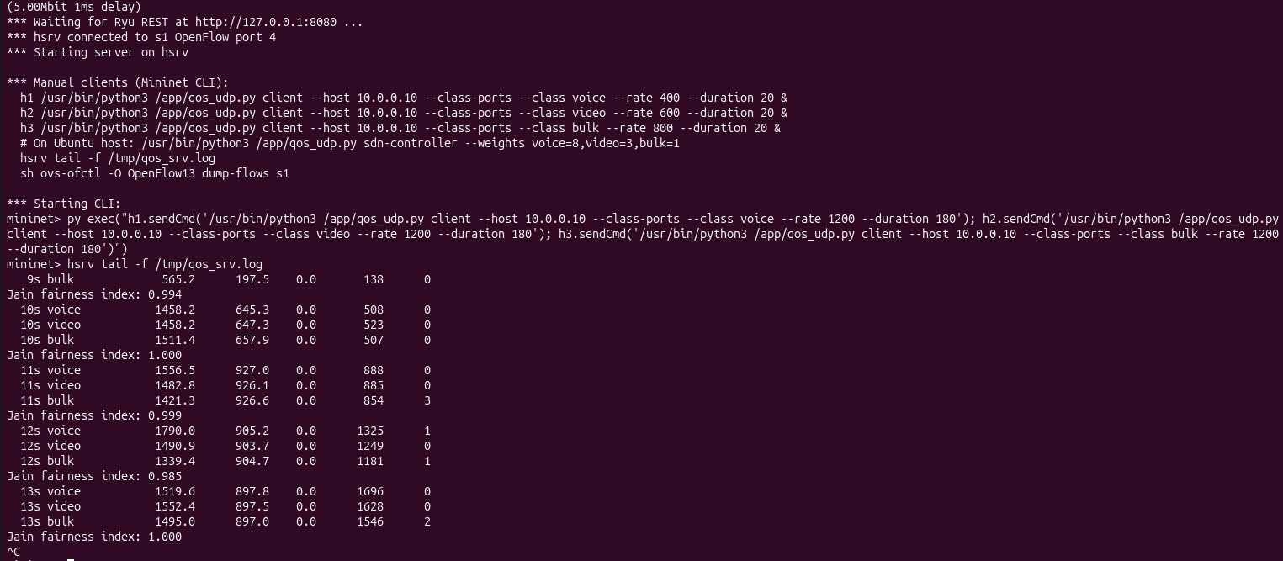
6. Dynamic Weight Modification & Policy Enforcement
Updating SDN Controller QoS Weights
Sends a REST API request to the running Ryu controller to update the queue scheduler weights (`voice=8`, `video=3`, `bulk=1`). This dynamically reconfigures OpenFlow queue priorities on Open vSwitch to favor high-priority voice and video traffic over bulk data during congestion.
python3 qos_udp.py sdn-controller --weights voice=8,video=3,bulk=1
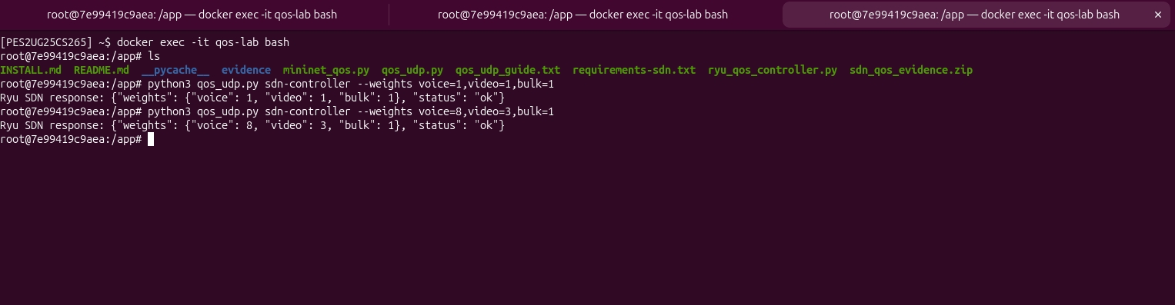

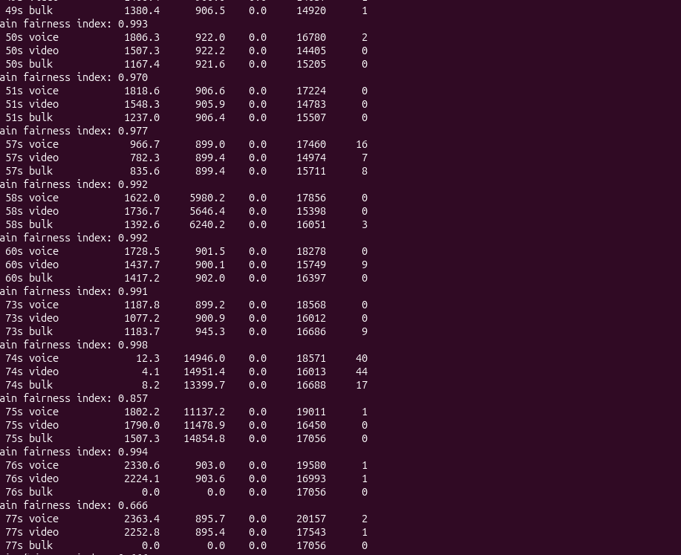

CONCLUSION AND INFERENCES
- End-to-End Connectivity: We first performed pingall to check connectivity between all virtual nodes (h1, h2, h3, and the server hsrsv). This helped us verify packet delivery and identify any packet loss in the network. We got 0 percent packet loss/dropped.
- Congestion Generation: We started multiple UDP client streams simultaneously, each sending data at 1200 kbps. This created congestion on the limited-bandwidth link and helped us test how the system handles heavy traffic.
- Multi-Class Traffic Handling: The server successfully received and identified incoming traffic as voice, video, and bulk data. It then placed each type of traffic into its respective queue based on application headers and destination ports.
- Fairness: Initially, all three traffic classes were assigned equal weights (voice=1, video=1, bulk=1). The Jain's Fairness Index remained consistently high, showing that bandwidth was shared fairly among the competing traffic streams.
- Real-Time Control Using Ryu Controller: We used REST API calls to change the scheduler weights while the network was running. For example, we changed the weights from equal values to voice=8, video=3, and bulk=1 without restarting the network or interrupting traffic.
- Impact of Prioritization: After changing the weights, the Ryu controller updated the OpenFlow queue priorities on the Open vSwitch (s1). This allowed voice and video traffic to receive higher priority than bulk data during congestion.

