CAPSTORE

Krithikaa M(152644)

Keerthi

Sai Krishna

MODULE 15: PRODUCT FEEDBACK

Users can give review on any product after he purchases it. All the users can view the feedback but giving feedback is restricted to those users who are purchasing the product.

Database model:

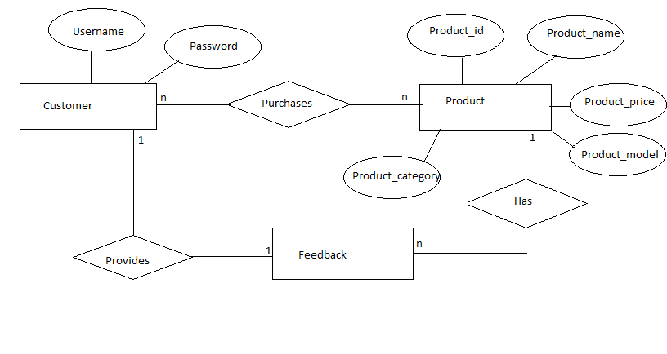

MODULE 16: COMMON FEEDBACK

Users can ask a question to the merchant via admin. This module provides more clarification about a product before user can purchase it. This module is visible to all the users which helps them understand about the product before purchasing it thus giving them more details.

Database model:

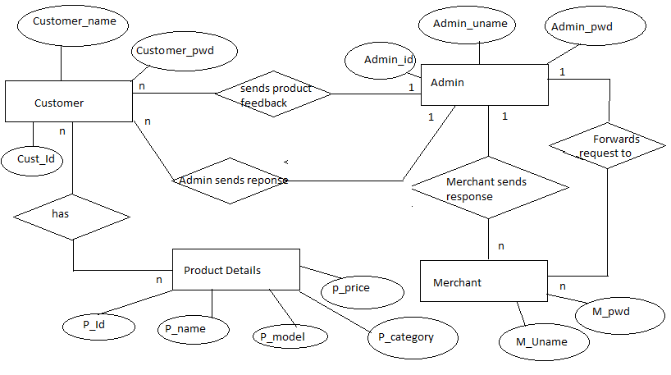

MODULE 17: SEARCH

Search feature allows user to search any product based on their name , brand or category. This feature is available on each and every page allowing users to search on any page.

Database model:

