Software Requirements Specification (SRS) Template

Project: Waste management system in a city like Bangalore
Version: 1.0
Authors: Krithika K, Monika, Khushi Dev
Date: 03-09-2025
Status:

Revision history
Version | Date | Author | Change summary | Approval
1.0 | 3-09-2025 | Krithika K, Monika, Khushi Dev | SRS with diagrams embedded

Approvals
Role | Name | Signature / Email | Date
Course Coordinator

Table of Contents
1. Introduction
2. Overall description
3. External interfaces
4. System features (detailed)
5. Non-functional requirements (detailed)
6. Quality attributes & Acceptance tests
7. UML Use-Case Diagram
8. Requirements Traceability Matrix (RTM)

1. Introduction

1.1 Purpose
This document is a Software Requirements Specification (SRS) for a Waste management system (WMS) in cities like Bangalore. It defines functional and non-functional requirements, interfaces, and verification criteria intended for instructors and students to use as a reference.

1.2 Scope
The system will: Enable citizens to report garbage issues like missed pickup, overflowing bins. Allow municipal authorities (BBMP) to monitor collection trucks, assign routes, and track waste data. Provide analytics on waste generation per ward/zone. Ensure citizens follow waste segregation rules. Excludes: actual physical waste collection; focuses only on software system.
.

1.3 Audience
Team Members: Build, Design the system and test the system.
BBMP Authorities: Use dashboard to manage schedules, complaints, and reports
Citizens: Use mobile/web app to submit complaints, reports, and view schedules
Truck Drivers: Use mobile app to view routes and update collection status.

1.4 Definitions
List of acronyms: BBMP: Bruhat Bengaluru Mahanagara Palike, WMS: Waste Management System, GPS: Global Positioning System, API: Application Programming Interface, UI: User Interface, RTM: Requirements Traceability Matrix, FR: Functional Requirement, NFR: Non-Functional Requirement, RBAC: Role-Based Access Control, TLS: Transport Layer Security.

2. Overall description

2.1 Product perspective
-Citizen-facing mobile/web app for complaints, bin location, and schedule. Admin dashboard for BBMP to track trucks, monitor complaints, and generate reports. GPS integration for trucks

2.2 Major product functions (detailed)
-Complaint registration with location & photo.
-Waste collection schedule tracking.
-Real-time truck monitoring.
-Data analytics and reports.
-Waste Segregation tracking.
-GPS- Based truck monitoring.
-Notifications and alerts.
-Driver task management.
-Citizen feedback and rating.

2.3 User roles and characteristics (expanded)
-Citizen: Reports issues, views schedules.
-BBMP Officer: Assigns trucks with routes, monitors complaints, views reports.
-Truck Driver: Uses assigned routes, Update the status.
-Admin: Manages users, maintains system.

2.4 Operating environment
Web & Mobile Platforms, Network: Requires stable internet connectivity (public/private WAN) for real-time communication between citizens, officers, and drivers. External APIs: Integration with GPS/Maps API for vehicle tracking and Notification services (SMS/email/push)

2.5 Constraints
Government Regulations, Data Privacy, Security Standards,
Scalability Limits, Operational Constraints: Requires periodic server maintenance and database backup to ensure high availability.

3. External interface requirements

3.1 User interfaces
-Citizen app : Simple UI with complaint form, camera integration, View the scheduled calendar.
-BBMP dashboard: Charts (schedule calendar), maps with truck locations, complaint status.

3.2 Hardware interfaces
-GPS modules on trucks.
-Smartphones for citizens and staff.
3.3 Software interfaces
-Google Maps API (location & routes).
-SMS/Email gateway for alerts.
-Database to store complaints, schedules, reports.
-Authentication system for citizens, officers and drivers

3.4 Communications
-Secure REST APIs (HTTPS).
-Real-time updates using Web Sockets/Push notifications.

4. System features (detailed)

4.1 Citizen Function
Description: This section describes the features available to citizens, including reporting complaints, submitting waste collection reports, viewing schedules, receiving notifications, and ensuring segregation compliance.
Req ID | Requirement | Type | Priority | Source/Stakeholder | Acceptance criteria / Test case ref | Comments / Dependencies
WMS-F-001 | The system shall allow citizens to register complaints with photo and GPS location | Functional | High | Citizens / BBMP | AC-WMS-F-001:  A complaint submitted by a citizen appears in the BBMP dashboard with correct location and timestamp.  Test: TC-Comp-01 | Depends on GPS/Maps API and stable mobile network
WMS-F-002 | The system shall allow citizens to submit waste collection reports confirming collection or non-collection. | Functional | High | Citizens | AC-WMS-F-002:  Submitted reports are visible to BBMP officers in the dashboard.  Test :TC-Report-01 | Depends on citizen app usability and backend sync with officer dashboard.
WMS-F-003 | The system shall allow citizens to view waste collection schedules of their ward. | Functional | Medium | Citizens | AC-WMS-F-003:  Citizens can view schedules based on their ward selection.  Test : TC-Schedule-01 | Depends on officer publishing/updating schedules on time.
WMS-F-004 | The system shall record whether citizens supply segregated waste and log it for officer review. | Functional | High | Citizens / BBMP | AC-WMS-F-004:  Segregation compliance appears in BBMP segregation report dashboard.  Test:TC-Seg-01 | Requires citizens to follow segregation rules; officers must verify logs.
WMS-F-005 | The system shall send notifications to citizens for schedule changes, delays, or reminders. | Functional | Medium | Citizens / BBMP | AC-WMS-F-005:  Citizens receive alerts within 1 minute of schedule change.  Test: TC-Notify-01 | Depends on Notification Service

4.2 BBMP Officers Functions
Description: This section defines the functions available to BBMP officers, such as publishing schedules, assigning trucks, monitoring GPS tracking, managing complaints, and generating analytics and segregation reports.

Req ID | Requirement (shall...) | Type | Priority | Source/Stakeholder | Acceptance criteria / Test case ref | Comments / Dependencies
WMS-F-006 | The system shall allow officers to publish and update collection schedules. | Functional | High | BBMP Officers | AC-WMS-F-006:  Updated schedules appear in citizen apps within 5 minutes.  Test: TC-Schedule-02 | Citizen apps depend on timely sync with backend servers.
WMS-F-007 | The system shall allow officers to assign trucks and drivers to wards/zones. | Functional | High | BBMP Officers | AC-WMS-F-007:  Assigned routes are visible in driver app/dash board  Test: TC-Assign-01 | Depends on driver availability and GPS devices
WMS-F-008 | The system shall display real-time truck locations to officers using GPS integration. | Functional | High | BBMP Officers | AC-WMS-F-008:  Dashboard shows truck locations updated at least every 30 seconds.  Test: TC-GPS-01 | Depends on GPS/Maps API and truck device connectivity.
WMS-F-009 | The system shall provide a dashboard of all citizen complaints for officer monitoring. | Functional | High | BBMP Officers | AC-WMS-F-009:  Officers can filter complaints by date, ward, and status.  Test: TC-Comp-02 | Requires citizens to submit complaints correctly; depends on complaint database
WMS-F-010 | The system shall display segregation compliance reports for each ward/zone. | Functional | Medium | BBMP Officers | AC-WMS-F-010:  Reports show compliance % per ward.  Test :- TC-Seg-02 | Depends on accurate citizen segregation logs and officer reviews
WMS-F-011 | The system shall generate analytics on waste collected, complaints, and missed pickups. | Functional | Medium | BBMP Officers | AC-WMS-F-011:  Officers can download daily/weekly/monthly reports.  Test: TC-Report-02 | Depends on availability of historical data (complaints, routes, pickups

4.3 Truck Driver Functions
Requirements: This section covers the features provided to truck drivers, including viewing assigned routes and updating collection status after completing tasks.

WMS-F-012 | The system shall provide truck drivers with their assigned routes. | Functional | High | Drivers / Officers | AC-WMS-F-012:  Drivers can view assigned routes in mobile app/dashboard.  Test : TC-Driver-01 | Depends on officer assignments and GPS sync.
WMS-F-013 | The system shall allow drivers to update collection status after completing an area. | Functional | High | Drivers / Officers | AC-WMS-F-013:  Completed status is reflected in officer dashboard within 5 minutes.  Test: TC-Driver-02 | Depends on network availability and timely sync with officer dashboard.

4.4 System-Level Functions
Requirements: This section includes system-wide functions such as storing photo evidence for verification and ensuring automatic backup and recovery of critical data.

WMS-F-014 | The system shall provide truck drivers with their assigned routes. | Functional | Medium | Citizens / Drivers / Officers | AC-WMS-F-014:  Photos are stored with timestamps and linked to reports.  Test: TC-Photo-01 | Depends on device camera access.
WMS-F-015 | The system shall allow drivers to update collection status after completing an area. | Functional | High | Drivers / Officers | AC-WMS-F-015:  Backup logs are available; recovery is successful in test restore.  Test :TC-Backup-01 | Depends on backup server and storage availability; requires periodic testing.

5. Non-functional requirements (detailed)
NFRs below are measurable and tied to test plans.

Req ID | Requirement | Category | Priority | Acceptance criteria / Measurement
WMS-NF-001 | The system  shall provide  a response  time of ≤ 3  seconds for  90% of user  requests  under normal  load. | Performance | High | Measured  average  response ≤  3s in  Production  like  environment.
WMS-NF-002 | The system  shall provide  99.5% uptime  monthly,  excluding  planned  maintenance  windows. | Reliability /  Availability | High | Uptime  monitoring  reports show  ≥ 99.5%  availability.
WMS-NF-003 | The system  shall support  bilingual user  interfaces  (Kannada  and English). | Usability /  Accessibility | Medium | Users can  switch  language  preference;  usability  testing  confirms  correct  translations.
WMS-NF-004 | The system  shall support  Android v8.0+  and iOS 13+  for the mobile  application,  and run on  standard web  browser  Chrome | Portability /  Compatibility | Medium | App passes  compatibility  tests on at  least 5  Android and 3  iOS devices,  plus major  browsers.
WMS-NF-005 | All user data  (complaints,  schedules,  reports) shall  be encrypted  during  transmission  and at rest.. | Security /  Compliance | High | Verified by  penetration  test and data  storage audit.

5.1. Security

5.1.1 Security Objectives
Confidentiality of Citizen Data – Ensure that all personal, location, and complaint/report data provided by citizens is kept private and not disclosed to unauthorized users.
Access Control and Authorization – Guarantee that only authenticated users (citizens, officers, drivers, and admins) can access their respective modules, and sensitive administrative data is restricted.
Data Integrity – Ensure that all complaints, reports, and GPS logs cannot be altered or tampered with during transmission or storage.
System Availability – Maintain high availability of the system (99.5% uptime) so that users and officers can always access waste management services

5.1.2 Security Requirements
Req ID | Requirement (shall...) | Type | Priority | Acceptance criteria / Test case ref
PRJ-SR-001 | All client-server communication shall use HTTPS (TLS 1.2 or higher). | Security | High | Verified by network sniff test (TC-Sec-01).
PRJ-SR-002 | BBMP officer and admin logins shall require role-based access control (RBAC). | Security | High | Unauthorized roles cannot access admin dashboard (TC-Sec-02).
PRJ-SR-003 | All user passwords shall be stored using salted hashing (e.g., bcrypt/argon2). | Security | High | Database audit shows no plaintext passwords (TC-Sec-03).
PRJ-SR-004 | The system shall lock user accounts after 5 consecutive failed login attempts. | Security | Medium | Login blocked after 5 failures; reset required (TC-Sec-04).
PRJ-SR-005 | Daily encrypted backups of the database shall be maintained and stored securely. | Security | Medium | Test restore from encrypted backup is successful (TC-Sec-05).

6. Quality attributes & Acceptance tests
- Exit criteria for acceptance: All high-priority functional requirements implemented and verified, no critical NFR failures, and RTM shows all test cases passed.
- Quality Attributes: Performance, Reliability, Usability, Security, and Scalability shall be maintained to ensure system efficiency and trustworthiness.
- Acceptance test suites: Citizen Functions, Officer Functions, Driver Functions, Performance, Security, and Usability/Accessibility tests.

7. System models and diagrams

7.1 UML Use-Case diagram
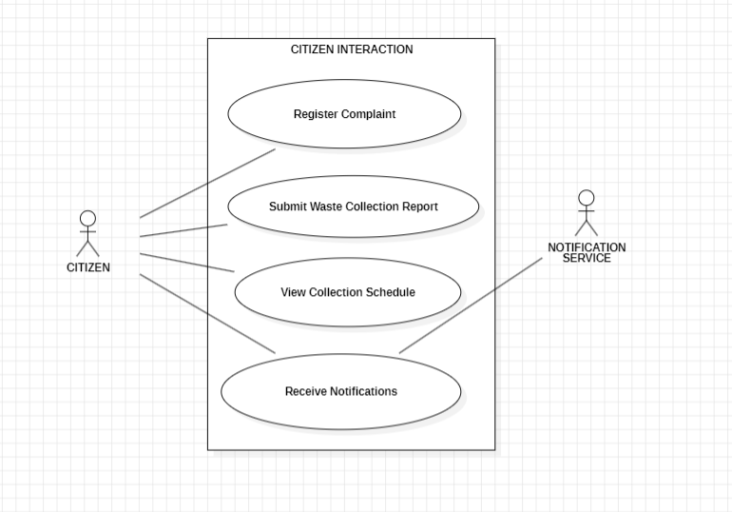
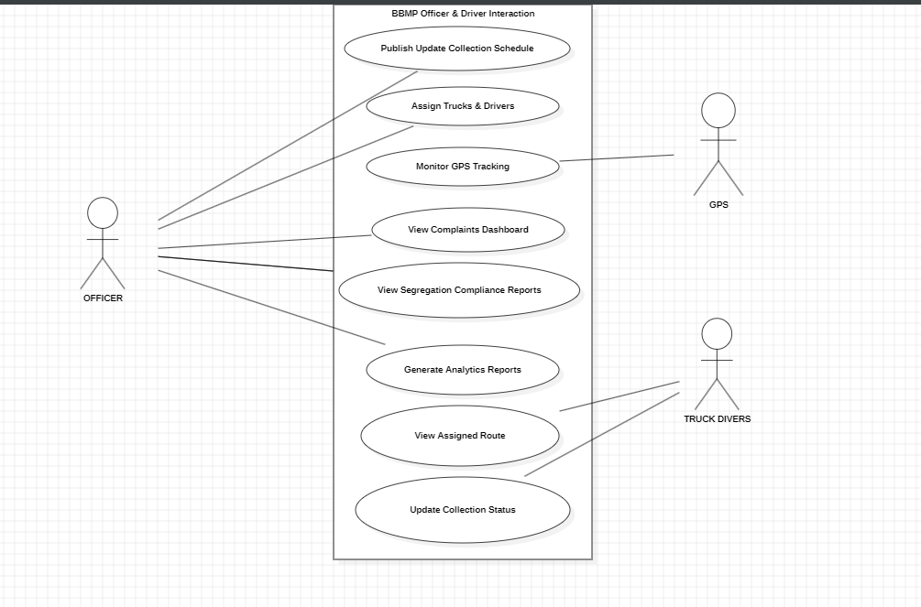

8. Requirements Traceability Matrix (RTM)

Req ID | Requirement short | Section ref / Design Spec | Module | Test case(s) | Status (N/P/A) | Comments
WMS-F-001 | Citizen registers complaint | 4.1 / DS-Citizen-01 | Complaint Module | TC-Comp-01 | N | Needs photo storage
WMS-F-002 | Citizen submits collection report | 4.1 / DS-Citizen-02 | Report Module | TC-Report-01 | N | Depends on citizen app usability
WMS-F-003 | Citizen views collection schedule | 4.1 / DS-Citizen-03 | Schedule Module | TC-Schedule-01 | N | Depends on officer schedule updates
WMS-F-004 | Record segregation compliance | 4.1 / DS-Citizen-04 | Segregation Module | TC-Seg-01 | N | Compliance logs needed
WMS-F-005 | Send notifications to citizens | 4.1 / DS-Citizen-05 | Notification Module | TC-Notify-01 | N | Depends on SMS/Push service
WMS-F-006 | Officer publishes schedule | 4.2 / DS-Officer-01 | Schedule Module | TC-Schedule-02 | N | Citizen app sync dependency
WMS-F-007 | Assign trucks & drivers | 4.2 / DS-Officer-02 | Assignment Module | TC-Assign-01 | N | GPS sync dependency
WMS-F-008 | Monitor GPS tracking | 4.2 / DS-Officer-03 | GPS Module | TC-GPS-01 | N | Needs Maps API link
WMS-F-009 | Officer views complaints dashboard | 4.2 / DS-Officer-04 | Dashboard Module | TC-Comp-02 | N | Depends on citizen complaint database
WMS-F-010 | Segregation compliance reports | 4.2 / DS-Officer-05 | Dashboard Module | TC-Seg-02 | N | Depends on citizen segregation logs
WMS-F-011 | Generate analytics reports | 4.2 / DS-Officer-06 | Reporting Module | TC-Report-02 | N | Requires historical data availability
WMS-F-012 | Driver views assigned route | 4.3 / DS-Driver-01 | Driver App/  Dashboard | TC-Driver-01 | N | Depends on officer assignments
WMS-F-013 | Driver updates collection status | 4.3 / DS-Driver-02 | Driver App/  Dashboard | TC-Driver-02 | N | Needs stable network for sync
WMS-F-014 | Store photo evidence | 4.4 / DS-System-01 | Media Storage | TC-Photo-01 | N | Needs compression
WMS-F-015 | Automatic daily backup | 4.4 / DS-System-02 | Backup Module | TC-Backup-01 | N | Requires backup server
WMS-NF-001 | Response time ≤ 3s | 5 / DS-Perf-01 | Backend/API | TC-Perf-01 | N | Load test required
WMS-NF-002 | 99.5% uptime | 5 / DS-Rel-01 | Server Infrastructure | TC-Rel-01 | N | Needs monitoring tool
WMS-NF-003 | Bilingual UI | 5 / DS-UX-01 | Frontend UI | TC-UX-01 | N | Translation
WMS-NF-004 | Mobile + Browser compatibility | 5 / DS-Comp-01 | Frontend App /Website | TC-Comp-01 | N | Device testing
WMS-NF-005 | Data encryption at rest & transit | 5 / DS-Sec-01 | Security Layer | TC-Sec-01 | N | Needs SSL configuration
WMS-SR-001 | Enforce HTTPS | 5.1 / DS-Sec-02 | Security Layer | TC-Sec-01 | N | Requires SSL certificate
WMS-SR-002 | Role-based access (RBAC) | 5.1 / DS-Sec-03 | Authentication Module | TC-Sec-02 | N | Role definitions needed (citizen, officer, driver, admin)
WMS-SR-003 | Password hashing | 5.1 / DS-Sec-04 | Authentication Module | TC-Sec-03 | N | Must use technique
WMS-SR-004 | Account lockout after 5 failures | 5.1 / DS-Sec-05 | Authentication Module | TC-Sec-04 | N | Depends on login attempt tracking
WMS-SR-005 | Encrypted backups | 5.1 / DS-Sec-06 | Backup Module | TC-Sec-05 | N | Requires encryption key management

