Software Architecture and Design Specification
Project: Waste Management System – Bengaluru
Version: 1.0
Authors: Khushi Dev, Krithika.K, Monika
Date: 6-10-25
Status: Draft

Revision History
Version | Date | Author | Change Summary
1.0 |6-10-25| Team | Final SAD with diagrams

Approvals
Role | Name | Signature/Date

1. Introduction
1.1 Purpose
This document specifies the architecture and design of the Waste Management System (WMS), covering citizen, officer, and driver features along with system-level services like notifications, GPS tracking, and data storage.

1.2 Scope
The WMS enables citizens to report complaints, track waste collection, and receive schedules/notifications; officers to manage routes, trucks, and reports; drivers to update collection status; and the system to store evidence and backup data.

1.3 Audience
- Developers & Testers: Implement and validate architecture.
- BBMP Officers: End-users of dashboards.
-Citizens: End-users of mobile/web app.
- Drivers: Use driver app for routes.
-Instructors: Review project.

1.4 Definitions
-WMS: Waste Management System
-BBMP: Bruhat Bengaluru Mahanagara Palike
-GPS: Global Positioning System
-API: Application Programming Interface
-RTM: Requirements Traceability Matrix
-RBAC: Role-Based Access Control

2. Document Overview
2.1 How to use this document
Provides architectural deliverables including UML diagrams, component descriptions, data flows, threat models, and API design.
2.2 Related Documents
- SRS (Software Requirement Spec.)
- STP (Software Test Plan)
- RTM (Requirement Traceability Matrix)

3. Architecture

3.1 Goals & Constraints
- Goals: Secure, scalable, reliable, multilingual, citizen-friendly.
- Constraints: Integration with GPS/Notification APIs, budget limits, compliance with BBMP .

3.2 Stakeholders & Concerns
-Citizens: Ease of use, real-time updates.
-Officers: Accurate dashboards, compliance reports.
-Drivers: Simple route app.
-Regulators: Transparency, compliance.
-Developers: Maintainability, modularity

3.3 Component (UML) Diagram

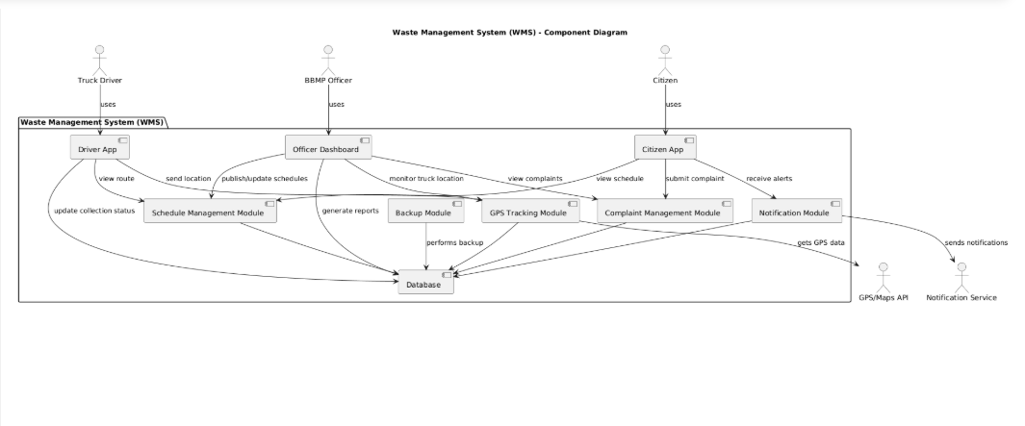

3.4 Component Descriptions
-Citizen App: Complaint submission, schedule view, notifications.
-Officer Dashboard: Route assignments, monitoring, analytics.
-Driver App: Route viewing, collection status updates.
-Notification Service: External SMS/Email/Push service.
-GPS API: Provides live truck tracking.
-Database: Stores complaints, schedules, routes, logs.
-Backup Module: Ensures data backup and recovery.

.

3.5 Chosen Architecture Pattern and Rationale
A layered architecture with presentation, application, and data layers.
- Clear separation of concerns.
- Supports scalability and modular development.

3.6 Technology Stack & Data Stores
-Frontend: ReactJS (Web), Flutter/Android app.
-Backend: Node.js + Express.
-Database: MongoDB.
-APIs: REST/GraphQL, GPS/Maps, Notification APIs.
-Security: TLS/HTTPS, RBAC.

3.7 Risks & Mitigations

- Risk: GPS downtime→ Mitigation: cache last known location

- Risk: Notification delay → Mitigation: retry queues

- Risk: Data loss risk → Mitigation: automated backups

3.8 Traceability to Requirements
-Complaint Registration (WMS-F-001) → Citizen App + DB.
-GPS Tracking (WMS-F-008) → GPS API + Dashboard.
-Analytics (WMS-F-011) → Officer Dashboard + DB.
-Backup (WMS-F-015) → Backup Module.

3.9 Security Architecture
Threat Model (STRIDE):
- Spoofing → Enforce authentication & HTTPS.
- Tampering → Integrity checks on logs.
- Info Disclosure → Data encryption.
- DoS → Rate limiting.
- Elevation of Privilege → RBAC for roles (citizen, officer, driver).

4. Design

4.1 Citizen login - login Module – Test plan

4.1 Citizen Register Complaint -Test plan
Layered design:
- Presentation Layer: Web & Mobile UIs (citizen, officer, driver).
- Application Layer: Services (complaint, schedule, GPS, notification, backup).
- Data Layer: MongoDB storage and backups.

5.2 UML Sequence Diagrams
At least 2 sequence diagrams covering 2 flows specific to your project
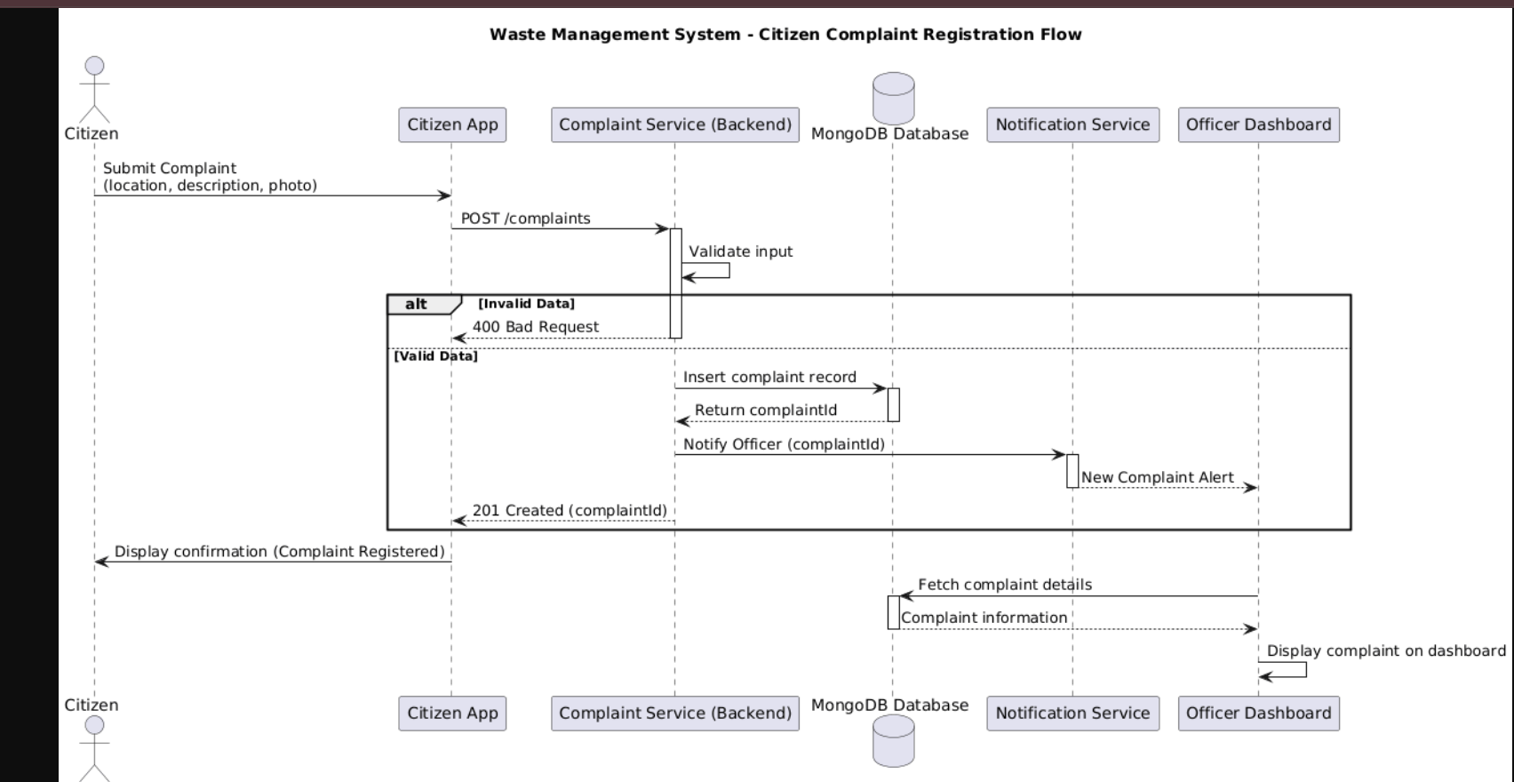

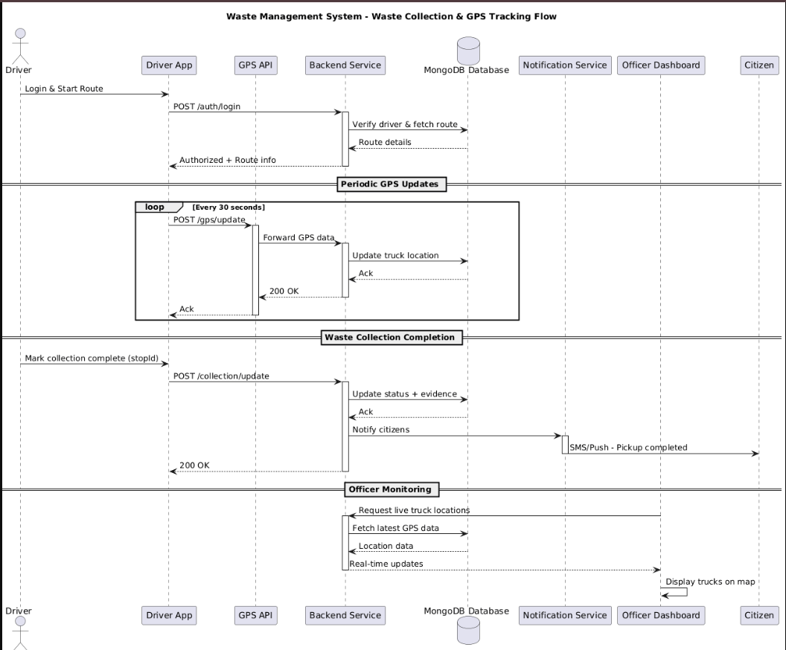

5.3 API Design
Interface definition for at least 2 components.
Endpoint: /complaints
- Method: POST
- Request: {citizenId, location, photo, description}
- Response: {status, complaintId
Endpoint: /gps/update
- Method: POST
- Request: {driverId, lat, long, timestamp}
- Response: {status}
.

5.4 Error Handling, Logging & Monitoring
-Standard JSON error format.
-Logs without sensitive data.
-Monitoring for downtime, failed notifications, missed pickups.

5.5 UX Design
-Citizen App: Simple, bilingual (Kannada + English).
-Officer Dashboard: Charts, filters, drill-down reports.
-Driver App: Minimalistic with route maps.
.

5.6Open Issues & Next Steps
-Integration testing with live BBMP GPS.
-Optimization of notification retries.
-Explore machine learning for route optimization (future)

6. Appendices
6.1 Glossary: WMS, BBMP, GPS, API, RTM, RBAC.
6.2 References:
-IEEE 42010 (Architecture Description).
-OWASP Security Guidelines.
-Swachh Bharat Mission Documentation.
6.3 Tools:
-StarUML (UML diagrams).
-Swagger (API docs).
-MongoDB Atlas.
-Postman (API testing).

