**PES1201701369 – Krithika Suwarna**

**PES1201701271 – Aiswarya Y B**

**PES1201700973 – Shamitha K**

**PES1201700742 – Neha N D**

**ASSIGNMENT – 4**

Problem statement:

Perform Simple Linear Regression, Multiple Regression and Multivariate Regression on the IRIS dataset.

1. Simple Regression:

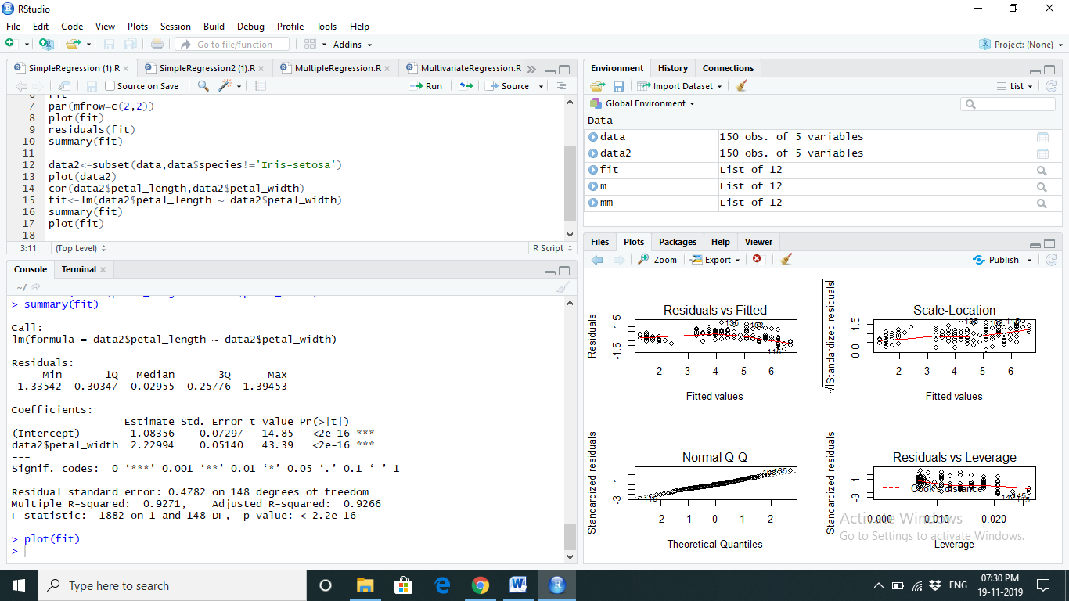

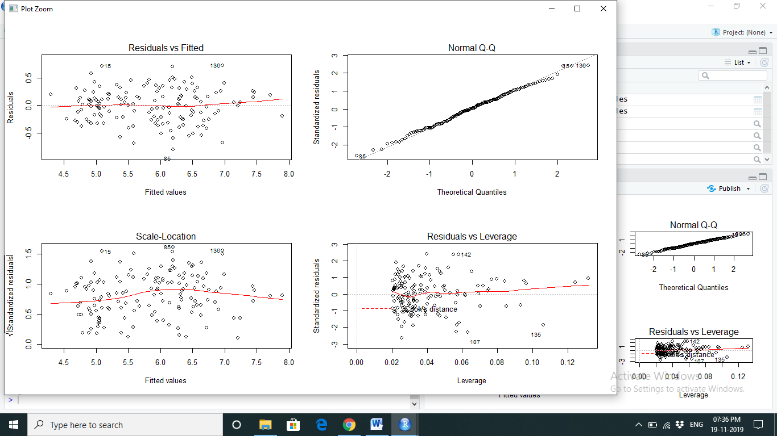

1. Multiple Regression:

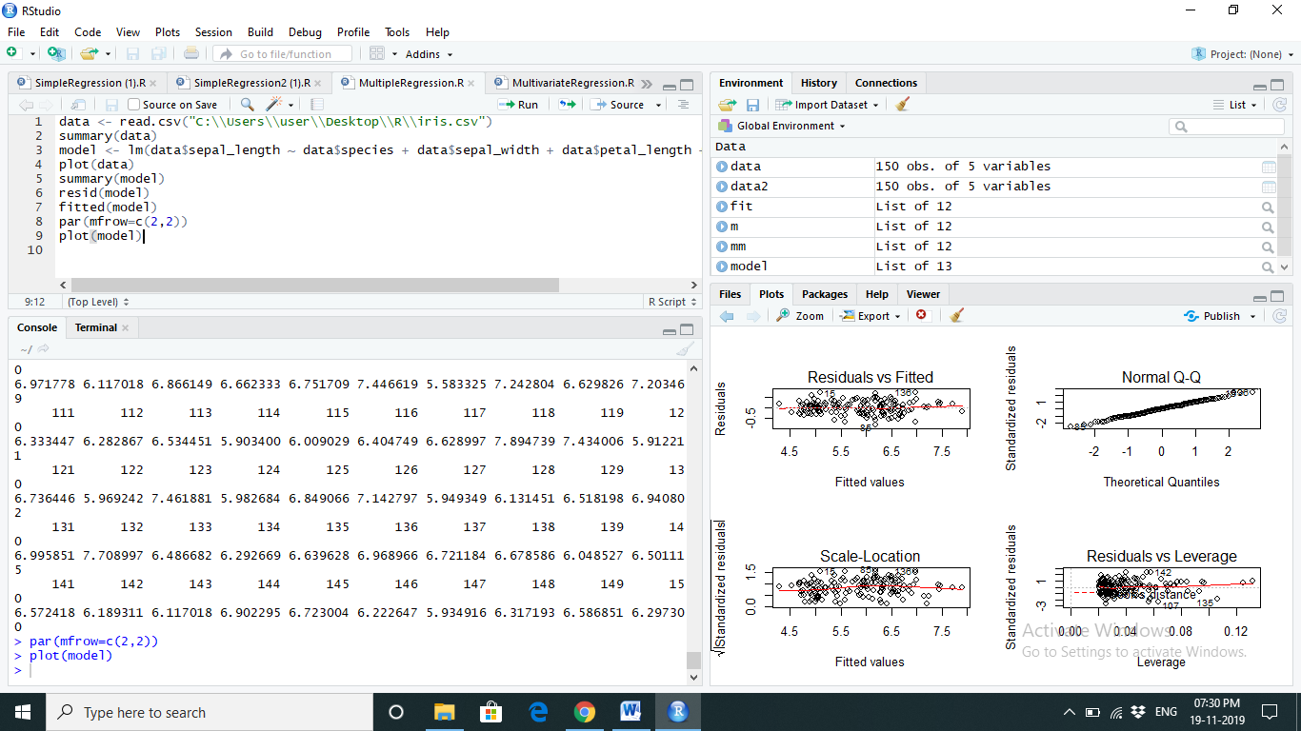



1. Multivariate Regression:

