

**NAME : KRITHIKA V**

**REG NO : 22BCT0091**

**COURSE : WEB PROGRAMMING**

**SLOT : L1+L2+L25+L26**

Assessment 6

**PORTFOLIO**

**index.html**

**CODE:**

<!DOCTYPE html>

<html lang="en">

  <head>

    <meta charset="UTF-8" />

    <meta http-equiv="X-UA-Compatible" content="IE=edge" />

    <meta name="viewport" content="width=device-width,initial-scale=1.0" />

    <title>Welcome to my Page!</title>

    <link rel="stylesheet" href="style.css" />

    <link

      href="https://unpkg.com/boxicons@2.1.4/css/boxicons.min.css"

      rel="stylesheet"

    />

  </head>

  <body>

    <header class="header">

      <a href="#" class="logo">Welcome to my Page!</a>

      <nav class="navbar">

        <a href="#" class="active">HOME</a>

        <a href="abo-ut.html">ABOUT</a>

        <a href="#technicalskills">TECHNICAL SKILLS</a>

        <a href="#contact">CONTACT</a>

      </nav>

      *

    </header>

    <section class="home">

      <div class="home-img">

        <img class="im" src="kr.jpg" width="65%" height="75%" alt="" />

      </div>

      <div class="home-content">

        <h1>Hi,I'm Krithika</h1>

        <h3>Aspirant to IOT/Cloud software engineer</h3>

        <p>

          I am currently pursuing my Btech degree in CSE with Internet of Things

          at Vellore Institute of Technology , Vellore.

        </p>

        <div class="btn-box">

          <a href="#">Hire Me</a>

          <a href="#">Let's Talk</a>

        </div>

      </div>

      <div class="home-sci">

        <a href="#"><i class="bx bxl-facebook"></i></a>

        <a href="#"><i class="bx bxl-twitter"></i></a>

        <a href="#"><i class="bx bxl-linkedin"></i></a>

      </div>

      <span class="home-imgHover"></span>

    </section>

    <section class="technicalskills" id="technicalskills">

      <div class="technicalskills-content">

        <p></p>

        <h2 class="heading">Technical<span> Skills</span></h2>

        <li>peer-to-Peer</li>

        <br />

        <li>Node.js development</li>

        <br />

        <li>Moblie app development</li>

        <br />

        <li>API Automation and testing</li>

        <br />

        <li>leadership</li>

        <br />

        <li>Web hacking</li>

        <br />

      </div>

    </section>

    <section class="contact" id="contact">

      <p></p>

      <h2 class="heading">Contact<span> Me!</span></h2>

      <form action="#">

        <div class="input-box">

          <input type="text" placeholder="Full Name:Krithika.V" />

          <input

            type="email"

            placeholder="Email Address :krithika.v@vitstudent.ac.in"

          />

        </div>

        <div class="input-box">

          <input type="number" placeholder="Mobile number:9566700692" />

          <input type="text" placeholder="Email Subject" />

        </div>

        <textarea

          name=""

          id=""

          cols="30"

          rows="10"

          placeholder="Your Message"

        ></textarea>

        <input type="submit" value="Send Message" class="btn" />

      </form>

    </section>

    <script src="js/script.js"></script>

  </body>

</html>

**about.html**

<!DOCTYPE html>

<html>

  <head>

    <title>ABOUT ME</title>

    <style>

      .img-container {

        float: right;

        padding-left: 6em;

        padding-right: 6em;

        margin-left: 10px;

        margin-bottom: 10px;

      }

      .img-contain {

        float: right;

        padding-left: 8em;

        padding-right: 8em;

        margin-left: 30px;

        margin-bottom: 30px;

      }

      h1 {

        text-align: left;

        line-height: 1;

        color: red;

        padding-left: 7em;

        padding-right: 7em;

        font-size: 8vh;

      }

      h2 {

        font-size: 6vh;

        padding-left: 1em;

        padding-right: 1em;

      }

      p {

        color: aliceblue;

        width: 50%;

        padding-left: 1em;

        padding-right: 1em;

        font-size: 4.5vh;

      }

    </style>

  </head>

  <body background="blue.jpg">

    <div class="img-container">

      <br /><br /><br /><br />

      <img

        align="left"

        src="kr.jpg"

        alt="Your Image"

        height="90%"

        width="230px"

      />

    </div>

    <h1>ABOUT<span> ME</span></h1>

    <h2 style="color: palevioletred">ABOUT MY COURSE:</h2>

    <p>

      The Internet of Things (IoT) describes the network of physical

      objects—“things”—that are embedded with sensors, software, and other

      technologies for the purpose of connecting and exchanging data with other

      devices and systems over the internet. Internet of Things, refers to the

      collective network of connected devices and the technology that

      facilitates communication between devices and the cloud, as well as

      between the devices themselves.

    </p>

    <br />

    <br />

    <div class="img-contain">

      <img

        align="left"

        src="kr1.jpg"

        alt="Your Image"

        height="200%"

        width="200px"

      />

    </div>

  </body>

</html>

**style.css**

@import url("https://fonts.googleapis.com/css2?family=Poppins:wght@300;400;500;600;700;800;900&display=swap");

* {

  margin: 0;

  padding: 0;

  box-sizing: border-box;

  font-family: "Poppins", sans-serif;

}

body {

  color: #ededed;

}

.header {

  position: fixed;

  top: 0;

  left: 0;

  width: 100%;

  padding: 20px 10%;

  background: transparent;

  display: flex;

  justify-content: space-between;

  align-items: center;

  z-index: 100;

}

.logo {

  position: relative;

  font-size: 25px;

  color: palevioletred;

  text-decoration: none;

  font-weight: 600;

}

.logo::before {

  content: "";

  position: absolute;

  top: 0;

  right: 0;

  width: 100%;

  height: 100%;

  background: #081b29;

  animation: showRight 1s ease forwards;

  animation-delay: 0.4s;

}

.navbar a {

  font-size: 18px;

  color: #ededed;

  text-decoration: none;

  font-weight: 500;

  margin-left: 35px;

  transition: 0.3s;

}

.navbar a:hover,

.navbar a.active {

  color: #00abf0;

  background: #081b29;

}

.home {

  height: 100vh;

  background: url("blue.jpg") no-repeat;

  background-size: cover;

  background-position: center;

  display: flex;

  align-items: center;

  justify-content: center;

  padding: 0 10%;

  gap: 3rem;

}

.home-img {

  width: 45vw;

  margin-left: 0cm;

  padding-left: 1em;

  padding-right: 1em;

}

.home-content {

  max-width: 1000px;

}

.home-content h1 {

  position: relative;

  font-size: 50px;

  font-weight: 700;

  line-height: 1.2;

}

.home-content h1::before {

  content: "";

  position: absolute;

  top: 0;

  right: 3;

  width: 100%;

  height: 100%;

  background: #081b29;

  animation: showRight 1s ease forwards;

  animation-delay: 1.1s;

}

.home-content h3 {

  position: relative;

  font-size: 32px;

  font-weight: 700;

  color: #00abf0;

}

.home-content h3::before {

  content: "";

  position: absolute;

  top: 0;

  right: 0;

  width: 100%;

  height: 100%;

  background: #081b29;

  animation: showRight 1s ease forwards;

  animation-delay: 1.3s;

}

.home-content p {

  position: relative;

  font-size: 20px;

  margin: 20px 0 40px;

}

.home-content p::before {

  content: "";

  position: absolute;

  top: 0;

  right: 0;

  width: 100%;

  height: 100%;

  background: #081b29;

  animation: showRight 1s ease forwards;

  animation-delay: 1.6s;

}

.home-content .btn-box {

  position: relative;

  display: flex;

  justify-content: space-between;

  width: 345px;

  height: 50px;

}

.home-content .btn-box::before {

  content: "";

  position: absolute;

  top: 0;

  right: 0;

  width: 100%;

  height: 100%;

  background: #081b29;

  animation: showRight 1s ease forwards;

  animation-delay: 1.9s;

  z-index: 2;

}

.btn-box * {

  position: relative;

  display: inline-flex;

  justify-content: center;

  align-items: center;

  width: 150px;

  height: 100%;

  background: #00abf0;

  border: 2px solid #00abf0;

  border-radius: 8px;

  font-size: 19px;

  text-decoration: none;

  font-weight: 600;

  letter-spacing: 1px;

  z-index: 1;

  overflow: hidden;

  transition: 0.5s;

}

.btn-box a:hover {

  color: #00abf0;

}

.btn-box a:nth-child(2) {

  background: transparent;

  color: #00abf0;

}

.btn-box a:nth-child(2):hover {

  color: #081b29;

}

.btn-box a:nth-child(2)::before {

  background: #00abf0;

}

.btn-box a::before {

  content: "";

  position: absolute;

  top: 0;

  left: 0;

  width: 0;

  height: 100%;

  z-index: -1;

  transition: 0.5s;

}

.btn-box a:hover::before {

  width: 100%;

}

.home-sci {

  position: absolute;

  bottom: 40px;

  width: 170px;

  display: flex;

  justify-content: space-between;

}

.home-sci::before {

  content: "";

  position: absolute;

  top: 0;

  right: 0;

  width: 100%;

  height: 100%;

  animation: showRight 1s ease forwards;

  animation-delay: 2.5s;

  z-index: 2;

}

.home-sci a {

  position: relative;

  display: inline-flex;

  justify-content: center;

  align-items: center;

  width: 40px;

  height: 40px;

  background: transparent;

  border: 2px solid #00abf0;

  border-radius: 50%;

  font-size: 20px;

  color: #00abf0;

  text-decoration: none;

  z-index: 1;

  overflow: hidden;

  transition: 0.5s;

}

.home-sci a:hover {

  color: #081b29;

}

.home-sci a::before {

  content: "";

  position: absolute;

  top: 0;

  left: 0;

  width: 0;

  height: 100%;

  background: #00abf0;

  z-index: -1;

  transition: 0.5s;

}

.home-sci a:hover:before {

  width: 100%;

}

.home-imgHover {

  position: absolute;

  top: 0;

  right: 30px;

  width: 500px;

  height: 100%;

  background: transparent;

  transition: 3s;

  animation: manipActiveHover 0.1s forwards;

  animation-delay: 4s;

  pointer-events: none;

}

.home-imgHover:hover {

  opacity: 0.8;

}

.home-imgHover::after {

  content: "";

  position: absolute;

  top: 0;

  right: 0;

  width: 90%;

  height: 100%;

  animation: showRight 1s ease forwards;

  animation-delay: 3s;

  z-index: 2;

}

@keyframes showRight {

  100% {

    width: 0;

  }

}

@keyframes manipActiveHover {

  100% {

    pointer-events: auto;

  }

}

.about {

  background: url("blue.jpg") no-repeat;

  display: flex;

  justify-content: center;

  align-items: center;

  gap: 20rem;

}

.about-img img {

  width: 400%;

}

.heading {

  text-align: center;

  font-size: 4rem;

}

.about-content h2 {

  text-align: left;

  line-height: 1;

  color: red;

}

.about-content h3 {

  font-size: 2rem;

  color: aqua;

}

.about-content p {

  font-size: 1.5rem;

  margin: 4.5rem 0 4.5rem;

}

.technicalskills {

  background: url("blue.jpg") no-repeat;

  display: flex;

  justify-content: center;

  align-items: center;

  gap: 4rem;

}

.heading {

  text-align: center;

  font-size: 4rem;

}

.technicalskills-content h2 {

  text-align: left;

  line-height: 3;

  color: red;

}

.technicalskills-content li {

  font-size: 2rem;

}

.contact {

  background: url("blue.jpg") no-repeat;

}

.contact h2 {

  padding-left: 6em;

  padding-right: 6em;

  margin-bottom: 8;

}

.heading {

  line-height: 4;

  color: red;

  text-align: center;

  font-size: 3rem;

}

.contact form {

  max-width: 40rem;

  margin: 1rem auto;

  text-align: center;

  margin-bottom: 2rem;

}

.contact form .input-box {

  color: blue;

  flex-wrap: wrap;

}

.contact form .input-box input,

.contact form textarea {

  width: 100%;

  padding: 1rem;

  font-size: 0.8rem;

  color: blue;

  background: "aliceblue";

  border-radius: 0.5rem;

  margin: 0;

}

.contact form .input-box input {

  width: 100%;

}

.contact form textarea {

  color: blue;

  resize: none;

}

.contact form .btn {

  margin-top: 2.3rem;

  cursor: pointer;

  color: red;

}

**OUTPUT:**

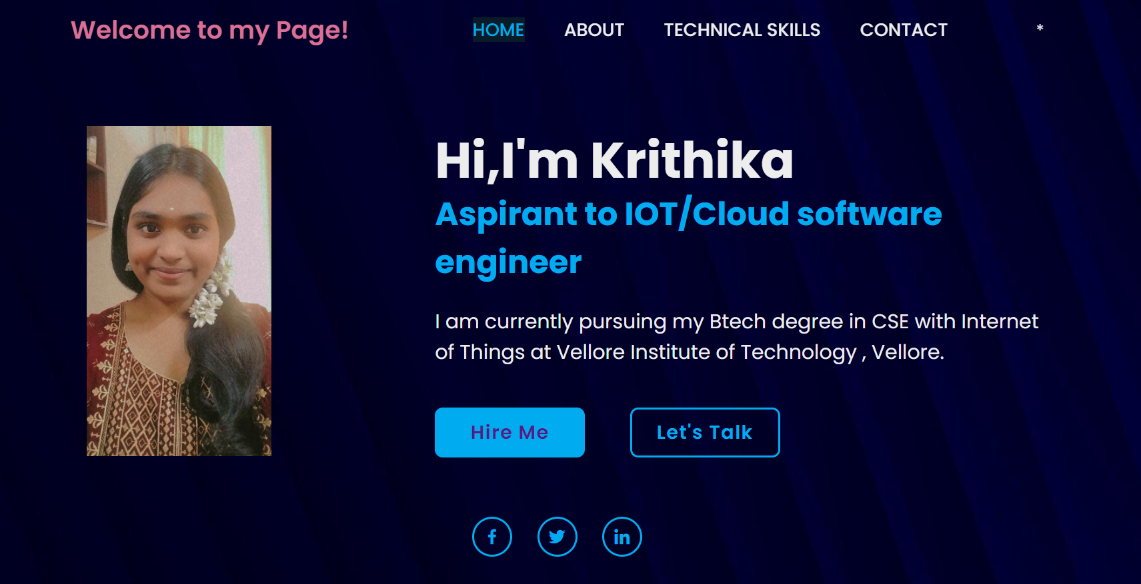

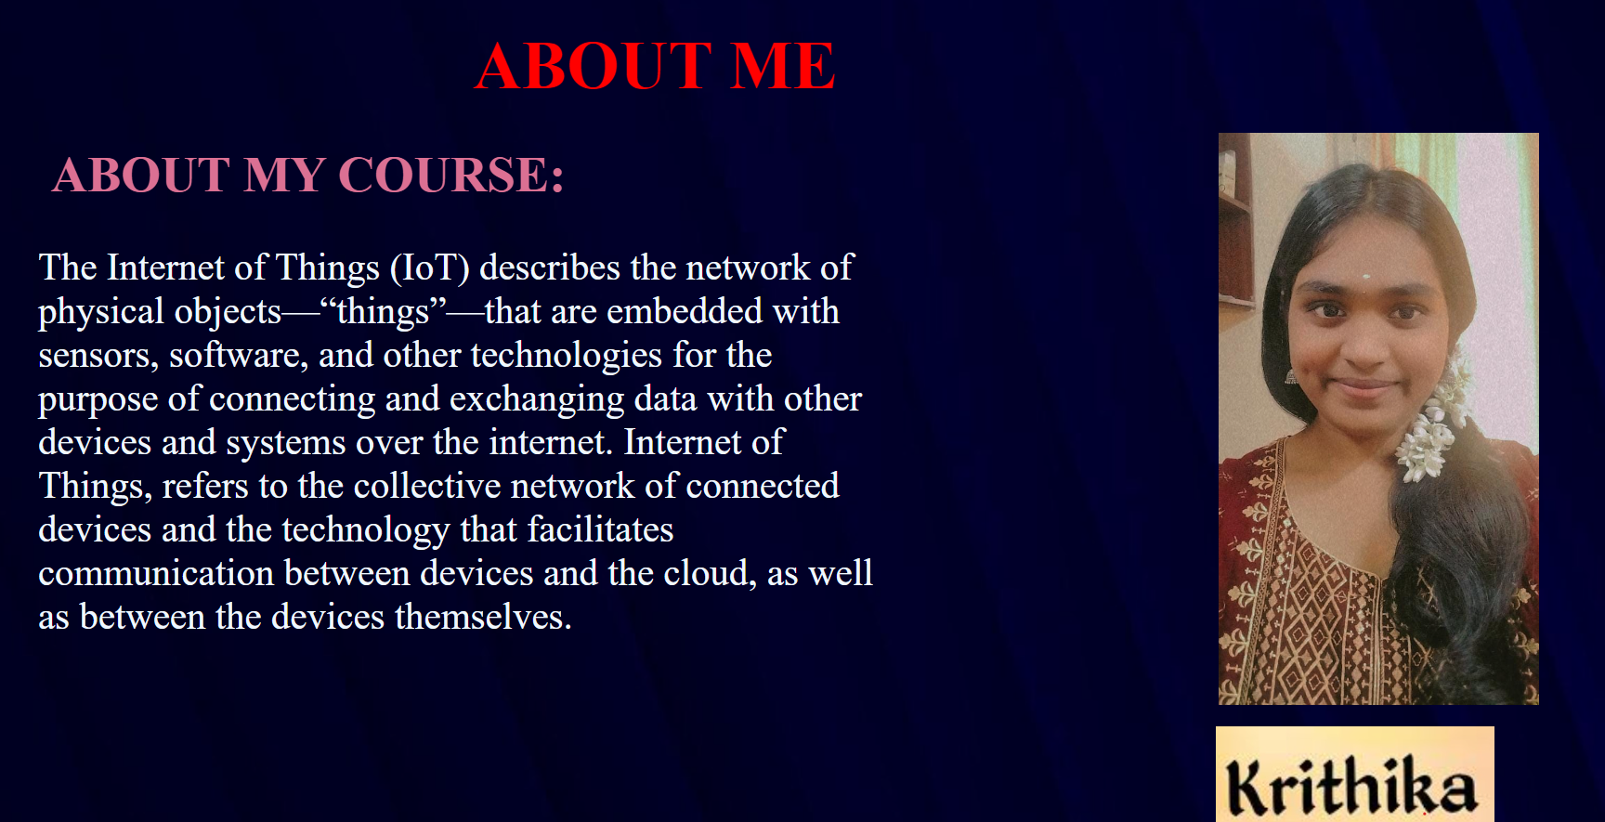

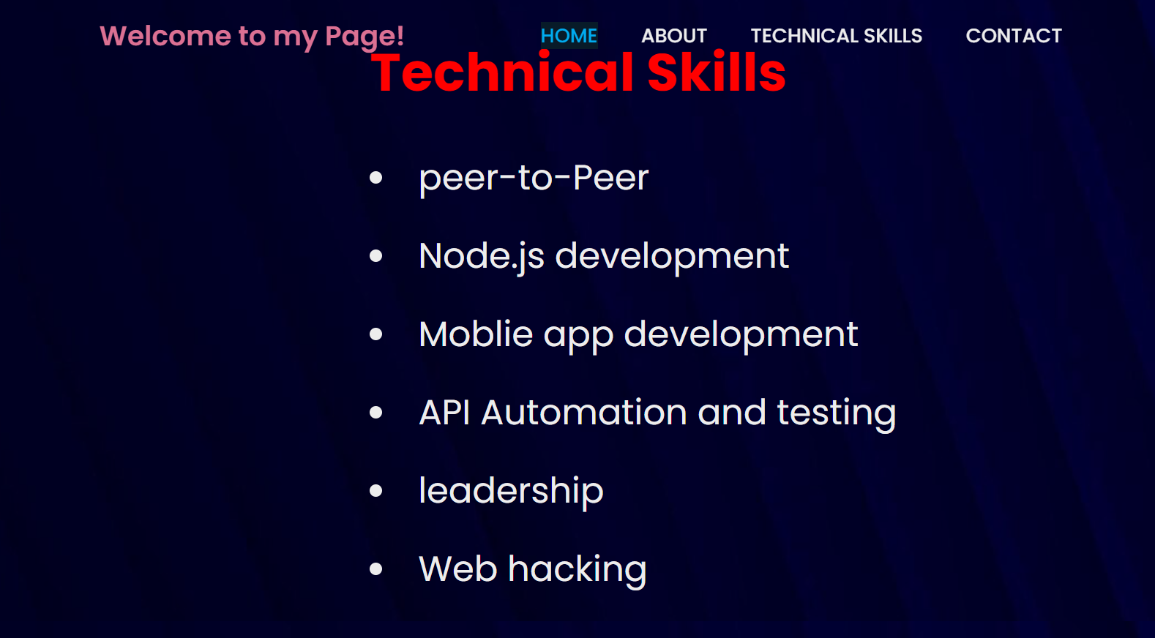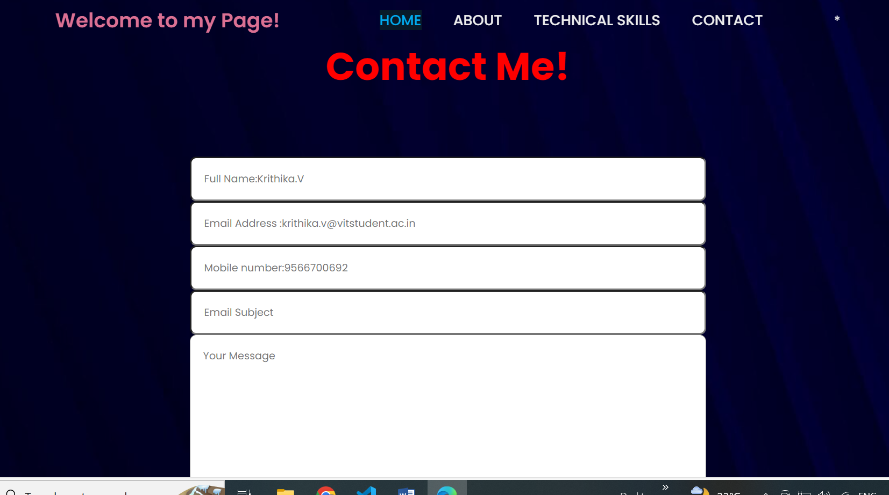

**GITHUB LINK:**

**https://github.com/Krithikavit**