Library Full Stack Demo
Student GitHub & Eclipse Assignment Workflow
Using Forks, Eclipse, Pull Requests and a Common Public Repository
Common Public Repository
https://github.com/vvekselva/Library-Full-Stack-KHAE

For Student Use

1. How the Class Repository Will Be Used
All students start from the same common public repository. Each student creates a fork in their own GitHub account and then clones that fork to the computer used for Eclipse development.
The instructor's common public repository is the place from which assignments and common project updates are distributed. Student work is submitted back to the same common repository using a Pull Request.
Important
Students develop on the main branch of their OWN fork. Students do not develop directly on the instructor's main repository.
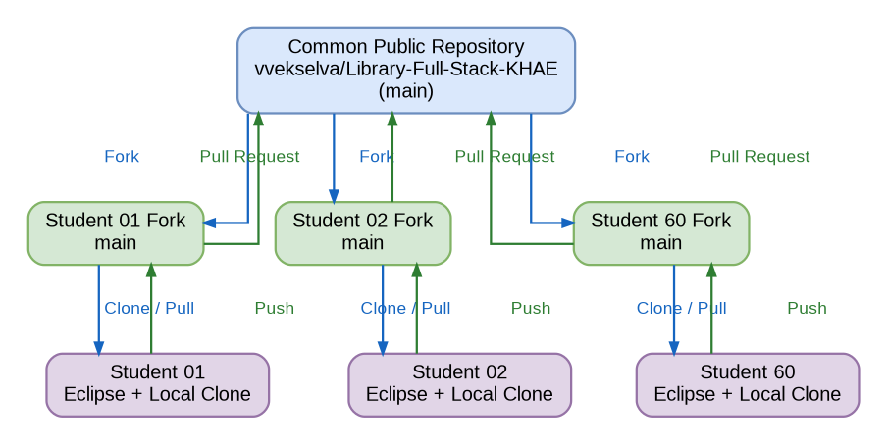
Figure 1. Developers working from one common repository using individual forks.

2. Terms Used in This Workflow
Term | Meaning
Common public repository | The instructor repository that contains the common classroom version of the project.
Fork | A GitHub copy of the common public repository created inside a student's own GitHub account.
Clone | A local copy of the student's fork created on the student computer.
Commit | A saved snapshot of the student's changes in the local Git repository.
Push | Sends committed changes from the student computer to the student's GitHub fork.
Pull | Gets the latest changes from the student's GitHub fork into the local repository used by Eclipse.
Sync fork | Updates the student's GitHub fork with newer changes from the instructor's common public repository.
Pull Request | A request to send the student's completed work from the student fork to the instructor's common public repository.
Merge | Accepts the approved Pull Request into the common main branch.

3. First-Time Student Setup
Step 1 - Open the common public repository
https://github.com/vvekselva/Library-Full-Stack-KHAE
Step 2 - Create your fork
1. Sign in to your GitHub account.
2. Open the common repository.
3. Click Fork.
4. Select your own GitHub account as the owner.
5. Keep the repository name as Library-Full-Stack-KHAE.
6. Create the fork.
Expected result
Your GitHub account now contains YOUR-USERNAME/Library-Full-Stack-KHAE. This is the repository to which you will push your work.
Step 3 - Clone your own fork using Eclipse
1. Open Eclipse.
2. Select File -> Import.
3. Select Git -> Projects from Git.
4. Select Clone URI.
5. Paste the HTTPS URL of YOUR fork, not the instructor repository.
6. Complete the clone and import procedure.
Example student clone URL:
https://github.com/student01/Library-Full-Stack-KHAE.git
Check before continuing
The remote named origin in Eclipse must point to the student's own fork.

4. How an Assignment Is Given
Assignments are published through the common public repository. The instructor may add an assignment instruction file, starter source code, test files, or other project changes.
Example:
assignments/Assignment-01.md
backend/...
frontend/...
A typical assignment instruction file can contain:
- Assignment number and title
- Task to be completed
- Files or components to be modified
- Expected program behaviour or output
- Testing to be performed
- Submission instructions
- Due date, when applicable
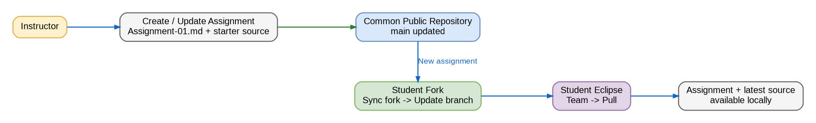
Figure 2. Assignment distribution from the common repository to each student Eclipse environment.

5. How to Receive a New Assignment
Step 1 - Synchronize your fork on GitHub
1. Open your fork on GitHub.
2. Click Sync fork.
3. Review the available upstream changes.
4. Click Update branch.
Step 2 - Pull the updated fork into Eclipse
1. Open the Git Repositories view in Eclipse.
2. Confirm that the current branch is main.
3. Use Team -> Pull, or right-click the repository and use Pull.
4. Wait until the Pull completes.
5. Refresh the project if new files are not immediately visible.
After this step
The latest assignment and common source files are present in the local repository used by Eclipse.

6. Work on the Assignment in Eclipse
1. Read the complete assignment before editing the project.
2. Work only on the files or components required by the assignment.
3. Run the backend/frontend as instructed.
4. Test the assigned behaviour.
5. Check the changed files before committing.
Shared course rule
Development is performed on main in the student's own fork. Do not change the instructor repository directly.

7. Save and Submit the Assignment
Step 1 - Commit the completed work
Use a clear commit message that identifies the assignment and the change.
Recommended format:
Assignment-01: Implement book list API
Another example:
Assignment-02: Add frontend book table
Step 2 - Push to your GitHub fork
Push the committed main branch from Eclipse to your own GitHub fork.
Step 3 - Create a Pull Request
1. Open your fork on GitHub.
2. Choose the option to create a Pull Request for your changes.
3. Confirm the base repository is vvekselva/Library-Full-Stack-KHAE.
4. Confirm the base branch is main.
5. Confirm the compare repository is your fork and the compare branch is main.
6. Enter the Pull Request title and description.
7. Create the Pull Request.
Recommended Pull Request title:
Assignment 01 - Register Number - Student Name
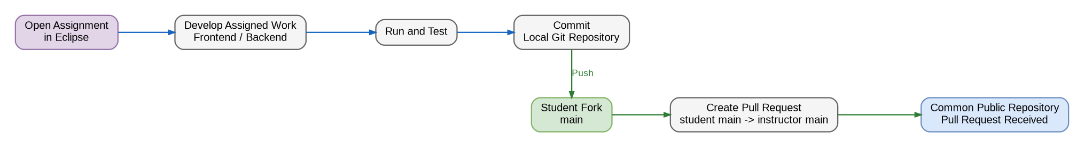
Figure 3. Student development and assignment submission.

8. Instructor Review and Corrections
The instructor reviews the Pull Request. The Pull Request may be accepted, or comments may be added asking for corrections.
Step 1 - If corrections are requested
1. Read all review comments on GitHub.
2. Make the required changes in Eclipse.
3. Run the required tests again.
4. Commit the correction.
5. Push the new commit to the same student fork and main branch.
No new Pull Request is required
When new commits are pushed to the branch used by the open Pull Request, the same Pull Request is updated with those commits.
Step 2 - If the work is accepted
The instructor merges the approved Pull Request into the common public repository.
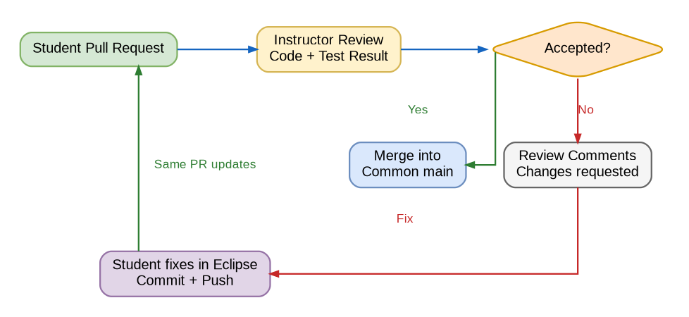
Figure 4. Review, correction and merge cycle.

9. Before Starting the Next Assignment
The common public repository may now contain changes merged from previous work and may also contain the next assignment. Before starting new work, update both the GitHub fork and the local Eclipse copy.
1. Open your fork on GitHub.
2. Use Sync fork -> Update branch.
3. Open Eclipse.
4. Pull the updated main branch.
5. Confirm that the new assignment and latest source files are available.
6. Start the new assignment.
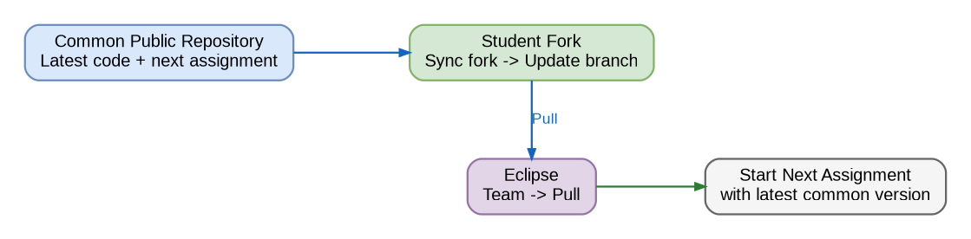
Figure 5. Preparing the student fork and Eclipse workspace for the next assignment.

10. Complete Student Assignment Cycle
1. Fork the common public repository - first time only.
2. Clone your own fork into Eclipse - first time only.
3. When an assignment is announced, Sync fork on GitHub.
4. Pull the latest main branch in Eclipse.
5. Read the assignment.
6. Develop and test in Eclipse.
7. Commit the changes locally.
8. Push to your own fork.
9. Create a Pull Request to the common public repository.
10. Respond to review comments if required.
11. After acceptance, prepare for the next assignment by synchronizing again.
Remember this sequence
SYNC FORK -> PULL -> DEVELOP -> TEST -> COMMIT -> PUSH -> PULL REQUEST -> REVIEW -> NEXT SYNC

11. Student Rules
Do | Do Not
• Fork the instructor public repository. | • Do not clone the instructor repository for your working copy.
• Clone your own fork. | • Do not push directly to the instructor repository.
• Work on main in your own fork. | • Do not create a second .git repository inside backend or frontend.
• Sync your fork before a new assignment. | • Do not commit passwords, tokens or secret keys.
• Pull before beginning the assignment. | • Do not delete files that are outside your assignment without instruction.
• Use clear commit messages. | • Do not force-push unless the instructor specifically directs it.
• Push only tested work.
• Use Pull Requests for submission.

12. Common Problems
Problem | Action
I cannot see the new assignment in Eclipse. | Sync your fork on GitHub first, then Pull in Eclipse and refresh the project.
Push goes to the wrong repository. | Check that origin points to YOUR-USERNAME/Library-Full-Stack-KHAE.
My Pull Request contains unexpected files. | Review changed files before submission. Remove accidental changes and push a correction.
The instructor requested changes. | Fix the same local project, commit, and push to the same fork/main. The open Pull Request will update.
I already created a fork earlier. | Do not create another fork. Use Sync fork to update the existing fork.

13. Official Reference Links
GitHub - Fork a repository: https://docs.github.com/articles/fork-a-repo
GitHub - Clone a repository: https://docs.github.com/articles/cloning-a-repository
GitHub - Syncing a fork: https://docs.github.com/articles/syncing-a-fork
GitHub - Creating a Pull Request from a fork: https://docs.github.com/articles/creating-a-pull-request-from-a-fork
Eclipse EGit - User Guide: https://help.eclipse.org/latest/topic/org.eclipse.egit.doc/help/EGit/User_Guide/Tasks.html

Appendix A - Draw.io Diagram Source
The figures in this student guide are accompanied by an editable Draw.io source file containing five pages, one page for each workflow illustration.
Library_Full_Stack_Student_Workflow_DrawIO.drawio

