Cloning the Library Full Stack Repository
using SourceTree
Windows - Step-by-Step Guide
Repository | Library-Full-Stack-KHAE
Clone URL | https://github.com/vvekselva/Library-Full-Stack-KHAE.git

Cloning creates the first local copy of a Git repository on the computer. SourceTree also records the connection to the GitHub repository so that later Git operations can synchronize the local and remote repositories.

Before You Start
- SourceTree must already be installed.
- GitHub must already be connected to SourceTree using OAuth.
- The computer must have Internet access during the clone operation.
- Choose a local folder where Git repositories will be stored.
Remember: Clone is normally performed only once. When the instructor later adds new files or updates to the repository, use Pull instead of cloning again.

Remote GitHub Repository → Clone → Local Git Repository

1 | Open SourceTree and Select the Remote Repository  Open SourceTree and click Remote. Under Remote repositories, locate Library-Full-Stack-KHAE. Use the Clone action for this repository.

Selection: The screenshot also shows Library-Full-Stack-KHAE-Master. For this procedure, select Library-Full-Stack-KHAE, which is the public classroom repository.

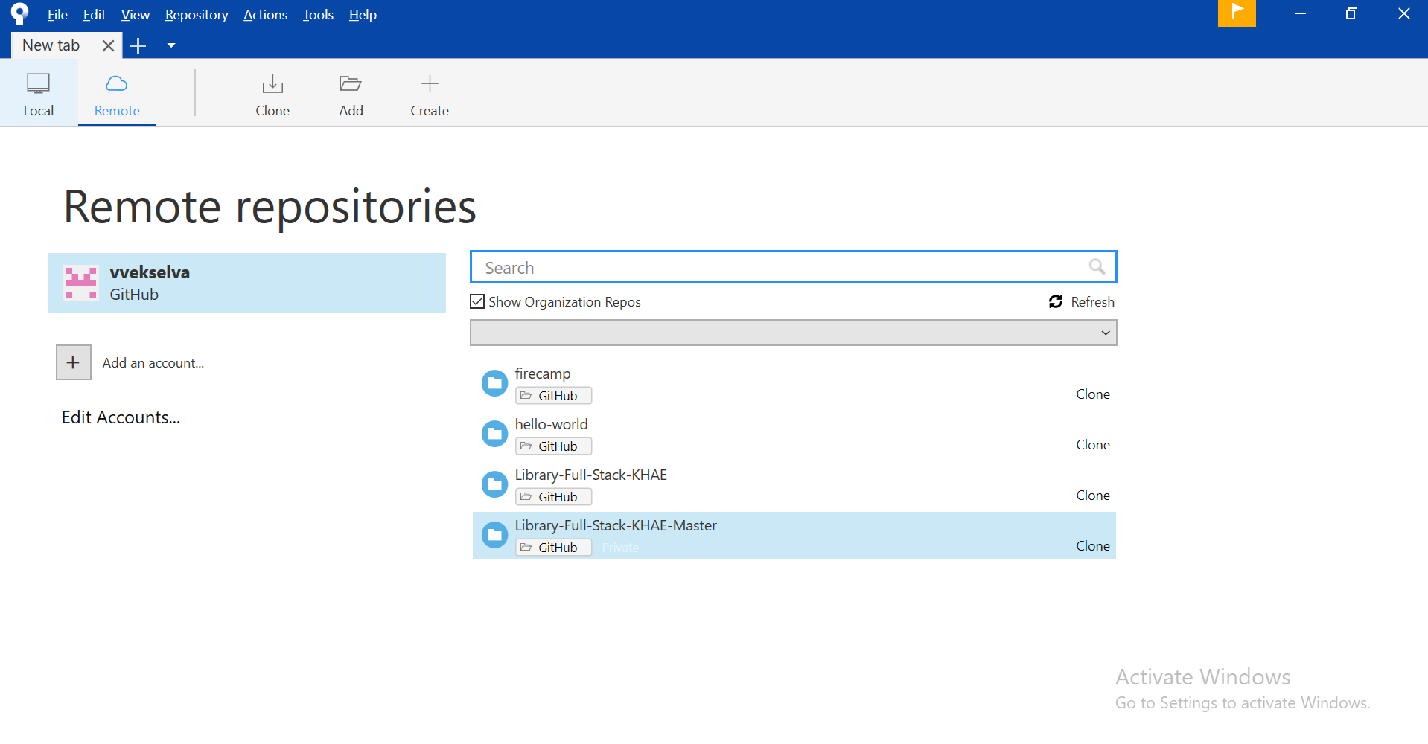
Screenshot 01 - SourceTree Remote repositories

2 | Click Clone  After selecting Library-Full-Stack-KHAE, click Clone. SourceTree opens the Clone screen. The remote repository URL should point to the Library-Full-Stack-KHAE GitHub repository.

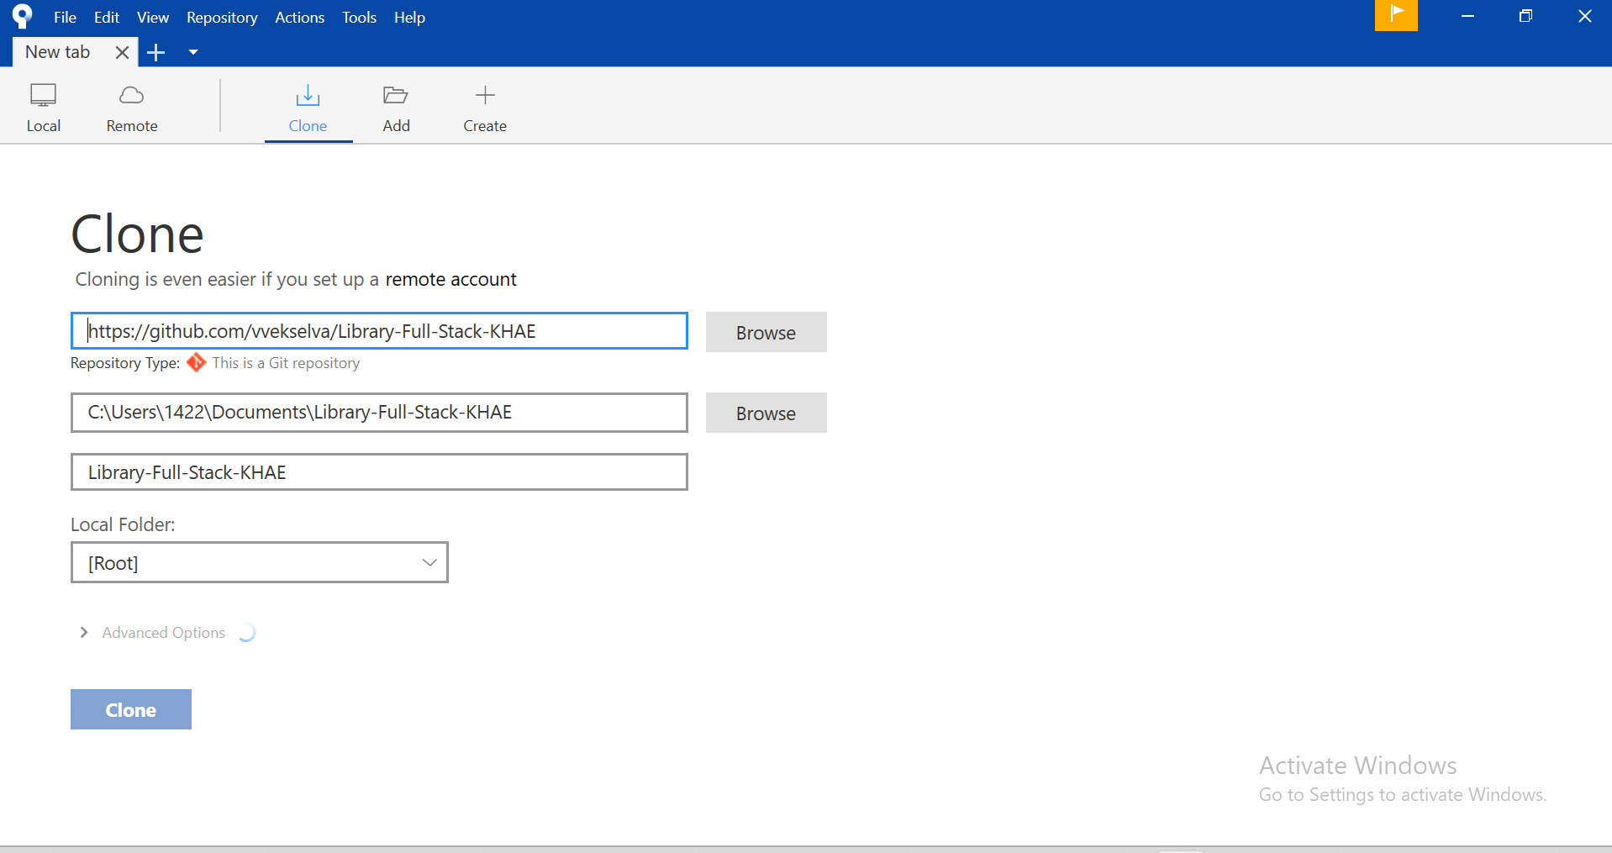
Screenshot 02 - SourceTree Clone screen
Remote repository: https://github.com/vvekselva/Library-Full-Stack-KHAE.git

3 | Select the Local Folder  Click Browse next to the local destination path. Select the folder where the repository should be stored. SourceTree shows the selected local path and repository folder name.

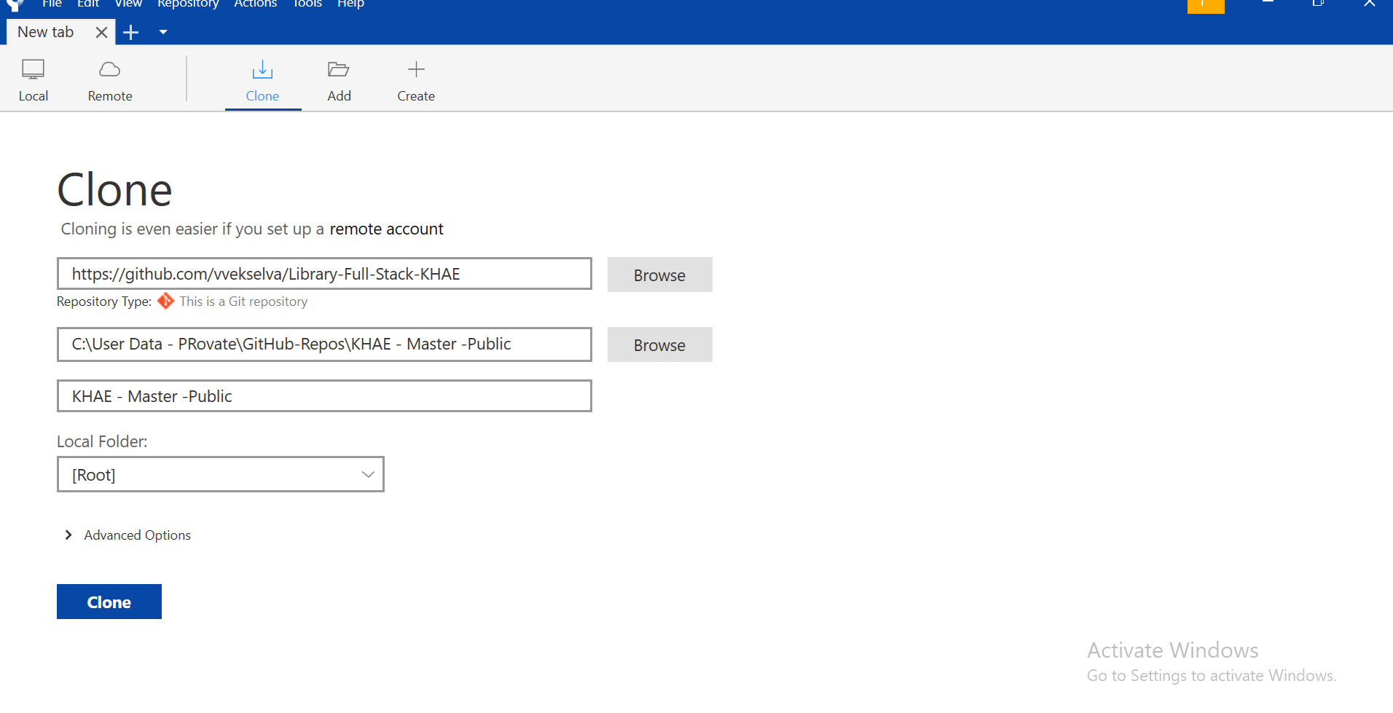
Screenshot 03 - Local destination folder selected
Note: The local folder name shown in the screenshot is only an example. Students may use the folder path specified by the instructor.

4 | Start the Clone Operation  After confirming the GitHub repository URL and the local destination folder, click Clone. SourceTree downloads the files and Git history into the selected local folder. Wait until the operation finishes.

5 | Verify the Local Clone  Open the selected local folder in Windows File Explorer. The repository files should now be available locally. The screenshot below shows an example cloned folder containing the docs folder and README file.

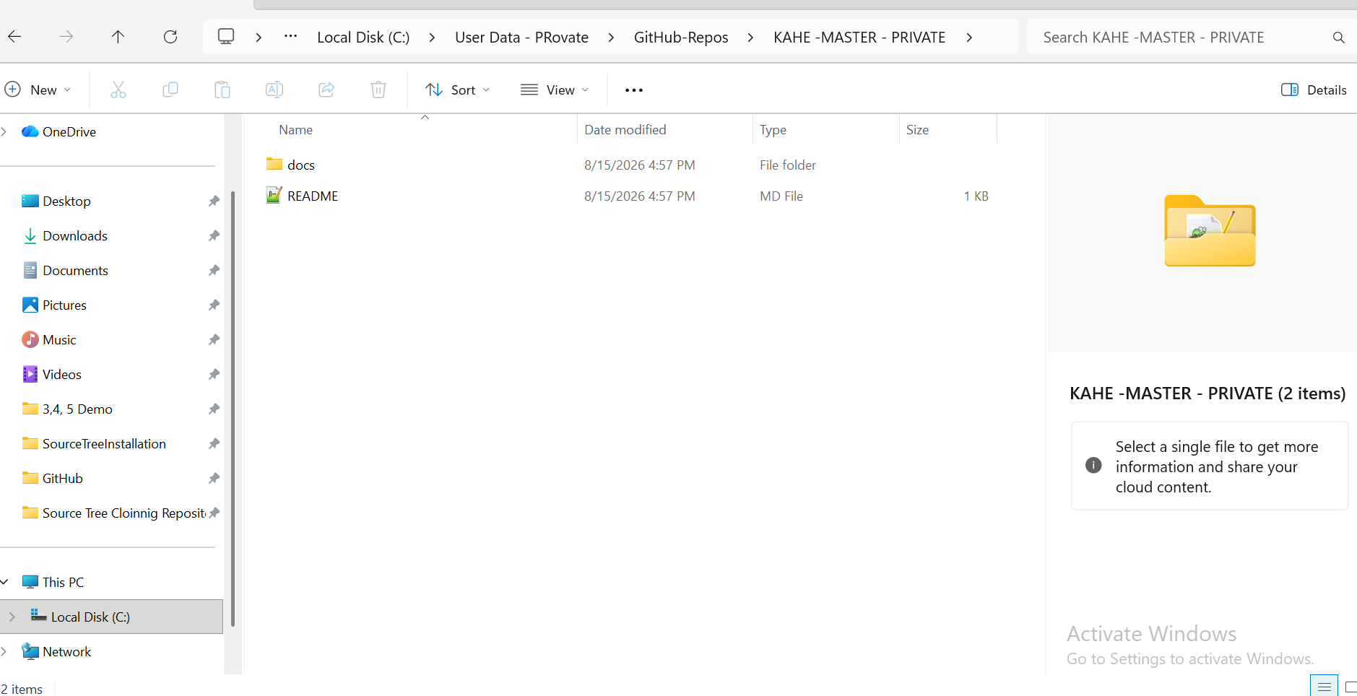
Screenshot 04 - Files available in the local cloned folder
Screenshot note: The folder name shown in this screenshot is an example local folder. The verification point is that the cloned repository files are present.

6 | Compare the Local Files with the GitHub Repository  Open the GitHub repository in the browser and compare its files with the files in the local clone. The remote repository below contains the docs folder and README.md. The same repository content should be available locally after cloning.

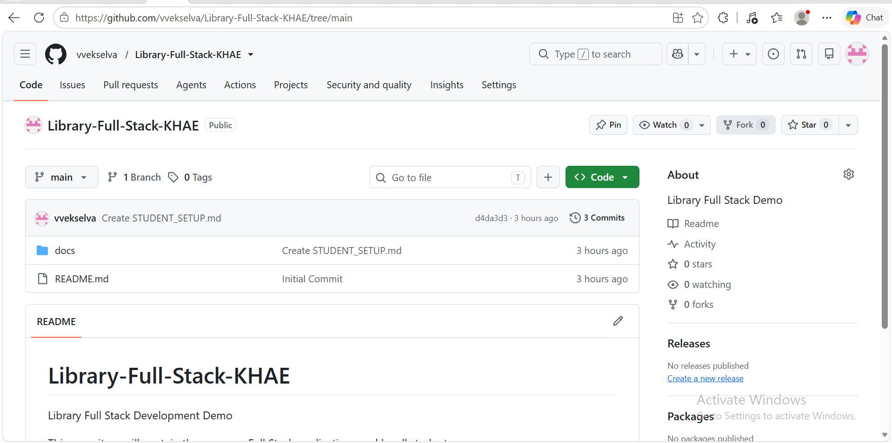
Screenshot 05 - Remote GitHub repository contents

Clone Verification Checklist
Check | Expected Result
Repository | Library-Full-Stack-KHAE
Remote URL | GitHub repository URL is correct
Local folder | Repository folder exists on the computer
Files | docs and README.md are available locally
SourceTree | Repository appears under Local after cloning

After Cloning
- Open the local repository in SourceTree when you begin development.
- Use Pull to obtain later updates from GitHub. Do not clone the same repository again for every update.
- Commit records local changes in Git history.
- Push sends committed changes to the configured remote repository when your workflow and permissions allow it.
Clone once → Work locally → Pull later updates → Commit changes → Push when required

