Installing SourceTree and Connecting GitHub
Windows - Student Step-by-Step Guide
This guide installs SourceTree and connects a GitHub account using OAuth.
Important
Use your own GitHub account. Never share your GitHub password, Personal Access Token, SSH private key, or recovery codes with another student.

Windows SourceTree Installer
Download: SourceTreeSetup-3.4.31.exe
URL: https://product-downloads.atlassian.com/software/sourcetree/windows/ga/SourceTreeSetup-3.4.31.exe

Step 1 - Install SourceTree and skip Bitbucket registration
1. Download and run SourceTreeSetup-3.4.31.exe.
2. Allow the installer to start SourceTree.
3. On the Registration screen, click Skip. A Bitbucket account is not required for this GitHub setup.
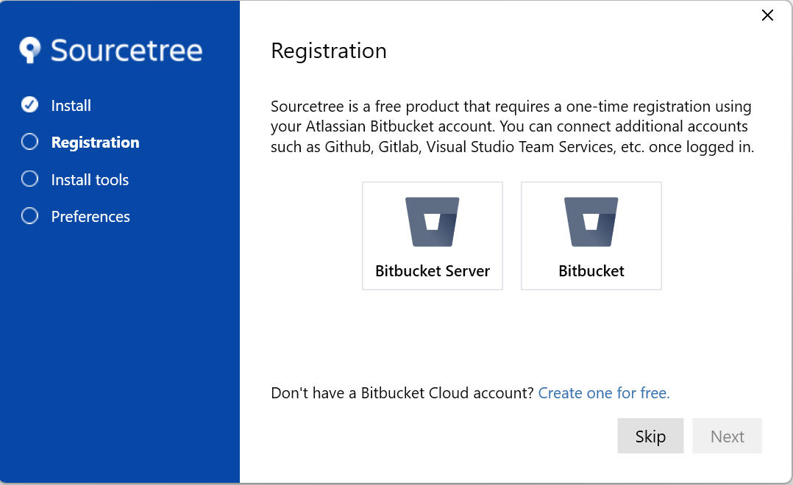
Screenshot 01 - Registration screen - click Skip

Step 2 - Confirm the Git installation
1. SourceTree checks whether Git is installed on the computer.
2. If Git is detected, its executable path is shown on the screen.
3. Click Next to continue.
Course note
Git is required for this course. Mercurial is not used in the Full Stack GitHub workflow.

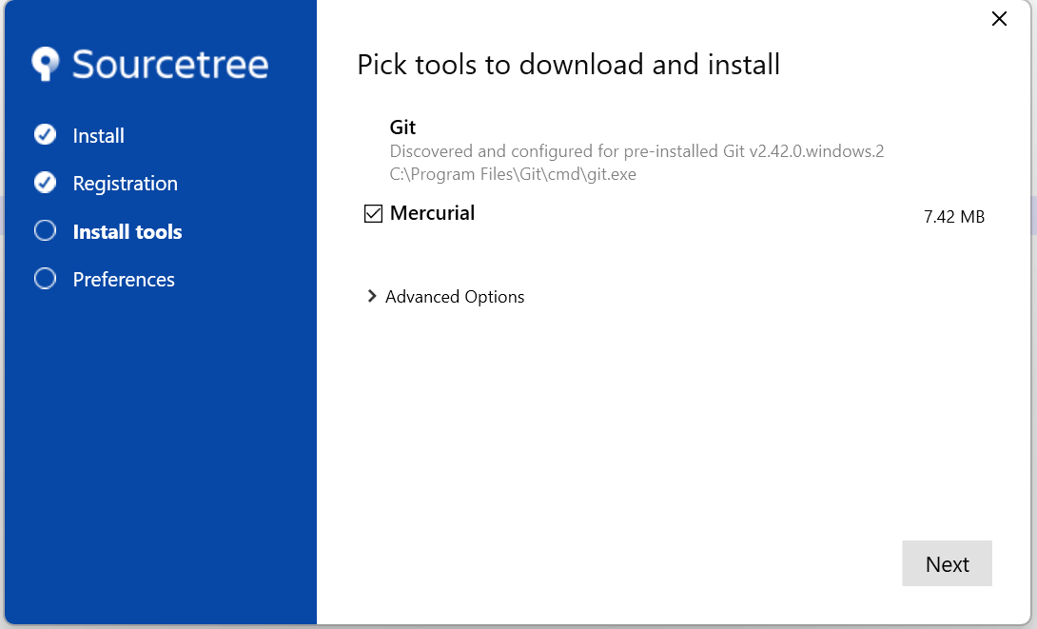
Screenshot 02 - Install tools screen - Git detected; click Next

Step 3 - Complete the tool installation
When SourceTree shows Tool installation completed, click Next.
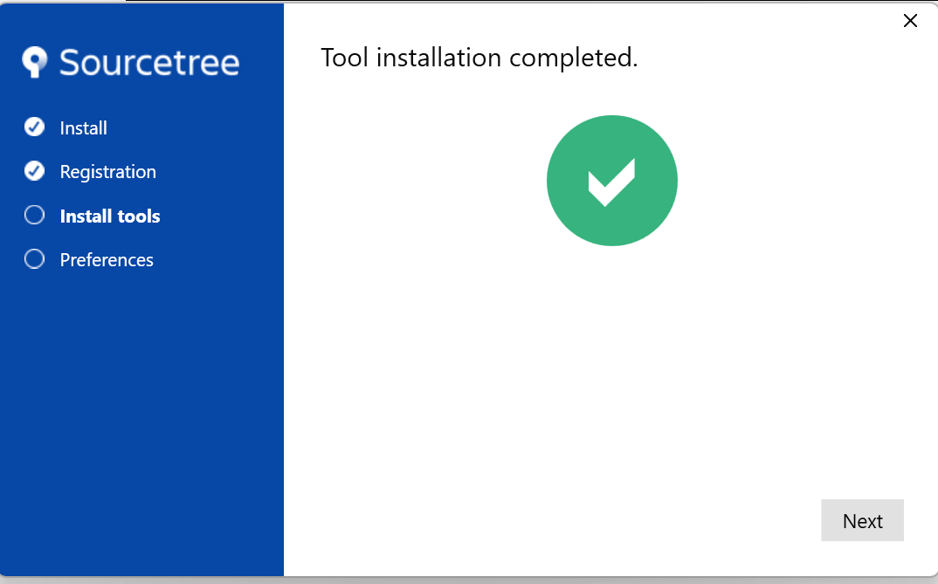
Screenshot 03 - Tool installation completed - click Next
Step 4 - Enter the Git author name and email address
1. Enter your name in the Author Name field. Replace an automatically inserted Windows account name if required.
2. Enter your email address in Author Email Address. Prefer the email address associated with your GitHub account.
3. Click Next.
Why this information is requested
Git records the author name and email address inside each commit so that the commit can be associated with its author.

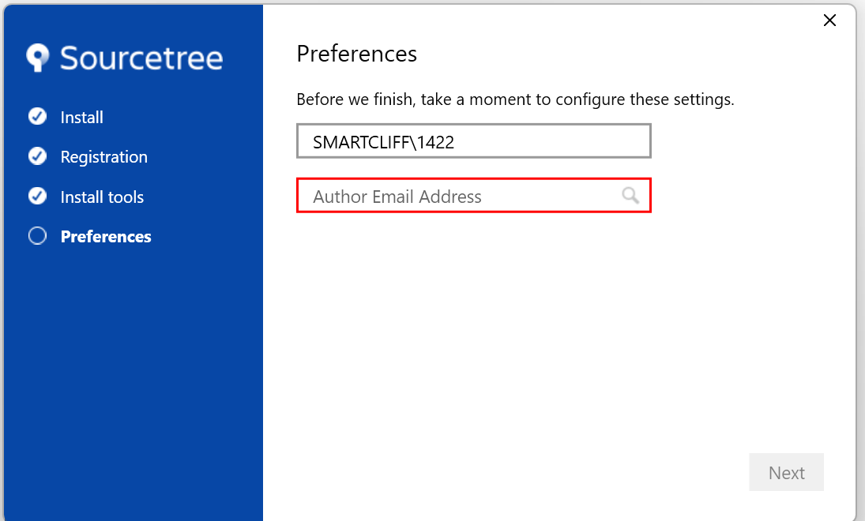
Screenshot 04 - Preferences screen - enter Author Name and Author Email Address
Step 5 - Do not load an SSH key for this setup
When the Load SSH Key? dialog appears, click No.
This guide uses OAuth
An SSH key can be configured separately later if the instructor specifically asks for SSH-based Git authentication.

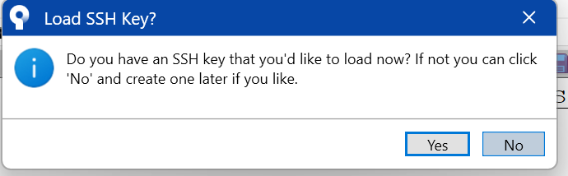
Screenshot 05 - Load SSH Key dialog - click No

Step 6 - Add a GitHub account
1. SourceTree opens the Remote repositories page.
2. Click Add an account... on the left side.
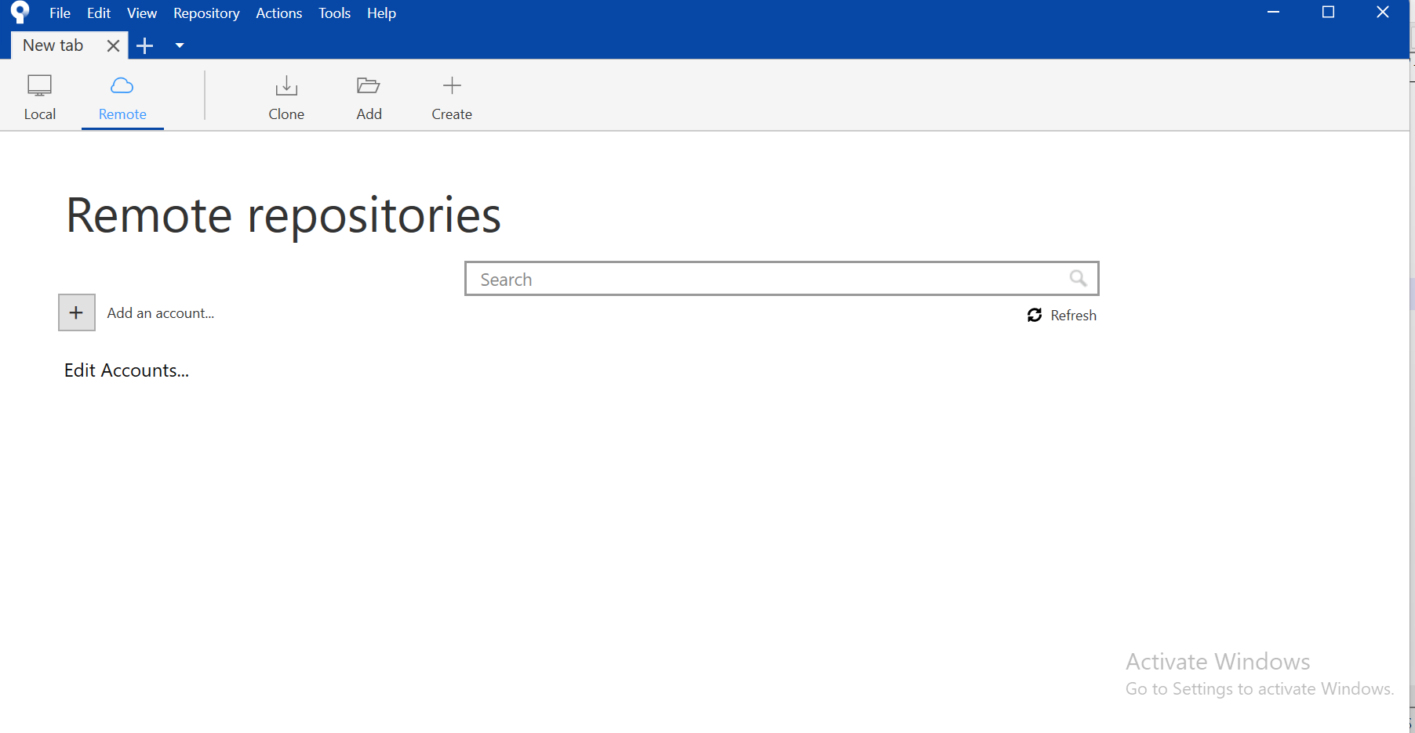
Screenshot 06 - Remote repositories page - click Add an account...
Step 7 - Configure GitHub OAuth
1. In the account configuration dialog, select GitHub as the Hosting Service.
2. Select OAuth as the Authentication Method.
3. Click Refresh OAuth Token.
Browser authorization
SourceTree opens your web browser. If GitHub asks you to sign in, sign in using the GitHub account that will be used for the class.

Step 8 - Authorize Atlassian in GitHub
1. Review the GitHub authorization page.
2. Click Authorize atlassian.
3. GitHub redirects the browser to a localhost address so SourceTree can receive the OAuth authorization result.
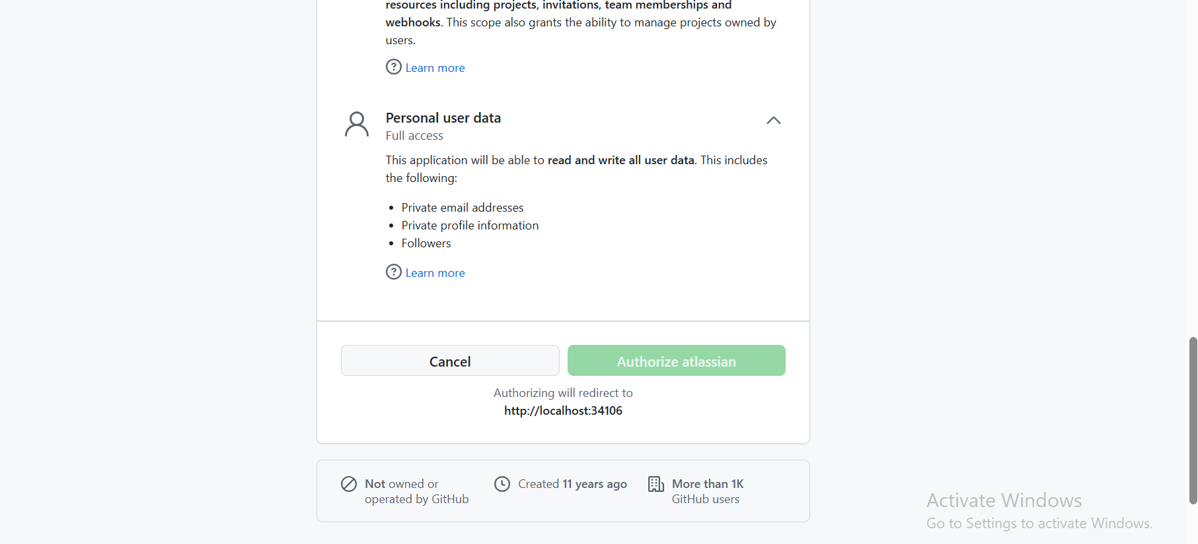
Screenshot 07 - GitHub OAuth authorization page - click Authorize atlassian
Security reminder
For this OAuth procedure, do not enter your normal GitHub password into a SourceTree password field. Authentication is completed through the GitHub browser authorization page.

Step 9 - Verify the GitHub account and repositories
1. Return to SourceTree after the browser authorization is complete.
2. Your GitHub account should appear in the left side of the Remote repositories page.
3. Click Refresh if the repositories do not appear immediately.
4. Confirm that the repositories available to your GitHub account are listed.
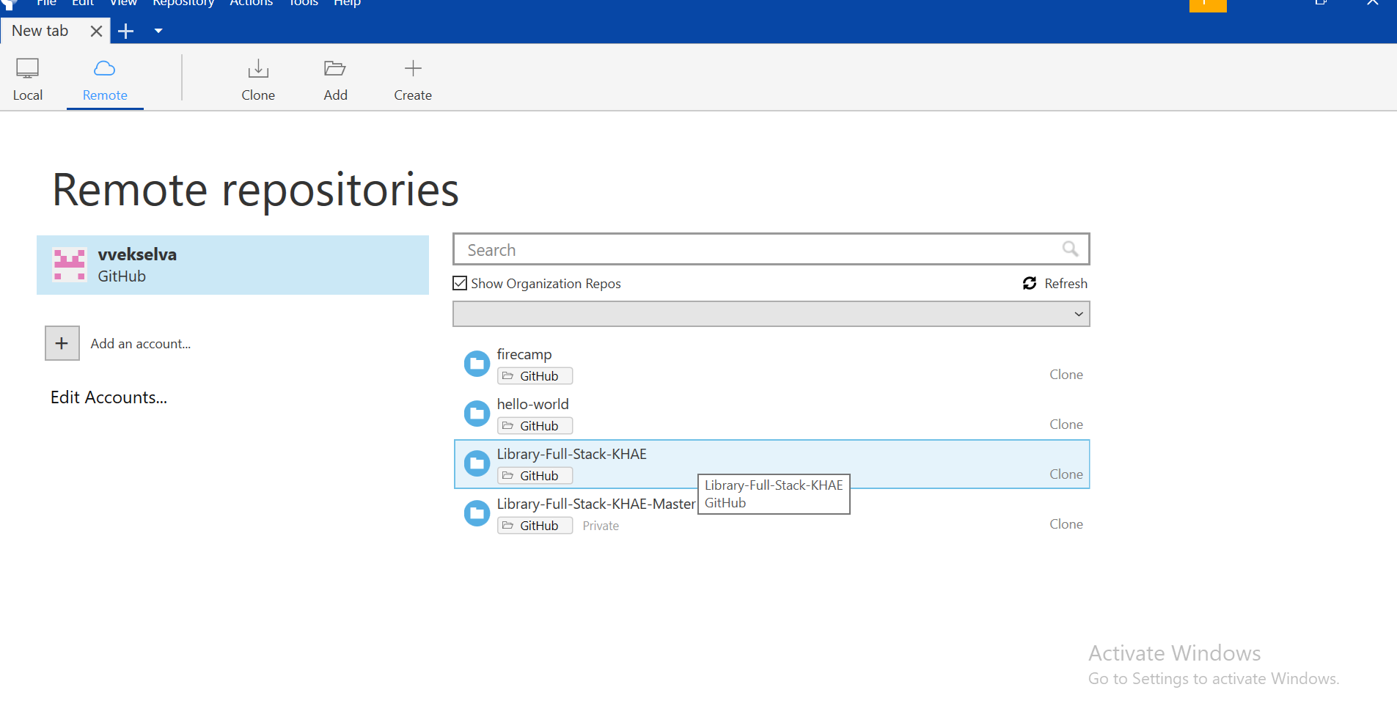
Screenshot 08 - Successful GitHub connection - repositories are visible in SourceTree
Setup complete
When the GitHub account and repository list are visible in SourceTree, the SourceTree-to-GitHub account connection is complete.

Quick Reference
Screen / Setting | Action
Registration | Click Skip
Install tools | Confirm Git; click Next
Tool installation completed | Click Next
Preferences | Enter Author Name and Author Email Address
Load SSH Key? | Click No
Remote repositories | Click Add an account...
Hosting Service | GitHub
Authentication Method | OAuth
OAuth Token | Click Refresh OAuth Token
GitHub authorization | Click Authorize atlassian
Final verification | GitHub repositories are listed

